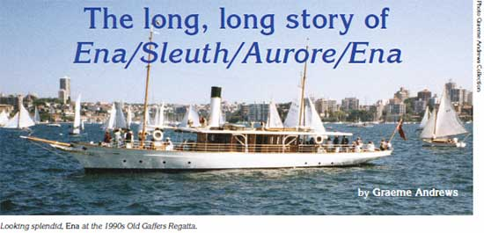

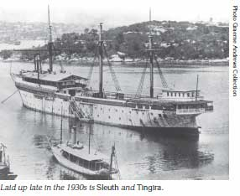
Every now and then one of the most elegant steam ships in Australia can be seen gliding around Sydney’s harbour. She is Ena, built more than a century ago for one of Australia’s richest men, and still catering for those with very deep pockets.
Ena was designed by Walter Reeks and was built by Watty Ford of Berry Bay for Thomas A. Dibbs in 1902 to replace his older and smaller Ena. Co-incidentally, the operational museum ship Lady Hopetoun was built at the same yard in the same year and has a considerable similarity to Ena (1). Ena (2) cost the enormous sum of 5,800 pounds.
Both Ena and Lady Hopetoun are described as steam yachts or steam launches. The ‘Lady’ was set up as a day boat, to run, mainly, government VIPs around the port. Ena was set up with excellent accommodation for her owner and his guests and with coastal cruising ability. When in service Ena would, undoubtedly have been on the top of the harbour’s social ‘pecking order.’
While Lady Hopetoun has only rarely ever ventured out of Sydney’s Heads, Ena during several vastly-differing careers has travelled widely, of which more later.
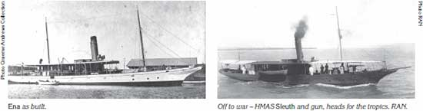
After cruising the harbour and probably the Hawkesbury River area, Ena was offered to the RAN – rather late in World War One – for the modest price of 1,000 pounds.
The Navy was very short of patrol vessels and quickly converted Ena to an austere patrol craft, intended for use in the areas of Torres Strait and Thursday Island. With a coal-fired engine, no refrigeration and very little water capacity the new HMAS Sleuth, commissioned on January 13 1917, arrived at Thursday Island towards the end of the hot and steamy Wet Season, on March 15 1917. Sleuth was armed with one 3pdr gun and had a crew of 10.
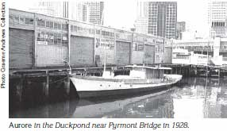
Oddly enough, Sleuth was not considered to be a success in her war-time role and was used along the coast of Queensland coast gradually getting closer to her old home port. Back in Sydney she was disarmed and became tender to the stationary naval training ship HMAS Tingira. As the late Lofty Batt stated in his book Pioneers of the RAN, Sleuth’s job was the take the lads to sea and show them what being seasick felt like.
The navy made a small profit when it sold Sleuth for 1,350 pounds in 1933. The new owner had ideas of using her to carry part of the Tasmania apple crop around local waterways and to Melbourne. Legal argument with IXL took so long that he went broke and laid the vessel up.
Sold about 1940, Ena was converted to a scallop boat with the name Aurore. In 1945 she was fitted with a diesel engine and was then employed in shark fishing and crayfish work as far north as Queensland where she worked in 1963 and 1964.

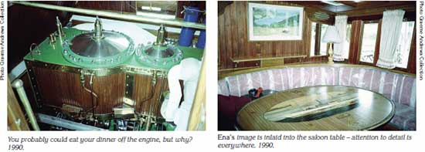
Back in Tasmania Aurore came to grief in 1981. She hit a submerged object in the Derwent River and sank, being left on the bottom for several months.
In 1982 the old boat was raised and was towed to Sydney where she was berthed in the Pyrmont ‘Duckpond’, having been purchased by a Sydney syndicate for $65,000. The intention was to bring Ena back to her original grace and style – and spare no expense. The job was given to the late Nick Masterman who took Ena up to Mortlake and began work.
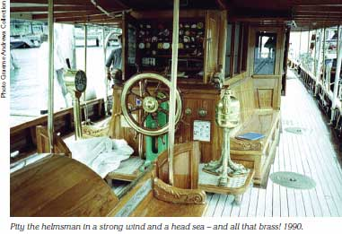
Apart from restoring the vessel, inside and out with the detail of fine furniture, Nick had to find a suitable compound steam engine and this was no easy job.
I was aware of an old Derwent River laid up in Prince Edward Bay. She had a compound engine of possibly suitable size and suggested Nick check it out. This was done – the engine had been badly damaged and lacked parts and was unusable but … the engine was removed, brought to Sydney and accurately measured. The parts were duplicated with modern replacements and the replica compound steam engine, including just a few original parts, was created and became fully operational for Ena.
As Ena neared completion I visited her several times, camera at the ready, and as she was tested I was often within camera shot. I had the pleasure of shooting her interior in detail.
ferry, Excella,
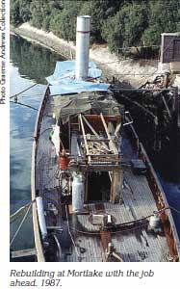
Fully found and crewed by a ship’s company of adventurers, steam yacht Ena circumnavigated Australia during 1987. Her crew did it the hard way, clockwise which exposed her and her crew to the long haul across the Great Australian Bight. There are very few places for shelter and support between Ceduna and the south west of WA but Ena made it and soon became prominent in TV news clips, shot during the defence of the America’s Cup, held off Fremantle in 1987.
Ena made the distance safely and since her return can usually be seen at Woodleys yard, Berrys Bay. She is usually covered with an all-enclosing canopy to protect that lovely finish from sun and weather. She has had several owners and presently is operated as a deluxe charter boat by Mariou Mistral Inc.
Ena was, originally, rated at 65 tons gross and 44 nett. Her registered length (not counting the bowsprit) was 88ft with a beam of 16.5ft and a depth of 8.1ft. Her compound steam engine (two cylinders) was rated at 25nhp and that removed from Excella was rated at 80nhp.

