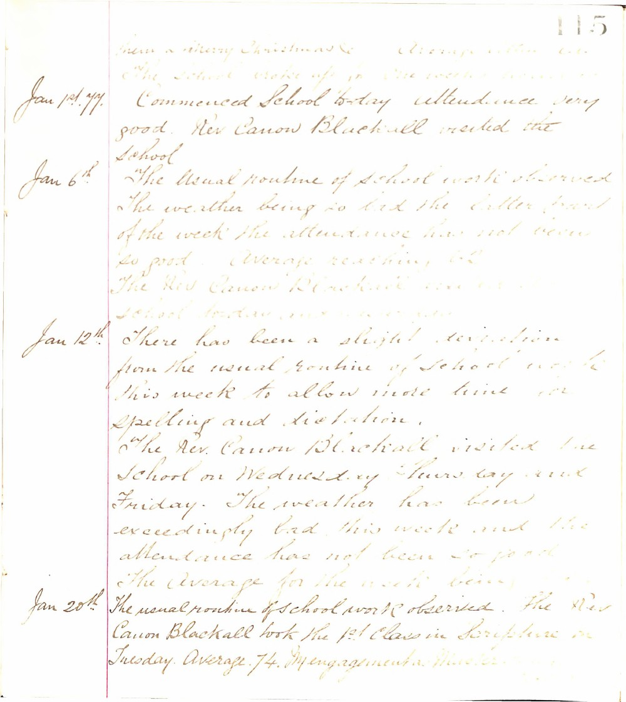

115
them a Merry Christmas & Average attend 62
The School broke up for one weeks holiday
Jan 1st. 77. Commenced School today attendance very good. Rev Canon Blackall visited the School
Jan 6th The usual routine of School work observed The weather being so bad the latter part of the week the attendance has not been so good Average reaching 62
The Rev Canon Blackall visited the school today and examined
Jan 12th There has been a slight deviation from the usual routine of School work this week to allow more time for Spelling and dictation.
The Rev Canon Blackall visited the School on Wednesday Thursday and Friday. The weather has been exceedingly bad this week and the attendance has not been so good the Average for the week being
Jan 20th The usual routine of School work observed. The Rev Canon Blackall took the 1st Class in Scripture on Tuesday. Average 74. M engagement as Master

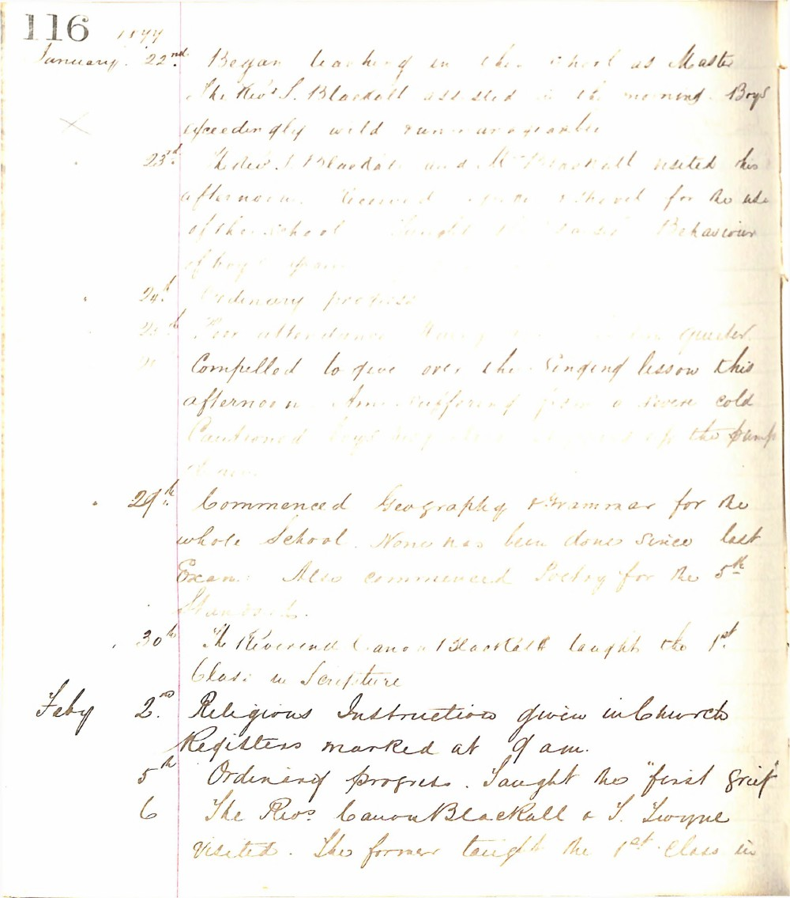

116 1877
January. 22nd. Began teaching in the school as Master The Revd. S. Blackall assisted in the morning. Boys exceedingly wild and ungovernable.
23rd. The Revd. S. Blackall and Mr. Marshall visited this afternoon. Received reports of the school for the use of the school. Taught the 1st. & 2nd. Behaviour of boys improved.
24th. Ordinary progress.
25th. Poor attendance. Rainy day. Boys much quieter.
26th. Compelled to give over the singing lesson this afternoon. Am suffering from a severe cold. Cautioned boys respecting the use of the pump at am.
29th. Commenced Geography & Grammar for the whole School. None has been done since last Exam. Also commenced Poetry for the 5th Standard.
30th. The Reverend Canon Blackall taught the 1st Class in Scripture.
Feby 2nd. Religious Instructions given in Church. Registers marked at 9 am.
5th. Ordinary progress. Taught the first group.
6th. The Revd. Canon Blackall & S. Thorpe visited. The former taught the 1st. Class in

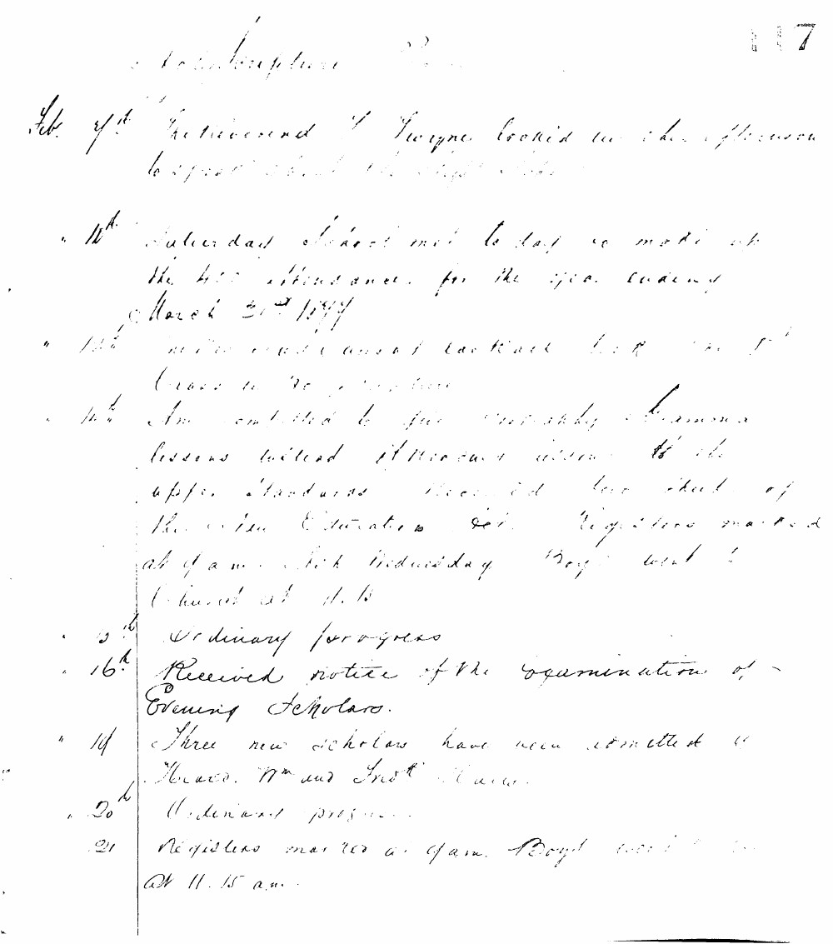

117
Feb. 9th The Reverend J. Thorpe looked in the afternoon to speak about the night school.
10th Saturday school met today to make up the 400 attendance for the year ending March 31st 1877.
12th New work commenced last week for the 1st Class in Geography.
14th Am entitled to give monthly Scripture lessons instead of reading daily to the upper standards. Received log sheet of the New Education Act. Registers marked at 9 a.m. Ash Wednesday Boys went to Church at 11.15.
15th Ordinary progress.
16th Received notice of the examination of Evening Scholars.
19th Three new scholars have been admitted viz Isaac, Wm and Fredk Mace.
20th Ordinary progress.
21st Registers marked at 9 a.m. Boys went to Church at 11.15 a.m.

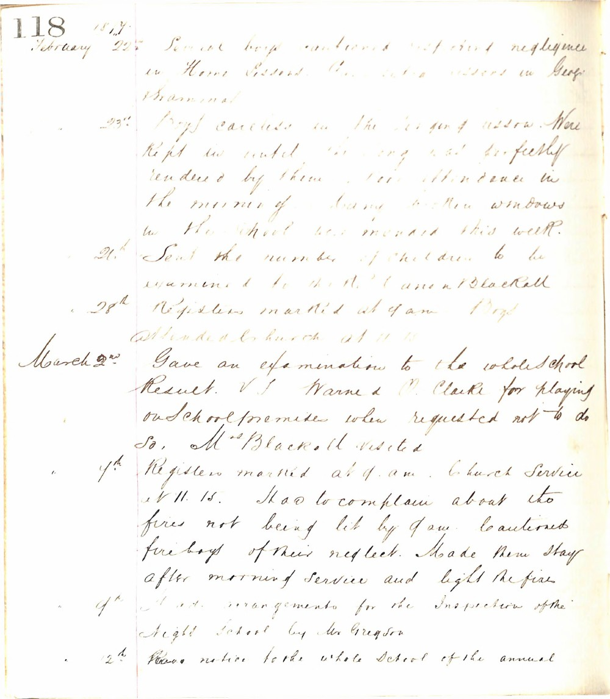

118
1877
February 22nd Senior boys cautioned for their negligence in Home Lessons. Also extra lessons in Geography examined.
23rd Boys careless in the doing of lessons. Were kept in until they were perfectly rendered by them. Low attendance in the morning of many broken windows in the School was increased this week.
26th Sent the number of children to be examined to the Rev. Canon Blackall.
28th Registers marked at 9 am. Boys attended Church at 11.15.
March 2nd Gave an examination to the whole school. Result. V. J. Warner & O. Clarke for playing on school premises when requested not to do so. Mrs Blackall visited.
4th Registers marked at 9. a.m. Church Service at 11. 15. Had to complain about the fires not being lit by 9 am. Cautioned fire boys of their neglect. Made them stay after morning service and light the fires.
9th Made arrangements for the Inspection of the Night School by Mr Gregson.
12th Gave notice to the whole School of the annual

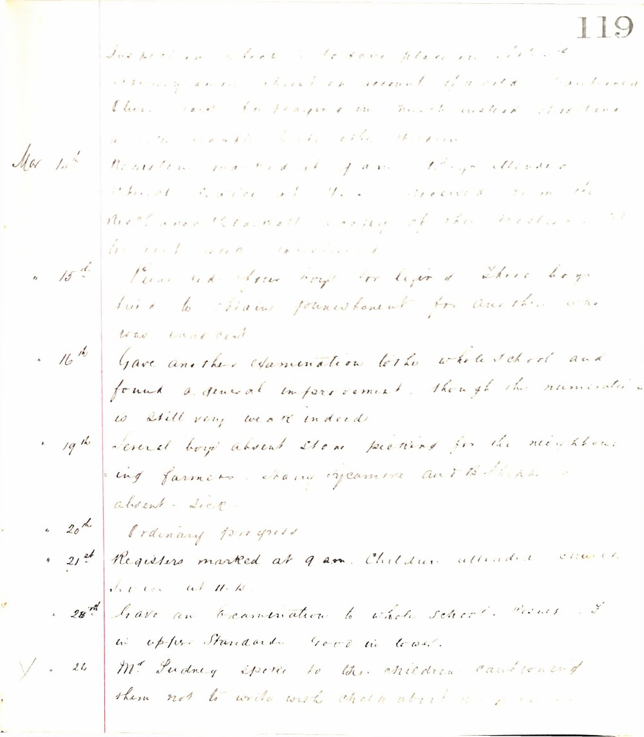

119
Inspection which is to take place in District shortly and which on account of a cold diphtheria illness and for playing in much water at settling a new mouth to the other children
Mar 1st Registers marked at 9 am. Boys allowed out of School at 4. Received from Mrs. Canon Parnell a copy of the Western Morning News and other papers
" 15th Punished four boys for lying. These boys tried to obtain punishment for another who was innocent
" 16th Gave another examination to the whole School and found a general improvement though the numeration is still very weak indeed
" 19th Several boys absent stone picking for the neighboring farmers. Mary Sycamore and B. Shipp absent - sick
" 20th Ordinary progress
" 21st Registers marked at 9 am. Children attended Church Service at 11.15
" 28th Gave an examination to whole School. Result in upper Standards Good in lower.
/ " 26 Mr. Pudney spoke to the children cautioning them not to write with chalk about the place

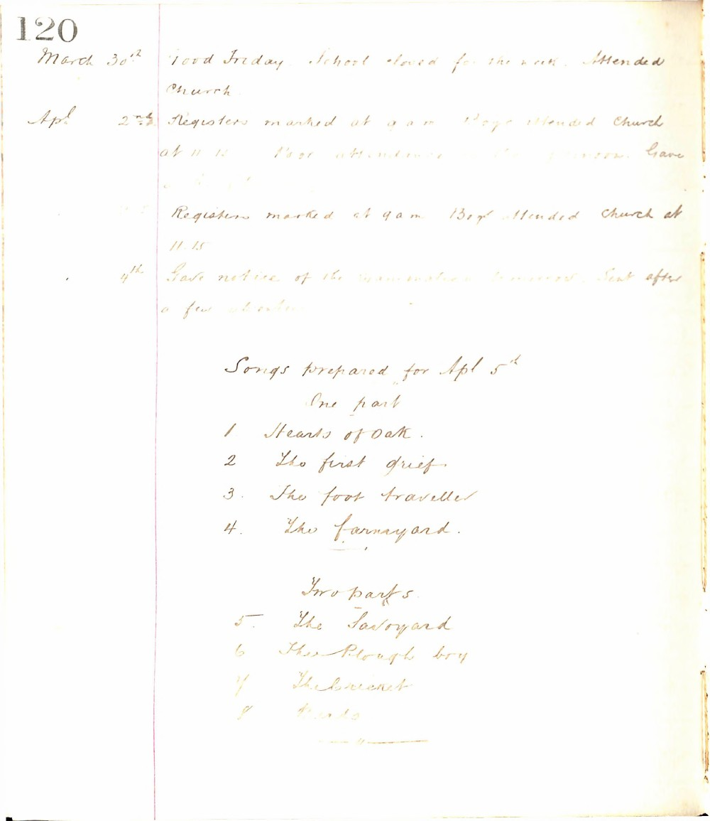

120
March 30th Good Friday. School closed for the week. Attended Church.
Apl 2nd Registers marked at 9 a.m. Boys attended Church at 11.15. Poor attendance in the afternoon. Gave
Registers marked at 9 a.m. Boys attended Church at 11.15
4th Gave notice of the examination tomorrow. Sent after a few absentees.
Songs prepared for Apl 5th
One part
- Hearts of Oak.
- The first grief.
- The foot traveller.
- The farmyard.
Two parts
- The Savoyard
- The Plough boy
- The Cricket
- Birds

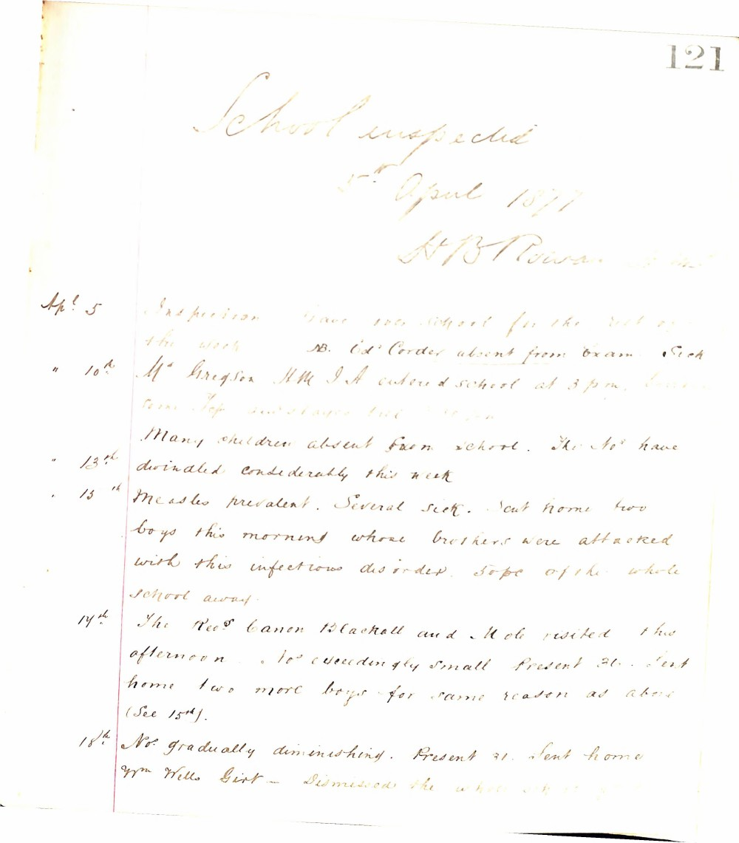

121
School inspected
5th April 1877
H B Rowan
Ap! 5 Inspection Gave over school for the rest of the week NB. Ed! Corder absent from Exam. Sick
" 10th M! Gregson HM I A entered school at 3 pm. [unclear] [unclear] [unclear] and stayed till 4.30 pm
Many children absent from school. The Nos have dwindled considerably this week
" 13th Measles prevalent. Several sick. Sent home two boys this morning whose brothers were attacked with this infectious disorder. 50 pr ct of the whole school away.
14th The Revd Canon Blackall and Mr Mole visited this afternoon. Nos exceedingly small Present 36. Sent home two more boys for same reason as above (See 15th).
18th Nos gradually diminishing. Present 31. Sent home Wm Wells Girt. Dismissed the whole school

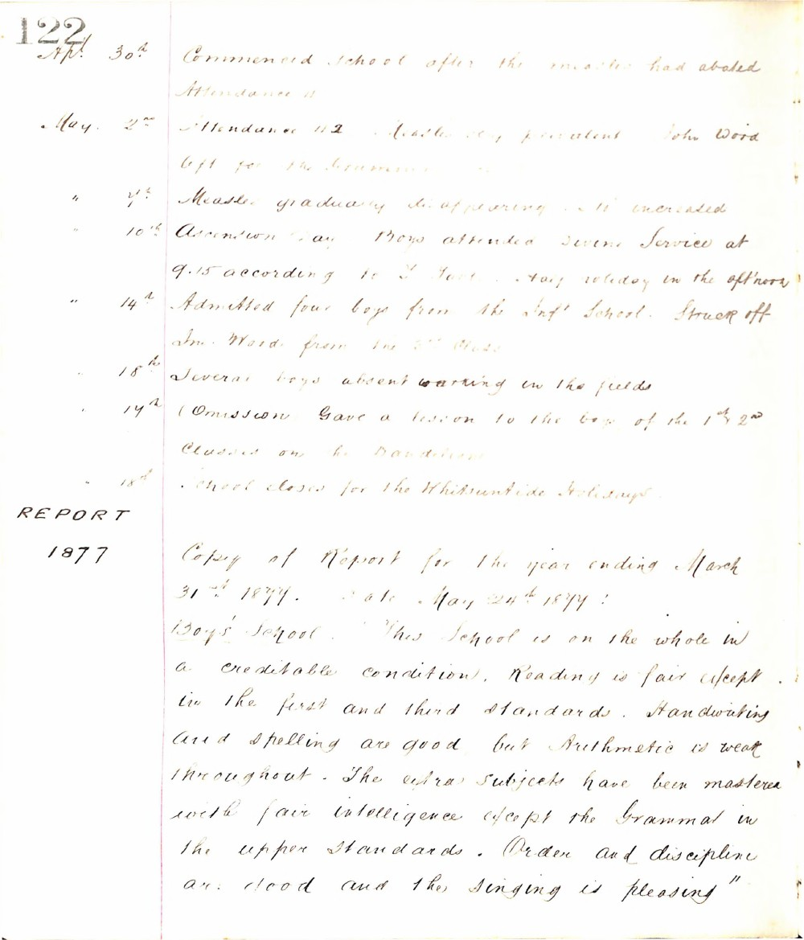

122
Ap. 30th Commenced School after the measles had abated Attendance 11
May. 2nd Attendance 112 Measles very prevalent John Wood left for the Grammar School
" 7th Measles gradually disappearing N increased
" 10th Ascension Day Boys attended Divine Service at 9.15 according to G. Govt. Half holiday in the aft'noon
" 14th Admitted four boys from the Inf' School. Struck off Jno. Wood from the 3rd Class
" 18th Several boys absent working in the fields
" 19th (Omission Gave a lesson to the boys of the 1st & 2nd Classes on the Dandelion
" 18th School closes for the Whitsuntide Holidays
REPORT
1877
Copy of Report for the year ending March 31st 1877. Date May 24th 1877 :
Boys' School. This School is on the whole in a creditable condition, Reading is fair except in the first and third standards. Handwriting and spelling are good but Arithmetic is weak throughout. The extra subjects have been mastered with fair intelligence except the Grammar in the upper standards. Order and discipline are good and the singing is pleasing"

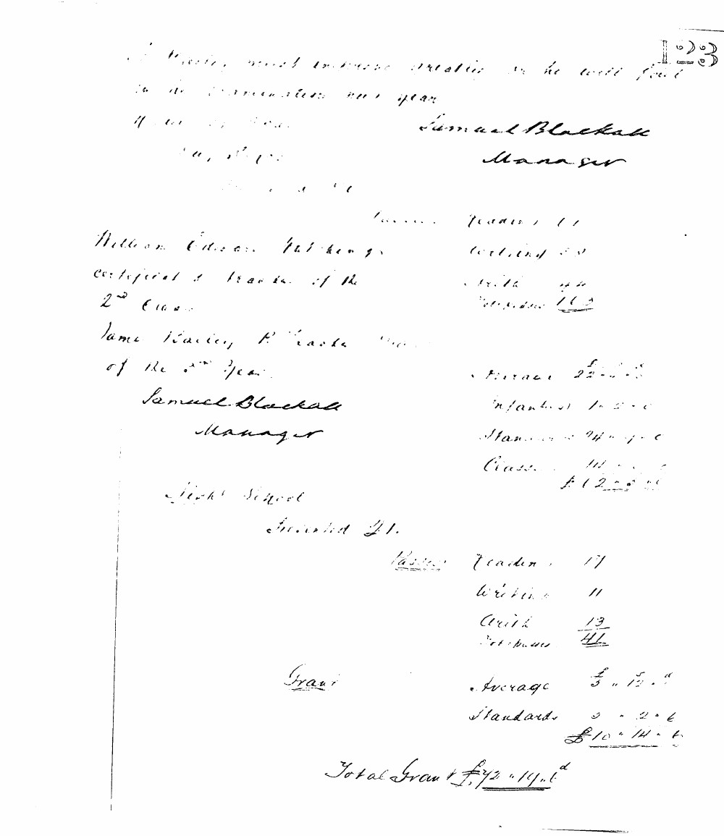

123
Master, most intense interest in he will find in the examination next year.
Samuel Blackall
Manager
Passes: Reader 11
Writing 11
Arith 12
Total passes 34
William Edward Wilkins, Certificated Teacher of the 2nd Class.
James Rainey, P. Teacher of the 2nd year.
Samuel Blackall
Manager
Average £2 .. 15 .. 0
Infants 1 .. 5 .. 0
Standards 14 .. 1 .. 0
Classes 14 .. 0 .. 0
£32 .. 1 .. 0
Girls' School
Enrolled 41.
Passes: Reader 17
Writing 11
Arith 13
Total passes 41
Grant: Average £3 .. 12 .. 0
Standards 7 .. 2 .. 6
£10 .. 14 .. 6
Total Grant £42 .. 15 .. 6

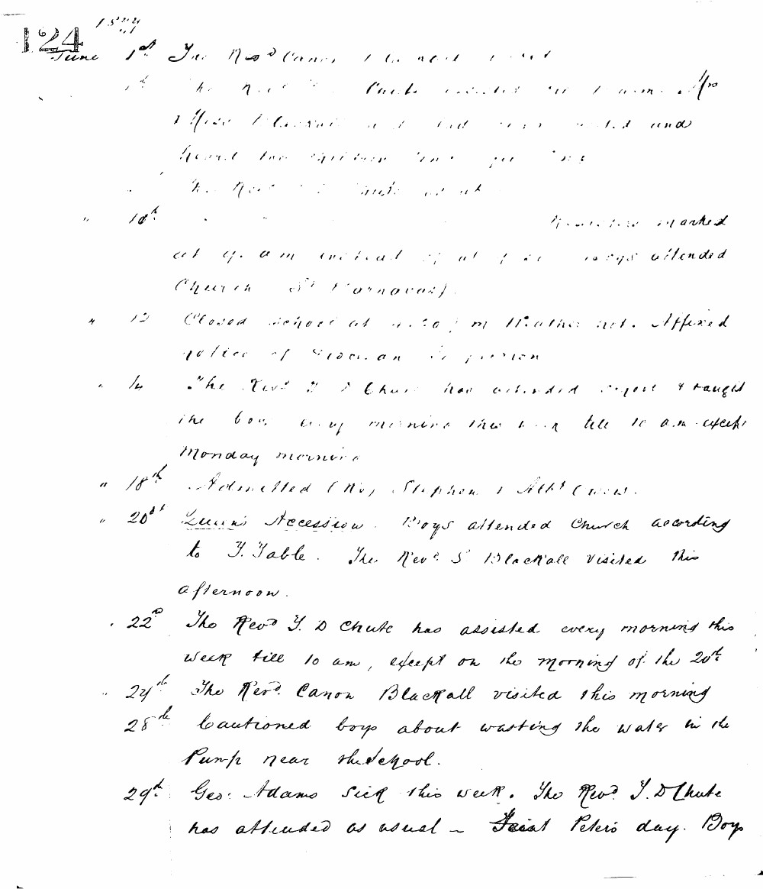

124
June 1st The Revd Canon Blackall visited this morning. Mrs Chute assisted in the morning. Miss Chute assisted in the afternoon and heard the children their parsing. The Revd J. D. Chute visited.
10th Registers marked at 9 a.m. instead of at 1.45. Boys attended Church (St Barnabas).
12 Closed school at 3.30 p.m. Weather wet. Affixed notice of election in person.
14 The Revd J. D. Chute has attended school & taught the boys every morning this week till 10 a.m. except Monday morning.
18th Admitted (No 1) Stephen J. Athl. Crow.
20th Queen's Accession. Boys attended Church according to T. Table. The Revd S. Blackall visited this afternoon.
22nd The Revd J. D. Chute has assisted every morning this week till 10 am, except on the morning of the 20th.
24th The Revd Canon Blackall visited this morning.
28th Cautioned boys about wasting the water in the Pump near the school.
29th Geo: Adams sick this week. The Revd J. D. Chute has attended as usual - Saint Peter's day. Boys

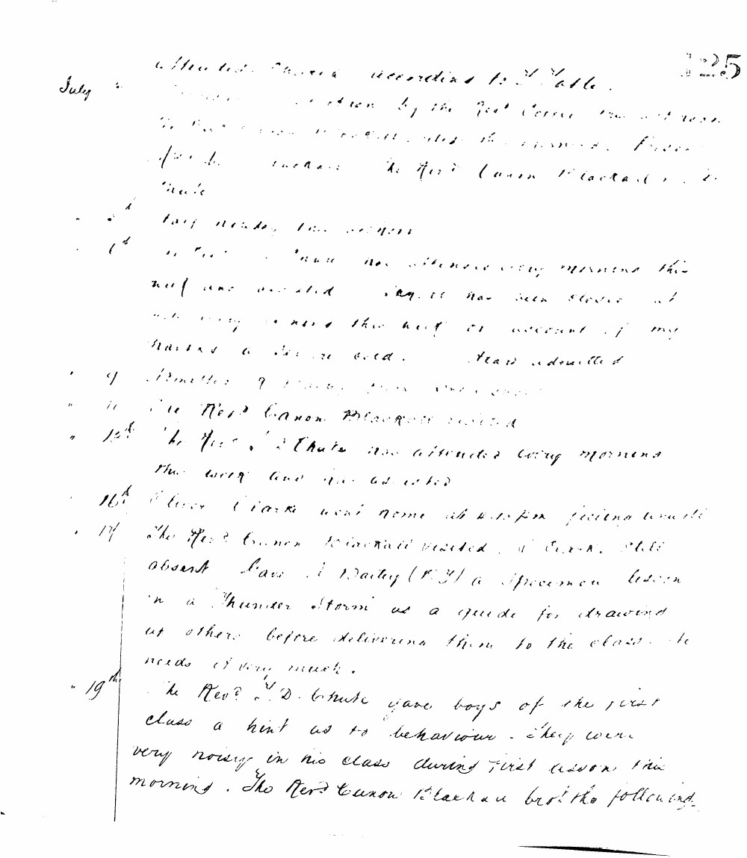

125
July attended Church according to Table.
visited by the Revd Canon Blackall.
visited the school. Revd J. D. Chute and the Revd Canon Blackall visited.
Very heavy rain today.
attended every morning this week and assisted. It has been closed at night every evening this week on account of my having a severe cold. Head admitted.
9 Admitted 7 boys from the school.
11 The Revd Canon Blackall visited.
12th The Revd J. D. Chute has attended every morning this week and has assisted.
16th Oliver Clarke went home at 4.15 pm feeling unwell.
17 The Revd Canon Blackall visited. J. Cook still absent. Gave J. Daily (F. Y) a specimen lesson on a Thunder Storm as a guide for drawing up others before delivering them to the class. He needs it very much.
19th The Revd J. D. Chute gave boys of the first class a hint as to behaviour. They were very noisy in his class during first lesson this morning. The Revd Canon Blackall brot the following.

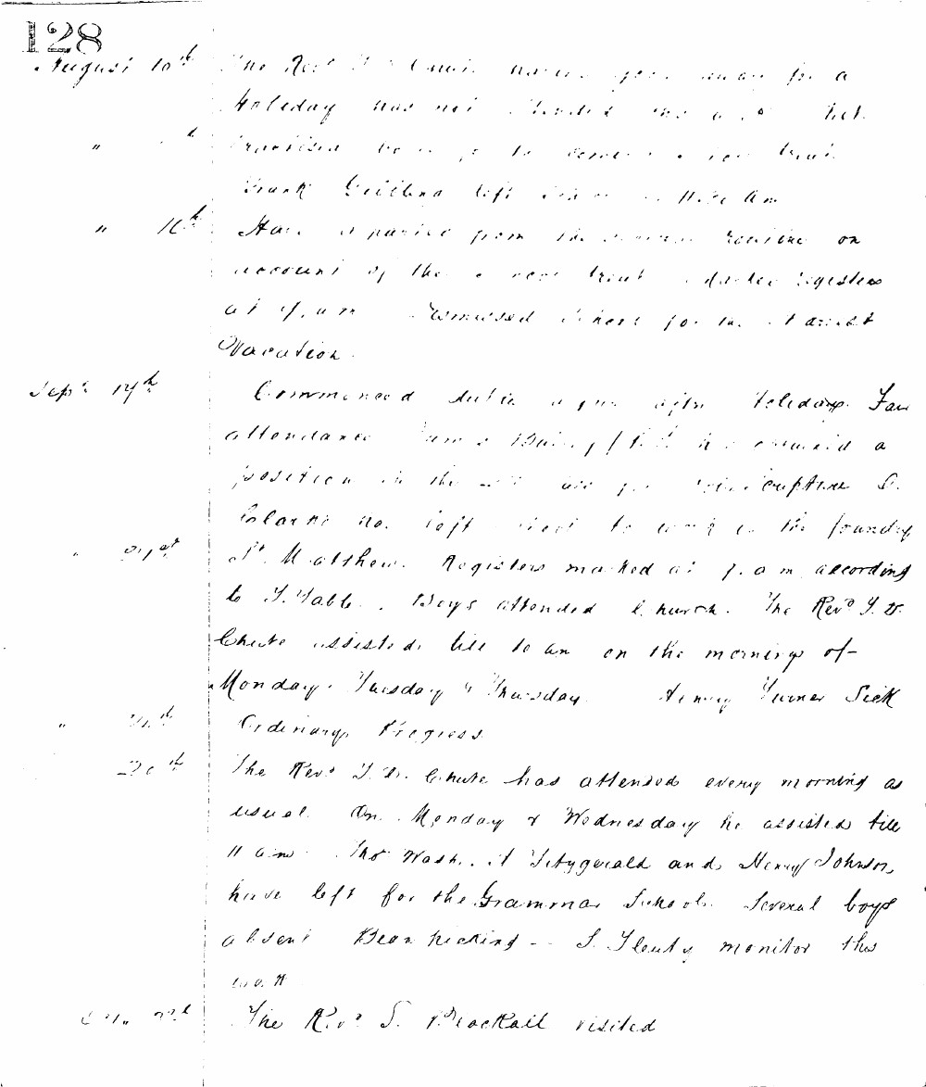

128
August 10th The Rev. J. D. Chute having gone away for a holiday was not present this morning but promised to be so tomorrow morning. Frank Gribben left school at 11.30 am.
" 16th At a meeting from the school committee on account of the very small attendance at school, dismissed school for the harvest vacation.
Sept 17th Commenced duties again after holidays. Fair attendance. James Davies / 1st cl / has obtained a position in the office of the capture Co. Edward No. left school to work in the foundry of Mr. Matthew. Registers marked at 9.0 am according to T. Table. Boys attended Church. The Rev. J. D. Chute assisted till 10 am on the mornings of Monday, Tuesday & Thursday. Henry Turner sick.
" 21st Ordinary progress.
" 28th The Rev. J. D. Chute has attended every morning as usual. On Monday & Wednesday he assisted till 11 am. Tho. West, A Fitzgerald and Henry Johnson, have left for the Grammar School. Several boys absent Bean picking. S. Gouty monitor this week.
Oct 2nd The Rev. S. Brockall visited.

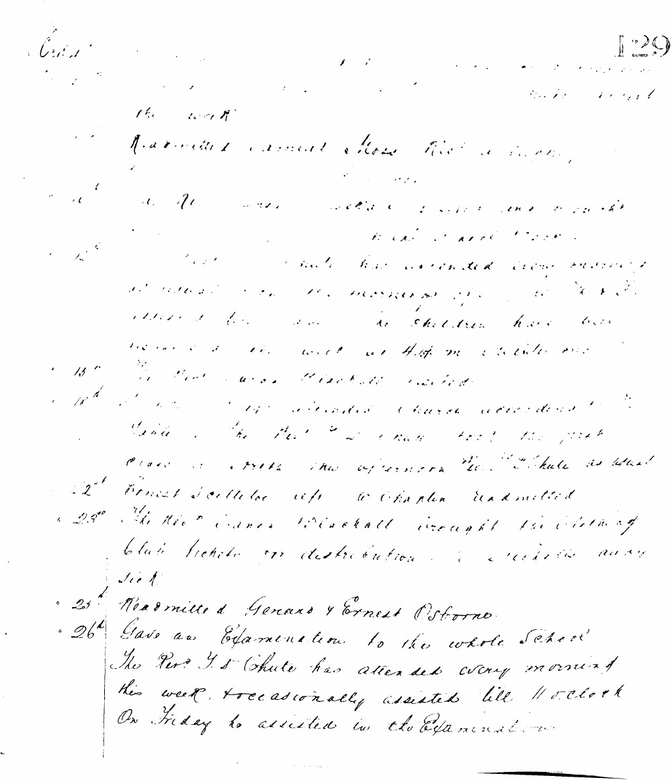

129
the work
Re-admitted Ernest Rose first week.
The Rev. J. S. Chute has attended every morning at school in the morning of the 12th. 115 children have been present in the hall at 11.30 in the morning.
15th The Rev. Canon Blackall visited.
18th The Rev. J. S. Chute attended Church according to notice the Rev. J. S. Chute took the first class in the afternoon. The school as usual.
21st Ernest Scullard left to Chaplin readmitted.
23rd The Rev. Canon Blackall brought the Clothing Club tickets for distribution. 2 children away sick.
25th Readmitted Gerard & Ernest Osborne.
26th Gave an Examination to the whole School. The Rev. J. S. Chute has attended every morning this week, & occasionally assisted till 11 o'clock. On Friday he assisted in the Examination.

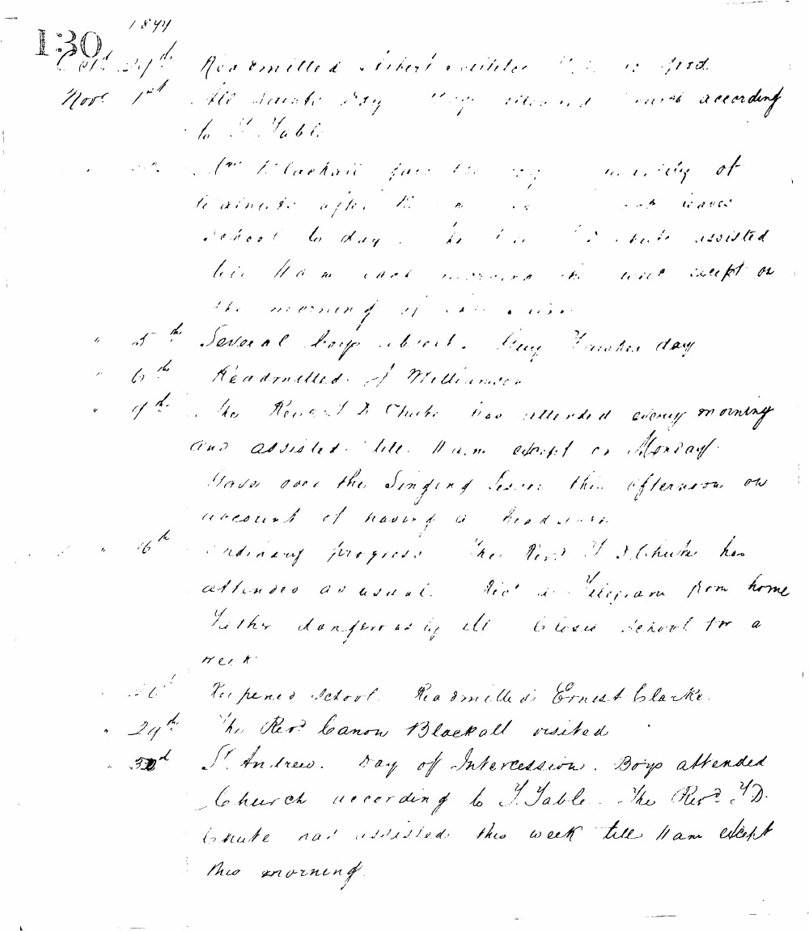

1899
130
Oct 29th Readmitted Robert Winter. V. G. is good.
Nov 1st All Saints Day. Boys attended Church according to T. Table.
" " Rev. T. Blackall gave the boys a holiday at 12 o'clock after the morning service. School to day. He has also assisted till 11 a.m. each morning this week except on the morning of All Saints.
" 5th Several boys absent. Guy Fawkes day.
" 6th Readmitted J. Williamson.
" 7th The Reverend J. D. Chute has attended every morning and assisted till 11 a.m. except on Monday.
Gave over the Singing lesson this afternoon on account of having a headache.
" 16th Ordinary progress. The Rev. J. D. Chute has attended as usual. Rec'd a telegram from home Father dangerously ill. Closed school for a week.
" 23rd Reopened school. Readmitted Ernest Clarke.
" 24th The Rev. Canon Blackall visited.
" 30th St. Andrew. Day of Intercession. Boys attended Church according to T. Table. The Rev. J. D. Chute has assisted this week till 11 a.m. except this morning.

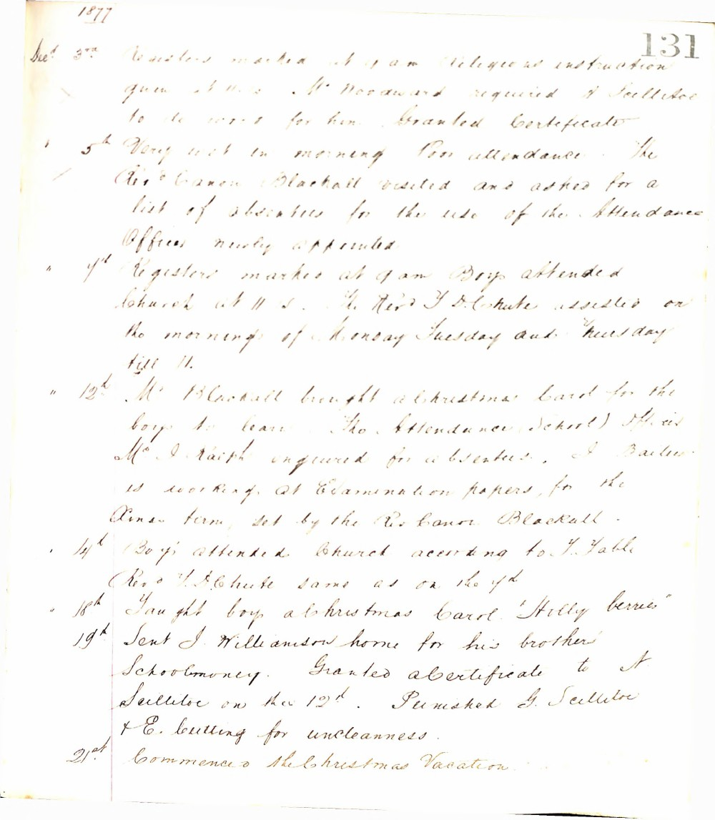

1877
131
Decr 3rd Registers marked at 9 am Religious instruction given at 11.15. Mr Woodward required A Scillitoe to do work for him. Granted Certificate
5th Very wet in morning Poor attendance. The Revd Canon Blackall visited and asked for a list of absentees for the use of the Attendance Officer newly appointed
7th Registers marked at 9 am Boys attended Church at 11.15. The Revd T D Chute assisted on the mornings of Monday Tuesday and Thursday till 11.
12th Mr Blackall brought a Christmas Card for the boys to learn. The Attendance (School) Officer Mr I Ralph enquired for absentees. I Bailum is working at Examination papers for the Xmas term set by the Rev Canon Blackall.
14th Boys attended Church according to T. Table Revd T D Chute same as on the 7th
18th Taught boys a Christmas Carol "Holly berries"
19th Sent J. Williamson home for his brother's Schoolmoney. Granted a Certificate to A. Scillitoe on the 12th. Punished G. Scillitoe & E. Bulling for uncleanness.
21st Commenced the Christmas Vacation.

