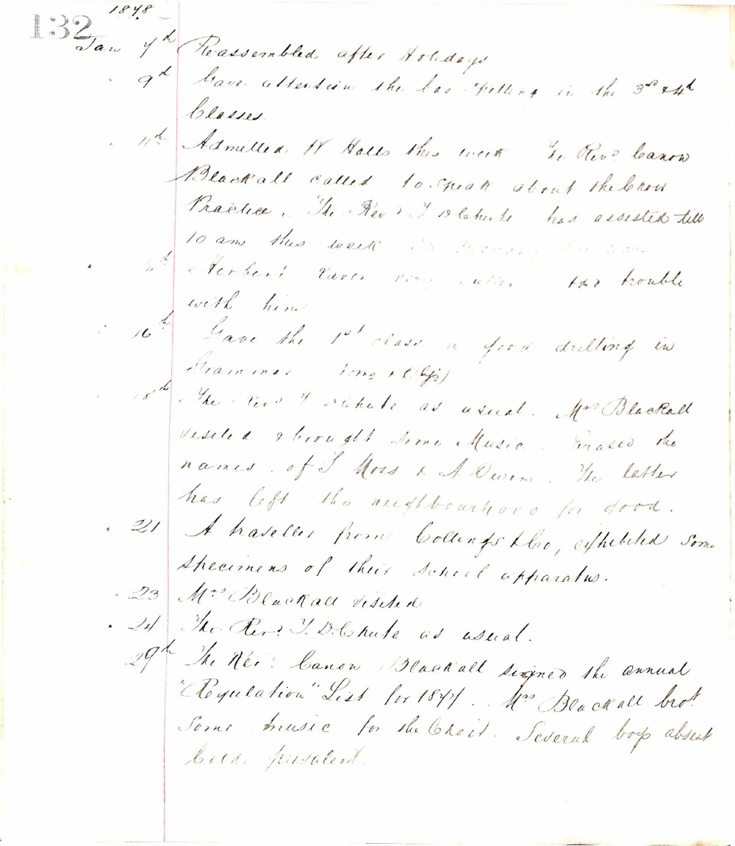

132
1878
Jan 7th Re-assembled after Holidays
9th Gave attention the low spelling in the 3rd & 4th Classes.
11th Admitted W Halls this week The Revd Canon Blackall called to speak about the low practice. The Revd T D Chute has assisted till 10 am this week
Herbert Carter very little trouble with him
16th Gave the 1st class a good drilling in Grammar (long & Obj)
18th The Revd T D Chute as usual. Mrs Blackall visited & brought some Music. Erased the names of S Moss & A Owen. The latter has left the neighbourhood for good.
21 A traveller from Collings & Co, exhibited some specimens of their school apparatus.
23 Mrs Blackall visited
24 The Revd T. D. Chute as usual.
29th The Revd Canon Blackall signed the annual "Regulation" List for 1878. Mrs Blackall brot some music for the Choir. Several boys absent Cold prevalent.

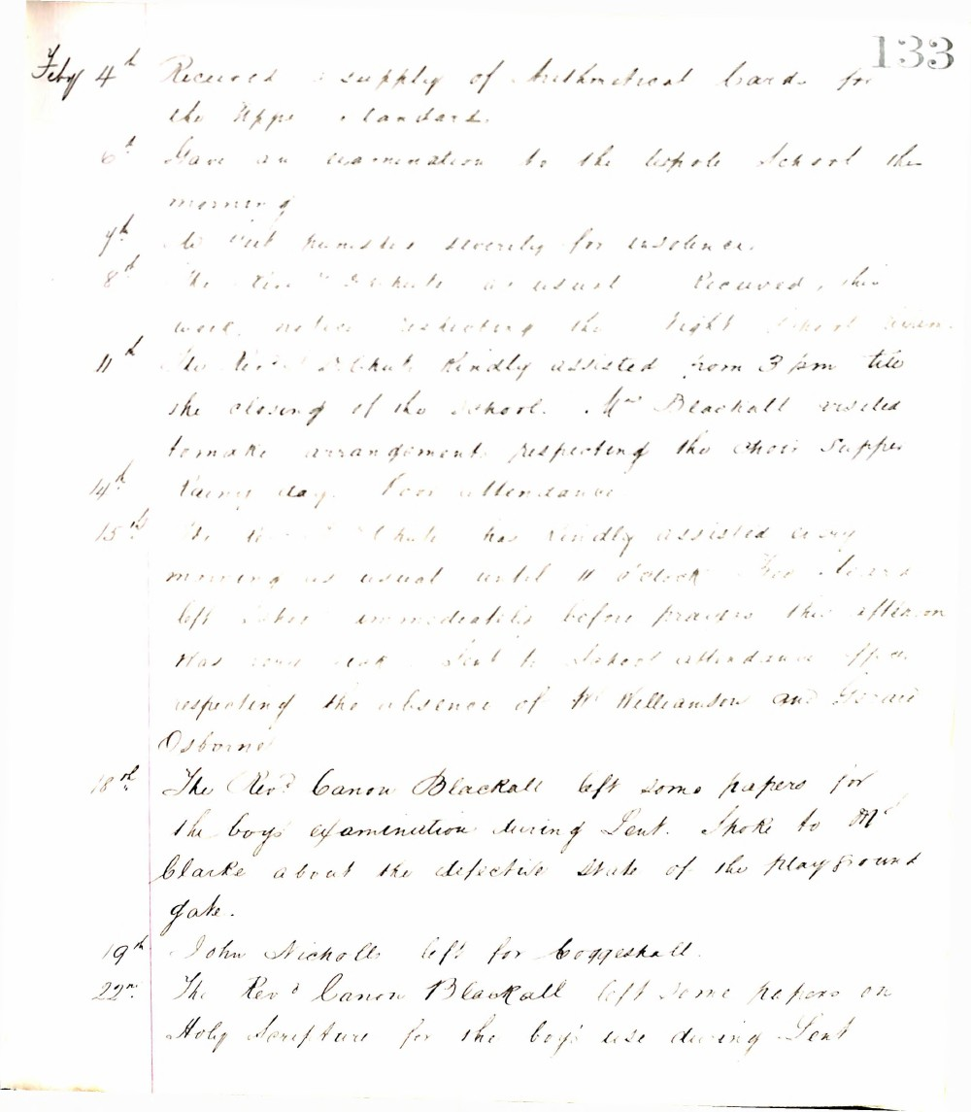

133
Feby 4th Received a supply of Arithmetical Cards for the Upper Standards.
6th Gave an examination to the whole School this morning.
7th Two pupils punished severely for insolence.
8th The Revd. D. Chute as usual. Received this week notice respecting the Night School Exam.
11th The Revd. D. Chute kindly assisted from 3 pm till the closing of the School. Mrs. Blackall visited to make arrangements respecting the Choir Supper.
14th Rainy day. Poor attendance.
15th The Revd. D. Chute has kindly assisted every morning as usual until 11 o'clock. Two boys left School immediately before prayers this afternoon. Has some talk about School attendance etc. respecting the absence of Wm. Williamson and Gerald Osborne.
18th The Revd. Canon Blackall left some papers for the boys examination during Lent. Spoke to Mr. Clarke about the defective state of the playground gate.
19th John Nicholls left for Coggeshall.
22nd The Revd. Canon Blackall left some papers on Holy Scripture for the boys use during Lent.

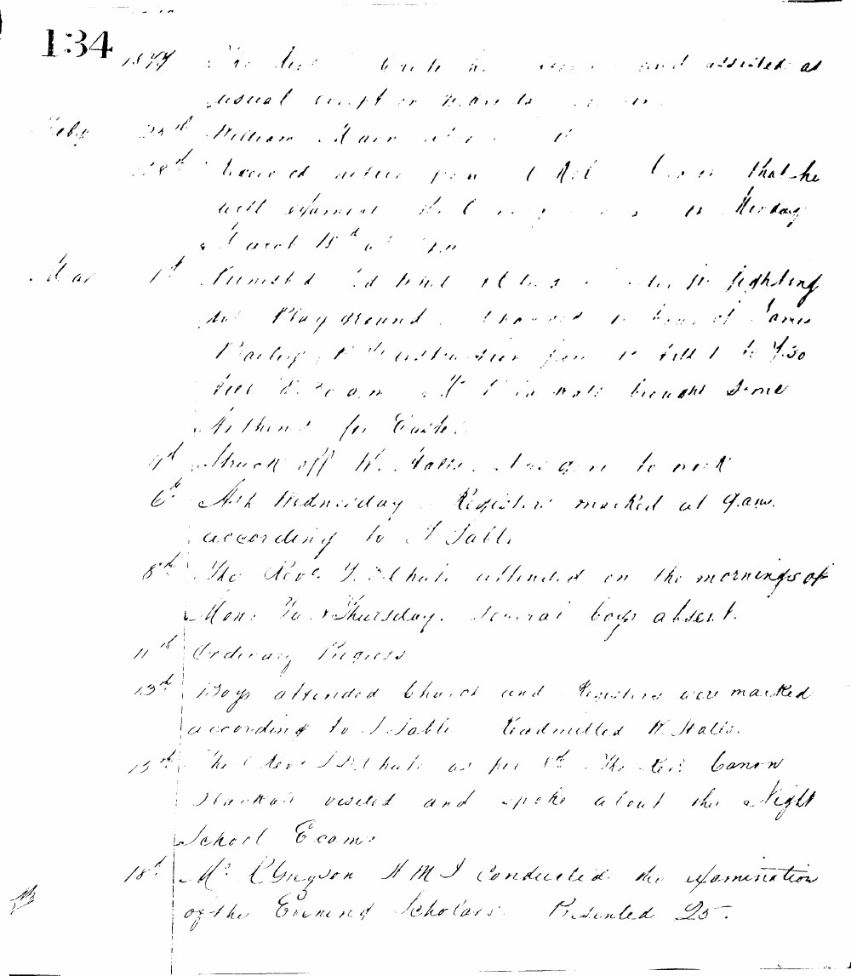

134
1877
Feby 23rd William Marr absent
28th Received notice from C. Hill Esq. that he will examine the Evening School on Monday March 15th at 7 p.m.
Mar 1st Punished Edward Hunt & Chas. Smith for fighting on Playground. Changed hours of James Bailey's instruction from 11 till 1 to 7.30 till 8.30 a.m. H. Hill in note brought some writing for Easter.
4th Struck off W. Wallis. Has gone to work.
6th Ash Wednesday. Registers marked at 9 a.m. according to T Table.
8th The Revd. J. D. Chute attended on the mornings of Mon. Tu. & Thursday. Several boys absent.
11th Ordinary Progress.
13th Boys attended Church and Registers were marked according to T. Table. Readmitted W. Wallis.
15th The Revd. J. D. Chute as per 8th. The Revd. Canon Slackman visited and spoke about the Night School Exam.
18th Mr. Gregson H.M.I. conducted the examination of the Evening Scholars. Presented 25.

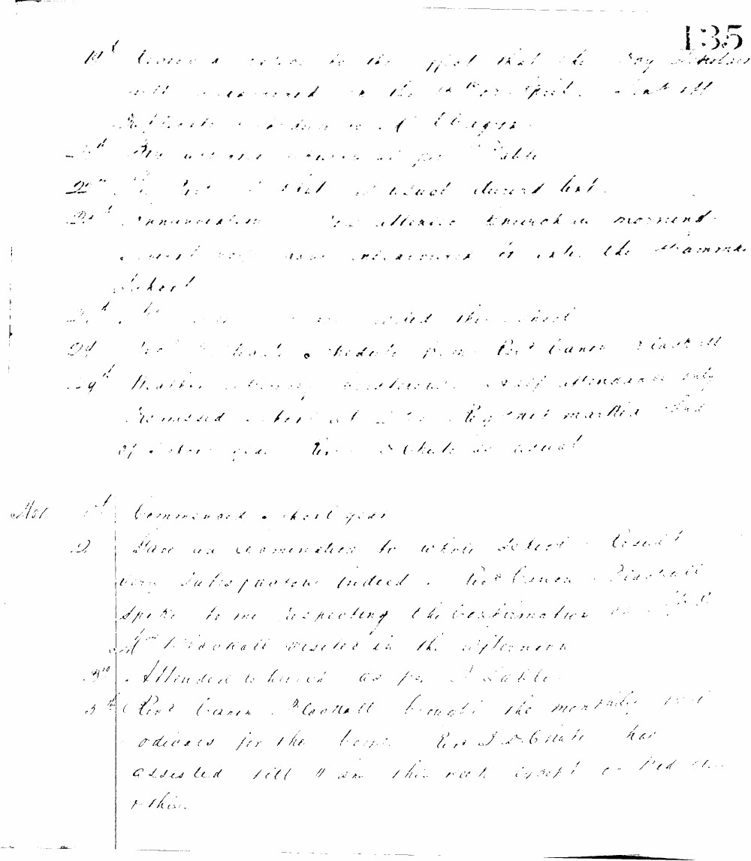

135
19th Received a notice to the effect that the Day Scholars will be examined on the 14th April. Sent off duplicate registers and charges.
21st No lessons given as per Table
22nd The Revd J. Hill at School during test.
23rd Annunciation. No attendance Church in morning. School work was resumed in after the morning School.
24th No lessons given as per the Table.
24th Revd Canon Woodall visited the School.
29th Martha Sherry assistant pupil attendance only promised her at the Regent Martha but of late she has been as usual.
Apl 1st Commenced a short year.
2nd Gave an examination to whole School result very satisfactory indeed. Revd Canon Woodall spoke to me respecting the Confirmation.
Mrs Woodall visited in the afternoon.
3rd Attended to Church as per Table.
5th Revd Canon Woodall brought the monthly periodicals for the boys. R. J. Estate has assisted till 11 am this week except on Wed then other.

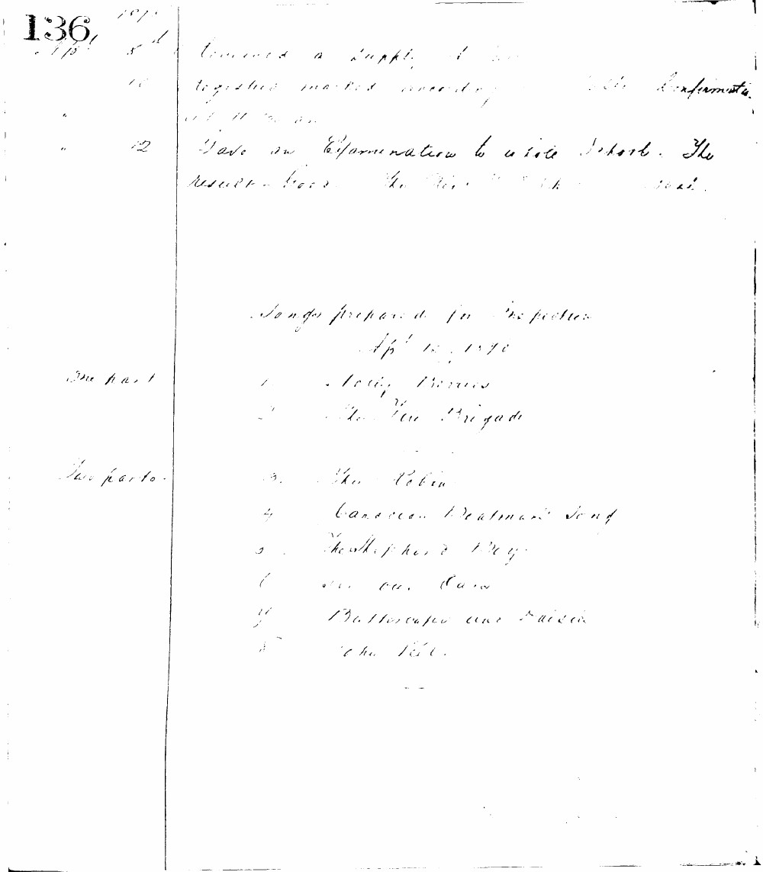

136
1870
Apr 8th Received a supply of books
10 Registers marked according to instructions
at 11 a.m.
12 Gave an Examination to whole School. The
results were the same as last.
Songs prepared for inspection
Apr 12, 1870
One part
- Little Birdie
- The Fire Brigade
Two parts
3. The Robin
4. Canadian Boatman's Song
5. The Shepherd Boy
6. Oh! Oh! Oh!
7. Buttercups and Daisies
8. The Tail

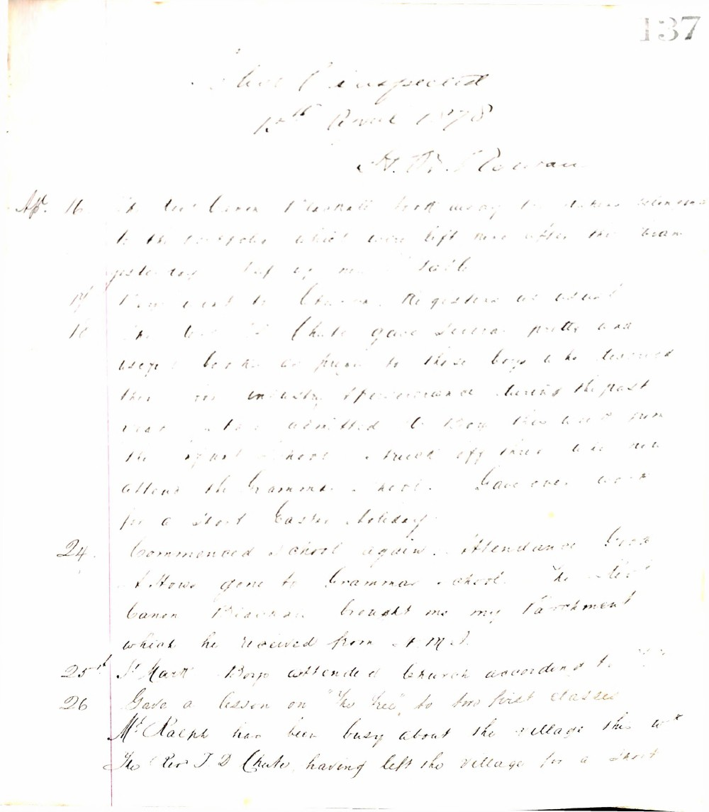

137
School inspected
12th April 1878
S. W. D. Rowan
Apr. 16. The Rev. Canon Pearson took away the statues belonging to the school, which were left here after the bazaar yesterday. Set up new table.
- New lists to classes. Registers as usual.
- The Rev. J. D. Chute gave several pretty and useful books as prizes to those boys who showed their industry & perseverance during the past year. Also admitted to school those who had from the infant school. Struck off those who now attend the Grammar school. Gave over work for a short Easter holiday.
- Commenced school again. Attendance good. S. Howe gone to Grammar school. The Rev. Canon Pearson brought me my Parchment which he received from S. M. D.
25th. St. Mark. Boys attended Church according to rule.
- Gave a lesson on "The Bee" to two first classes. Mr. Ralph has been busy about the village this week. The Rev. J. D. Chute, having left the village for a short

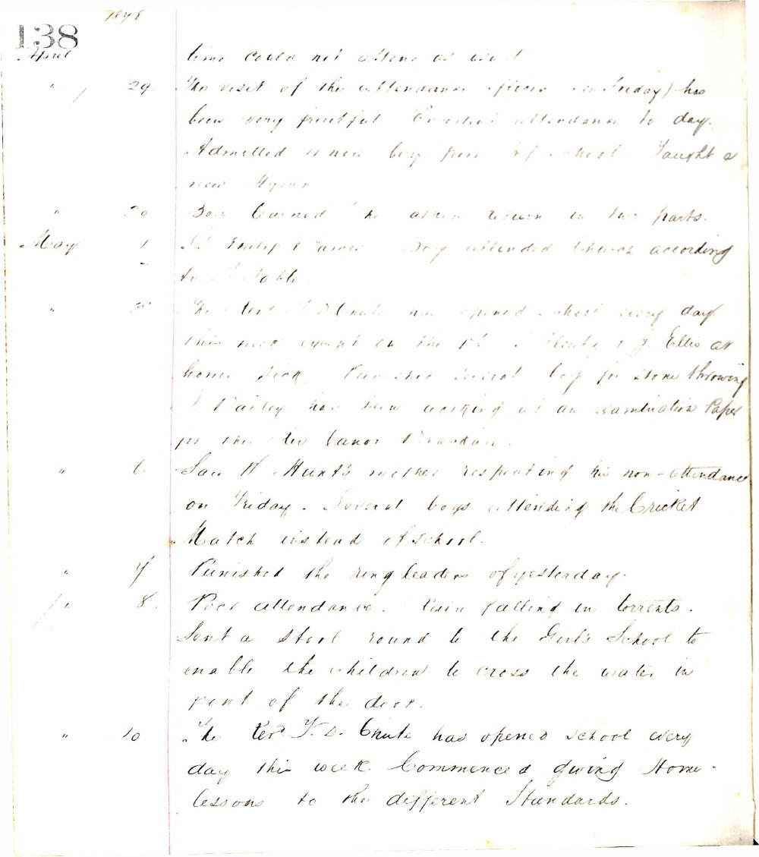

138
1878
April
- The visit of the attendance officer (on Friday) has been very fruitful. Excellent attendance today. Admitted 4 new boys from school. Taught a new Hymn.
- Earned the extra return in two parts.
May
- S. Philip & James Day attended Church according to table.
- The Rev. J. D. Chute has opened school every day this week except on the 1st. Plenty of J. Ellis at home sick. Punished several boys for stone throwing. J. Dailey has been working at an examination Paper for the Rev. Canon Dranton.
- Saw W. Hunt's mother respecting his non-attendance on Friday. Several boys attending the Cricket Match instead of school.
- Punished the ringleaders of yesterday.
- Poor attendance. Rain falling in torrents. Sent a stool round to the Girl's School to enable the children to cross the water in front of the door.
- The Rev. J. D. Chute has opened school every day this week. Commenced giving Home lessons to the different Standards.

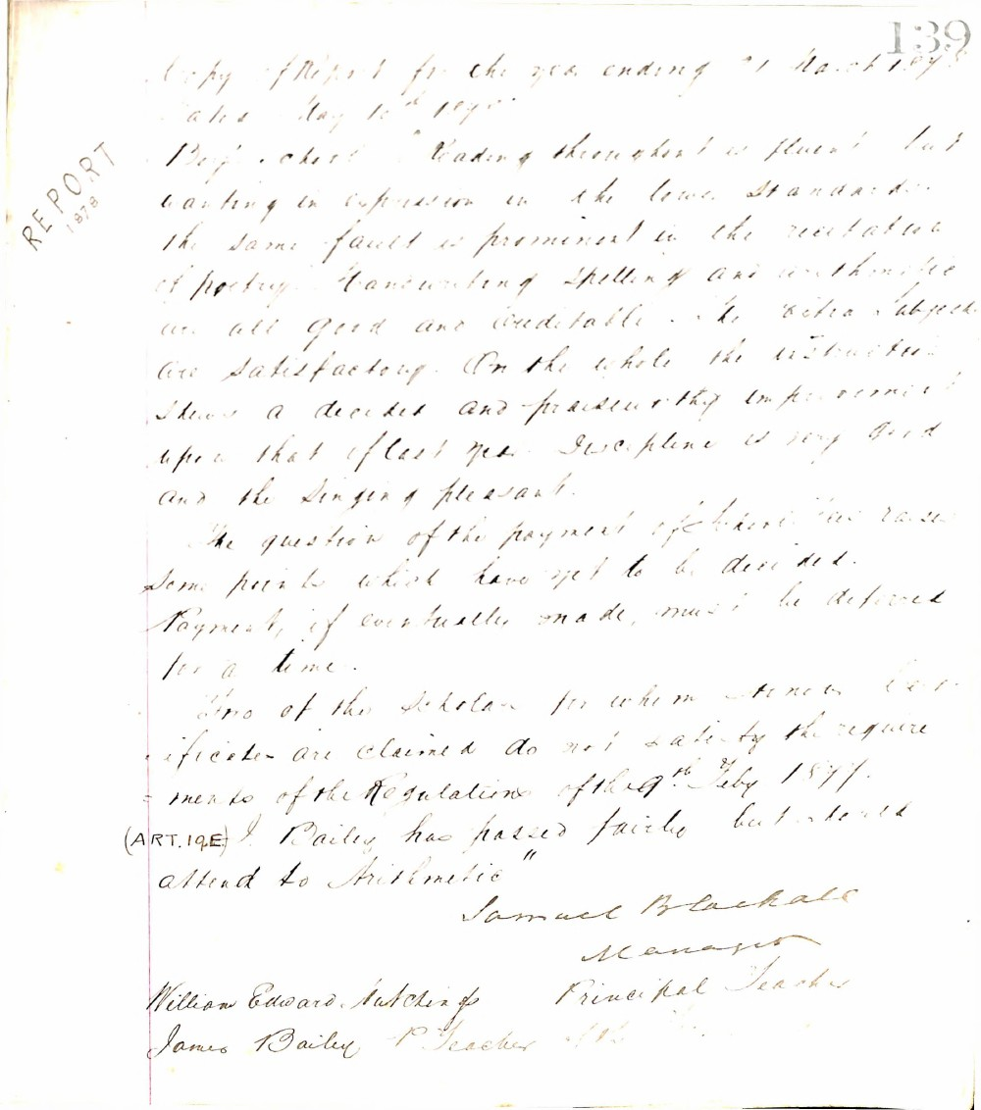

139
REPORT
1878
Copy of Report for the year ending 31 March 1878
dated May 10th 1878
Boys' School "Reading throughout is fluent but wanting in expression in the lower standards: the same fault is prominent in the recitation of poetry. Handwriting spelling and arithmetic are all good and creditable. The extra subjects are satisfactory. On the whole the instruction shows a decided and praiseworthy improvement upon that of last year. Discipline is very good and the singing pleasant.
The question of the payment of grant has raised some points which have yet to be decided. Payment, if eventually made, must be deferred for a time.
Two of the scholars for whom Honor Certificates are claimed do not satisfy the requirements of the Regulations of the 9th Feby 1877.
(ART. 19 E) J. Bailey has passed fairly but should attend to Arithmetic"
Samuel Blackhall
Manager
William Edward Hutchings Principal Teacher
James Bailey P. Teacher

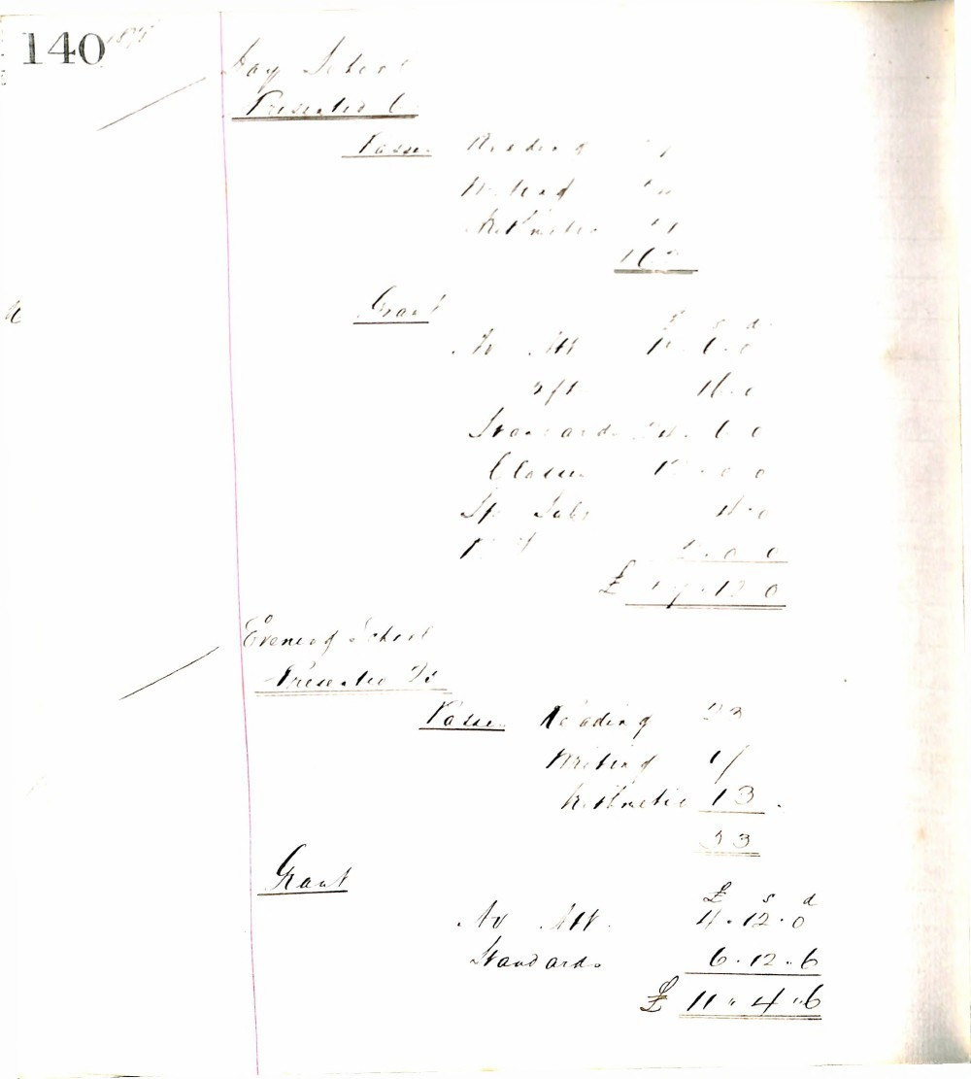

140
Day School
Presented 6
Passes
Reading 4
Writing 4
Arithmetic 4
12
Grant
£ s d
Av Att 10 . 0 . 0
4/1 16 . 0
Standards 4 . 6 . 0
Classes 1 . 0 . 0
Sp Subj 10 . 0
1 . 1 . 0 . 0
£ 17 . 12 . 0
Evening School
Presented 25
Passes
Reading 23
Writing 17
Arithmetic 13
53
Grant
£ s d
Av Att 4 . 12 . 0
Standards 6 . 12 . 6
£ 11 . 4 . 6

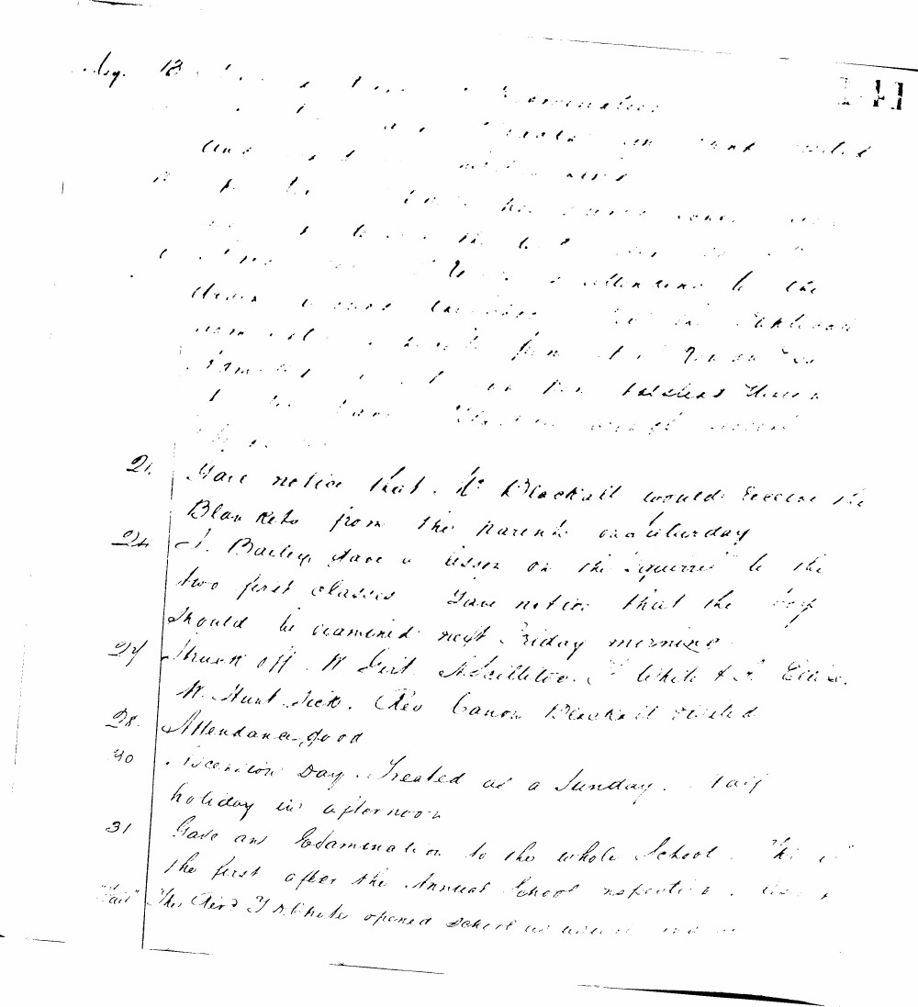

May 18 Examination
- Gave notice that Mr Blackall would receive the Blankets from the parents on Saturday
- J. Bailey gave a lesson on the "Squirrel" to the two first classes Gave notice that the boys should be examined next Friday morning
27 Struck off W Girt M Milliken T White & L Ellis. M Hunt sick. Rev Canon Blackall visited
- Attendance good
- Ascension Day. Treated as a Sunday. Half holiday in afternoon
31 Gave an Examination to the whole School. This is the first after the Annual School inspection. The Revd J D White opened School as usual

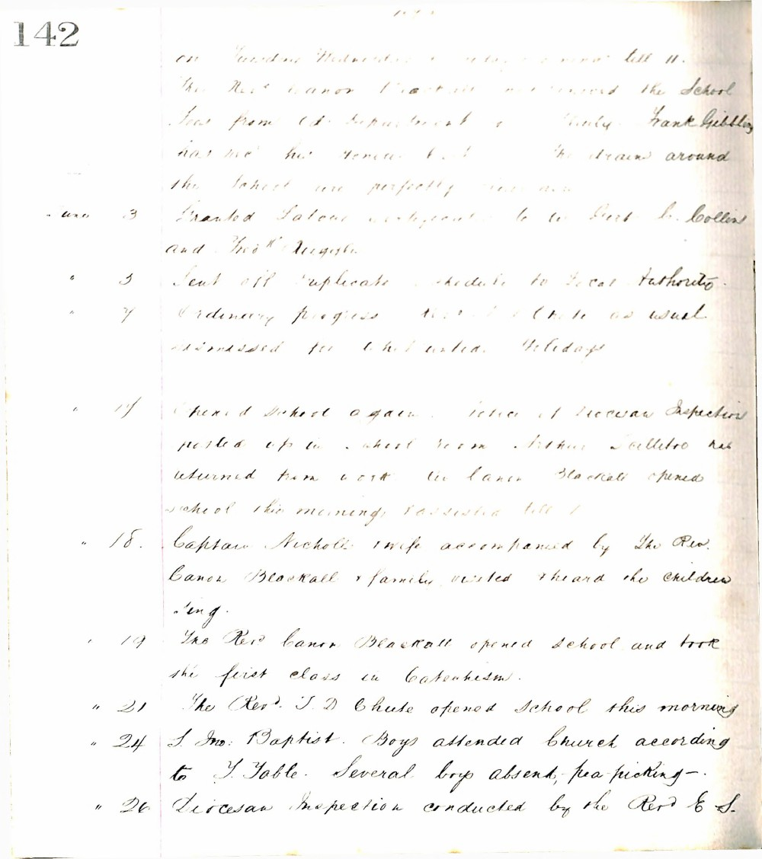

142
on Tuesday Wednesday & Friday till 11.
The Revd Canon Blackall mentioned the School Fees from Ed. Department & County. Frank Gribbling has met his Fees but the drains around the School are perfectly clean now.
June 3 Granted Labour certificate to Bert C. Collins and Thos H. Angell.
" 5 Sent off Duplicate schedule to Local Authority.
" 7 Ordinary progress. (Note as usual dismissed for Whitsuntide Holidays.
" 17 Opened School again. Notice of Diocesan Inspection posted up in school room. Arthur Poillettro has returned from work. Mr Canon Blackall opened school this morning & assisted till 1.
" 18 Captain Nicholls & wife accompanied by the Rev. Canon Blackall & family visited & heard the children sing.
" 19 The Rev Canon Blackall opened school and took the first class in Catechism.
" 21 The Revd J. D Chute opened School this morning.
" 24 S. Jno. Baptist. Boys attended Church according to T. Table. Several boys absent, pea-picking.
" 26 Diocesan Inspection conducted by the Revd E S.

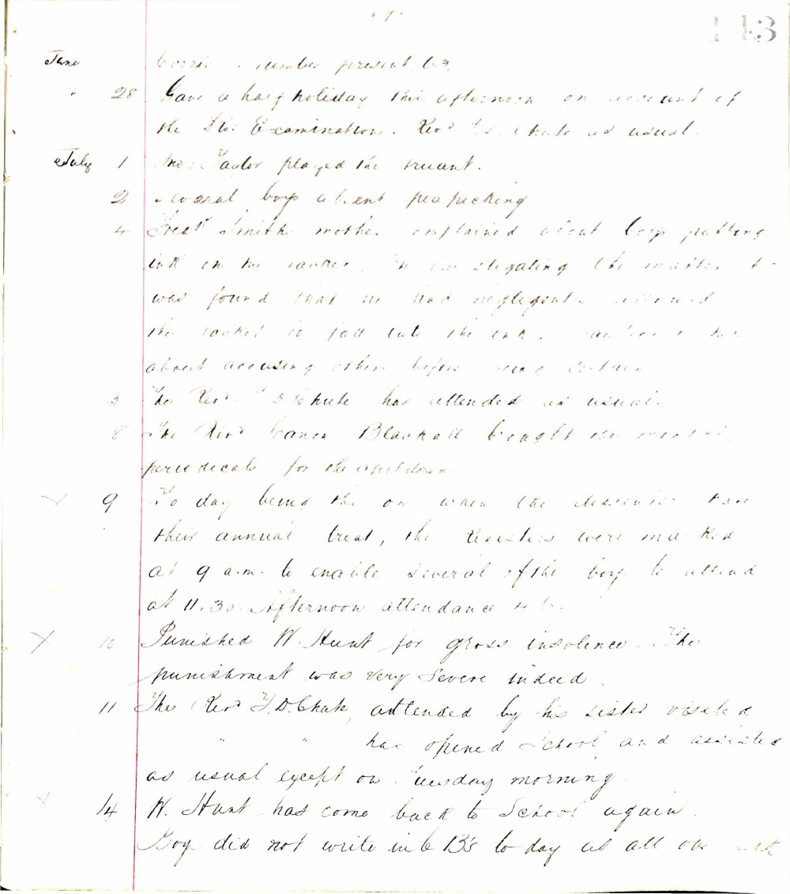

143
June
28 Gave a half holiday this afternoon on account of the St: Examination. Revd T. D. Chute as usual.
July 1 Mrs. Taylor played the truant.
2 Several boys absent pea picking.
4 Fred Smith's mother complained about boys putting ink on his jacket. On investigating the matter, it was found that he had negligently allowed the jacket to fall into the ink. Cautioned her about accusing others before being certain.
5 The Revd T. D. Chute has attended as usual.
8 The Revd Canon Blackall brought the monthly periodicals for the children.
- [x] 9 To day being the one when the dissenters have their annual treat, the registers were marked at 9 a.m. to enable several of the boys to attend at 11.30. Afternoon attendance 46.
- [x] 10 Punished W. Hunt for gross insolence. The punishment was very severe indeed.
11 The Revd T. D. Chute, attended by his sister visited has opened school and assisted as usual except on Tuesday morning.
- [x] 14 W. Hunt has come back to school again. Boy did not write in b B's to day at all or it

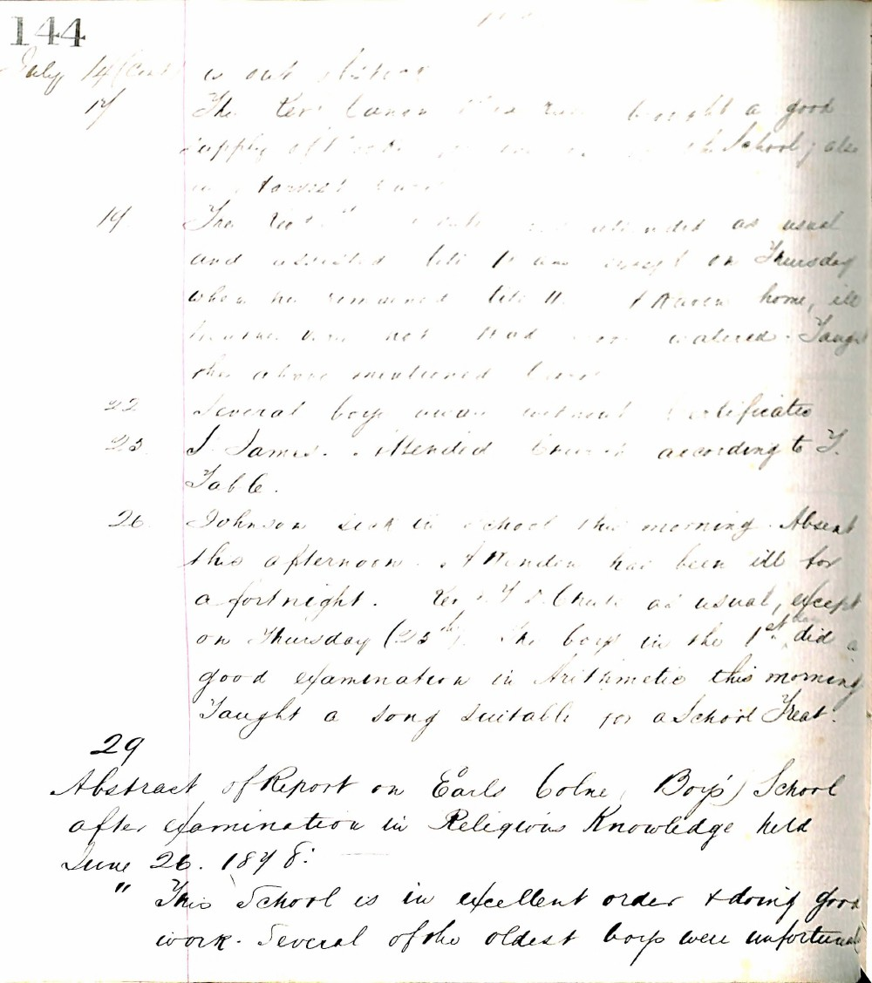

144
July 14 (cont) is out of school
17 The Rev Canon [?] has bought a good supply of books for use in the school; also a harvest hymn.
19 The Rev [?] [?] attended as usual and [?] till 11 am except on Thursday when he remained till 11. I [?] home, ill [?] [?] not [?] [?] [?] [?] the above mentioned [?]
22 Several boys away without certificates
25 J James attended Church according to T Table.
26 Johnson sick in school this morning. Absent this afternoon. J [?] has been ill for a fortnight. Rev J D Chute as usual, except on Thursday (25th). The boys in the 1st did a good examination in Arithmetic this morning. Taught a song suitable for a School Treat.
29 Abstract of Report on Earls Colne Boys' School after examination in Religious Knowledge held June 26. 1878:
"This school is in excellent order & doing good work. Several of the oldest boys were unfortunate

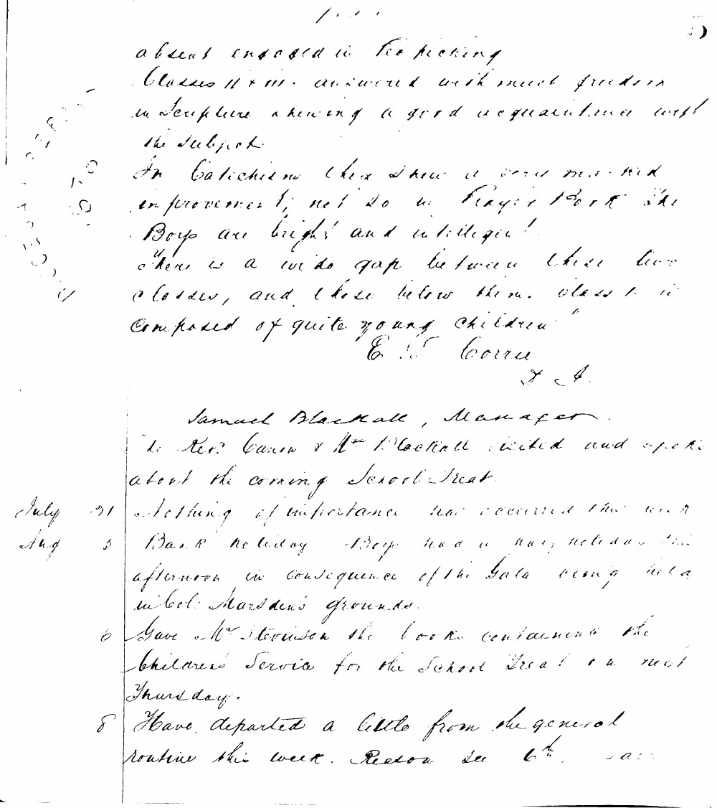

absent engaged in tea picking
Classes II + III answered with much freedom in Scripture showing a good acquaintance with the subject.
In Catechism they show a very marked improvement; not so in Prayer Book the Boys are bright and intelligent
There is a wide gap between these two classes, and those below them. Class I is composed of quite young children
E. S. Corrie
I. A.
Samuel Blackall, Manager
The Rev. Canon & Mrs Blackall visited and spoke about the coming School Treat.
July 31 Nothing of importance has occurred this week
Aug 3 Bank holiday Boys had a half holiday this afternoon in consequence of the Gala being held in Col: Marsden's grounds.
6 Gave Mrs Stevenson the books containing the children's service for the School Treat on next Thursday.
8 Have departed a little from the general routine this week. Reason see 6th

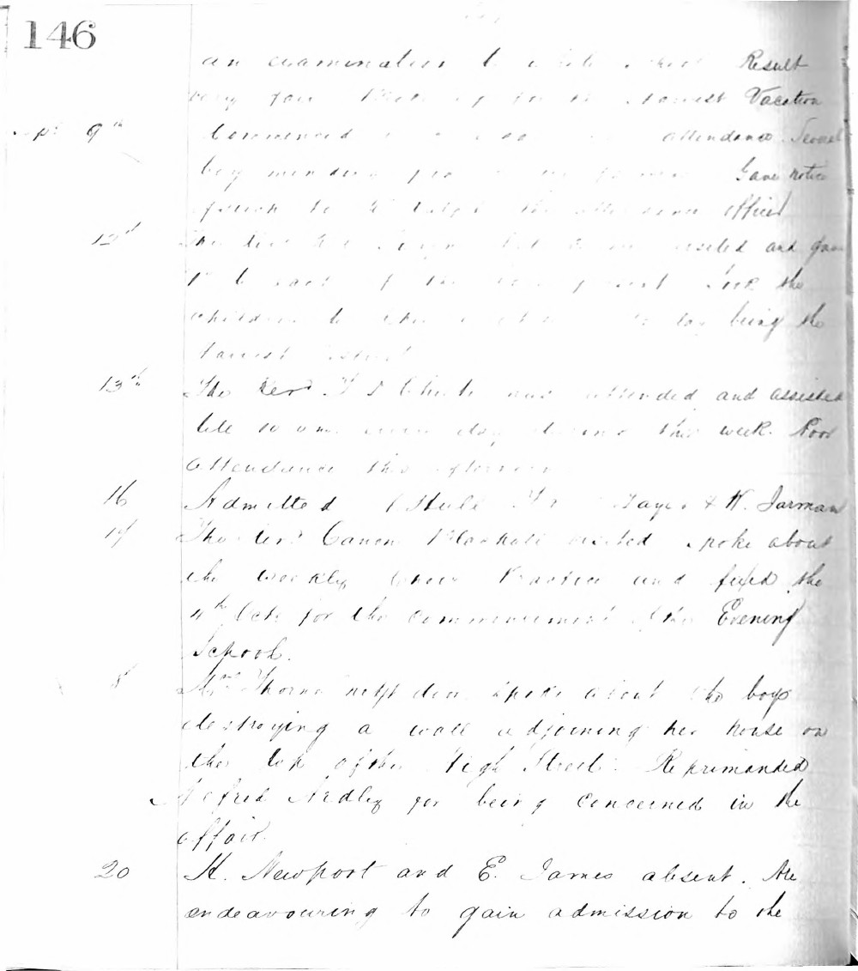

146
an examination. Result very fair. Harvest Vacation commenced attendance small
Sept 9th boy mending for me for me. Gave notice for to take the attendance officer
12th The Rev. J. S. Cluckie visited and gave 1st & last of the children to the boys being the harvest school
13th The Rev. J. S. Cluckie was attended and assisted till 10 a.m. every day during this week. Good attendance this afternoon.
16 Admitted Albert F. Daye & H. Jarman
17 The Rev. Canon Marshall visited spoke about the weekly choir practice and fixed the 4th Oct. for the commencement of the Evening School.
18 Mrs. Thorne next door spoke about the boys destroying a wall adjoining her house on the top of the High Street. Reprimanded Alfred Sidley for being concerned in the affair.
20 H. Newport and E. James absent. Are endeavouring to gain admission to the

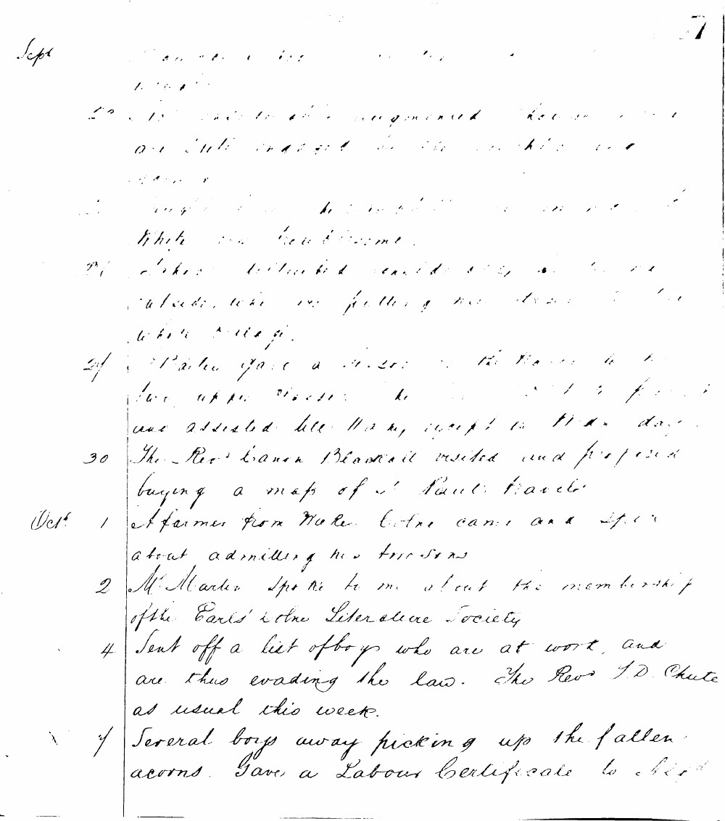

Sept
22 The number of children augmented this week and are still engaged in the work of the school.
23 Caught several boys picking up acorns in the White Horse Grove.
24 Stokes distributed cards etc. and was outside, while we were putting the school in order.
27 Parker gave a lesson to the boys in the two upper classes. He was assisted till 11 a.m., except for the last day.
30 The Rev'd Canon Blackall visited and proposed buying a map of St. Paul's travels.
Oct'r 1 A farmer from Norton Centre came and spoke about admitting his two sons.
2 Mr. Martin spoke to me about the membership of the Earl's Colne Literature Society.
4 Sent off a list of boys who are at work, and are thus evading the law. The Rev'd J. D. Chute as usual this week.
7 Several boys away picking up the fallen acorns. Gave a Labour Certificate to Bird.

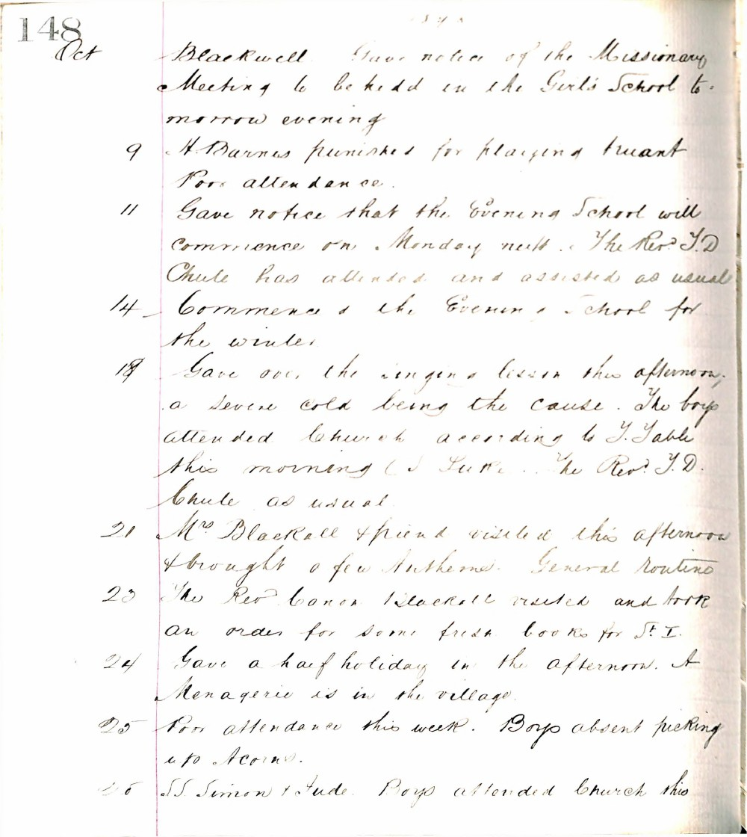

148
Oct Blackwell Gave notice of the Missionary Meeting to be held in the Girls' School tomorrow evening
9 H. Barnes punished for playing truant Poor attendance
11 Gave notice that the Evening School will commence on Monday next. The Rev. J. D. Chule has attended and assisted as usual
14 Commenced the Evening School for the winter
18 Gave over the singing lesson this afternoon, a severe cold being the cause. The boys attended Church according to Table this morning (St Luke). The Rev. J. D. Chule as usual
21 Mrs Blackwell & friend visited this afternoon & brought a few Anthems. General routine
23 The Rev. Canon Blackwell visited and took an order for some fresh books for St I
24 Gave a half holiday in the afternoon. A Menagerie is in the village
25 Poor attendance this week. Boys absent picking up Acorns
28 SS Simon & Jude. Boys attended Church this

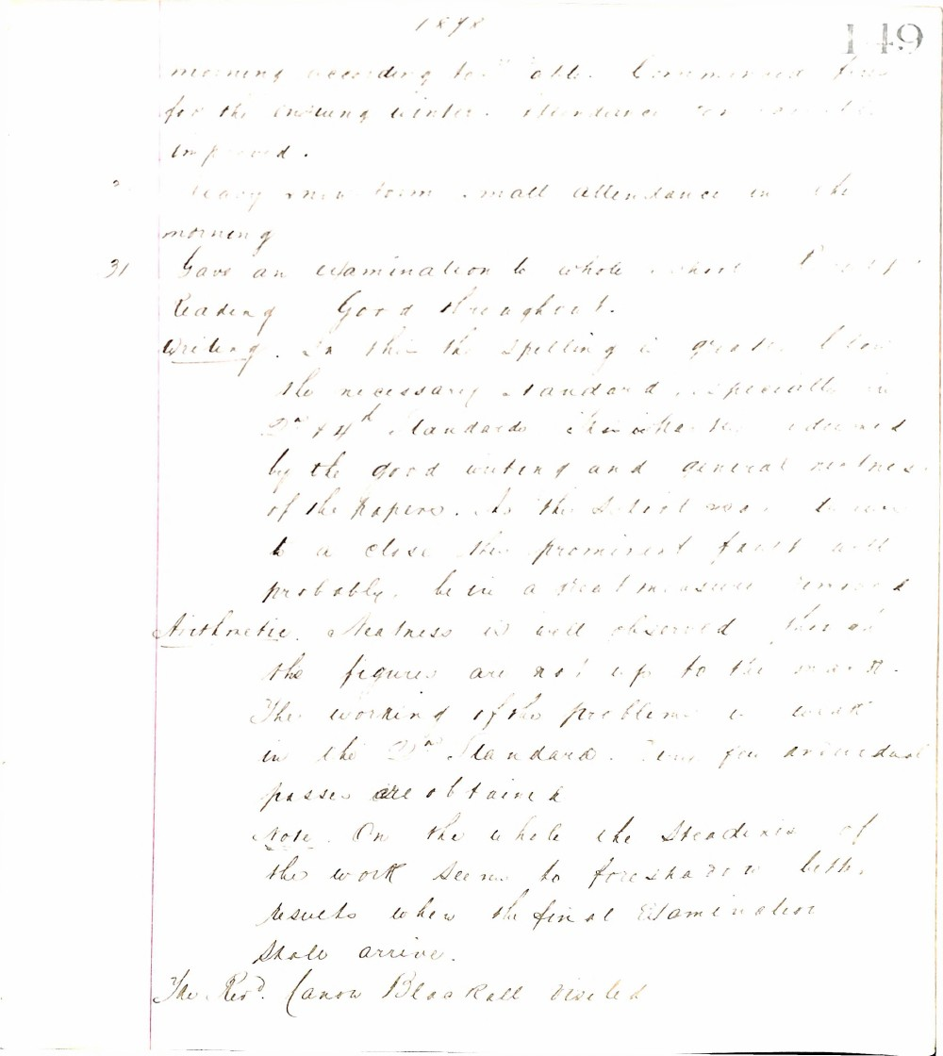

1898
149
morning according to table. Commenced fires for the ensuing winter. Attendance has improved.
Heavy rain term small attendance in the morning
31 Gave an examination to whole school. Reading Good throughout.
Writing. In this the spelling is greatly below the necessary standard, especially in 3rd & 4th standards which is the more to be regretted by the good writing and general neatness of the papers. As the defect was to some extent a close this prominent fault will probably be in a great measure removed.
Arithmetic. Neatness is well observed though the figures are not up to the mark. The working of the problems is weak in the 2nd standard. Very few individual passes are obtained.
Note. On the whole the steadiness of the work seems to foreshadow better results when the final examination shall arrive.
The Revd. Canon Blaxall visited

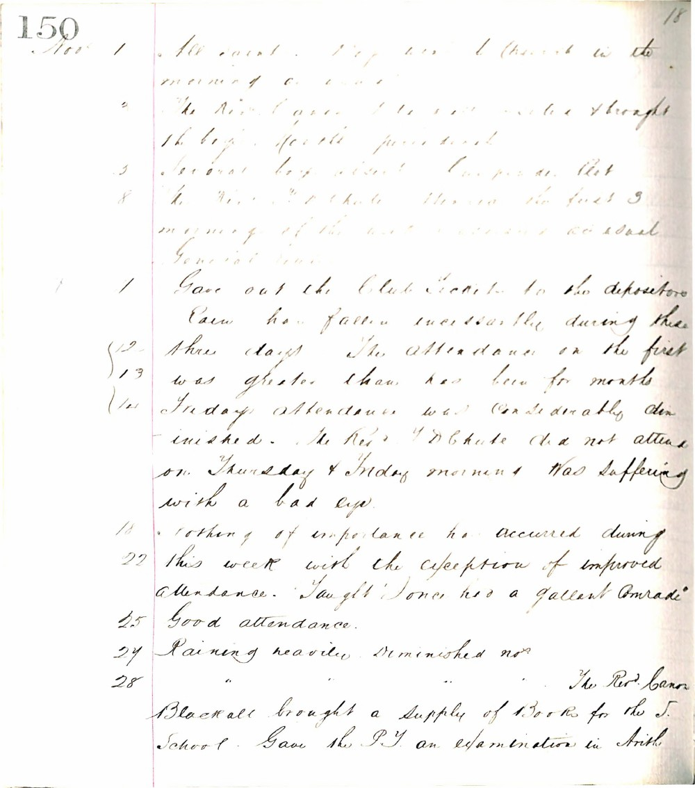

150
18
Nov 1 All quiet. P.T.s work (present in the morning of course).
2 The Rev. Canon Blackall visited & brought the boys' sports prizes.
5 Several boys absent. Cause as last.
8 The Rev. J. D. Chute visited the first 3 mornings of the week. Lessons as usual. General visit.
11 Gave out the Club Tickets to the depositors. Rain has fallen incessantly during these three days. The attendance on the first was greater than has been for months.
12
13
14 Friday's attendance was considerably diminished. The Rev. J. D. Chute did not attend on Thursday & Friday mornings. Was suffering with a bad eye.
18 Nothing of importance has occurred during this week with the exception of improved attendance. Taught 'Jones has a gallant comrade'.
22
25 Good attendance.
27 Raining heavily. Diminished nos.
28 " " The Rev. Canon Blackall brought a supply of Books for the S. School. Gave the P.T. an examination in Arith.

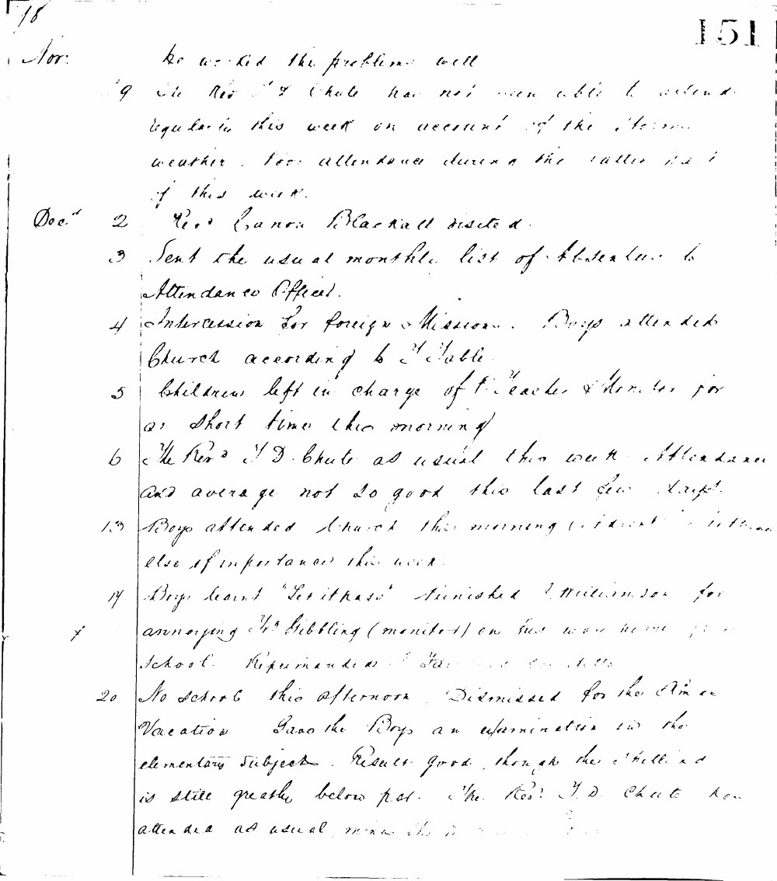

18
151
Nov: he worked the problems well
29 The Revd T Chute has not been able to attend regularly this week on account of the stormy weather. Poor attendance during the latter part of this week.
Decr 2 Revd Canon Blackall visited.
3 Sent the usual monthly list of Absentees to Attendance Officer.
4 Intercession for Foreign Missions. Boys attended Church according to Table.
5 Children left in charge of Teacher & Monitor for a short time this morning.
6 The Revd T D Chute as usual this week. Attendance and average not so good this last few days.
13 Boys attended Church this morning. Nothing else of importance this week.
14 Boys learnt "Let it pass". Punished J Williamson for annoying Mrs Gilling (monitor) on his way home from school. Reprimanded J Stevens & J Wills.
20 No school this afternoon. Dismissed for the Xmas vacation. Gave the Boys an examination in the elementary subjects. Results good, though the spelling is still greatly below par. The Revd T D Chute has attended as usual during the week.

