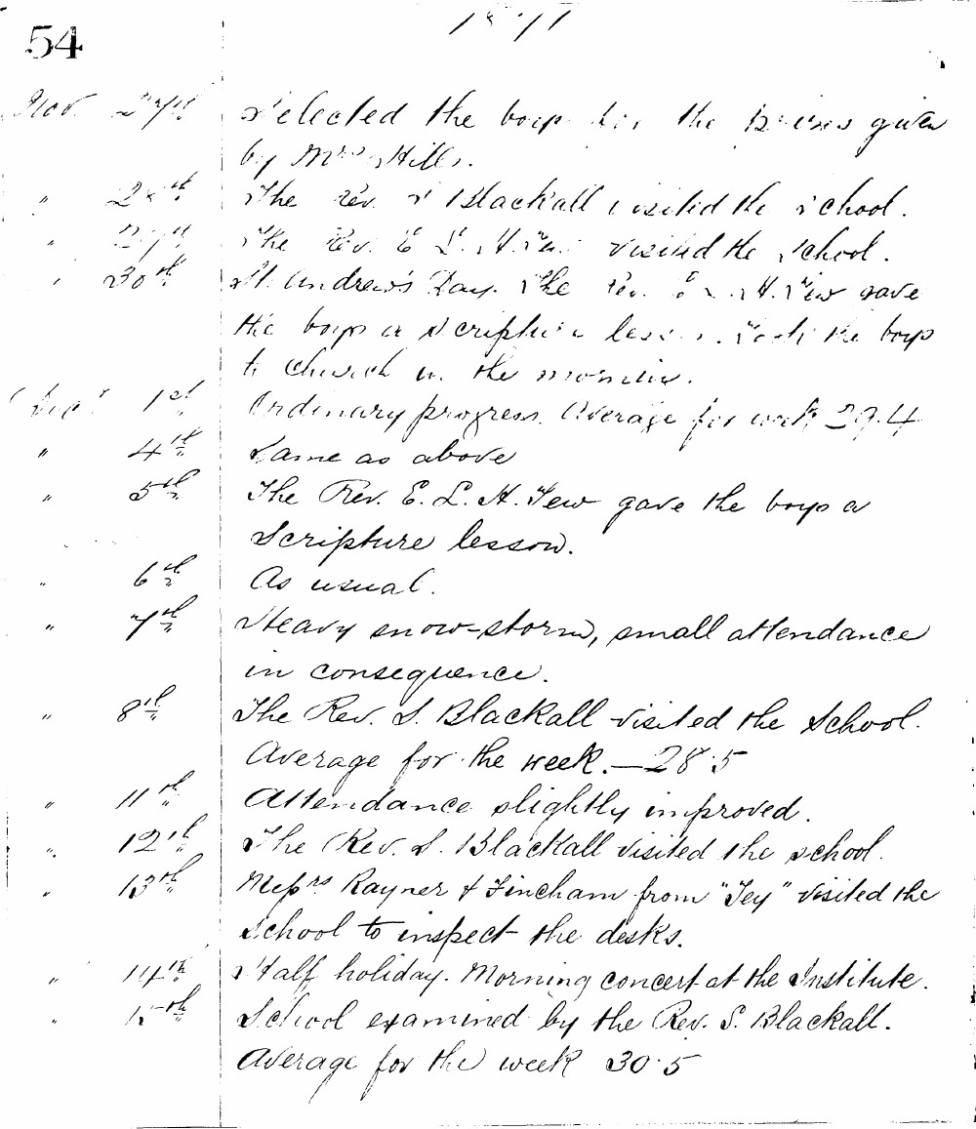

54
1871
Nov 27th Selected the boys for the prizes given by Mrs. Hill.
" 28th The Rev. S. Blackall visited the school.
" 29th The Rev. E. L. H. Tew visited the school.
" 30th St. Andrew's Day. The Rev. E. L. H. Tew gave the boys a scripture lesson. Took the boys to church in the morning.
Decr 1st Ordinary progress. Average for week 29.4
" 4th Same as above
" 5th The Rev. E. L. H. Tew gave the boys a Scripture lesson.
" 6th As usual.
" 7th Heavy snow-storm, small attendance in consequence.
" 8th The Rev. S. Blackall visited the school. Average for the week. - 28.5
" 11th Attendance slightly improved.
" 12th The Rev. S. Blackall visited the school.
" 13th Messrs Rayner & Fincham from "Tey" visited the school to inspect the desks.
" 14th Half holiday. Morning concert at the Institute.
" 15th School examined by the Rev. S. Blackall. Average for the week 30.5

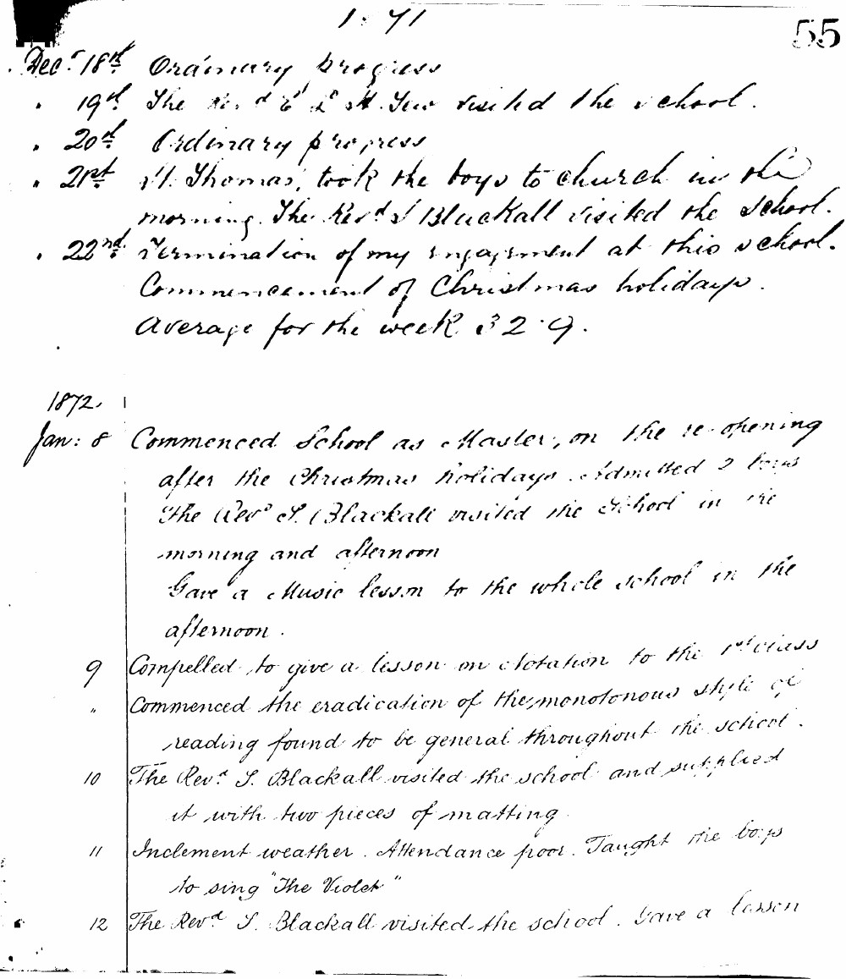

1871
55
Dec. 18th Ordinary progress
19th The Rev. S. B. & Mrs. S. visited the school.
20th Ordinary progress
21st St. Thomas, took the boys to church in the morning. The Rev. S. Blackall visited the school.
22nd Termination of my engagement at this school. Commencement of Christmas holidays. Average for the week 32.9.

Jan. 8 Commenced school as Master, on the re-opening after the Christmas holidays. Admitted 2 boys. The Rev. S. Blackall visited the school in the morning and afternoon. Gave a Music lesson to the whole school in the afternoon.
9 Compelled to give a lesson on Notation to the 1st Class. Commenced the eradication of the monotonous style of reading found to be general throughout the school.
10 The Rev. S. Blackall visited the school and supplied it with two pieces of matting.
11 Inclement weather. Attendance poor. Taught the boys to sing "The Violet"
12 The Rev. S. Blackall visited the school. Gave a lesson

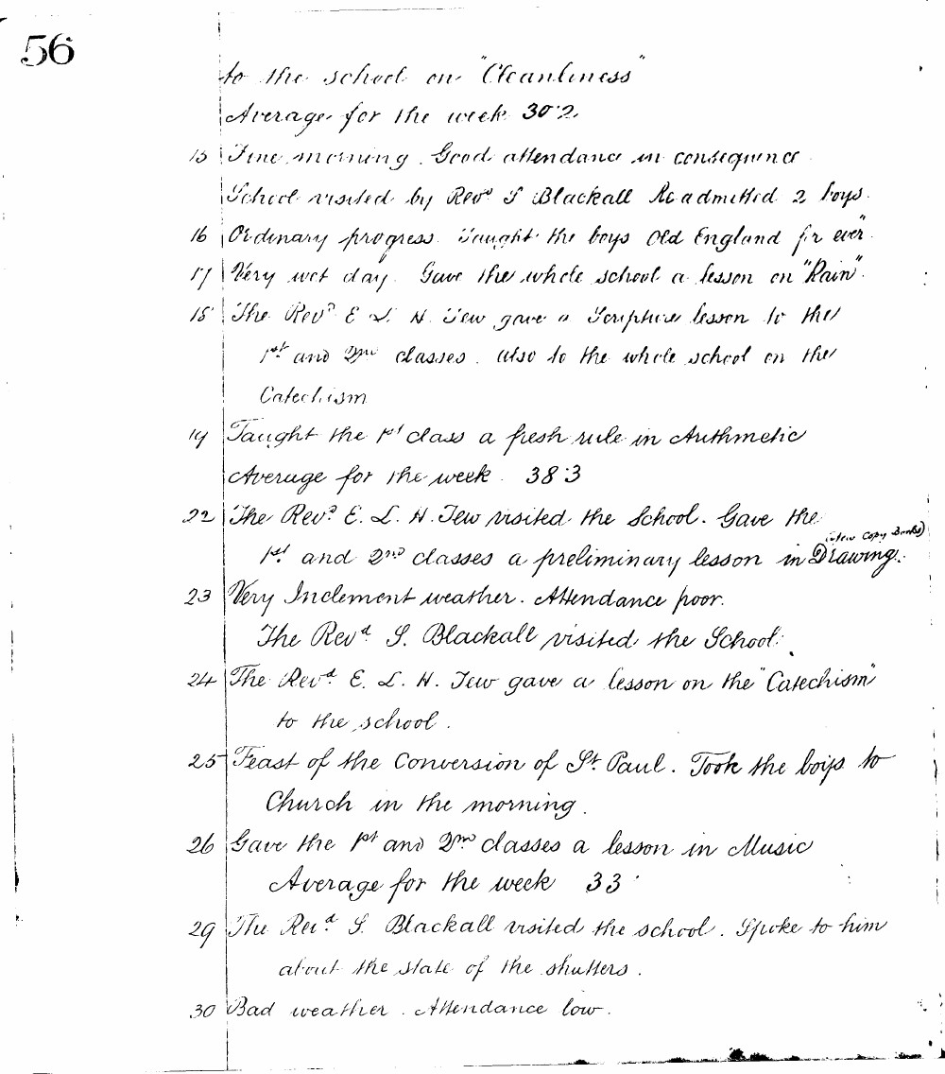

56
to the school on "Cleanliness"
Average for the week 30.2
15 Fine morning. Good attendance in consequence
School visited by Revd S Blackall Readmitted 2 boys
16 Ordinary progress. Taught the boys "Old England for ever"
17 Very wet day. Gave the whole school a lesson on "Rain"
18 The Revd E. L. H. Tew gave a Scripture lesson to the 1st and 2nd classes. also to the whole school on the Catechism
19 Taught the 1st class a fresh rule in Arithmetic
Average for the week 38.3
22 The Revd E. L. H. Tew visited the school. Gave the 1st and 2nd classes a preliminary lesson in Drawing (New Copy Books)
23 Very Inclement weather. Attendance poor.
The Revd S. Blackall visited the school
24 The Revd E. L. H. Tew gave a lesson on the "Catechism" to the school.
25 Feast of the Conversion of St. Paul. Took the boys to Church in the morning.
26 Gave the 1st and 2nd classes a lesson in Music
Average for the week 33
29 The Revd S. Blackall visited the school. Spoke to him about the state of the shutters.
30 Bad weather. Attendance low.

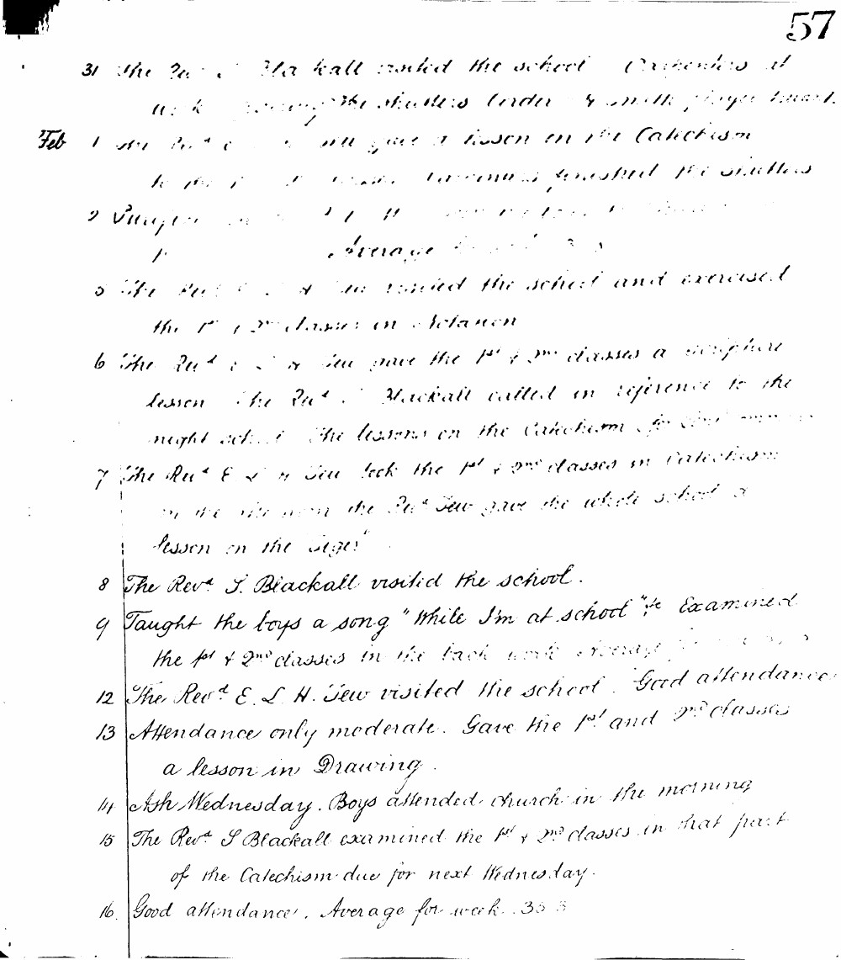

57
31 The Revd S. Blackall visited the school. Carpenters at work repairing the shutters. Order & work player board.
Feb 1 The Revd E. L. H. Tew gave a lesson on the Catechism to the 1st & 2nd classes. Carpenters finished the shutters.
2 Prayer as usual. Average for week 33.3
5 The Revd E. L. H. Tew visited the school and exercised the 1st & 2nd classes in Dictation.
6 The Revd E. L. H. Tew gave the 1st & 2nd classes a Scripture lesson. The Revd S. Blackall called in reference to the night school. The lessons on the Catechism for next week.
7 The Revd E. L. H. Tew took the 1st & 2nd classes in Catechism in the afternoon the Revd Tew gave the whole school a lesson on the Tiger.
8 The Revd S. Blackall visited the school.
9 Taught the boys a song "While I'm at school". Examined the 1st & 2nd classes in the back work. Average for week 34.2
12 The Revd E. L. H. Tew visited the school. Good attendance.
13 Attendance only moderate. Gave the 1st and 2nd classes a lesson in Drawing.
14 Ash Wednesday. Boys attended church in the morning.
15 The Revd S. Blackall examined the 1st & 2nd classes in that part of the Catechism due for next Wednesday.
16 Good attendance. Average for week 35.3

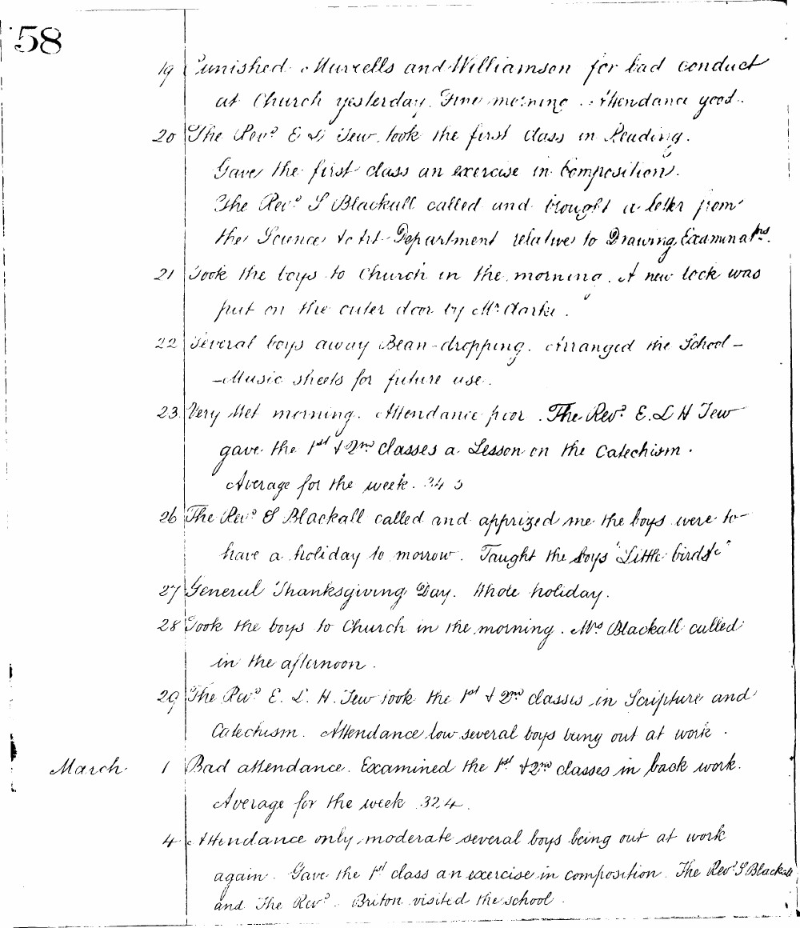

58
19 Punished Murrells and Williamson for bad conduct at Church yesterday. Fine morning. Attendance good.
20 The Rev. E. L. H. Tew took the first class in Reading. Gave the first class an exercise in Composition. The Rev. S. Blackall called and brought a letter from the Science to Art Department relative to Drawing Examinations.
21 Took the boys to Church in the morning. A new lock was put on the outer door by Mr. Clarke.
22 Several boys away Bean-dropping. Arranged the School-Music sheets for future use.
23 Very wet morning. Attendance poor. The Rev. E. L. H. Tew gave the 1st & 2nd classes a Lesson on the Catechism. Average for the week 34.5
26 The Rev. S. Blackall called and apprised me the boys were to have a holiday tomorrow. Taught the boys 'Little birds'.
27 General Thanksgiving Day. Whole holiday.
28 Took the boys to Church in the morning. Mr. Blackall called in the afternoon.
29 The Rev. E. L. H. Tew took the 1st & 2nd classes in Scripture and Catechism. Attendance low several boys being out at work.
March 1 Bad attendance. Examined the 1st & 2nd classes in back work. Average for the week 32.4.
4 Attendance only moderate several boys being out at work again. Gave the 1st class an exercise in composition. The Rev. S. Blackall and the Rev. Briton visited the school.

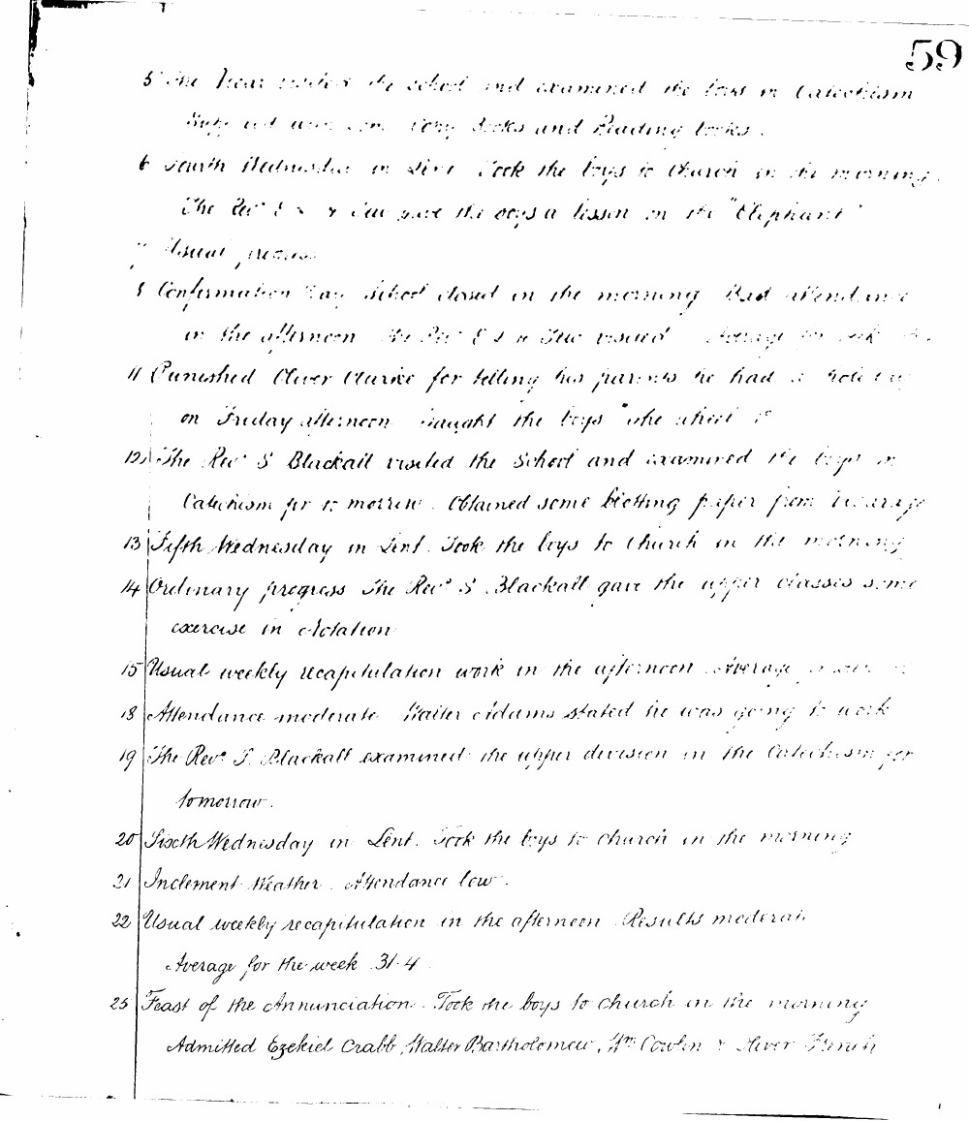

59
5 The Vicar visited the school and examined the boys in Catechism. Boys not using copy books and Reading books.
6 Fourth Wednesday in Lent. Took the boys to Church in the morning. The Rev. S. Blackall gave the boys a lesson on the "Elephant".
7 Usual progress.
8 Confirmation Day. School closed in the morning. Bad attendance in the afternoon. The Rev. S. Blackall visited. Average for week 31.
11 Punished Oliver Clarke for telling his parents he had a holiday on Friday afternoon. Taught the boys "The Wheel".
12 The Rev. S. Blackall visited the School and examined the boys in Catechism for tomorrow. Obtained some blotting paper from Vicarage.
13 Fifth Wednesday in Lent. Took the boys to Church in the morning.
14 Ordinary progress. The Rev. S. Blackall gave the upper classes some exercise in dictation.
15 Usual weekly recapitulation work in the afternoon. Average 31.2.
18 Attendance moderate. Walter Adams stated he was going to work.
19 The Rev. S. Blackall examined the upper division in the Catechism for tomorrow.
20 Sixth Wednesday in Lent. Took the boys to Church in the morning.
21 Inclement weather. Attendance low.
22 Usual weekly recapitulation in the afternoon. Results moderate. Average for the week 31.4.
25 Feast of the Annunciation. Took the boys to Church in the morning. Admitted Ezekiel Crabb, Walter Bartholomew, Wm Cowlen & Oliver French.

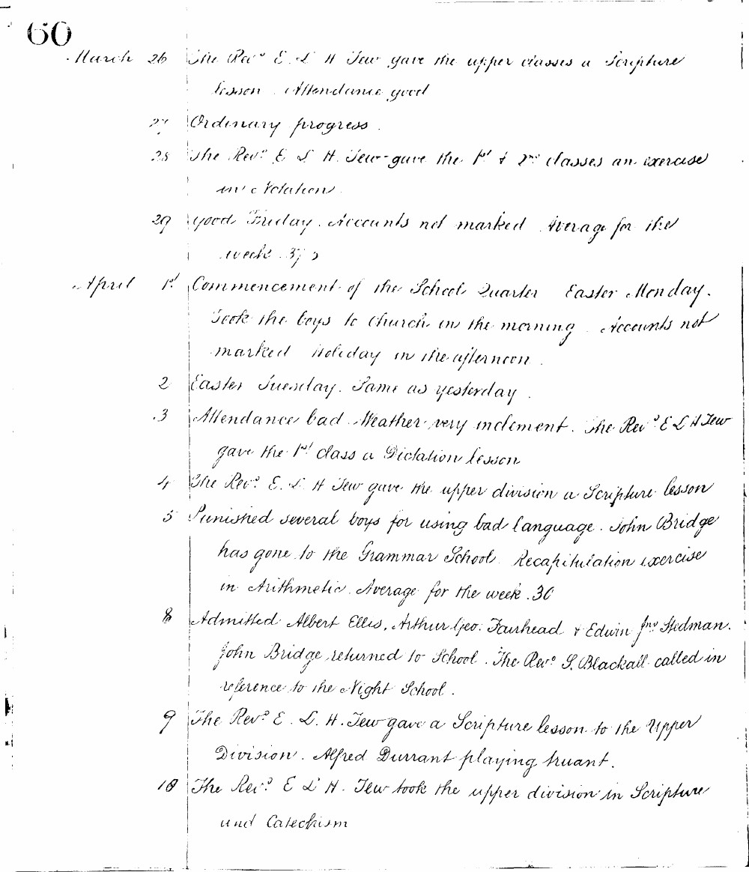

60
March 26 The Revd E. L. H. Tew gave the upper classes a Scripture lesson. Attendance good.
27 Ordinary progress.
28 The Revd E. L. H. Tew gave the 1st & 2nd classes an exercise in dictation.
29 Good Friday. Accounts not marked. Average for the week 37.2
April 1st Commencement of the School Quarter. Easter Monday. Took the boys to Church in the morning. Accounts not marked. Holiday in the afternoon.
2 Easter Tuesday. Same as yesterday.
3 Attendance bad. Weather very inclement. The Revd E. L. H. Tew gave the 1st class a Dictation lesson.
4 The Revd E. L. H. Tew gave the upper division a Scripture lesson.
5 Punished several boys for using bad language. John Bridge has gone to the Grammar School. Recapitulation exercise in Arithmetic. Average for the week 30
8 Admitted Albert Ellis, Arthur Geo. Fairhead & Edwin Jno Stedman. John Bridge returned to School. The Revd S. Blackall called in reference to the Night School.
9 The Revd E. L. H. Tew gave a Scripture lesson to the Upper Division. Alfred Durrant playing truant.
10 The Revd E. L. H. Tew took the upper division in Scripture and Catechism.

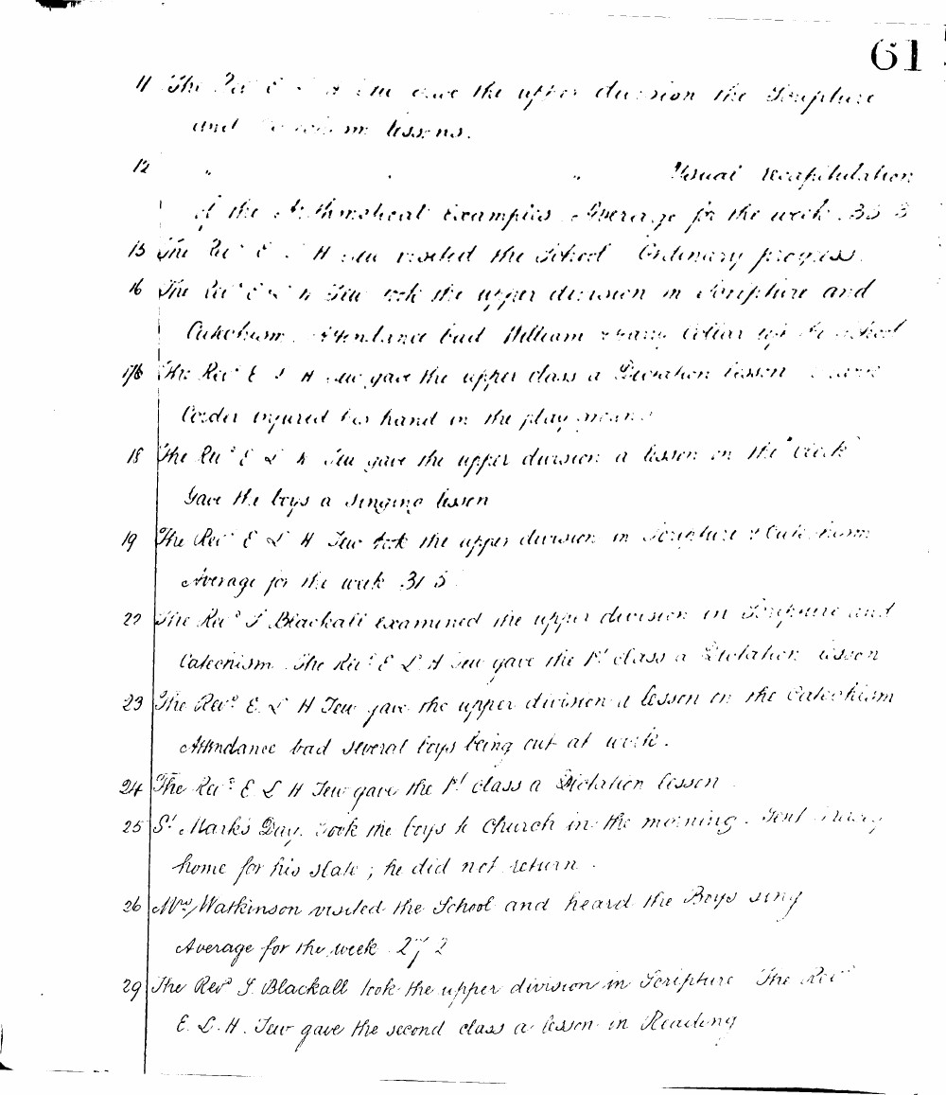

61
11 The Revd E L H Tew gave the upper division the Scripture and Catechism lessons.
12 " " " " Usual recapitulation of the Arithmetical examples. Average for the week 35.3
15 The Revd E L H Tew visited the School. Ordinary progress.
16 The Revd E L H Tew took the upper division in Scripture and Catechism. Attendance bad. William Young left the school.
17 The Revd E L H Tew gave the upper class a Dictation lesson. George Corda injured his hand in the play ground.
18 The Revd E L H Tew gave the upper division a lesson on the Clock. Gave the boys a singing lesson.
19 The Revd E L H Tew took the upper division in Scripture & Catechism. Average for the week 31.5
22 The Revd J Blackall examined the upper division in Scripture and Catechism. The Revd E L H Tew gave the 1st class a Dictation lesson.
23 The Revd E L H Tew gave the upper division a lesson on the Catechism. Attendance bad several boys being out at work.
24 The Revd E L H Tew gave the 1st class a Dictation lesson.
25 St. Mark's Day. Took the boys to Church in the morning. Sent Drury home for his slate; he did not return.
26 Mr. Watkinson visited the School and heard the Boys sing.
Average for the week 27.2
29 The Revd J Blackall took the upper division in Scripture. The Revd E L H Tew gave the second class a lesson in Reading.

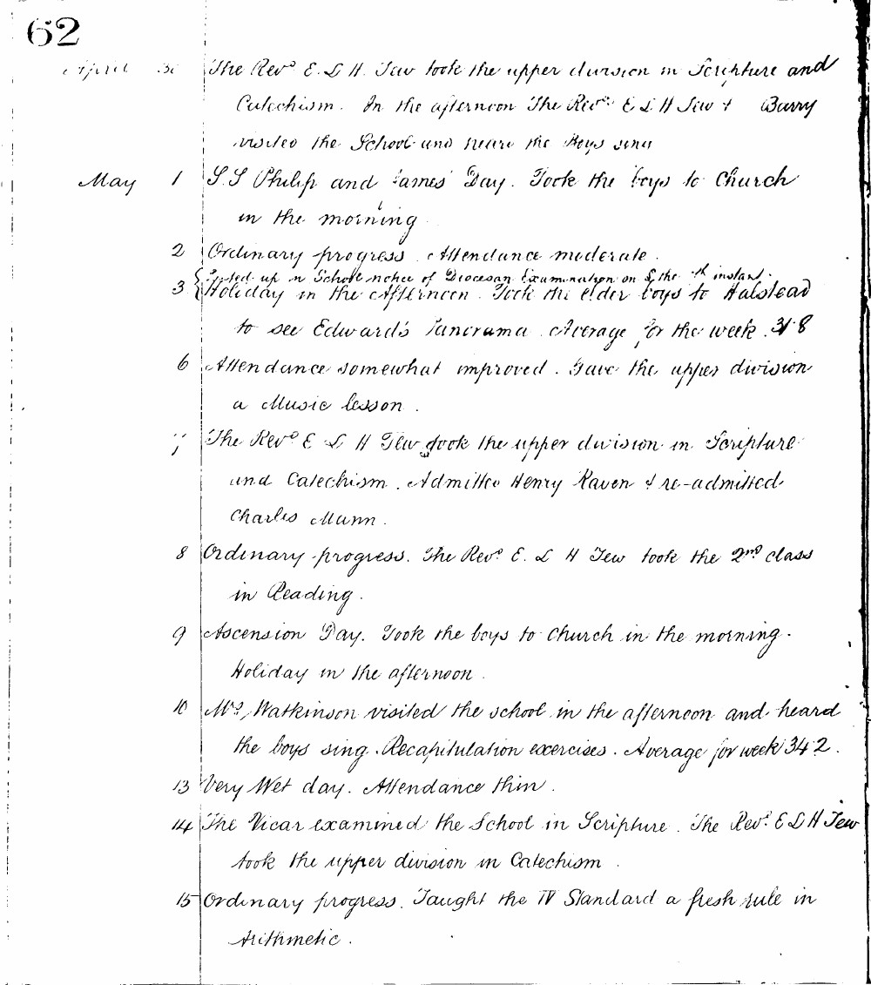

62
April 30 The Revd E. L. H. Tew took the upper division in Scripture and Catechism. In the afternoon The Revd E. L. H. Tew & Barry visited the school and heard the boys sing.
May 1 S.S Philip and James' Day. Took the boys to Church in the morning.
2 Ordinary progress. Attendance moderate.
3 Holiday in the afternoon. Took the elder boys to Halstead to see Edward's Panorama. Average for the week 31.8
6 Attendance somewhat improved. Gave the upper division a music lesson.
7 The Revd E. L. H. Tew took the upper division in Scripture and Catechism. Admitted Henry Raven & re-admitted Charles Munn.
8 Ordinary progress. The Revd E. L. H. Tew took the 2nd class in Reading.
9 Ascension Day. Took the boys to Church in the morning. Holiday in the afternoon.
10 Mrs Watkinson visited the school in the afternoon and heard the boys sing. Recapitulation exercises. Average for week 34.2.
13 Very Wet day. Attendance thin.
14 The Vicar examined the School in Scripture. The Revd E. L. H. Tew took the upper division in Catechism.
15 Ordinary progress. Taught the IV Standard a fresh rule in Arithmetic.

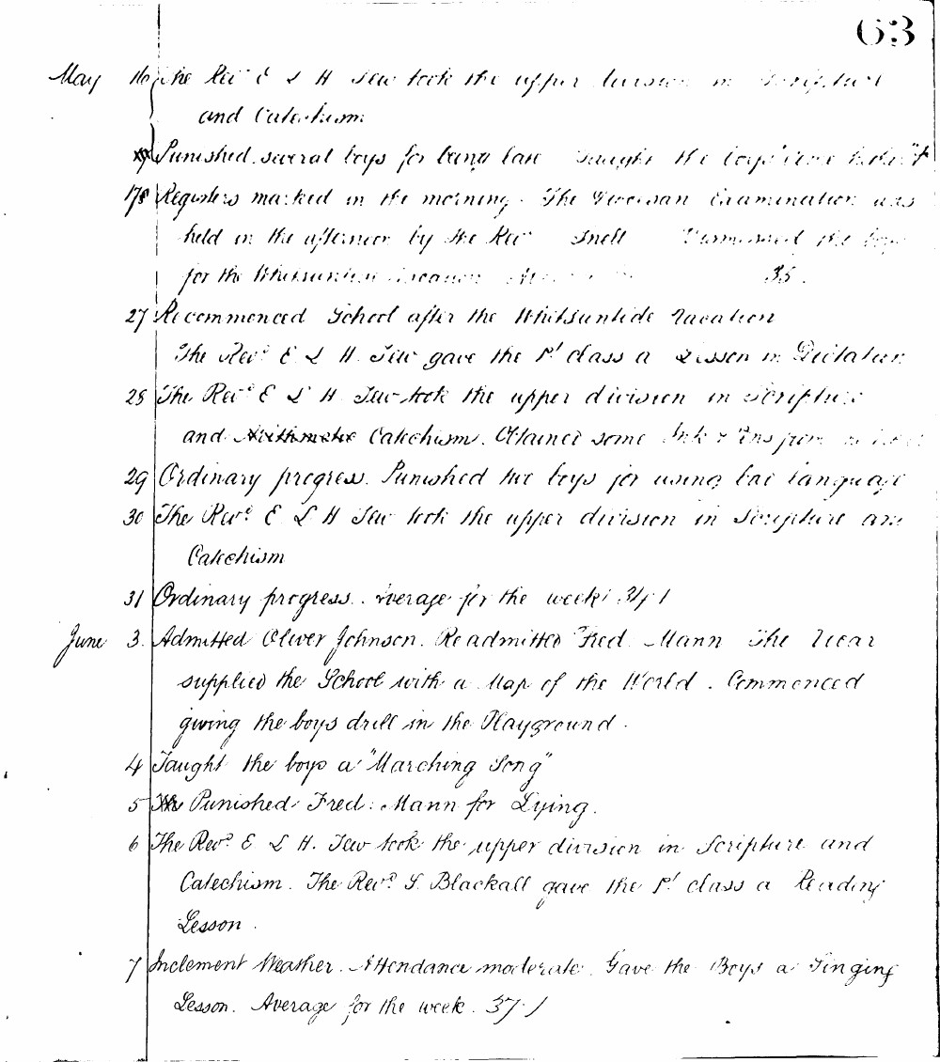

63
May the Rev. E. L. H. Tew took the upper division in Scripture and Catechism.
Punished several boys for using bad language. Taught the boys a new song.
17 Registers marked in the morning. The Diocesan Examination was held in the afternoon by the Rev. Snell. Dismissed the boys for the Whitsuntide vacation. Attendance 35.
27 Recommenced School after the Whitsuntide vacation. The Rev. E. L. H. Tew gave the 1st class a lesson in Dictation.
28 The Rev. E. L. H. Tew took the upper division in Scripture and Arithmetic Catechism. Obtained some ink & pens from the school.
29 Ordinary progress. Punished two boys for using bad language.
30 The Rev. E. L. H. Tew took the upper division in Scripture and Catechism.
31 Ordinary progress. Average for the week 34.1
June 3. Admitted Oliver Johnson. Readmitted Fred. Mann. The Vicar supplied the School with a Map of the World. Commenced giving the boys drill in the Playground.
4 Taught the boys a "Marching Song"
5 Punished Fred. Mann for Lying.
6 The Rev. E. L. H. Tew took the upper division in Scripture and Catechism. The Rev. J. Blackall gave the 1st class a Reading Lesson.
7 Inclement Weather. Attendance moderate. Gave the Boys a Singing Lesson. Average for the week 37.1

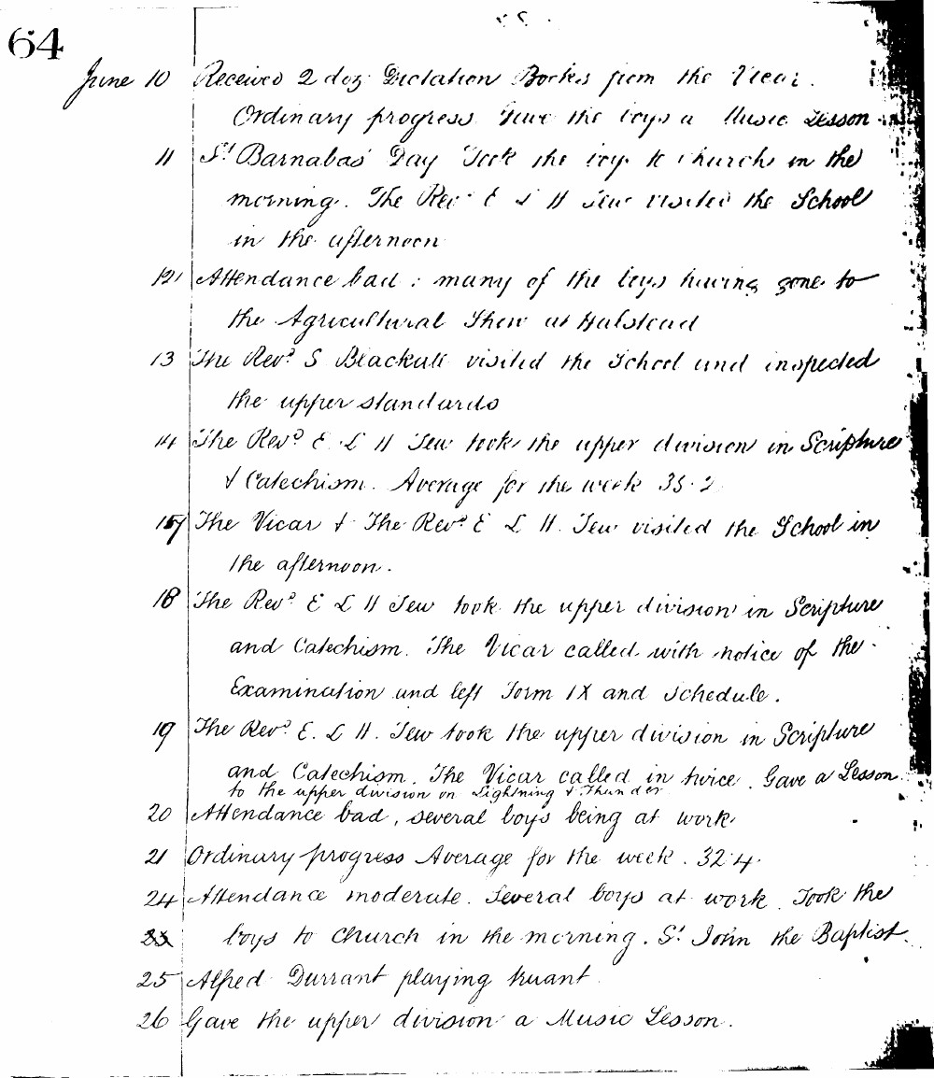

64
June 10 Received 2 doz. Dictation Books from the Vicar. Ordinary progress. Gave the boys a Music Lesson.
11 St Barnabas' Day. Took the boys to Church in the morning. The Revd E. L. H. Tew visited the School in the afternoon.
12 Attendance bad: many of the boys having gone to the Agricultural Show at Halstead.
13 The Revd S. Blackall visited the School and inspected the upper standards.
14 The Revd E. L. H. Tew took the upper division in Scripture & Catechism. Average for the week 35.2.
17 The Vicar & The Revd E. L. H. Tew visited the School in the afternoon.
18 The Revd E. L. H. Tew took the upper division in Scripture and Catechism. The Vicar called with notice of the Examination and left Form IX and Schedule.
19 The Revd E. L. H. Tew took the upper division in Scripture and Catechism. The Vicar called in twice. Gave a Lesson to the upper division on Lightning & Thunder.
20 Attendance bad, several boys being at work.
21 Ordinary progress. Average for the week 32.4.
24 Attendance moderate. Several boys at work. Took the boys to Church in the morning. St John the Baptist.
25 Alfred Durrant playing truant.
26 Gave the upper division a Music Lesson.

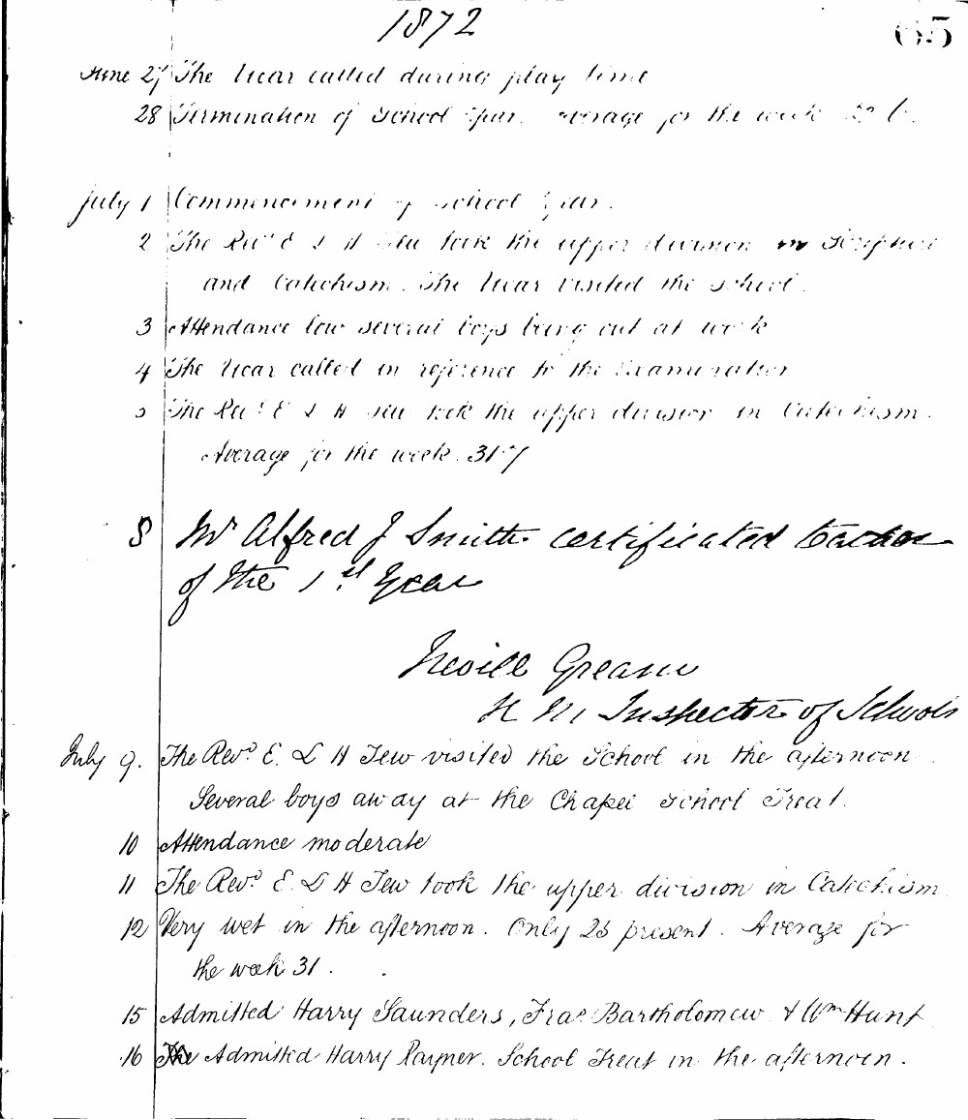

1872 65
June 27 The Vicar called during play time
28 Termination of school year. Average for the week 32.6.
July 1 Commencement of school year.
2 The Revd E L H Tew took the upper division in Scripture and Catechism. The Vicar visited the school.
3 Attendance low several boys being out at work
4 The Vicar called in reference to the Examination
5 The Revd E L H Tew took the upper division in Catechism. Average for the week 31.7
8 Mr Alfred J Smith certificated teacher of the 1st year
Nevill Gream H M Inspector of Schools
July 9. The Revd E L H Tew visited the school in the afternoon Several boys away at the Chapel school Treat.
10 Attendance moderate
11 The Revd E L H Tew took the upper division in Catechism.
12 Very wet in the afternoon. Only 25 present. Average for the week 31.
15 Admitted Harry Saunders, Fras Bartholomew & Wm Hunt
16 Admitted Harry Palmer. School Treat in the afternoon.

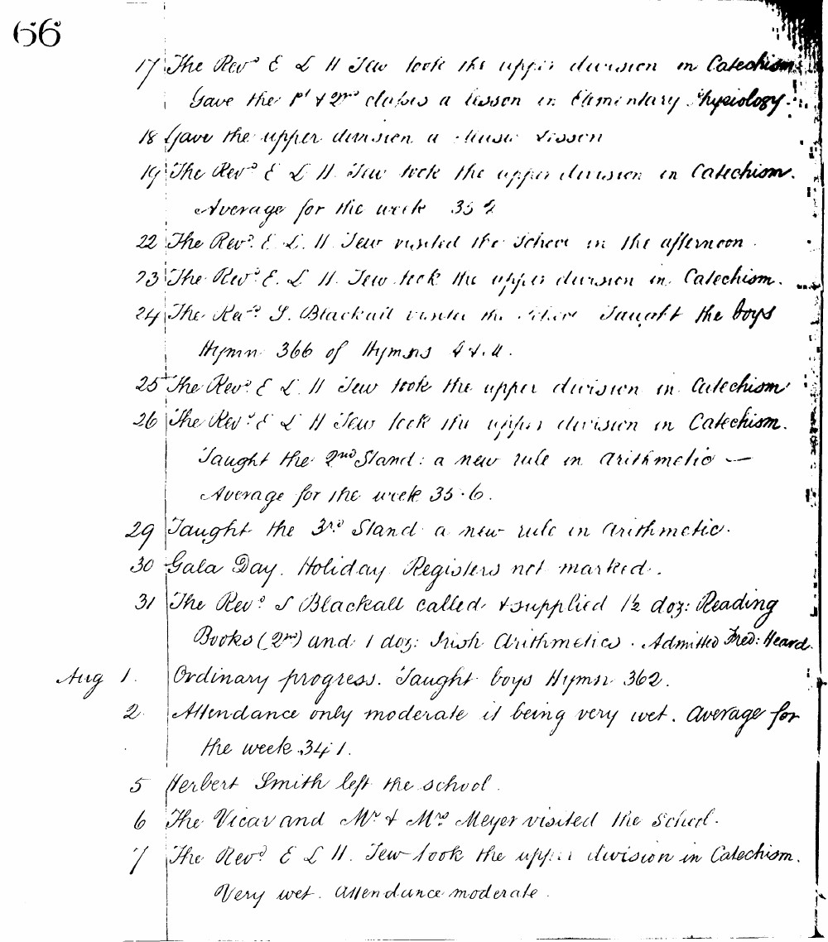

66
17 The Revd E L H Tew took the upper division in Catechism. Gave the 1st & 2nd classes a lesson in Elementary Physiology.
18 Gave the upper division a Music lesson
19 The Revd E L H Tew took the upper division in Catechism. Average for the week 35.2
22 The Revd E L H Tew visited the School in the afternoon
23 The Revd E L H Tew took the upper division in Catechism.
24 The Revd J. Blackall visited the School Taught the boys Hymn 366 of Hymns A & M.
25 The Revd E L H Tew took the upper division in Catechism
26 The Revd E L H Tew took the upper division in Catechism. Taught the 2nd Stand: a new rule in Arithmetic - Average for the week 35.6.
29 Taught the 3rd Stand: a new rule in Arithmetic.
30 Gala Day. Holiday Registers not marked.
31 The Revd J Blackall called & supplied 1/2 doz: Reading Books (2nd) and 1 doz: Irish Arithmetics. Admitted Fred: Heard.
Aug 1. Ordinary progress. Taught boys Hymn 362.
2 Attendance only moderate it being very wet. Average for the week 34.1.
5 Herbert Smith left the school.
6 The Vicar and Mr & Mrs Meyer visited the school.
7 The Revd E L H Tew took the upper division in Catechism. Very wet. Attendance moderate.

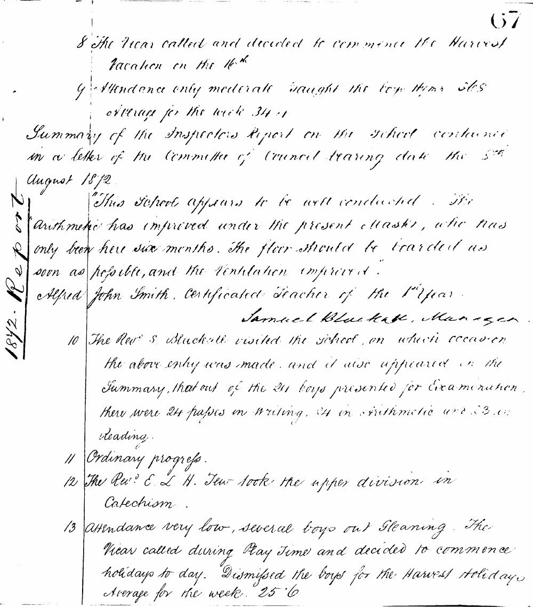

67
8 The Vicar called and decided to commence the Harvest Vacation on the 16th
9 Attendance only moderate taught the boys their S.S.S. average for the week 34.4
Summary of the Inspectors Report on the School contained in a letter of the Committee of Council bearing date the 5th August 1872.
"This School appears to be well conducted. The Arithmetic has improved under the present Master, who has only been here six months. The floor should be boarded as soon as possible, and the Ventilation improved."
Alfred John Smith, Certificated Teacher of the 1st Year.
Samuel Blackall, Manager.
1872 Report
10 The Revd S. Blackall visited the school, on which occasion the above entry was made, and it also appeared in the Summary, that out of the 24 boys presented for Examination, there were 24 passes in Writing, 24 in Arithmetic and 23 in Reading.
11 Ordinary progress.
12 The Revd E. L. H. Tew took the upper division in Catechism.
13 Attendance very low, several boys out Gleaning. The Vicar called during Play Time and decided to commence holidays today. Dismissed the boys for the Harvest holidays Average for the week 25.6

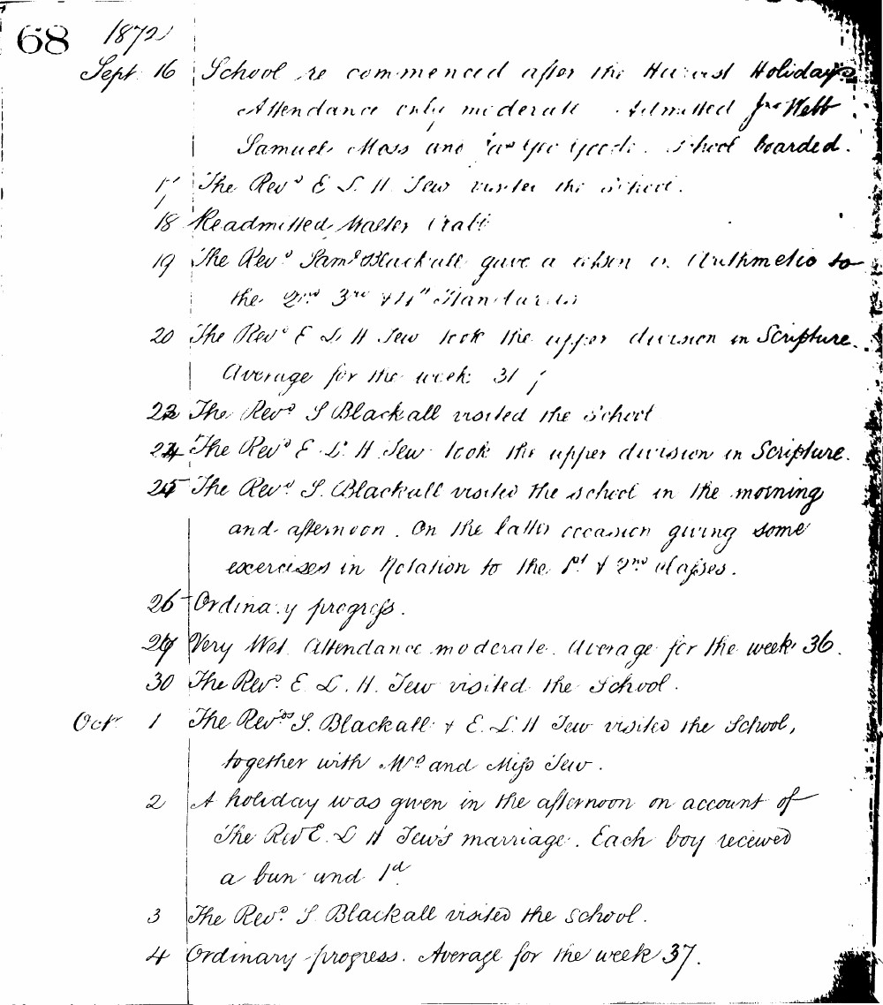

68 1872
Sept 16 School re commenced after the Harvest Holidays Attendance only moderate. Admitted Jno Webb Samuel Moss and George Goode. School boarded.
17 The Revd E. L. H. Tew visited the school.
18 Readmitted Master Pratt
19 The Revd Saml Blackall gave a lesson in Arithmetic to the 2nd 3rd & 4th Standards
20 The Revd E. L. H. Tew took the upper division in Scripture. Average for the week 31
23 The Revd S Blackall visited the school
24 The Revd E. L. H. Tew took the upper division in Scripture.
25 The Revd S. Blackall visited the school in the morning and afternoon. On the latter occasion giving some exercises in Notation to the 1st & 2nd classes.
26 Ordinary progress.
27 Very Wet. Attendance moderate. Average for the week 36.
30 The Revd E. L. H. Tew visited the School.
Oct 1 The Revds S. Blackall & E. L. H. Tew visited the School, together with Mrs and Miss Tew.
2 A holiday was given in the afternoon on account of the Rev E. L. H Tew's marriage. Each boy received a bun and 1d
3 The Revd S. Blackall visited the school.
4 Ordinary progress. Average for the week 37.

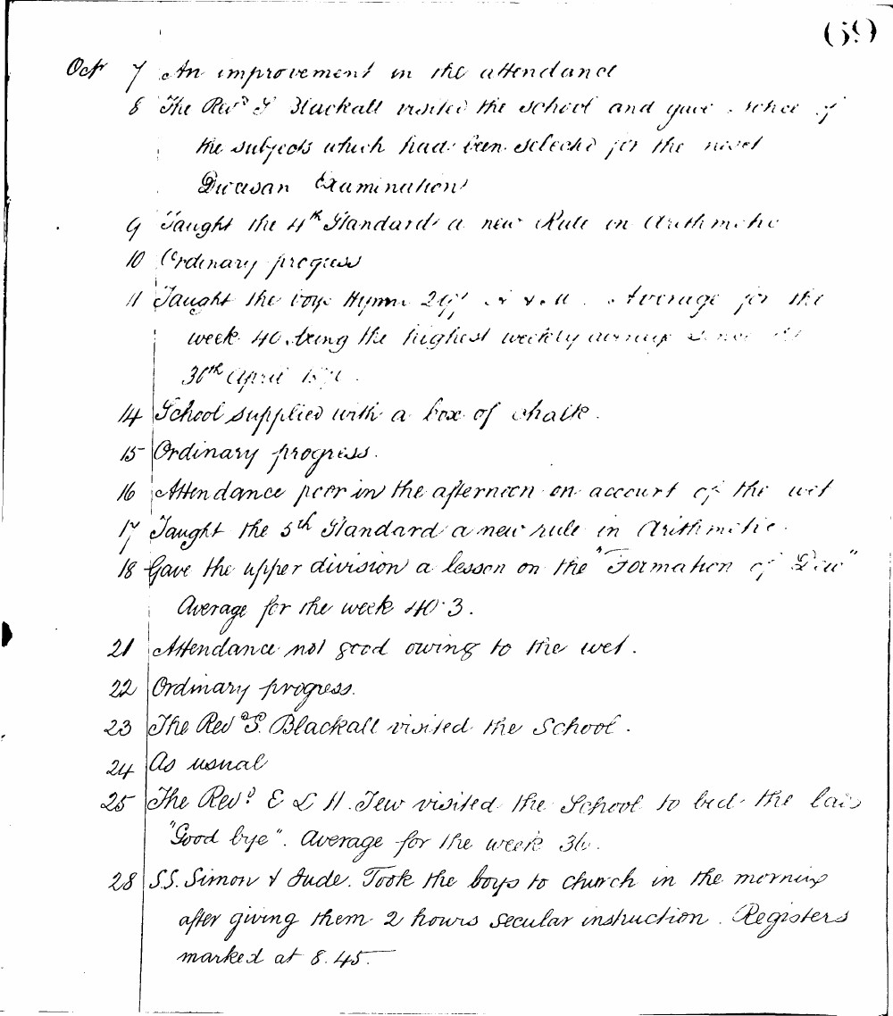

(69)
Oct 7 An improvement in the attendance
8 The Revd T Blackall visited the school and gave notice of the subjects which had been selected for the next Diocesan Examination
9 Taught the 4th Standard a new Rule in Arithmetic
10 Ordinary progress
11 Taught the boys Hymn 297 A. & M. Average for the week 40, being the highest weekly average since April 30th 1871.
14 School supplied with a box of chalk.
15 Ordinary progress.
16 Attendance poor in the afternoon on account of the wet
17 Taught the 5th Standard a new rule in Arithmetic.
18 Gave the upper division a lesson on the "Formation of Dew" Average for the week 40.3.
21 Attendance not good owing to the wet.
22 Ordinary progress.
23 The Revd T. Blackall visited the School.
24 As usual
25 The Revd E L H Tew visited the School to bid the boys "Good bye". Average for the week 36.
28 S.S. Simon & Jude. Took the boys to church in the morning after giving them 2 hours secular instruction. Registers marked at 8.45.

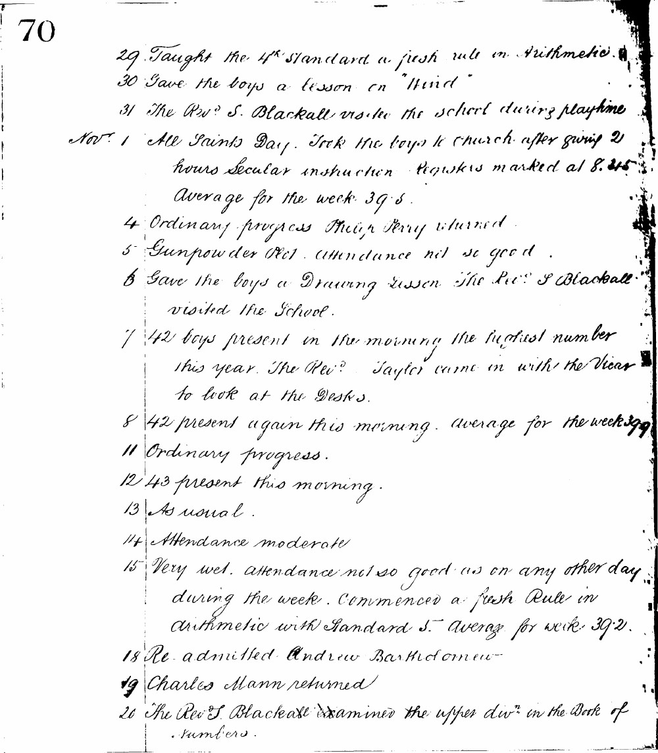

70
29 Taught the 4th Standard a fresh rule in Arithmetic.
30 Gave the boys a lesson on "Wind"
31 The Revd S. Blackall visited the school during playtime
Novr 1 All Saints Day. Took the boys to church after giving 2 hours Secular instruction Registers marked at 8.45 Average for the week 39.5.
4 Ordinary progress Philip Perry returned.
5 Gunpowder Plot. Attendance not so good.
6 Gave the boys a Drawing lesson The Revd S Blackall visited the school.
7 42 boys present in the morning the highest number this year. The Revd Taylor came in with the Vicar to look at the Desks.
8 42 present again this morning. Average for the week 39.9
11 Ordinary progress.
12 43 present this morning.
13 As usual.
14 Attendance moderate
15 Very wet. Attendance not so good as on any other day during the week. Commenced a fresh Rule in arithmetic with Standard 5. Average for week 39.2.
18 Re-admitted Andrew Bartholomew
19 Charles Mann returned
20 The Revd S. Blackall examined the upper divn in the Book of Numbers.

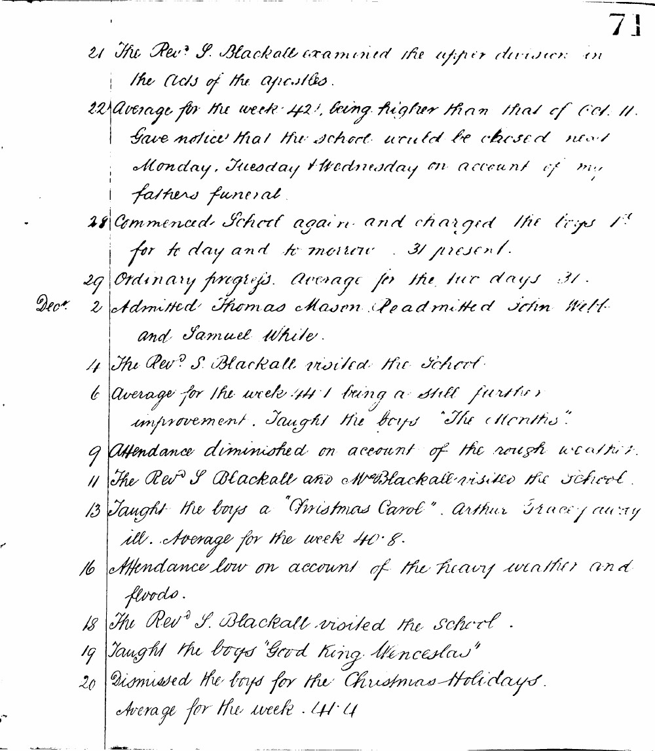

71
21 The Revd S. Blackall examined the upper division in the Acts of the apostles.
22 Average for the week 42.1, being higher than that of Oct. 11. Gave notice that the school would be closed next Monday, Tuesday & Wednesday on account of my fathers funeral.
28 Commenced School again and charged the boys 1d for today and tomorrow 31 present.
29 Ordinary progress. Average for the two days 31.
Decr 2 Admitted Thomas Mason Readmitted John Webb and Samuel White.
4 The Revd S. Blackall visited the school.
6 Average for the week 44.1 being a still further improvement. Taught the boys "The Months".
9 Attendance diminished on account of the rough weather.
11 The Revd S Blackall and Mrs Blackall visited the school.
13 Taught the boys a "Christmas Carol". Arthur Grace away ill. Average for the week 40.8.
16 Attendance low on account of the heavy weather and floods.
18 The Revd S. Blackall visited the school.
19 Taught the boys "Good King Wenceslas"
20 Dismissed the boys for the Christmas Holidays. Average for the week 44.4

