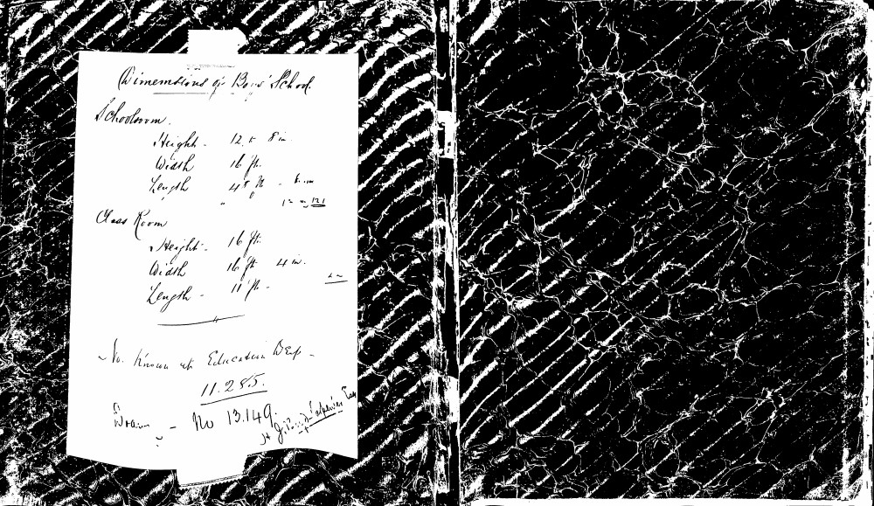

Dimensions of Boys' School
Schoolroom
Height - 12 ft 8 in.
Width 16 ft.
Length 48 ft. 6 in.
Class Room
Height - 16 ft.
Width 16 ft. 4 in.
Length - 11 ft.
No. known at Education Dep -
11.255.
No 13.149.
J. G. Wood-Carpenter Esq

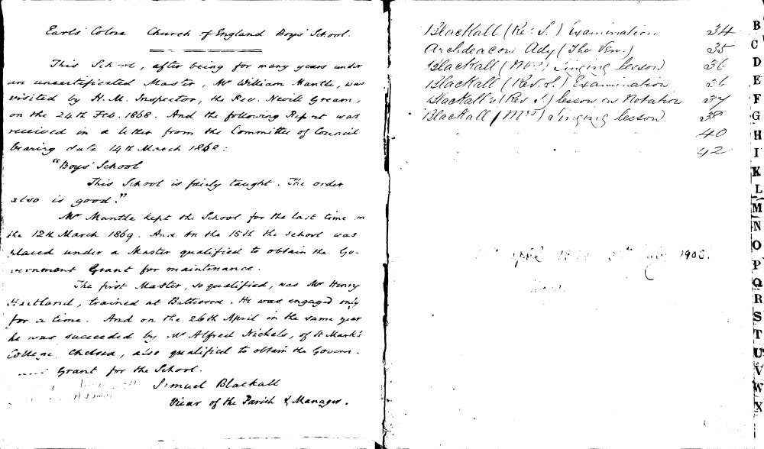

Earls' Colne Church of England Boys' School.
==========
This School, after being for many years under an uncertificated Master, Mr William Mantle, was visited by H. M. Inspector, the Rev. Nevile Gream, on the 24th Feb. 1868. And the following Report was received in a letter from the Committee of Council bearing date 14th March 1868:
"Boys' School
This School is fairly taught. The order also is good."
Mr Mantle kept the School for the last time on the 12th March 1869. And on the 15th the School was placed under a Master qualified to obtain the Government Grant for maintenance.
The first Master, so qualified, was Mr Henry Westland, trained at Battersea. He was engaged only for a time. And on the 26th April in the same year he was succeeded by Mr Alfred Nickels, of St Mark's College, Chelsea, also qualified to obtain the Government Grant for the School.
Samuel Blackall
Vicar of the Parish & Manager.
Blackall (Rev. S.) Examination | 34 | B
Archdeacon Ady (The Ven.) | 35 | C
Blackall (Mrs.) Singing lesson | 36 | D
Blackall (Rev. S.) Examination | 36 | E
Blackall's (Rev. S.) lesson on Notation | 37 | F
Blackall (Mrs.) Singing lesson | 38 | G
 | 40 | H
 | 42 | I
 |  | K
 |  | L
 |  | M
 |  | N
 |  | O
 |  | P
 |  | Q
 |  | R
 |  | S
 |  | T
 |  | U
 |  | V
 |  | W
 |  | X

April 1889 31st May 1905.

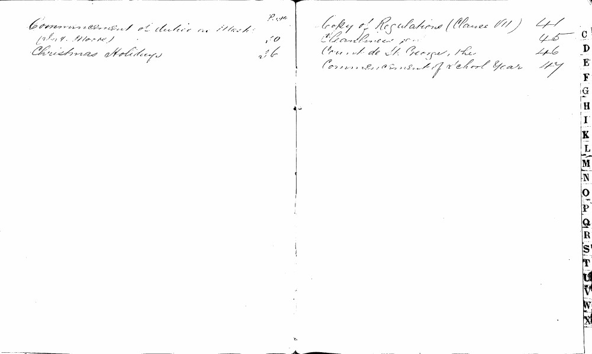

Commencement of duties as Master (W. G. Moore) 10
Christmas Holidays 36
Copy of Regulations (Clause VII) 41
Cleanliness 45
Count de St. George, the 46
Commencement of School Year 47
C
D
E
F
G
H
I
K
L
M
N
O
P
Q
R
S
T
U
V
W
X

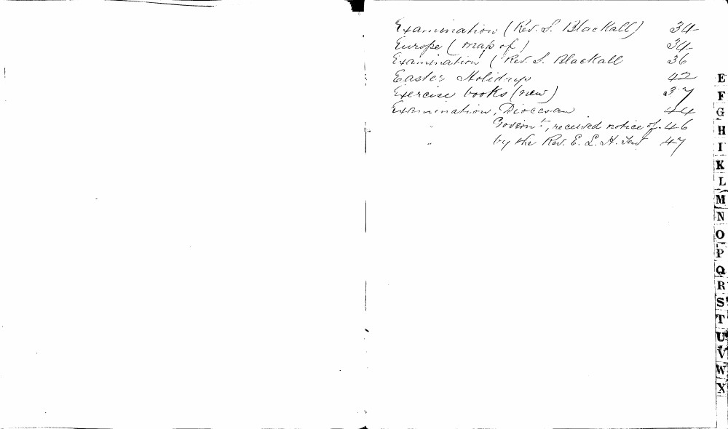

Examination (Rev. S. Blackall) 34
Europe (map of) 34
Examination (Rev. S. Blackall) 36
Easter Holidays 42
Exercise books (new) 37
Examination, Diocesan 44
" Govern.t, received notice of 46
" by the Rev. E. L. H. Tew 47
E
F
G
H
I
K
L
M
N
O
P
Q
R
S
T
U
V
W
X

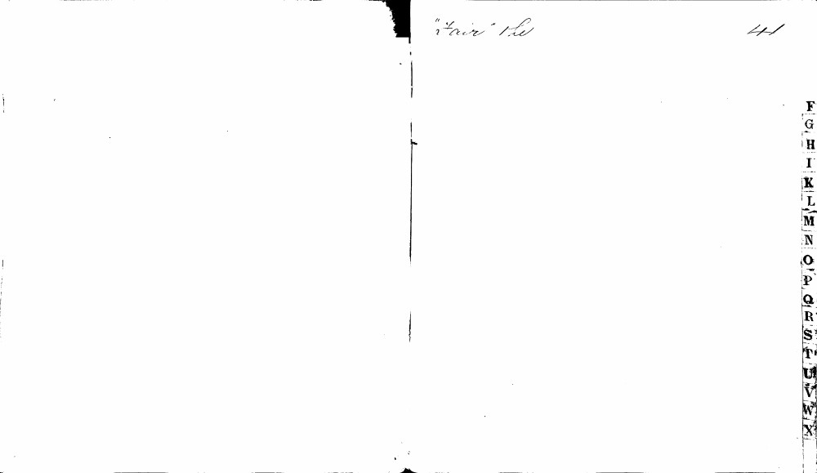

"Fair" the
41
F
G
H
I
K
L
M
N
O
P
Q
R
S
T
U
V
W
X

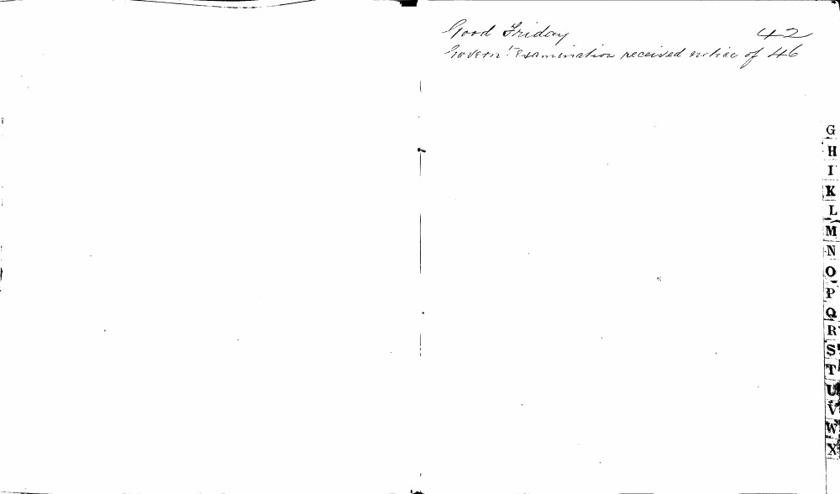

Good Friday 42
Govern Examination received notice of 46
G
H
I
K
L
M
N
O
P
Q
R
S
T
U
V
W
X

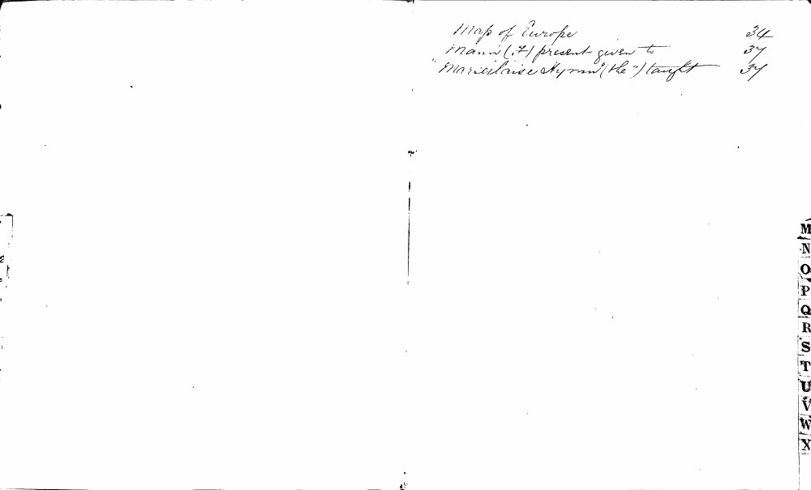

Map of Europe 34
Mann (A) present given to 37
"Marseillaise Hymn" (the) taught 37
M
N
O
P
Q
R
S
T
U
V
W
X

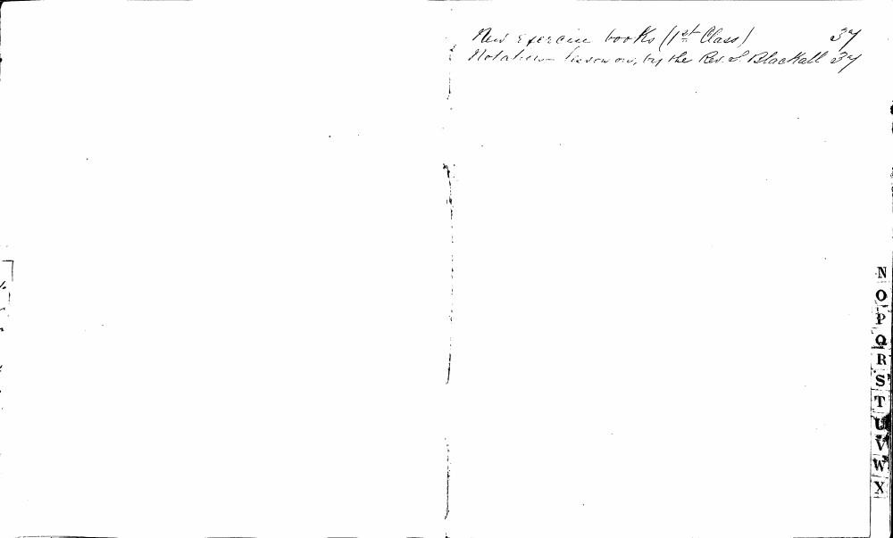

New exercise books (1st Class) 37
Notation - lesson on, by the Rev. S. Blackall 37
N
O
P
Q
R
S
T
U
V
W
X

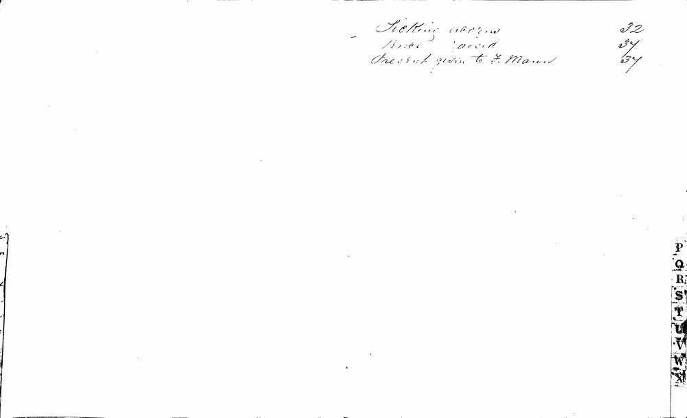

Sicking acorns 32
Price paid 37
Present given to F. Mann 37
P
Q
R
S
T
U
V
W
X

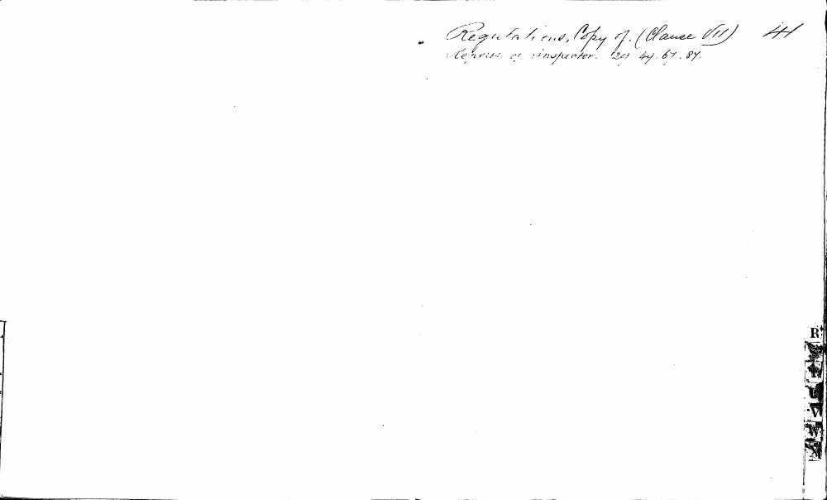

Regulations, Copy of. (Clause VII) 41
Reports of Inspector. 24. 49. 67. 87.
R
S
T
U
V
W
X
Y

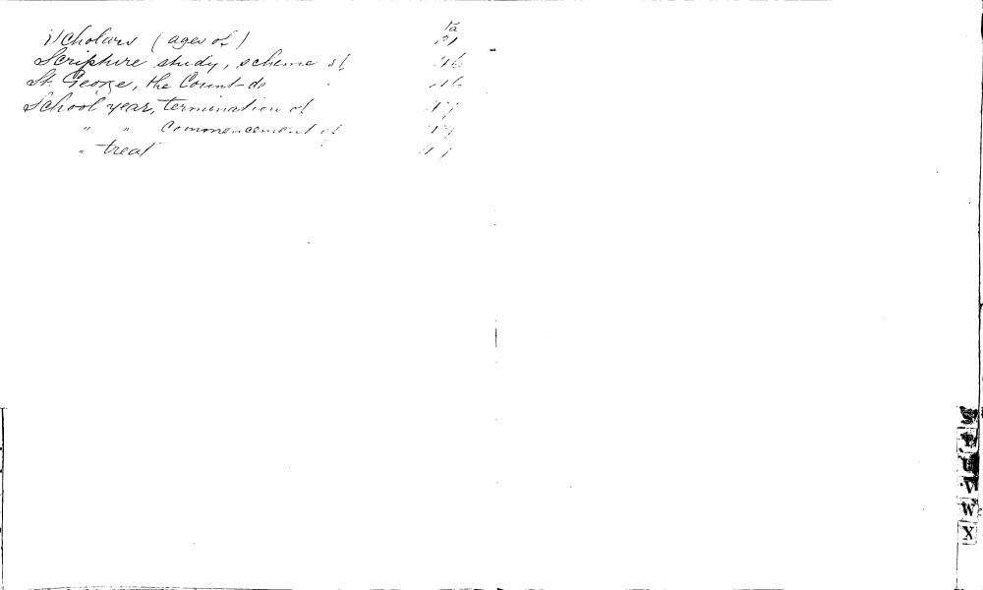

Scholars (ages of) 15, 21
Scripture study, scheme of 16
St. George, the Count de 16
School year, termination of 17
" " commencement of 17
" -treat 17

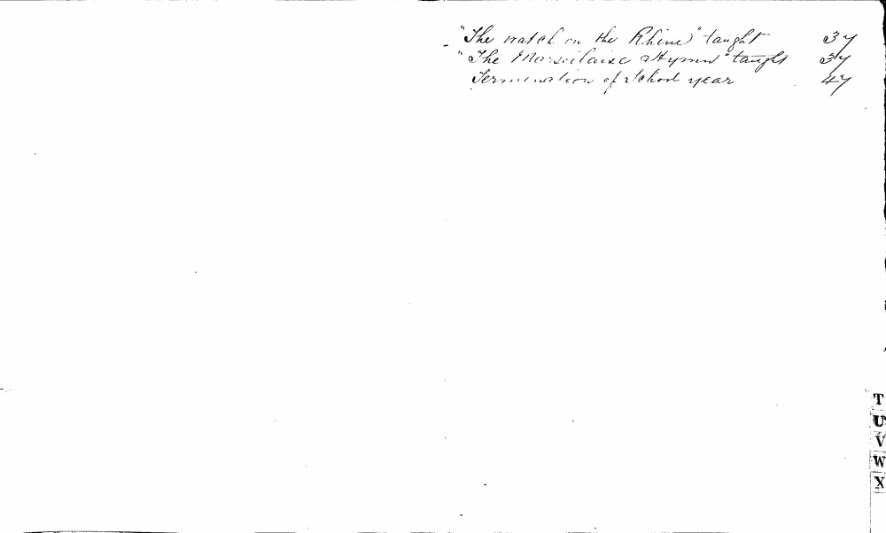

"The watch on the Rhine" taught 37
"The Marseillaise Hymn" taught 34
Termination of school year 47
T
U
V
W
X

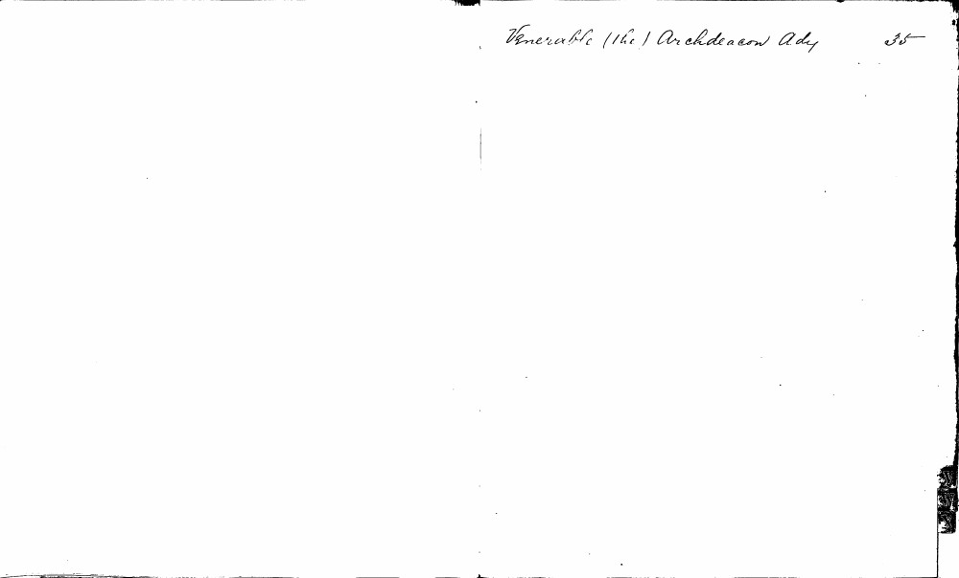

Venerable (the) Archdeacon Ady 35

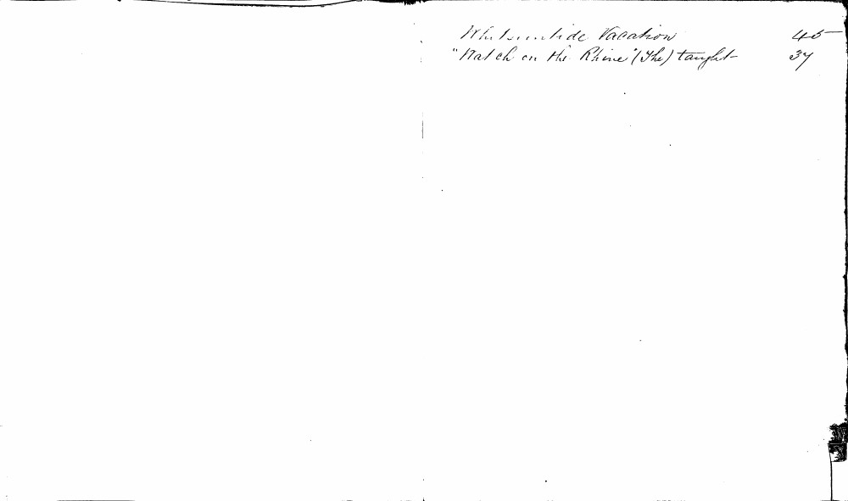

Whitsuntide Vacation 46
"Watch on the Rhine" (The) taught 37

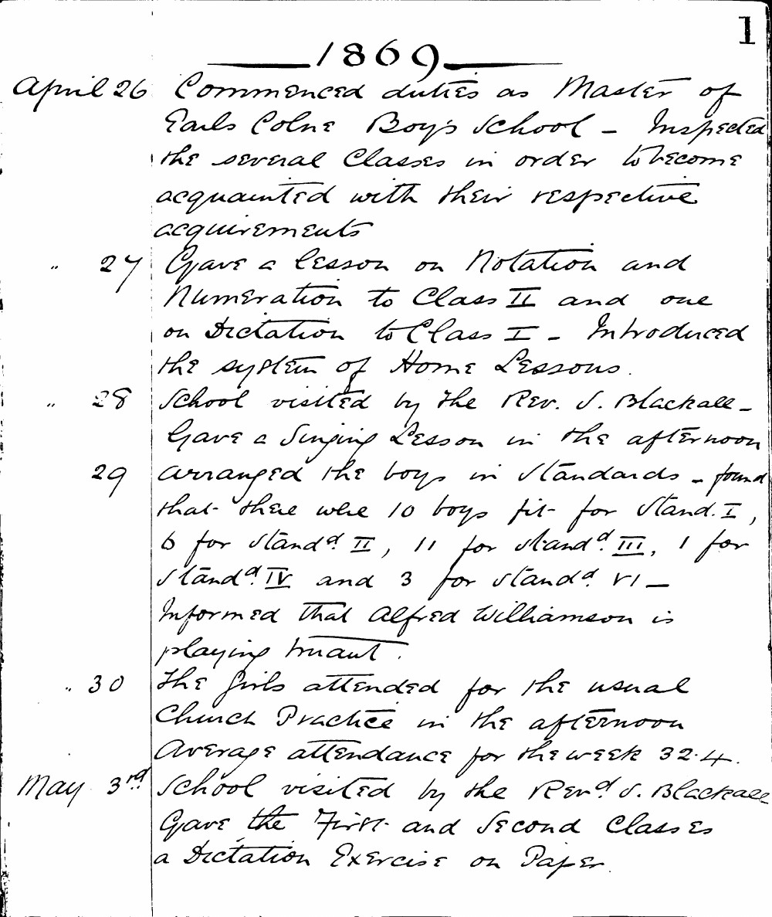

1
1869
April 26 Commenced duties as Master of Earls Colne Boy's School - Inspected the several Classes in order to become acquainted with their respective acquirements
" 27 Gave a lesson on Notation and Numeration to Class II and one on Dictation to Class I - Introduced the system of Home Lessons.
" 28 School visited by the Rev. S. Blackall - Gave a Singing Lesson in the afternoon
29 arranged the boys in Standards - found that there were 10 boys fit for Stand. I, 6 for Stand. II, 11 for Stand. III, 1 for Stand. IV and 3 for Stand. VI - Informed that Alfred Williamson is playing truant.
" 30 The girls attended for the usual Church Practice in the afternoon Average attendance for the week 32.4.
May 3rd School visited by the Revd S. Blackall Gave the First and Second Classes a Dictation Exercise on Paper.

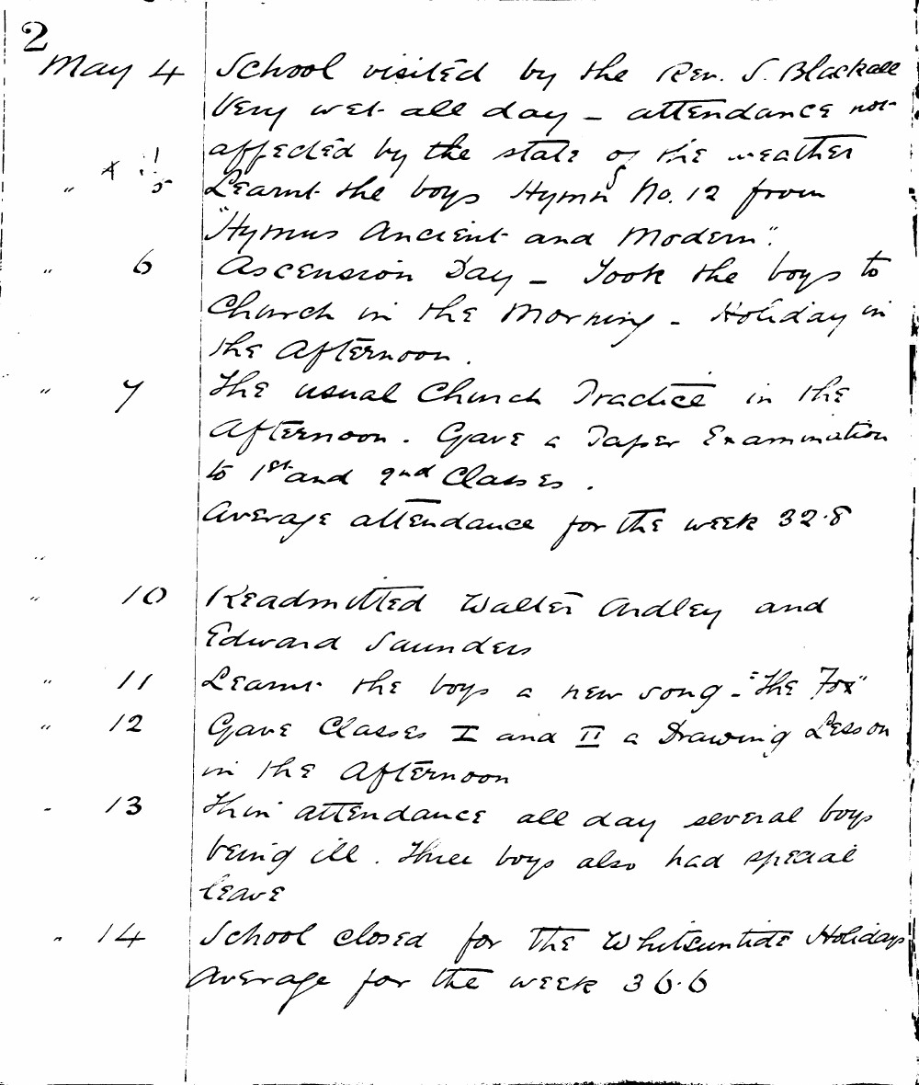

2
May 4 School visited by the Rev. S. Blackall Very wet all day - attendance not affected by the state of the weather
" 5 Learnt the boys Hymn No. 12 from "Hymns Ancient and Modern"
" 6 Ascension Day - Took the boys to Church in the Morning - Holiday in the Afternoon.
" 7 The usual Church Practice in the Afternoon. Gave a Paper Examination to 1st and 2nd Classes.
Average attendance for the week 32.8
" 10 Readmitted Walter Ardley and Edward Saunders
" 11 Learnt the boys a new song - "The Fox"
" 12 Gave Classes I and II a Drawing Lesson in the Afternoon
" 13 Thin attendance all day several boys being ill. Three boys also had special leave
" 14 School closed for the Whitsuntide Holiday Average for the week 36.6

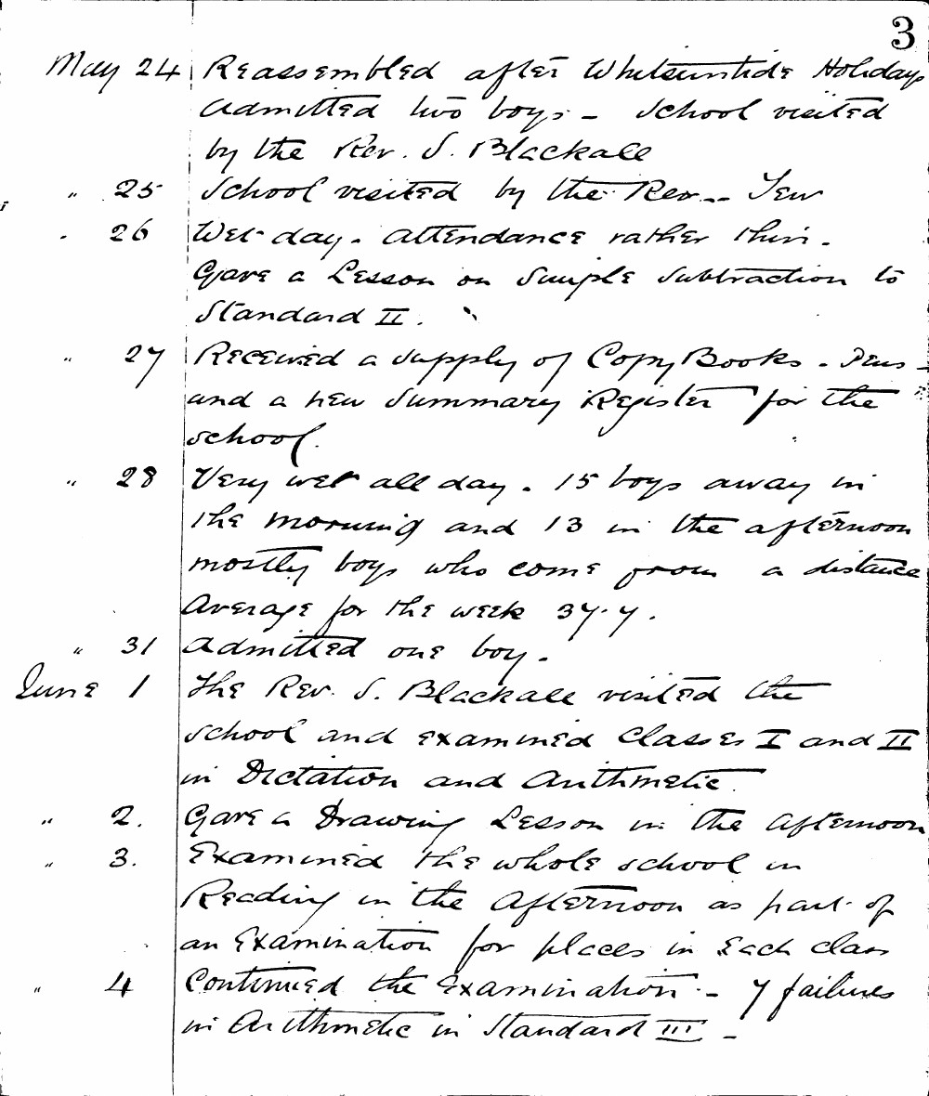

3
May 24 Reassembled after Whitsuntide Holiday, admitted two boys. School visited by the Rev. S. Blackall
" 25 School visited by the Rev. J. Tew
" 26 Wednesday. Attendance rather thin. Gave a Lesson on Simple Subtraction to Standard II.
" 27 Received a supply of Copy Books. Pens and a new Summary Register for the school.
" 28 Very wet all day. 15 boys away in the morning and 13 in the afternoon, mostly boys who come from a distance. Average for the week 37.7.
" 31 Admitted one boy.
June 1 The Rev. S. Blackall visited the school and examined Classes I and II in Dictation and Arithmetic.
" 2. Gave a Drawing Lesson in the afternoon.
" 3. Examined the whole school in Reading in the afternoon as part of an Examination for places in each class.
" 4 Continued the examination. 7 failures in Arithmetic in Standard III.

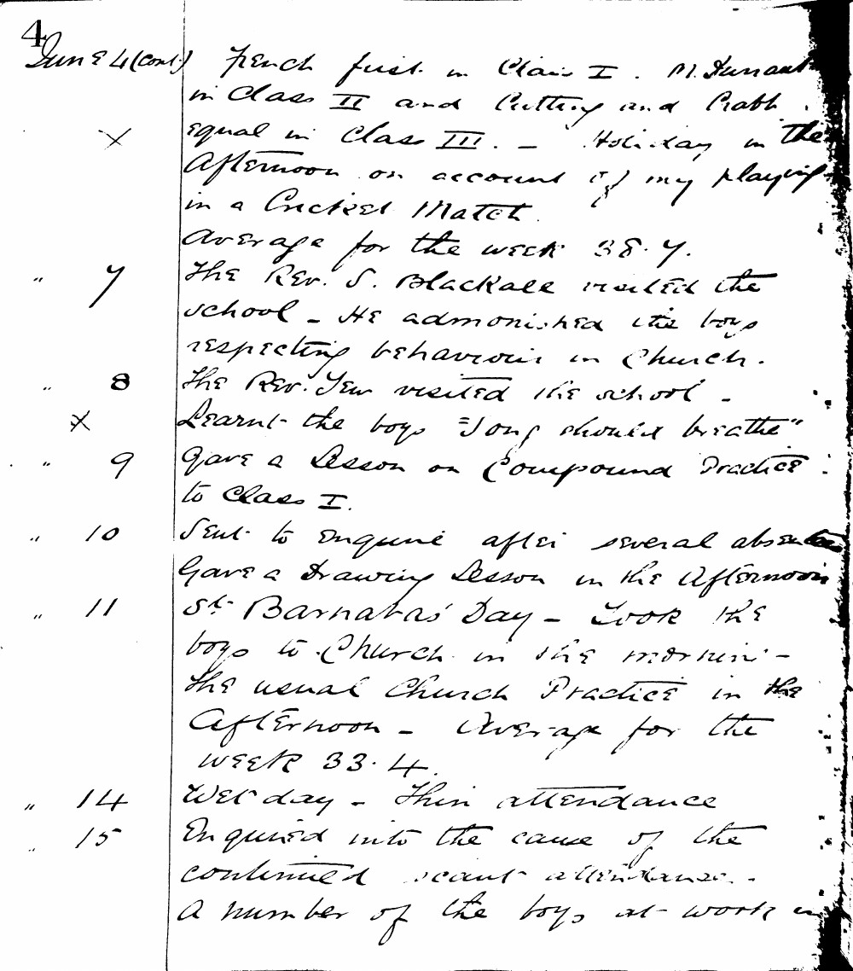

4 June 4 (cont.) French first in Class I. M. Durant in Class II and Cutting and Pratt equal in Class III. - Holiday in the Afternoon on account of my playing in a Cricket Match.
Average for the week 38.7.
- [x] 7 The Rev. S. Blackall visited the school - He admonished the boys respecting behaviour in Church.
" 8 The Rev. Yew visited the school -
- [x] Learnt the boys "Song should breathe"
" 9 Gave a lesson on Compound Practice to Class I.
" 10 Sent to enquire after several absent. Gave a Drawing Lesson in the Afternoon.
" 11 St. Barnabas' Day - Took the boys to Church in the morning - The usual Church Practice in the Afternoon - Average for the week 33.4.
" 14 Wet day - Thin attendance
" 15 Enquired into the cause of the continued scant attendance - A number of the boys at work

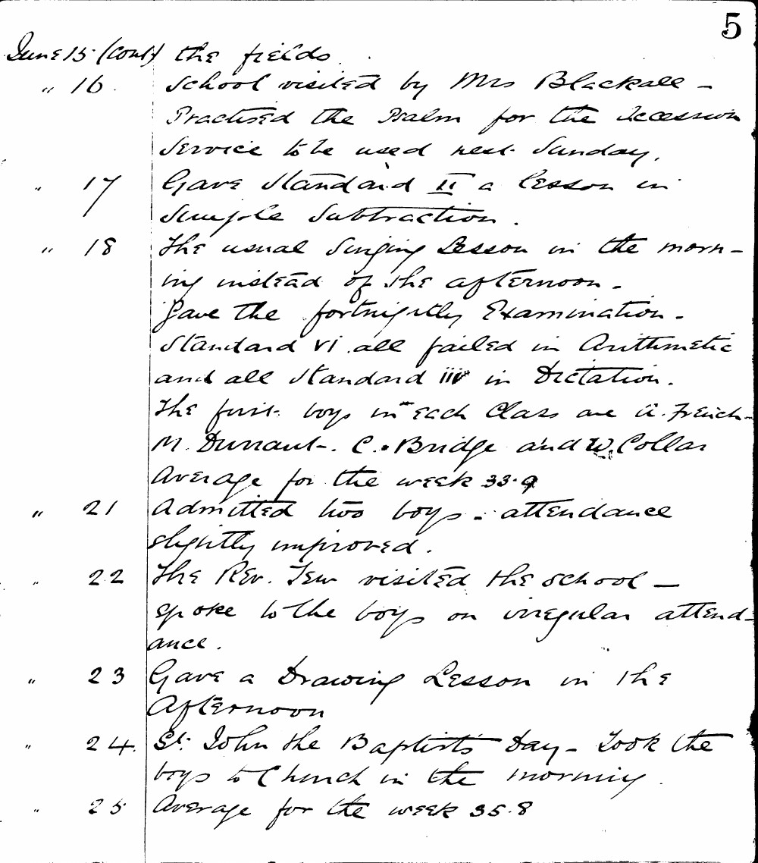

5
June 15 (cont) the fields.
" 16. School visited by Mrs Blackall - Practised the Psalm for the Accession Service to be used next Sunday.
" 17 Gave Standard II a lesson in Simple Subtraction.
" 18 The usual Singing Lesson in the morning instead of the afternoon. Gave the fortnightly Examination. Standard VI all failed in Arithmetic and all Standard III in Dictation. The first boys in each class are A. French M. Dunant - C. Bridge and W. Collar Average for the week 33.9
" 21 Admitted two boys - attendance slightly improved.
" 22 The Rev. Tew visited the school - spoke to the boys on irregular attendance.
" 23 Gave a Drawing Lesson in the Afternoon
" 24 St. John the Baptists day - Took the boys to Church in the morning.
" 25 Average for the week 35.8

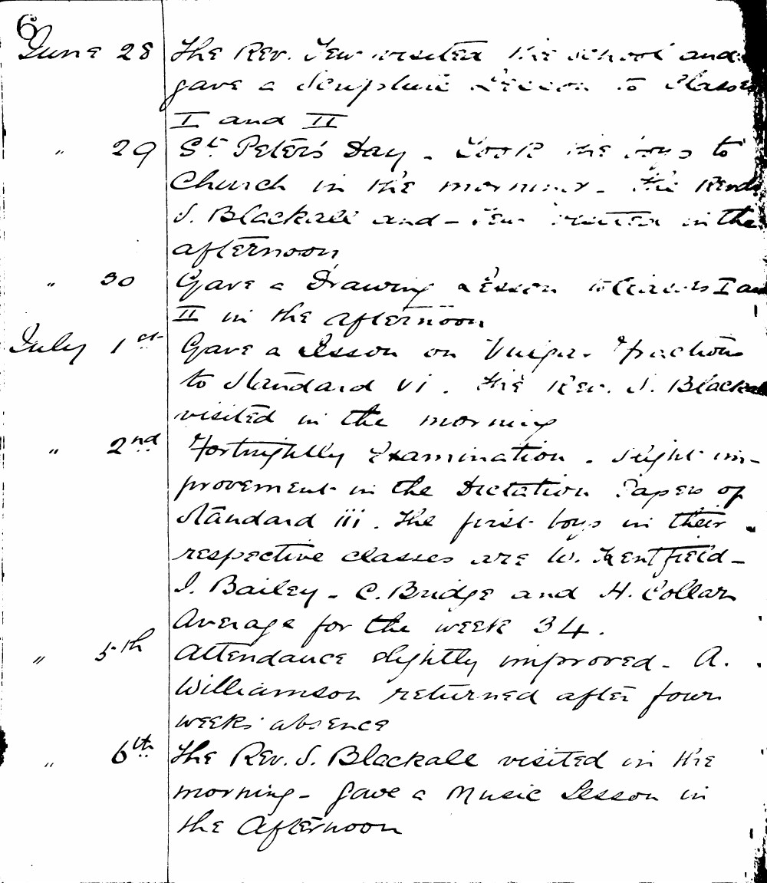

June 28 The Rev. New visited the school and gave a scripture lesson to Classes I and II
" 29 St. Peter's Day. Took the boys to Church in the morning. The Rev. J. Blackall and Rev. New visited in the afternoon
" 30 Gave a Drawing lesson to Classes I and II in the afternoon.
July 1st Gave a lesson on Vulgar Fractions to Standard VI. The Rev. J. Blackall visited in the morning
" 2nd Fortnightly Examination. Slight improvement in the Dictation Papers of Standard III. The first boys in their respective classes are W. Kentfield - J. Bailey - C. Bridge and H. Collar Average for the week 34.
" 5th Attendance slightly improved. A. Williamson returned after four weeks absence
" 6th The Rev. J. Blackall visited in the morning - gave a Music Lesson in the Afternoon

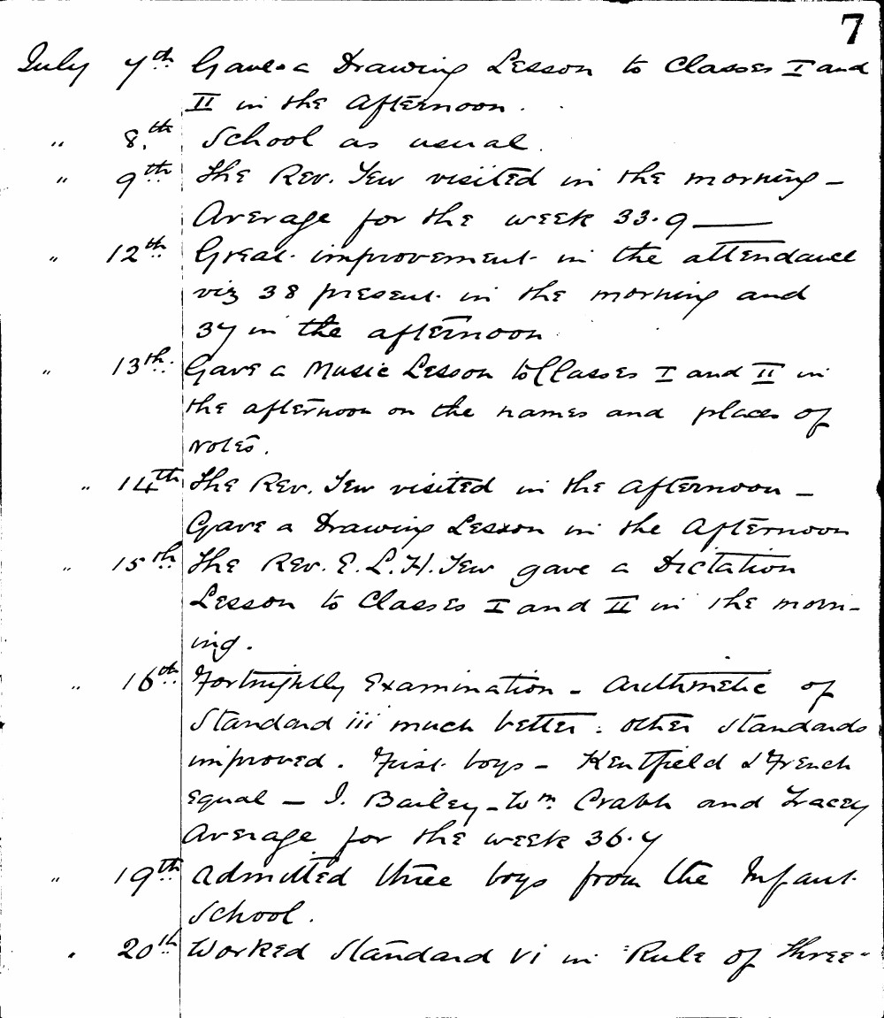

7
July 7th Gave a Drawing Lesson to Classes I and II in the afternoon.
" 8th School as usual.
" 9th The Rev. Tew visited in the morning - Average for the week 33.9
" 12th Great improvement in the attendance viz 38 present in the morning and 37 in the afternoon.
" 13th Gave a Music Lesson to Classes I and II in the afternoon on the names and places of notes.
" 14th The Rev. Tew visited in the afternoon - Gave a Drawing Lesson in the afternoon.
" 15th The Rev. E. L. H. Tew gave a Dictation Lesson to Classes I and II in the morning.
" 16th Fortnightly Examination - Arithmetic of Standard iii much better: other standards improved. First boys - Kentfield & French equal - J. Bailey - W. Crabb and Lacey Average for the week 36.7
" 19th Admitted three boys from the Infant School.
" 20th Worked Standard vi in "Rule of Three"

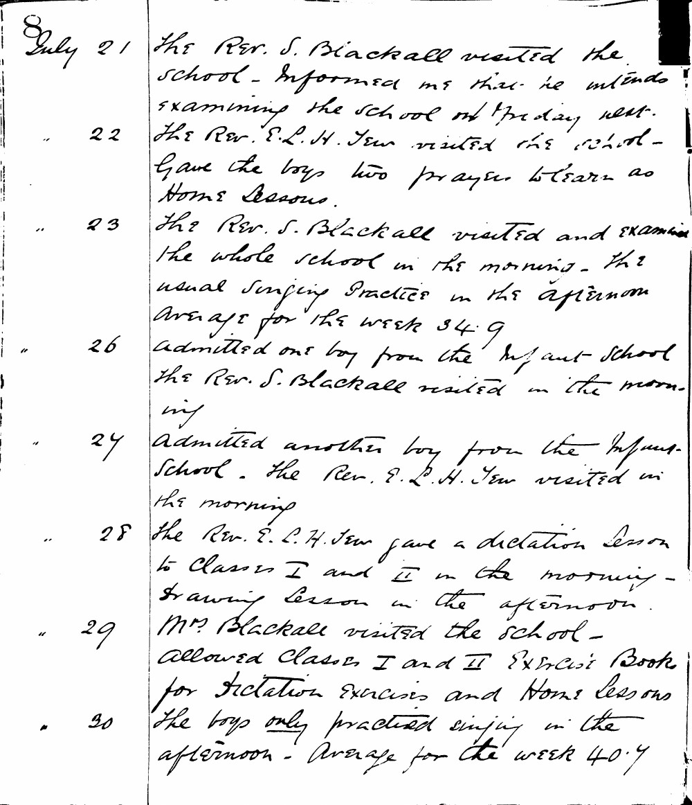

July 21 The Rev. S. Blackall visited the school - informed me that he intends examining the school on Friday next.
" 22 The Rev. E. L. H. Tew visited the school - Gave the boys two prayers to learn as Home Lessons.
" 23 The Rev. S. Blackall visited and examined the whole school in the morning. The usual singing practice in the afternoon Average for the week 34.9
" 26 Admitted one boy from the Infant School The Rev. S. Blackall visited in the morning
" 27 Admitted another boy from the Infant School. The Rev. E. L. H. Tew visited in the morning
" 28 The Rev. E. L. H. Tew gave a dictation lesson to Classes I and II in the morning - drawing lesson in the afternoon.
" 29 Mrs. Blackall visited the school - allowed Classes I and II Exercise Books for dictation exercises and Home lessons
" 30 The boys only practiced singing in the afternoon - Average for the week 40.7

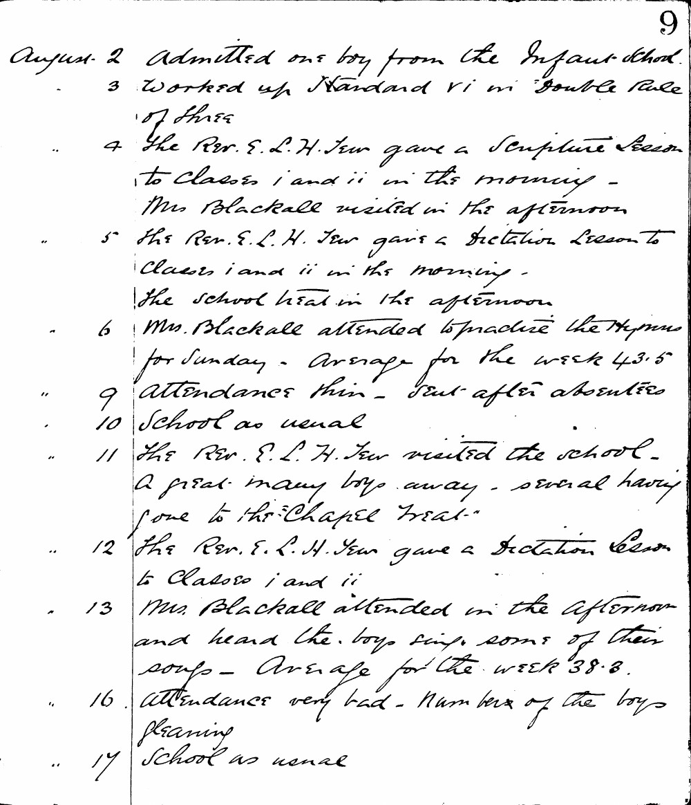

9
August 2 Admitted one boy from the Infant School.
3 Worked up Standard VI in "Double Rule of Three"
4 The Rev. E. L. H. Tew gave a Scripture Lesson to classes i and ii in the morning - Mrs Blackall visited in the afternoon
5 The Rev. E. L. H. Tew gave a Dictation Lesson to classes i and ii in the morning - The school heat in the afternoon
6 Mrs. Blackall attended to practice the Hymns for Sunday. Average for the week 43.5
9 Attendance thin - Sent after absentees
10 School as usual
11 The Rev. E. L. H. Tew visited the school. A great many boys away - several having gone to the "Chapel Treat."
12 The Rev. E. L. H. Tew gave a Dictation Lesson to classes i and ii
13 Mrs. Blackall attended in the afternoon and heard the boys sing some of their songs - Average for the week 38.3
16 Attendance very bad - Numbers of the boys gleaning
17 School as usual

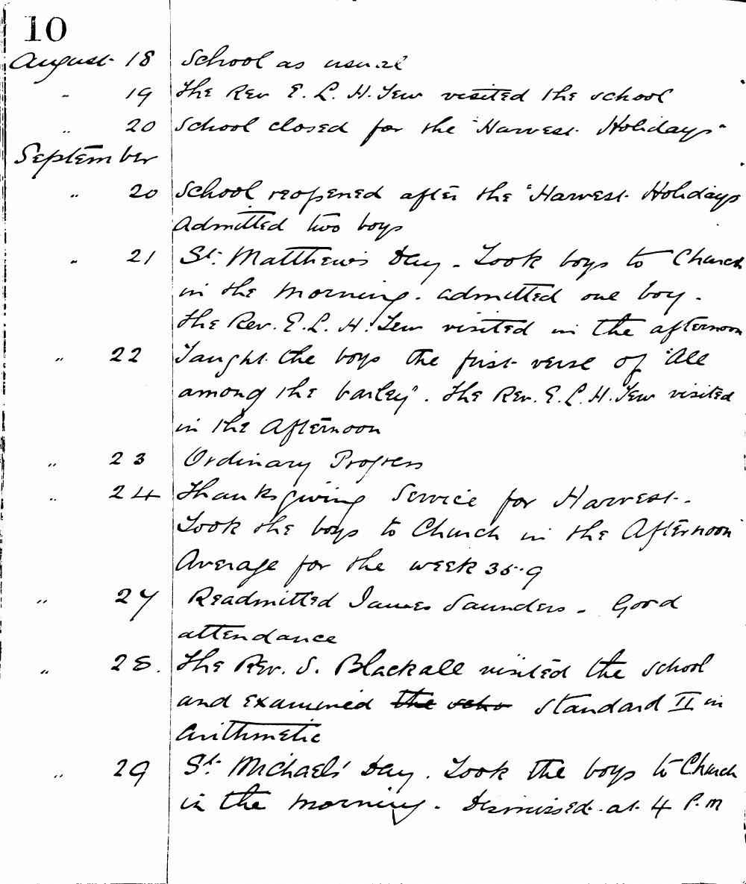

10
August 18 School as usual
- 19 The Rev. E. L. H. Tew visited the school
- 20 School closed for the "Harvest Holidays"
September
- 20 School reopened after the "Harvest Holidays" Admitted two boys
- 21 St. Matthew's Day. Took boys to Church in the morning. admitted one boy. The Rev. E. L. H. Tew visited in the afternoon
- 22 Taught the boys the first verse of "All among the barley". The Rev. E. L. H. Tew visited in the afternoon
- 23 Ordinary Progress
- 24 Thanksgiving Service for Harvest. Took the boys to Church in the afternoon Average for the week 35.9
- 27 Readmitted James Saunders. Good attendance
- 28 The Rev. S. Blackall visited the school and examined the standard II in Arithmetic
- 29 St. Michael's Day. Took the boys to Church in the morning. Dismissed at 4 P.M

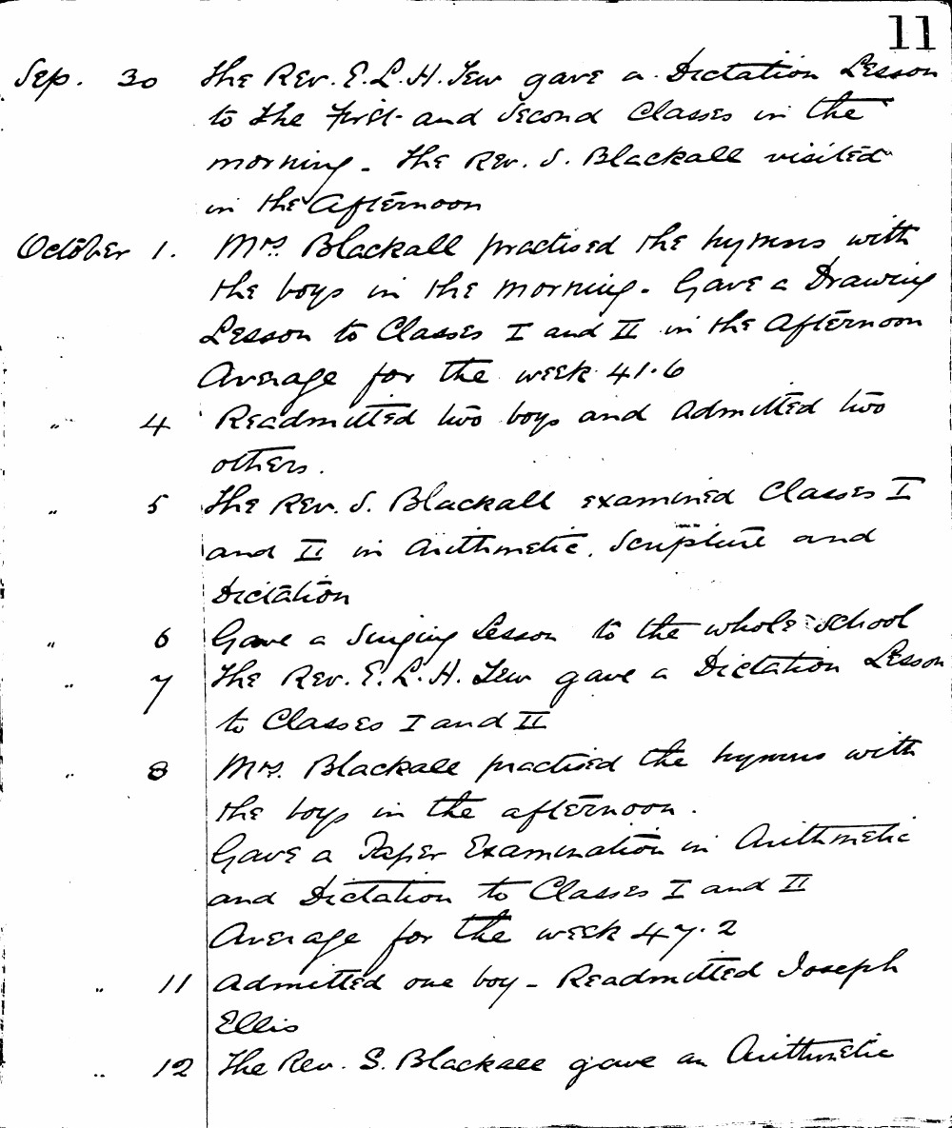

11
Sep. 30 The Rev. E. L. H. Tew gave a Dictation Lesson to the First and Second Classes in the morning. The Rev. S. Blackall visited in the afternoon
October 1. Mrs. Blackall practised the hymns with the boys in the morning. Gave a Drawing Lesson to Classes I and II in the afternoon Average for the week 41.6
" 4 Readmitted two boys and Admitted two others.
" 5 The Rev. S. Blackall examined Classes I and II in Arithmetic, Scripture and Dictation
" 6 Gave a Singing lesson to the whole school
" 7 The Rev. E. L. H. Tew gave a Dictation Lesson to Classes I and II
" 8 Mrs. Blackall practised the hymns with the boys in the afternoon. Gave a Paper Examination in Arithmetic and Dictation to Classes I and II Average for the week 47.2
" 11 Admitted one boy - Readmitted Joseph Ellis
" 12 The Rev. S. Blackall gave an Arithmetic

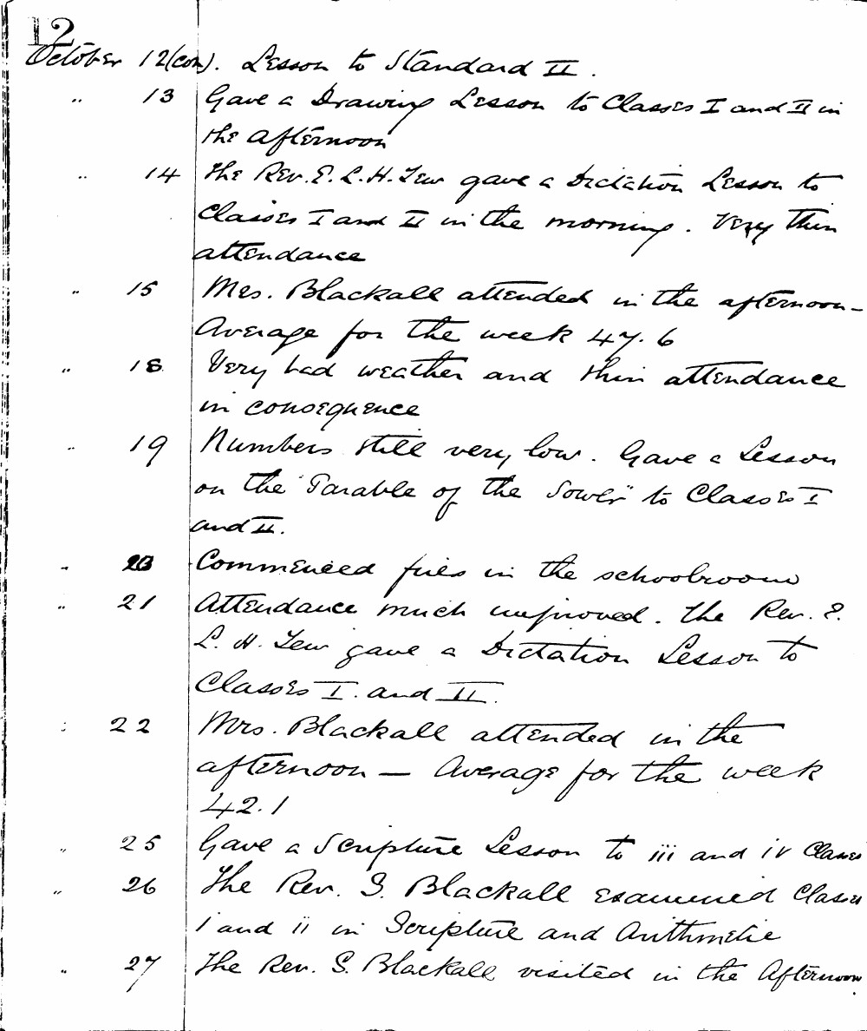

October 12(con). Lesson to Standard II .
.. 13 Gave a Drawing Lesson to Classes I and II in the afternoon
.. 14 The Rev. E. L. H. Tew gave a Dictation Lesson to Classes I and II in the morning. Very thin attendance
.. 15 Mrs. Blackall attended in the afternoon. Average for the week 47.6
.. 18 Very bad weather and thin attendance in consequence
.. 19 Numbers still very low. Gave a Lesson on the "Parable of the Sower" to Classes I and II.
.. 20 Commenced fires in the schoolroom
.. 21 Attendance much improved. the Rev. E. L. H. Tew gave a Dictation Lesson to Classes I and II.
: 22 Mrs. Blackall attended in the afternoon - Average for the week 42.1
" 25 Gave a Scripture Lesson to iii and iv Classes
" 26 The Rev. S. Blackall examined Classes i and ii in Scripture and Arithmetic
" 27 The Rev. S. Blackall visited in the Afternoon

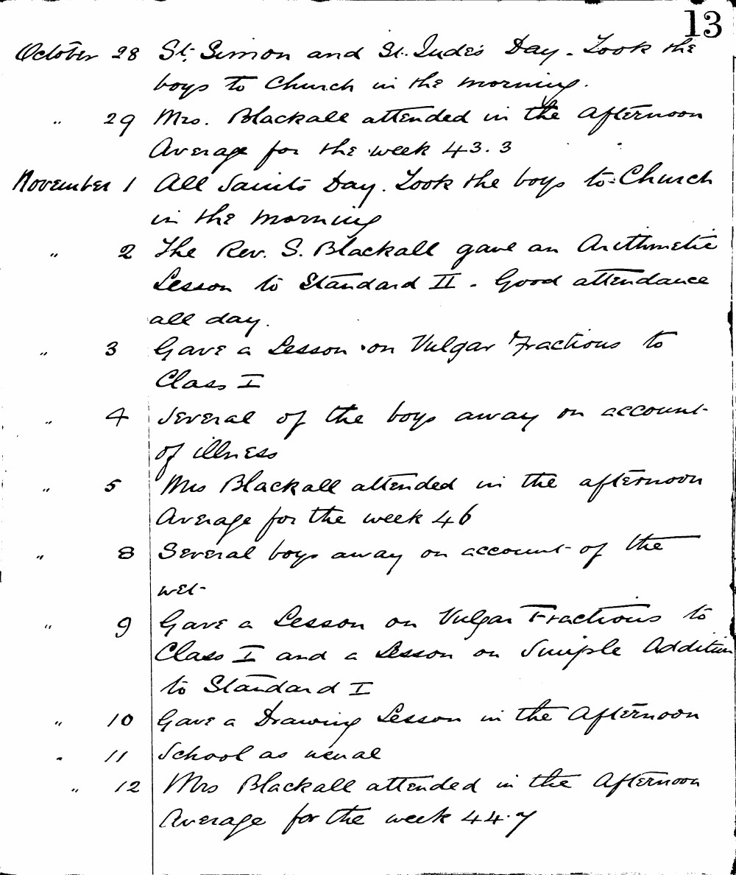

13
October 28 St. Simon and St. Jude's Day. Took the boys to Church in the morning.
" 29 Mrs. Blackall attended in the afternoon Average for the week 43.3
November 1 All Saints Day. Took the boys to Church in the morning.
" 2 The Rev. S. Blackall gave an Arithmetic Lesson to Standard II. Good attendance all day.
" 3 Gave a Lesson on Vulgar Fractions to Class I
" 4 Several of the boys away on account of illness
" 5 Mrs Blackall attended in the afternoon Average for the week 46
" 8 Several boys away on account of the wet-
" 9 Gave a Lesson on Vulgar Fractions to Class I and a Lesson on Simple Addition to Standard I
" 10 Gave a Drawing Lesson in the Afternoon
" 11 School as usual
" 12 Mrs Blackall attended in the Afternoon Average for the week 44.7

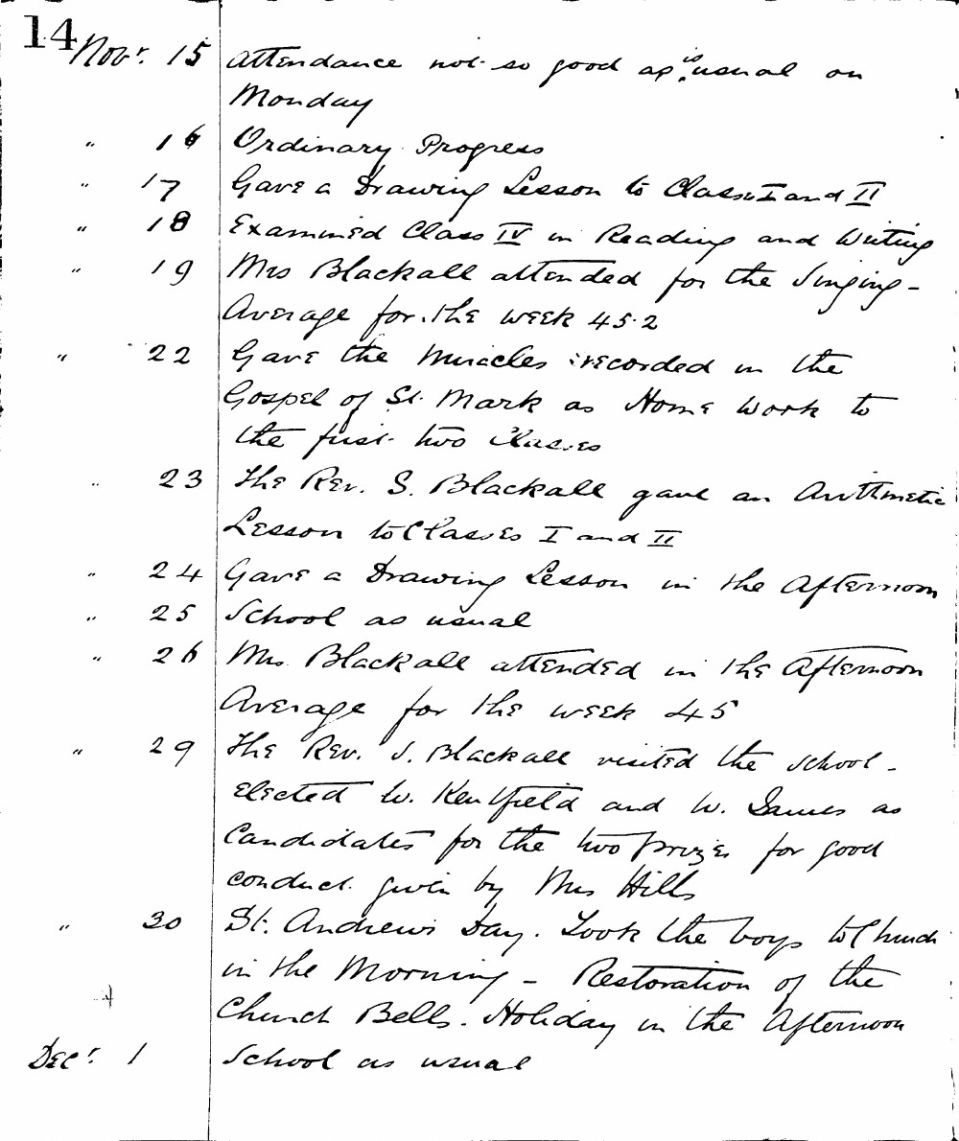

14 Nov: 15 Attendance not so good as usual on Monday
" 16 Ordinary Progress
" 17 Gave a Drawing Lesson to Class I and II
" 18 Examined Class IV in Reading and Writing
" 19 Mrs Blackall attended for the Singing - Average for the week 45.2
" 22 Gave the miracles recorded in the Gospel of St. Mark as Home Work to the first two classes
" 23 The Rev. S. Blackall gave an Arithmetic Lesson to Classes I and II
" 24 Gave a Drawing lesson in the Afternoon
" 25 School as usual
" 26 Mrs. Blackall attended in the Afternoon Average for the week 45
" 29 The Rev. S. Blackall visited the school. Elected W. Kenfield and W. James as Candidates for the two prizes for good conduct given by Mrs Hill
" 30 St. Andrews Day. Took the boys to Church in the Morning - Restoration of the Church Bells. Holiday in the Afternoon
Dec: 1 School as usual

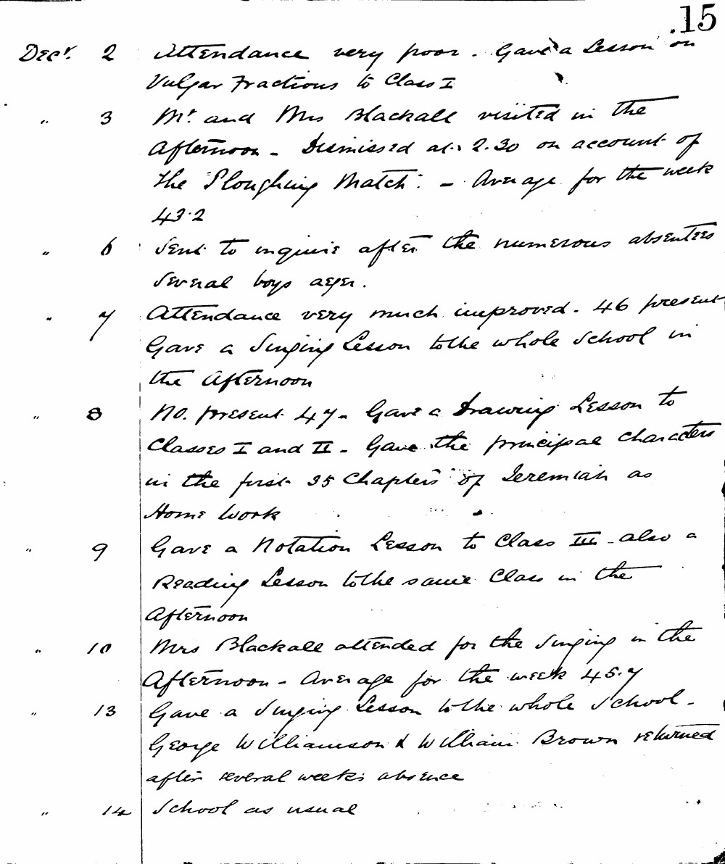

.15
Decr 2 Attendance very poor. Gave a lesson on Vulgar Fractions to Class I
" 3 Mr and Mrs Blackall visited in the afternoon. Dismissed at 2.30 on account of the Ploughing Match. - Average for the week 43.2
" 6 Sent to inquire after the numerous absentees several boys away.
" 7 Attendance very much improved. 46 present Gave a Singing Lesson to the whole school in the afternoon
" 8 No. present 47. Gave a Drawing Lesson to Classes I and II. - Gave the principal characters in the first 35 chapters of Jeremiah as Home Work
" 9 Gave a Notation Lesson to Class III - also a Reading Lesson to the same class in the afternoon
" 10 Mrs Blackall attended for the singing in the afternoon - Average for the week 45.7
" 13 Gave a Singing Lesson to the whole school. George Williamson & William Brown returned after several weeks absence
" 14 School as usual

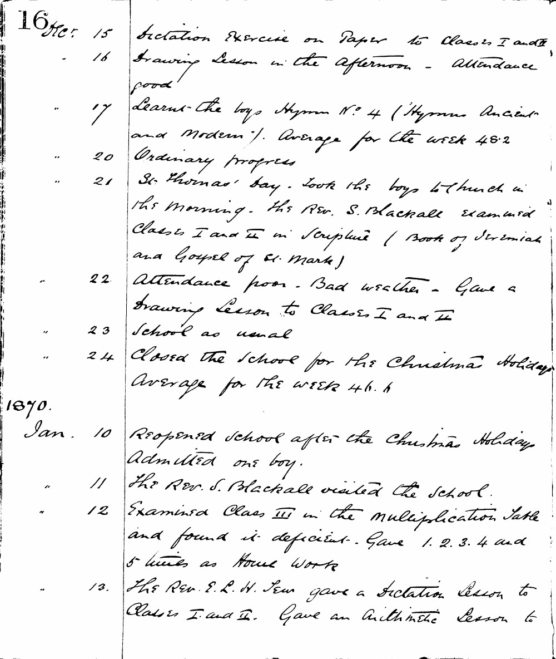

16 Dec. 15 Dictation Exercise on Paper to Classes I and II
. 16 Drawing Lesson in the afternoon - Attendance good
" 17 Learnt the boys Hymn No. 4 ("Hymns Ancient and Modern"). Average for the week 48.2
" 20 Ordinary progress
" 21 St. Thomas' Day. Took the boys to Church in the morning. The Rev. S. Blackall examined Classes I and II in Scripture (Book of Jeremiah and Gospel of St. Mark)
" 22 Attendance poor. Bad weather. Gave a Drawing Lesson to Classes I and II
" 23 School as usual
" 24 Closed the School for the Christmas Holidays Average for the week 46.4

Jan. 10 Reopened school after the Christmas Holidays Admitted one boy.
" 11 The Rev. S. Blackall visited the school.
" 12 Examined Class III in the multiplication table and found it deficient. Gave 1. 2. 3. 4 and 5 times as Home Work
" 13 The Rev. E. L. H. Tew gave a Dictation Lesson to Classes I and II. Gave an Arithmetic Lesson to

