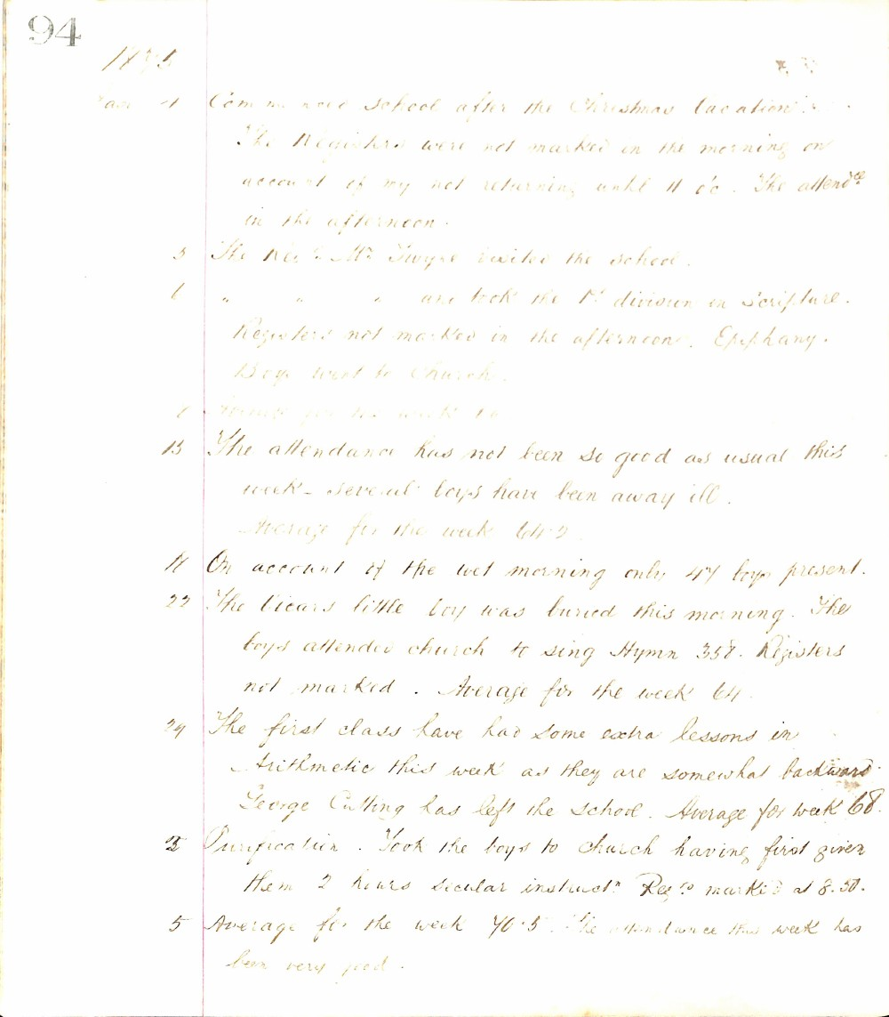

94
1895
Jan 4 Commenced School after the Christmas Vacation. The Registers were not marked in the morning on account of my not returning until 11 o'c. The attendance in the afternoon.
5 The Rev. & Mrs. Twyne visited the school.
6 " " " and took the 1st division in Scripture. Registers not marked in the afternoon. Epiphany. Boys went to Church.
7 Average for the week 66
13 The attendance has not been so good as usual this week - several boys have been away ill. Average for the week 64.2
14 On account of the wet morning only 47 boys present.
22 The Vicar's little boy was buried this morning. The boys attended church to sing Hymn 358. Registers not marked. Average for the week 64.
24 The first class have had some extra lessons in Arithmetic this week as they are somewhat backward. George Cutting has left the school. Average for week 68.
25 Purification. Took the boys to church having first given them 2 hours secular instructn. Regs marked at 8.30.
5 Average for the week 70.5. The attendance this week has been very good.

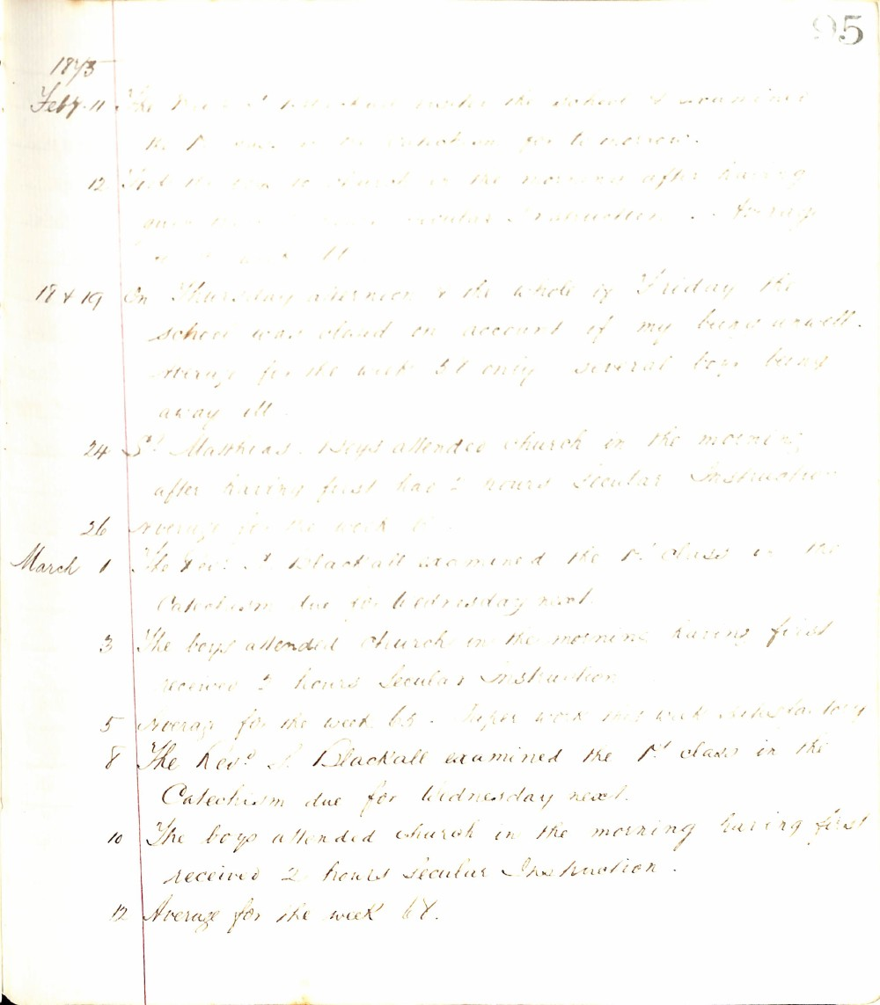

95
1873
Feby. 11 The Revd. J. Blackall visited the school & examined the 1st class in the Catechism for tomorrow.
12 The boys attended church in the morning after having given 2 hours secular instruction. Average for the week 61.
1874 19 On Thursday afternoon & the whole of Friday the school was closed on account of my being unwell. Average for the week 51 only several boys being away ill.
24 St. Matthias. Boys attended church in the morning after having first had 2 hours Secular Instruction.
26 Average for the week 61.
March 1 The Revd. J. Blackall examined the 1st class in the Catechism due for Wednesday next.
3 The boys attended church in the morning having first received 2 hours Secular Instruction.
5 Average for the week 65. Paper work this week satisfactory.
8 The Revd. J. Blackall examined the 1st class in the Catechism due for Wednesday next.
10 The boys attended church in the morning having first received 2 hours secular Instruction.
12 Average for the week 67.

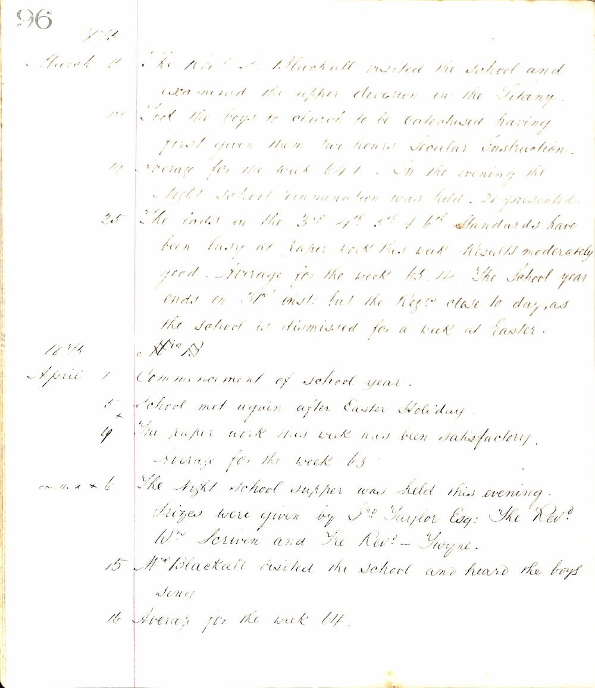

96
1875
March 11 The Rev. J. Blackall visited the school and examined the upper division in the Litany.
12 Took the boys to church to be catechised having first given them two hours Secular Instruction.
19 Average for the week 64.1. In the evening the Night School Examination was held. 21 presented.
25 The lads in the 3rd 4th 5th & 6th Standards have been busy at paper work this week. Results moderately good. Average for the week 65.14. The school year ends on 31st inst: but the Regrs close today, as the school is dismissed for a week at Easter.
1875
April 1 Commencement of school year.
5 School met again after Easter Holiday.
9 The paper work this week has been satisfactory. Average for the week 65
12 The Night School supper was held this evening. Prizes were given by Jno Taylor Esq: The Rev. W. Scriven and the Rev. Gwynne.
15 Mr. Blackall visited the school and heard the boys sing.
16 Average for the week 64.

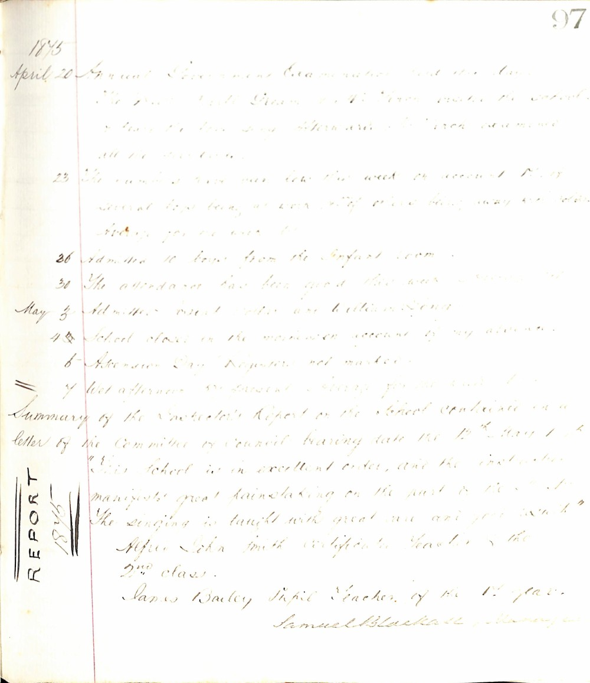

97
1875
April 20 Annual Government Examination held this day.
The Rev. J. W. Green & Mr. Green visited the school & heard the boys sing afterwards. Mr. Green examined all the classes.
23 The numbers have been low this week on account of several boys being at work & others being away with colds. Average for the week 61.
26 Admitted 10 boys from the Infant room.
30 The attendance has been good this week. Average 81.
May 3 Admitted Ernest Potter and William Long.
4 School closed in the afternoon on account of my absence.
6 Ascension Day. Registers not marked.
7 Wet afternoon. 50 present. Average for the week 80.
Summary of the Inspector's Report on the School contained in a letter of the Committee of Council bearing date the 12th May 1875
REPORT 1875
"This school is in excellent order, and the instruction manifests great painstaking on the part of the Master. The singing is taught with great care and good taste."
Alfred John Smith Certificate Teacher of the 2nd class.
James Bailey, Pupil Teacher, of the 1st year.
Samuel Blackall, Manager

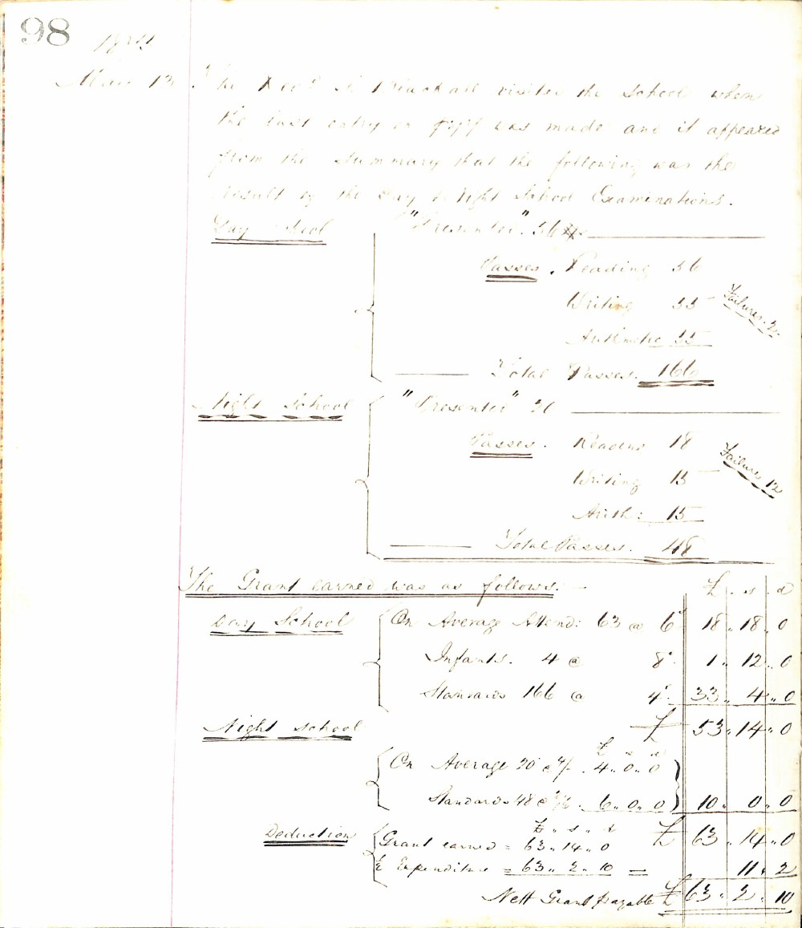

98
1874
May 13. The Rev. J. Blackall visited the school when the last entry on page 97 was made and it appeared from the summary that the following was the result of the Day & Night School Examinations.
Day School
"Presented" 54
Passes
Reading | 56
Writing | 55 | Failures 2
Arithmetic | 55
Total Passes | 166

Night School
"Presented" 20
Passes
Reading | 18
Writing | 15 | Failure 12
Arith: | 15
Total Passes | 48

The Grant earned was as follows:-
Day School |  |  | £ | s | d
 | On Average Attend: 63 @ 6/ | 18 | 18 | 0
 | Infants 4 @ 8/ | 1 | 12 | 0
 | Standards 166 @ 4/ | 33 | 4 | 0
Night School |  |  | 53 | 14 | 0
 | On Average 20 @ 4/ 4..0..0
 | Standards 48 @ 2/6 6..0..0 | 10 | 0 | 0
 |  | £ | 63 | 14 | 0
Deduction | Grant earned = 63..14..0
 | & Expenditure = 63..2..10 | = |  | 11 | 2
 | Nett Grant Payable | £ | 63 | 2 | 10

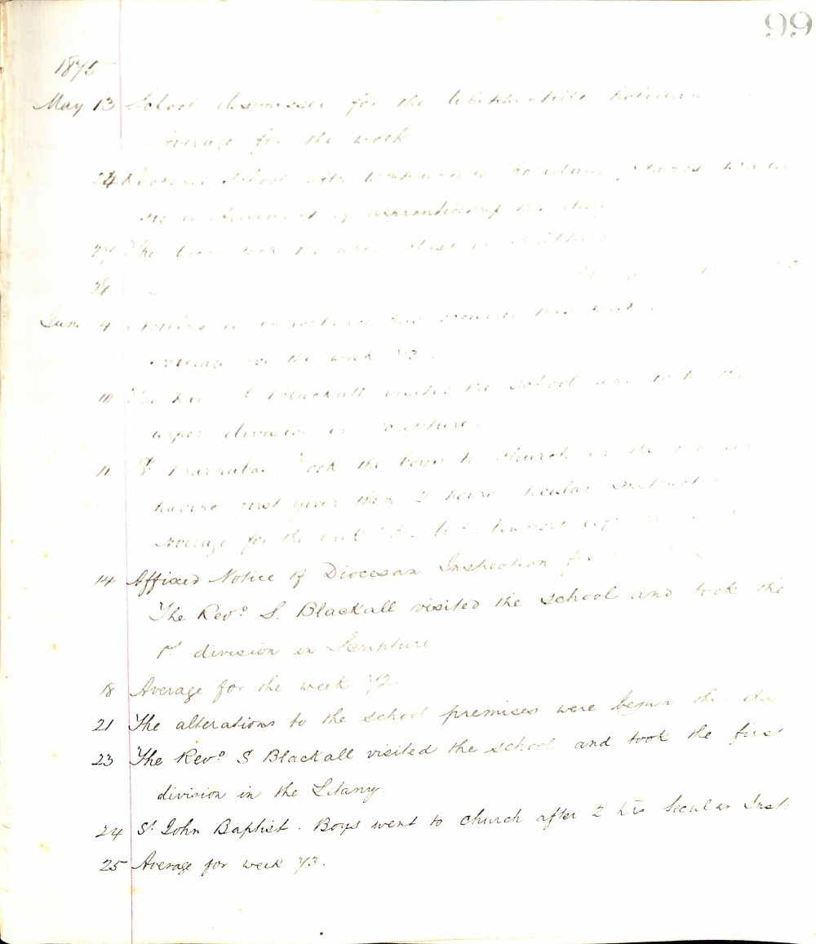

99
1875
May 13 School dismissed for the Whitsuntide holidays
Average for the week
24 Reopened school after Whitsuntide holidays. James Winter commenced his 1st year apprenticeship this day
27 The Revd took the upper class in Scripture
28 Average for the week
June 4 Nothing of importance has occurred this week
Average for the week 73
10 The Revd S Blackall visited the school and took the upper division in Scripture
11 St Barnabas. Took the boys to church in the morning having first given them 2 hours secular instruction
Average for the week 73. W. H. Harvest left
14 Affixed Notice of Diocesan Inspection for
The Revd S. Blackall visited the school and took the 1st division in Scripture
18 Average for the week 72
21 The alterations to the school premises were begun this day
23 The Revd S Blackall visited the school and took the first division in the Litany
24 St John Baptist. Boys went to church after 2 hrs secular Inst.
25 Average for week 73.

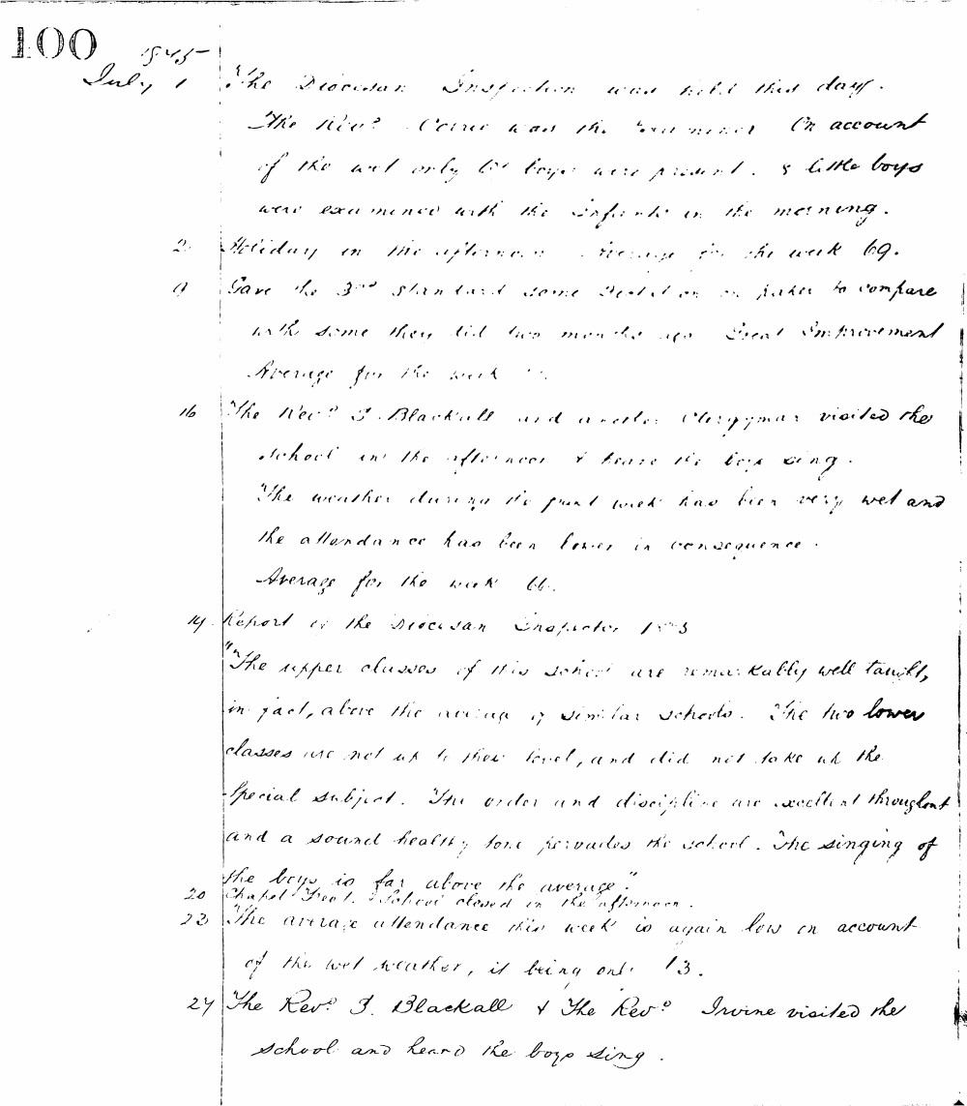

100
1875
July 1 The Diocesan Inspection was held this day. The Revd. Crane was the Examiner. On account of the wet only 65 boys were present. 8 little boys were examined with the Infants in the morning.
2 Holiday in the afternoon. Average for the week 69.
9 Gave the 3rd standard some Dictation on paper to compare with some they did two months ago. Great Improvement. Average for the week 72.
16 The Revd. S. Blackall and another Clergyman visited the school in the afternoon & heard the boys sing. The weather during the past week has been very wet and the attendance has been lower in consequence. Average for the week 66.
19 Report of the Diocesan Inspector 1875 "The upper classes of this school are remarkably well taught, in fact, above the average of similar schools. The two lower classes are not up to their level, and did not take up the special subject. The order and discipline are excellent throughout and a sound healthy tone pervades the school. The singing of the boys is far above the average."
20 Chapel Free School closed in the afternoon.
23 The average attendance this week is again low on account of the wet weather, it being only 73.
27 The Revd. S. Blackall & the Revd. Irvine visited the school and heard the boys sing.

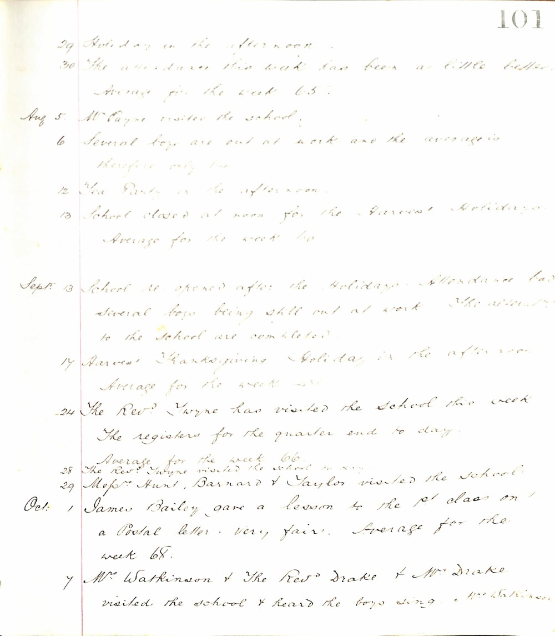

101
29 Holiday in the afternoon
30 The attendance this week has been a little better. Average for the week 65.
Aug 5. Mr Payne visited the school.
6 Several boys are out at work and the average is therefore only 60.
12 Tea Party in the afternoon.
13 School closed at noon for the Harvest Holidays. Average for the week 60
Sept. 13 School re-opened after the Holidays. Attendance bad several boys being still out at work. The alterations to the School are completed.
17 Harvest Thanksgiving Holiday in the afternoon. Average for the week 44
24 The Revd Twyne has visited the School this week. The registers for the quarter end to day. Average for the week 66.
28 The Revd Twyne visited the school to day.
29 Messrs Hunt, Barnard & Taylor visited the School.
Oct. 1 James Bailey gave a lesson to the 1st class on a Postal letter. Very fair. Average for the week 68.
7 Mr Watkinson & The Revd Drake & Mrs Drake visited the school & heard the boys sing. E. W. Watkinson

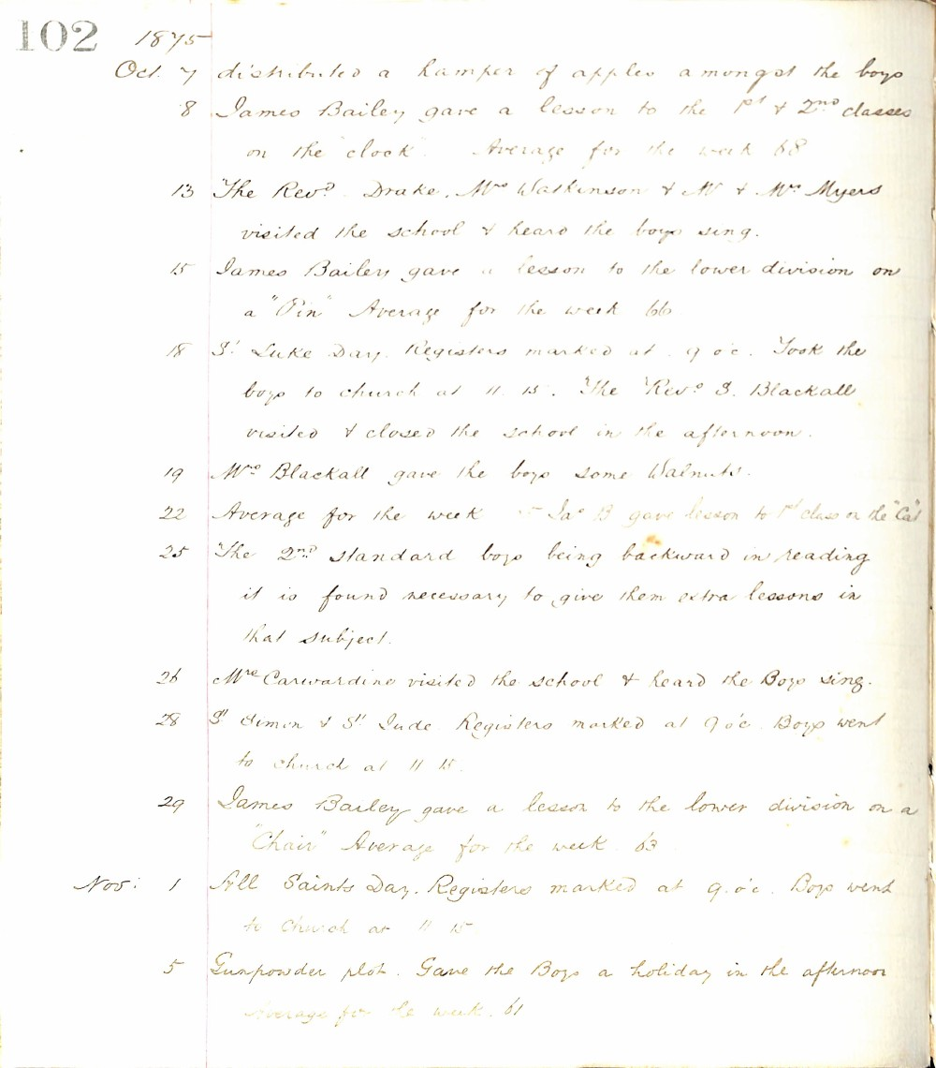

102 1875
Oct. 7 distributed a hamper of apples amongst the boys
8 James Bailey gave a lesson to the 1st & 2nd classes on the "clock". Average for the week 68
13 The Revd. Drake, Mrs Watkinson & Mr & Mrs Myers visited the school & heard the boys sing.
15 James Bailey gave a lesson to the lower division on a "Pin" Average for the week 66
18 St. Luke Day. Registers marked at 9 o'c. Took the boys to church at 11.15. The Revd. S. Blackall visited & closed the school in the afternoon.
19 Mrs Blackall gave the boys some Walnuts.
22 Average for the week - Jas B gave lesson to 1st class on the "Cat"
25 The 2nd Standard boys being backward in reading it is found necessary to give them extra lessons in that subject.
26 Mrs Carwardine visited the school & heard the Boys sing.
28 St Simon & St Jude. Registers marked at 9 o'c. Boys went to church at 11.15.
29 James Bailey gave a lesson to the lower division on a "Chair" Average for the week 63
Nov: 1 All Saints Day. Registers marked at 9.o'c. Boys went to Church at 11 15
5 Gunpowder plot. Gave the Boys a holiday in the afternoon Average for the week 61

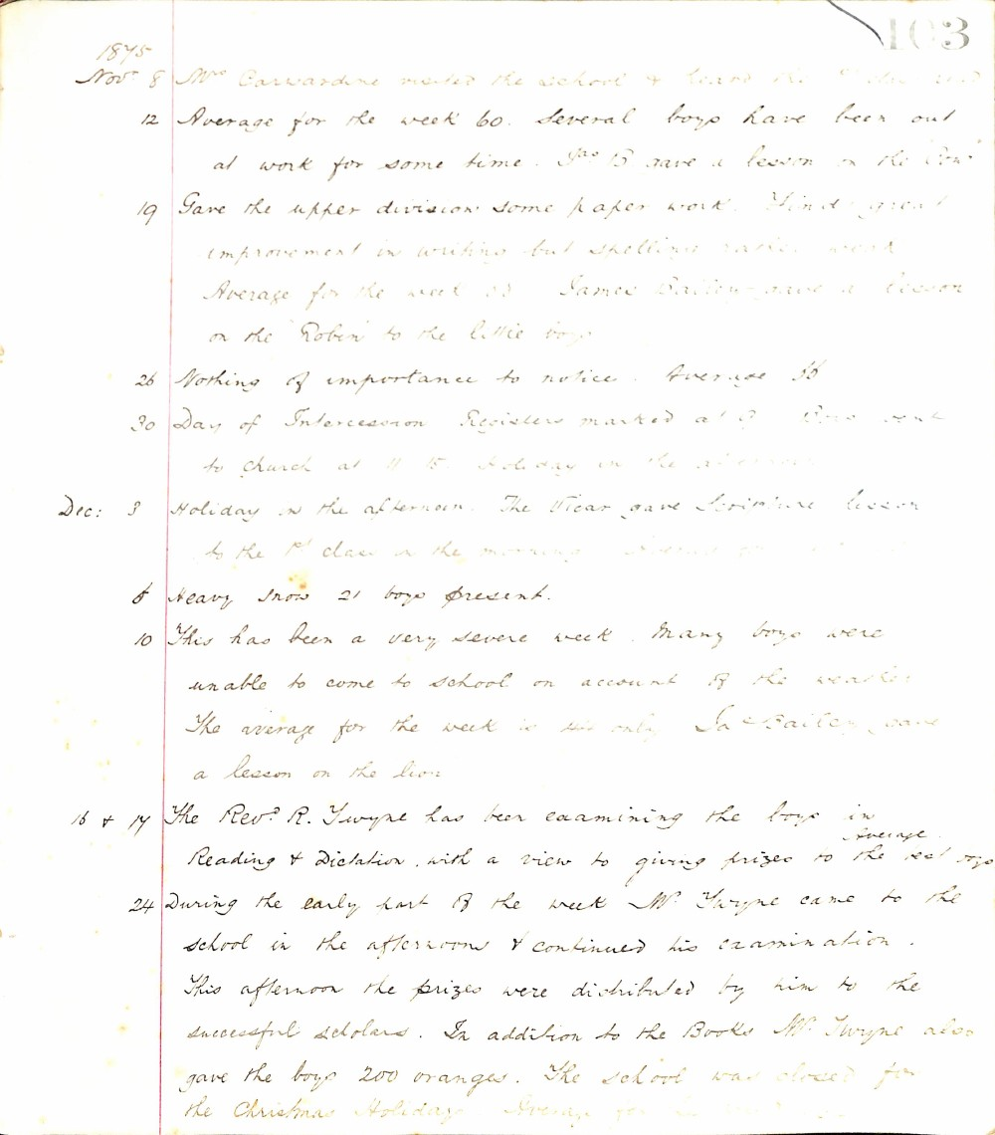

1875
Nov. 8 Mrs Carwardine visited the school & heard the 1st class read
12 Average for the week 60. Several boys have been out at work for some time. Jas B. gave a lesson on the 'Cow'
19 Gave the upper division some paper work. Find great improvement in writing but spelling rather weak. Average for the week 58. James Bailey gave a lesson on the 'Robin' to the little boys
26 Nothing of importance to notice. Average 56
30 Day of Intercession Registers marked at 9. Boys went to church at 11.15. Holiday in the afternoon
Dec: 3 Holiday in the afternoon. The Vicar gave Scripture lesson to the 1st class in the morning. Average 54
6 Heavy Snow 21 boys present.
10 This has been a very severe week. Many boys were unable to come to school on account of the weather. The average for the week is 44 only. Jas Bailey gave a lesson on the lion.
16 & 17 The Rev. R. Twype has been examining the boys in Reading & Dictation with a view to giving prizes to the best boys. Average 52
24 During the early part of the week Mr. Twype came to the school in the afternoon & continued his examination. This afternoon the prizes were distributed by him to the successful scholars. In addition to the Books Mr. Twype also gave the boys 200 oranges. The school was closed for the Christmas Holidays. Average for the week 50

