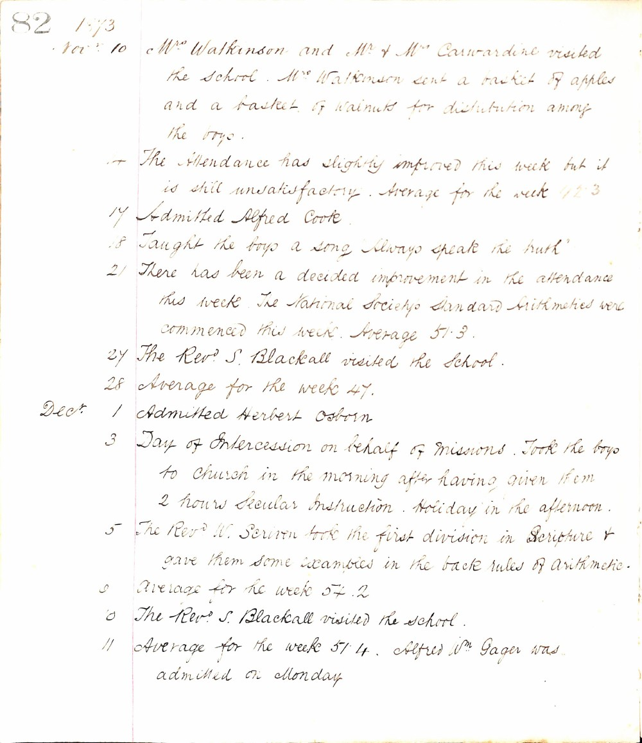

82 1873
Novr 10 Mrs Watkinson and Mr & Mrs Carwardine visited the school. Mrs Watkinson sent a basket of apples and a basket of walnuts for distribution among the boys.
14 The Attendance has slightly improved this week but it is still unsatisfactory. Average for the week 42.3
17 Admitted Alfred Cooke.
18 Taught the boys a song "Always speak the truth"
21 There has been a decided improvement in the attendance this week. The National Society's Standard Arithmetics were commenced this week. Average 51.3.
27 The Revd S. Blackall visited the school.
28 Average for the week 47.
Decr 1 Admitted Herbert Osborn
3 Day of Intercession on behalf of Missions. Took the boys to Church in the morning after having given them 2 hours Secular Instruction. Holiday in the afternoon.
5 The Revd W. Scriven took the first division in Scripture & gave them some examples in the back rules of Arithmetic.
9 Average for the week 54.2
10 The Revd S. Blackall visited the school.
11 Average for the week 51.4. Alfred Wm Gager was admitted on Monday.

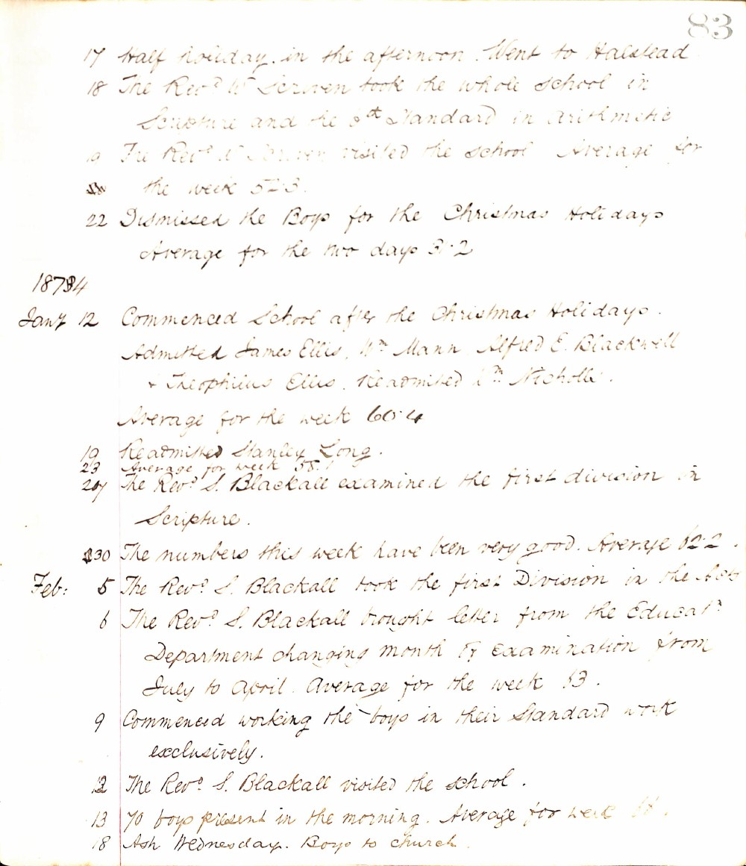

83
17 half holiday in the afternoon. Went to Halstead
18 The Revd W. Seriven took the whole school in Scripture and the 6th Standard in Arithmetic
19 The Revd W. Seriven visited the school. Average for the week 52.3.
22 Dismissed the Boys for the Christmas Holidays. Average for the two days 51.2
1878/4
Jany 12 Commenced School after the Christmas Holidays. Admitted James Ellis, Wm Mann, Alfred E. Blackwell & Theophilus Ellis. Readmitted Wm Nicholls. Average for the week 60.4
19 Readmitted Stanley Long.
23 Average for week 58.1
27 The Revd S. Blackall examined the first division in Scripture.
30 The numbers this week have been very good. Average 62.2
Feb: 5 The Revd S. Blackall took the first Division in the Acts
6 The Revd S. Blackall brought letter from the Educatn Department changing month of examination from July to April. Average for the week 63.
9 Commenced working the boys in their Standard work exclusively.
12 The Revd S. Blackall visited the school.
13 70 boys present in the morning. Average for week 61.
18 Ash Wednesday. Boys to church.

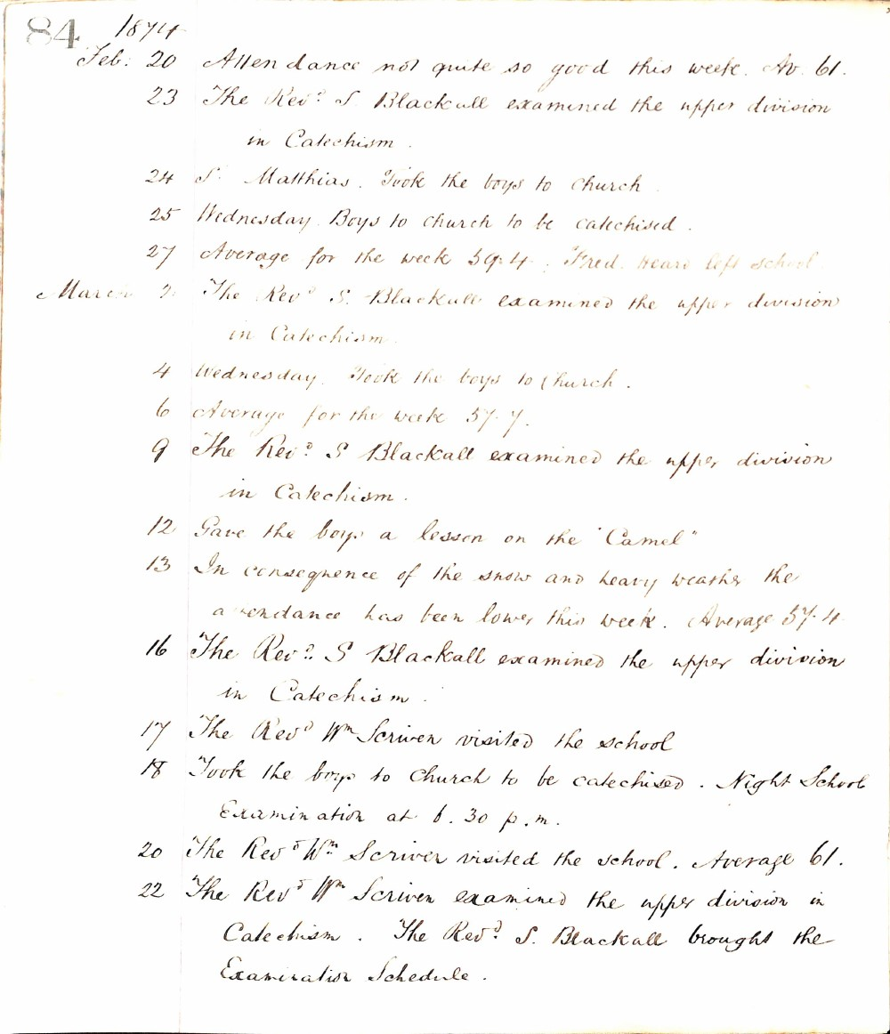

84 1874
Feb: 20 Attendance not quite so good this week. Av. 61.
23 The Revd. S. Blackall examined the upper division in Catechism.
24 St. Matthias. Took the boys to Church
25 Wednesday. Boys to church to be catechised.
27 Average for the week 59.4. Fred. Beard left school.
March 2 The Revd. S. Blackall examined the upper division in Catechism.
4 Wednesday. Took the boys to Church.
6 Average for the week 57.7.
9 The Revd. S. Blackall examined the upper division in Catechism.
12 Gave the boys a lesson on the "Camel"
13 In consequence of the snow and heavy weather the attendance has been lower this week. Average 57.4
16 The Revd. S Blackall examined the upper division in Catechism.
17 The Revd. Wm. Scriven visited the school
18 Took the boys to Church to be catechised. Night School Examination at 6.30 p.m.
20 The Revd. Wm. Scriven visited the school. Average 61.
22 The Revd. Wm. Scriven examined the upper division in Catechism. The Revd. S. Blackall brought the Examination Schedule.

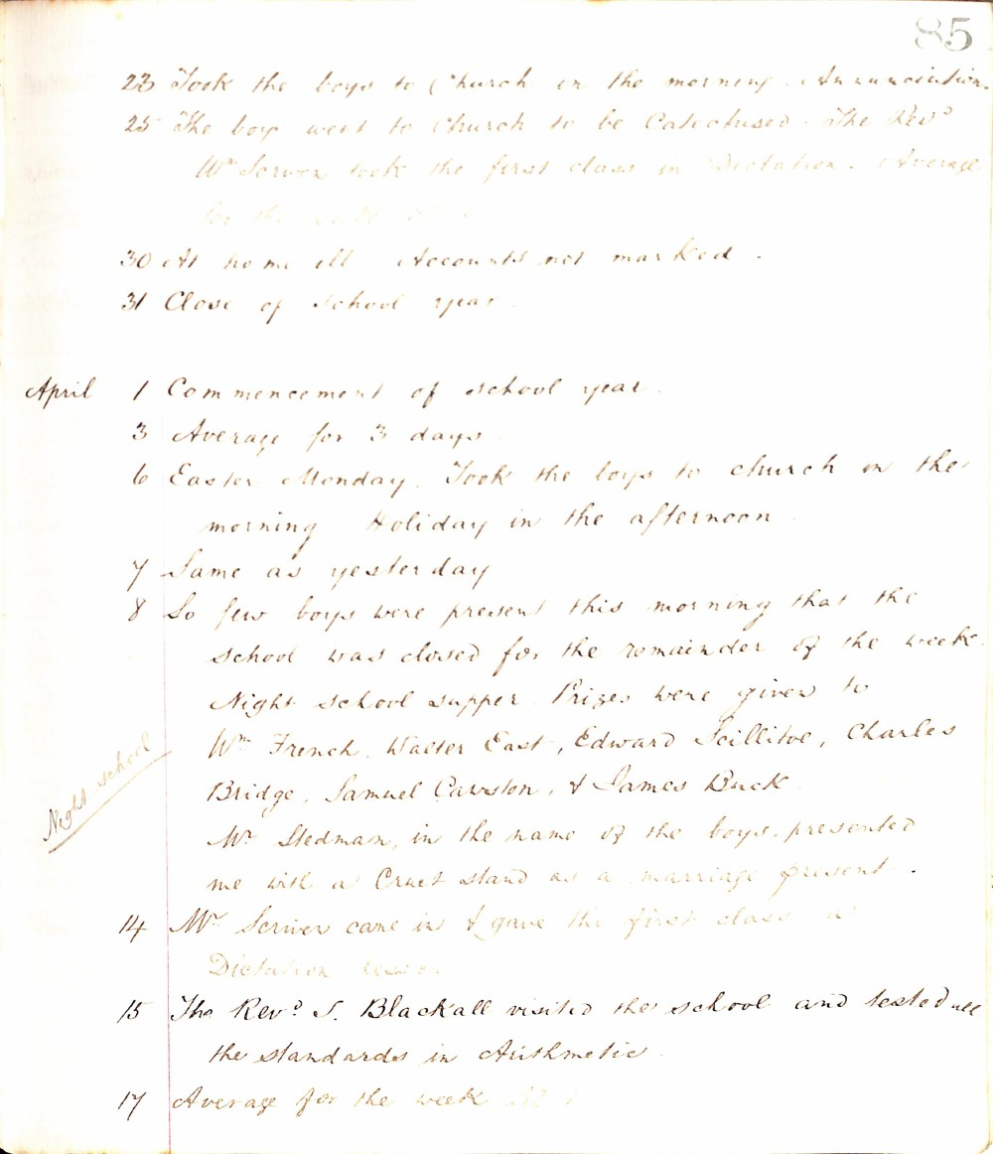

85
23 Took the boys to Church in the morning. Annunciation.
25 The boys went to Church to be Catechised. The Revd. Mr. Scriven took the first class in Dictation. Average for the week 51.5
30 At home ill. Accounts not marked.
31 Close of School year.
April 1 Commencement of school year.
3 Average for 3 days
6 Easter Monday. Took the boys to church in the morning. Holiday in the afternoon.
7 Same as yesterday
8 So few boys were present this morning that the school was closed for the remainder of the week. Night school supper. Prizes were given to Wm French, Walter East, Edward Scillitoe, Charles Bridge, Samuel Carston, & James Buck. Mr. Stedman, in the name of the boys, presented me with a Cruet stand as a marriage present.
Night school
14 Mr. Scriven came in & gave the first class a Dictation lesson
15 The Revd. J. Blackall visited the school and tested all the standards in Arithmetic.
17 Average for the week 52.1

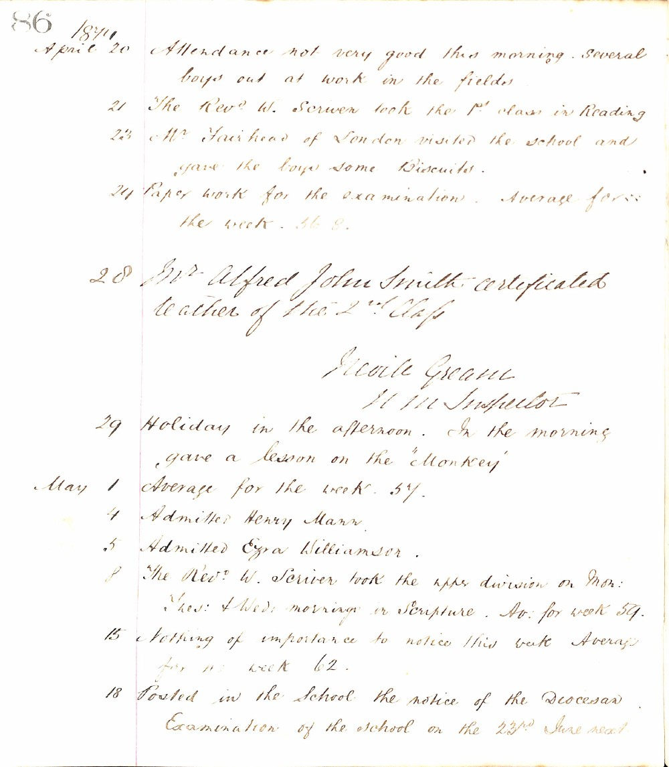

86 1874
April 20 Attendance not very good this morning. Several boys out at work in the fields.
21 The Revd W. Scriven took the 1st class in Reading
23 Mr Fairhead of London visited the school and gave the boys some Biscuits.
24 Paper work for the examination. Average for the week. 56.8.
28 Mr Alfred John Smith certificated teacher of the 2nd Class
Neville Greane
H M Inspector
29 Holiday in the afternoon. In the morning gave a lesson on the 'Monkey'
May 1 Average for the week. 57.
4 Admitted Henry Mann.
5 Admitted Ezra Williamson.
8 The Revd W. Scriven took the upper division on Mon: Tues: & Wed: mornings in Scripture. Av: for week 59.
15 Nothing of importance to notice this week Average for week 62.
18 Posted in the school the notice of the Diocesan Examination of the school on the 23rd June next.

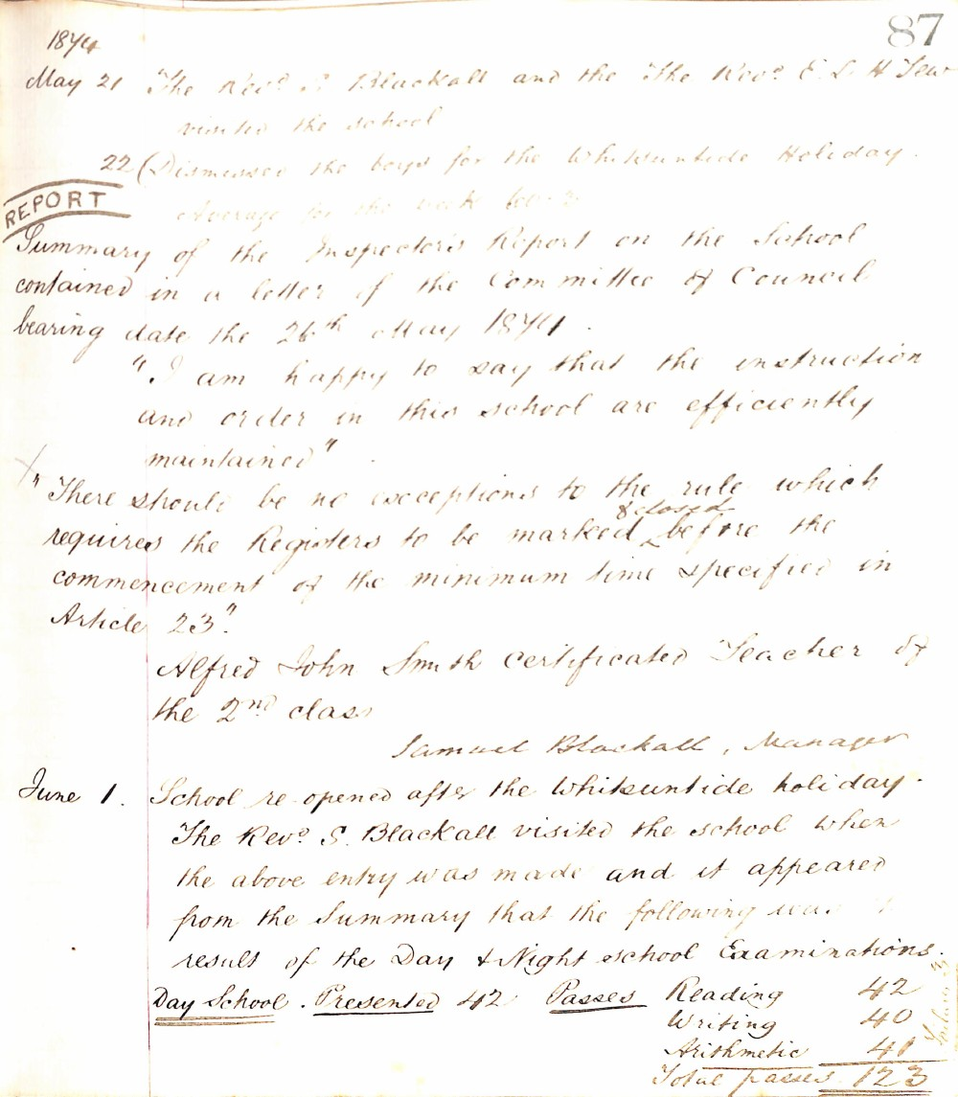

87
1874
May 21 The Revd S Blackall and the The Revd E L H Tew visited the school
22 Dismissed the boys for the Whitsuntide Holiday.
Average for the week 60.2
REPORT
Summary of the Inspector's Report on the School contained in a letter of the Committee of Council bearing date the 26th May 1874.
"I am happy to say that the instruction and order in this school are efficiently maintained"
"There should be no exceptions to the rule which requires the Registers to be marked before the commencement of the minimum time specified in Article 23"
Alfred John Smith Certificated Teacher of the 2nd class
Samuel Blackall, Manager
June 1. School re-opened after the Whitsuntide holiday.
The Revd S. Blackall visited the school when the above entry was made and it appeared from the Summary that the following was result of the Day & Night school Examinations.
Day School | Presented 42 | Passes
 |  | Reading | 42
 |  | Writing | 40
 |  | Arithmetic | 41
 |  | Total passes | 123

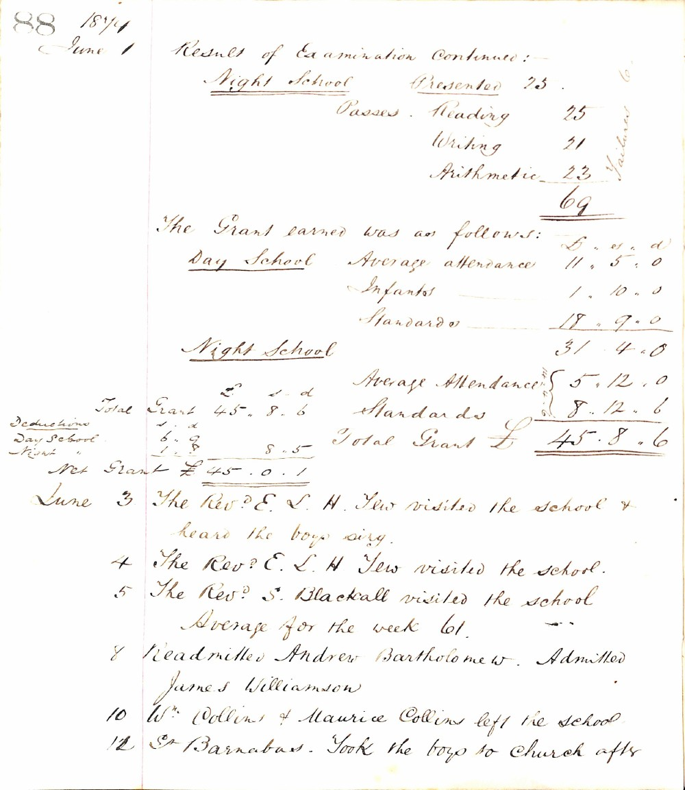

88 1874
June 1 Result of Examination Continued:-
Night School Presented 25
Passes. Reading 25
Writing 21
Arithmetic 23
69
- Failures
The Grant earned was as follows:
Day School Average attendance 11. 5. 0
Infants 1. 10. 0
Standards 18. 9. 0
31. 4. 0
Night School
Average Attendance 5. 12. 0
Standards 8. 12. 6
Total Grant £ 45. 8. 6
£ s. d
Total Grant 45. 8. 6
Deductions s. d
Day School 6. 9
Night " 1. 8 8. 5
Net Grant £ 45. 0. 1
June 3 The Revd. E. L. H. Tew visited the school & heard the boys sing.
4 The Revd. E. L. H. Tew visited the school.
5 The Revd. S. Blackall visited the school
Average for the week 61.
8 Readmitted Andrew Bartholomew. Admitted James Williamson
10 W. Collins & Maurice Collins left the school.
11 St Barnabas. Took the boys to Church aftr

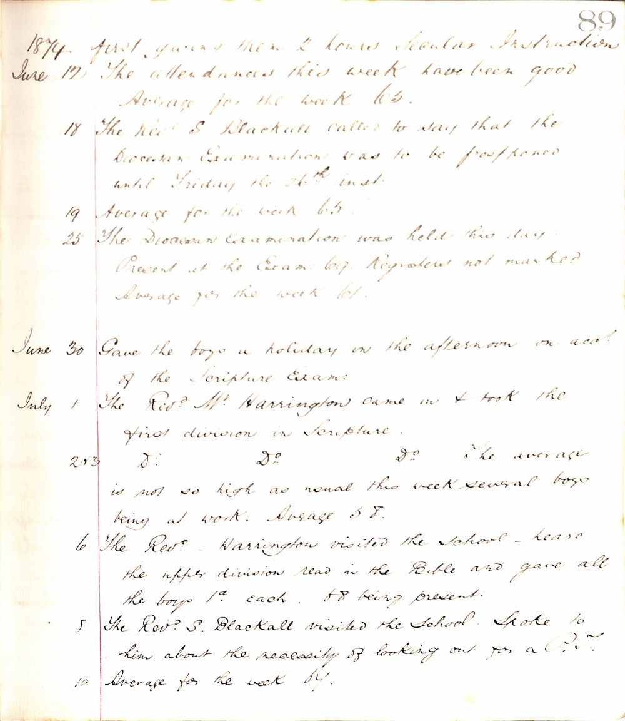

89
1874 first giving them 2 hours Secular Instruction
June 12 The attendances this week have been good Average for the week 65.
18 The Revd S Blackall called to say that the Diocesan Examination was to be postponed until Friday the 26th inst.
19 Average for the week 65.
25 The Diocesan Examination was held this day. Present at the Exam: 67. Registers not marked Average for the week 61.
June 30 Gave the boys a holiday in the afternoon on acct. of the Scripture Exam.
July 1 The Revd Mr. Harrington came in & took the first division in Scripture.
2 & 3 Do Do Do The average is not so high as usual this week several boys being at work. Average 58.
6 The Revd Harrington visited the School - heard the upper division read in the Bible and gave all the boys 1d each. 58 being present.
8 The Revd S. Blackall visited the School. Spoke to him about the necessity of looking out for a P.T.
10 Average for the week 61.

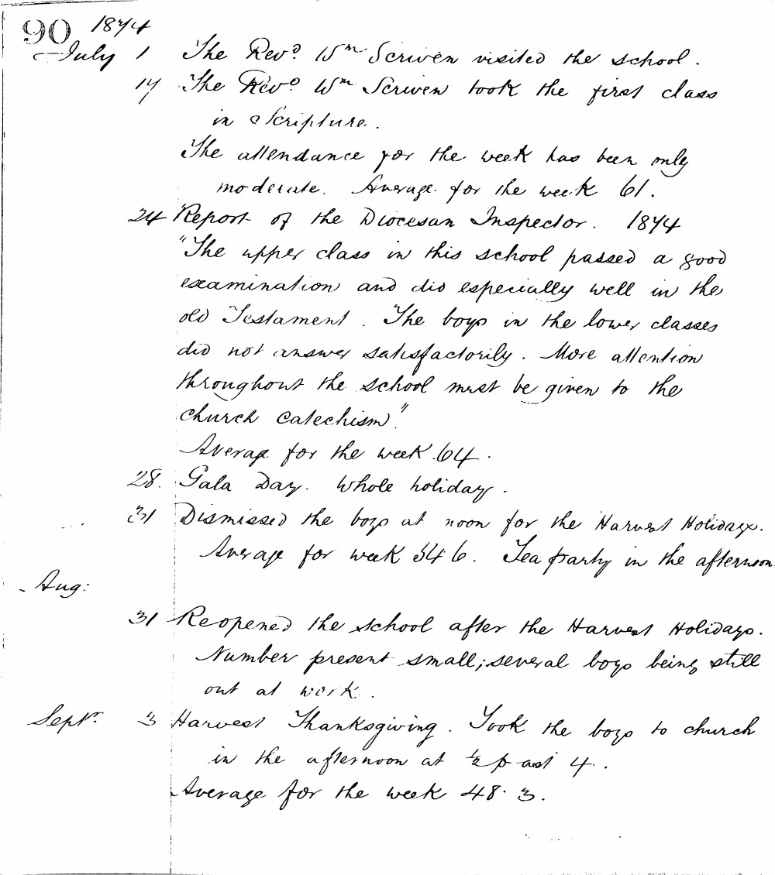

90 1874
July 1 The Revd. Wm. Scriven visited the school.
17 The Revd. Wm. Scriven took the first class in Scripture.
The attendance for the week has been only moderate. Average for the week 61.
24 Report of the Diocesan Inspector. 1874
"The upper class in this school passed a good examination and did especially well in the Old Testament. The boys in the lower classes did not answer satisfactorily. More attention throughout the school must be given to the Church Catechism."
Average for the week 64.
28 Gala Day. Whole holiday.
31 Dismissed the boys at noon for the Harvest Holidays. Average for week 54.6. Tea party in the afternoon.
Aug.
31 Reopened the school after the Harvest Holidays. Number present small; several boys being still out at work.
Sept. 3 Harvest Thanksgiving. Took the boys to church in the afternoon at 1/2 past 4.
Average for the week 48.3.

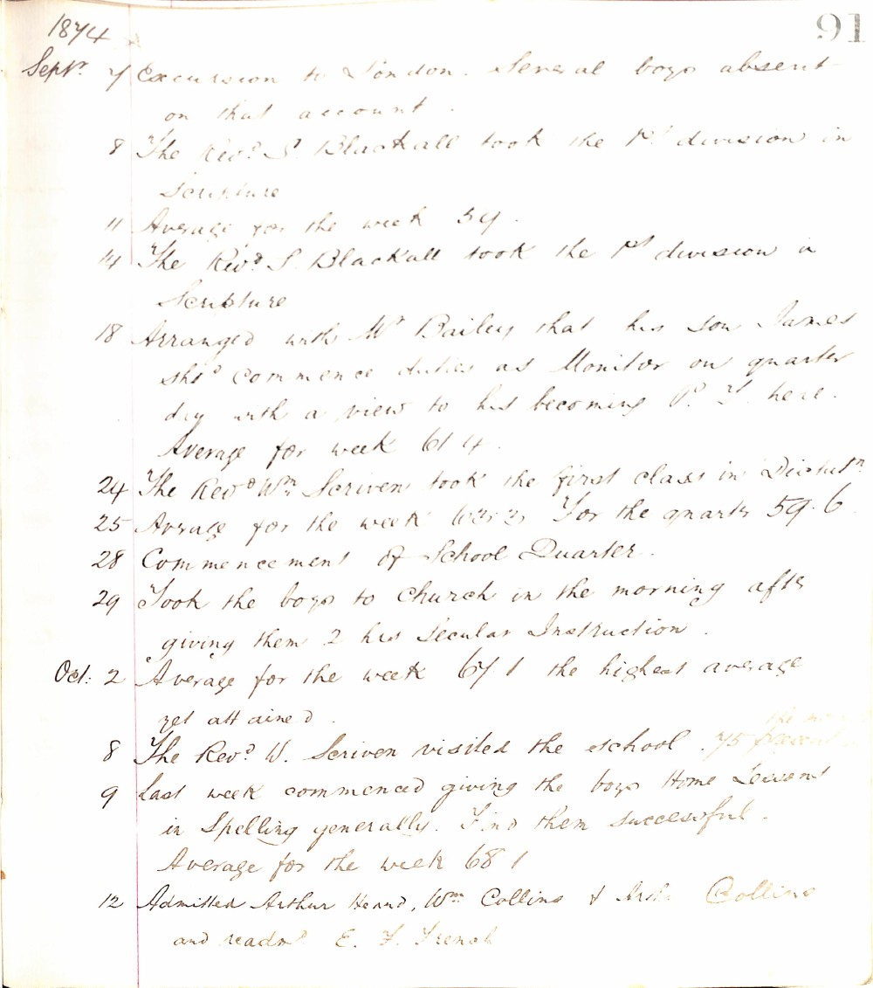

1874 91
Sept. 7 Excursion to London. Several boys absent on that account.
8 The Rev. S. Blackall took the 1st division in Scripture
11 Average for the week 59.
14 The Rev. S. Blackall took the 1st division in Scripture
18 Arranged with Mr. Bailey that his son James should commence duties as Monitor on quarter day with a view to his becoming P.T. here. Average for week 61.4.
24 The Rev. Wm. Scriven took the first class in Dictation
25 Average for the week 63.2. For the quarter 59.6.
28 Commencement of School Quarter.
29 Took the boys to Church in the morning after giving them 2 hrs Secular Instruction.
Oct. 2 Average for the week 67.1 the highest average yet attained.
8 The Rev. W. Scriven visited the school. 75 present
9 Last week commenced giving the boys Home Lessons in Spelling generally. Find them successful. Average for the week 68.1
12 Admitted Arthur Heard, Wm. Collins & Arthur Collins and readmitted E. F. French

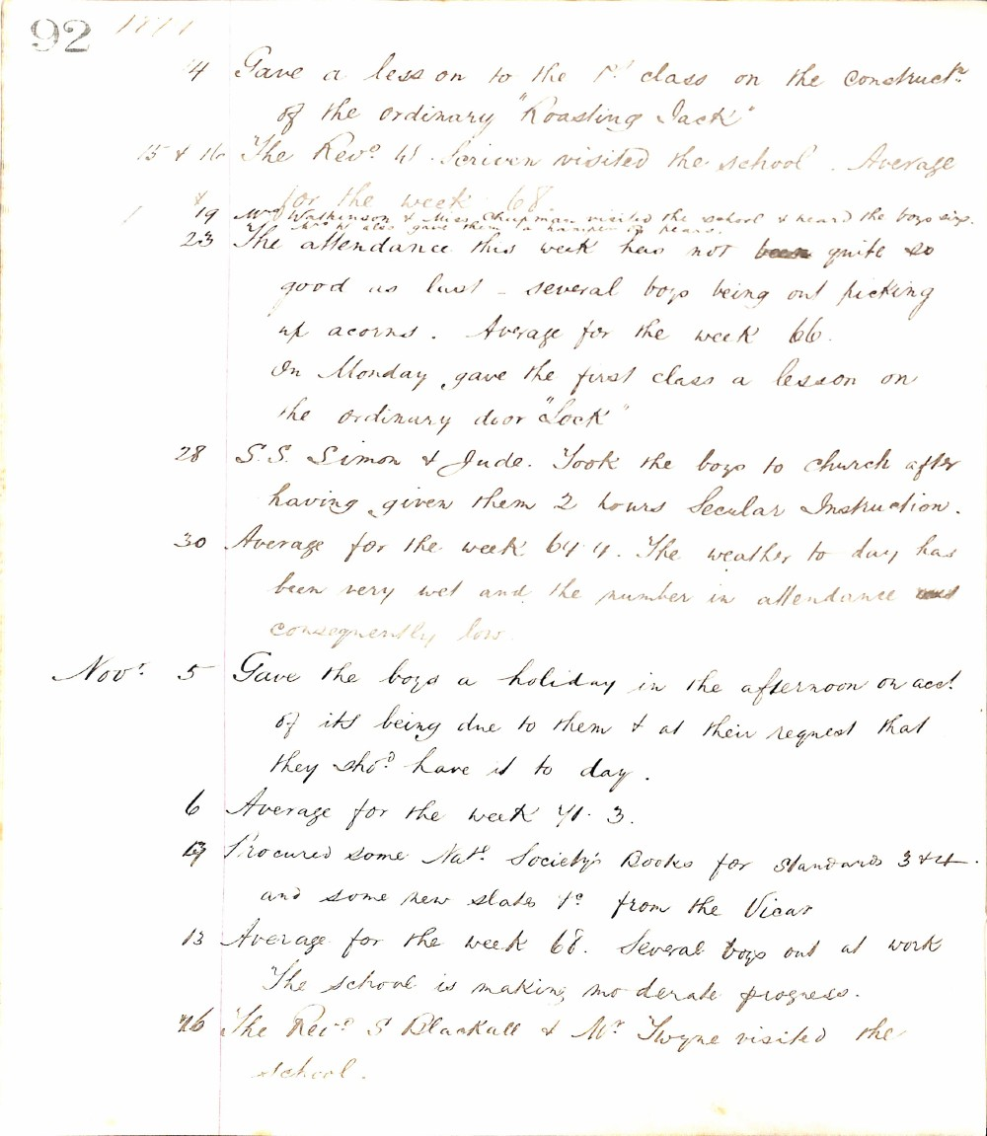

92 1871
14 Gave a lesson to the 1st class on the construction of the ordinary "Roasting Jack"
15 & 16 The Revd H. Scriven visited the school. Average for the week 68.
19 Mrs Watkinson & Miss Chapman visited the school & heard the boys sing. Mr W. also gave them a basket of pears.
23 The attendance this week has not been quite so good as last - several boys being out picking up acorns. Average for the week 66.
On Monday gave the first class a lesson on the ordinary door "lock"
28 S.S. Simon & Jude. Took the boys to church after having given them 2 hours Secular Instruction.
30 Average for the week 64.4. The weather to day has been very wet and the number in attendance consequently low.
Novr 5 Gave the boys a holiday in the afternoon on acct of its being due to them & at their request that they shd have it to day.
6 Average for the week 71.3.
7 Procured some Natl Society's Books for Standards 3 & 4 and some new slates &c from the Vicar
13 Average for the week 68. Several boys out at work. The school is making moderate progress.
16 The Revd S Blackall & Mr Twyne visited the school.

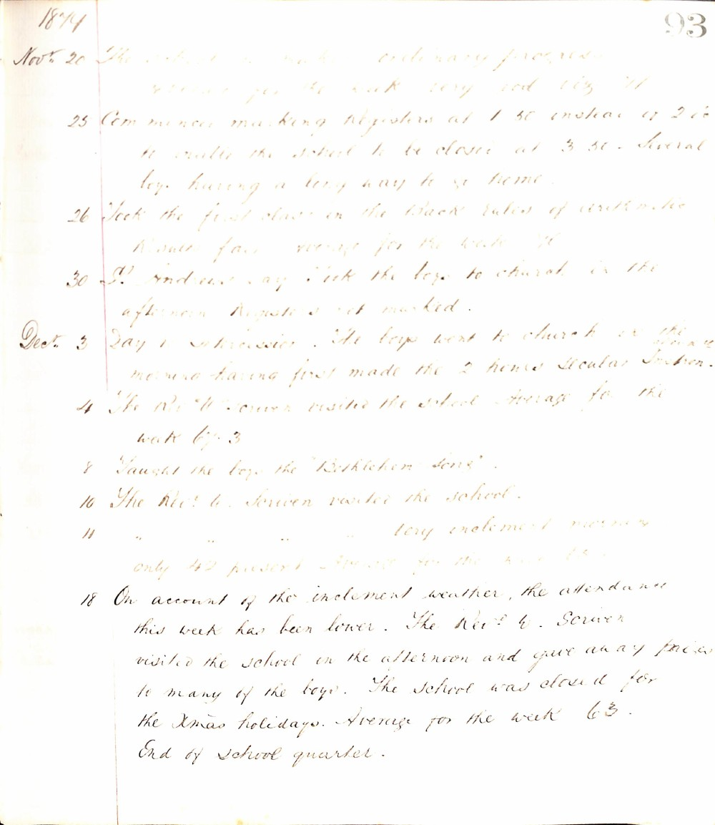

1894
93
Nov. 20 The school is making ordinary progress. Average for the week very good viz 71
25 Commenced marking registers at 1.30 instead of 2.0 to enable the school to be closed at 3.30. Several boys having a long way to go home.
26 Took the first class in the back rules of arithmetic. Results fair average for the week 70
30 St. Andrews Day. Took the boys to church in the afternoon. Registers not marked.
Dec. 3 Day of Intercession. The boys went to church in the morning having first made the 2 hours secular instruction.
4 The Rev. W. Scriven visited the school. Average for the week 67.3
8 Taught the boys the "Bethlehem Song".
10 The Rev. W. Scriven visited the school.
11 " " " " Very inclement morning only 42 present. Average for the week 65.
18 On account of the inclement weather, the attendance this week has been lower. The Rev. W. Scriven visited the school in the afternoon and gave away prizes to many of the boys. The school was closed for the Xmas holidays. Average for the week 63.
End of school quarter.

