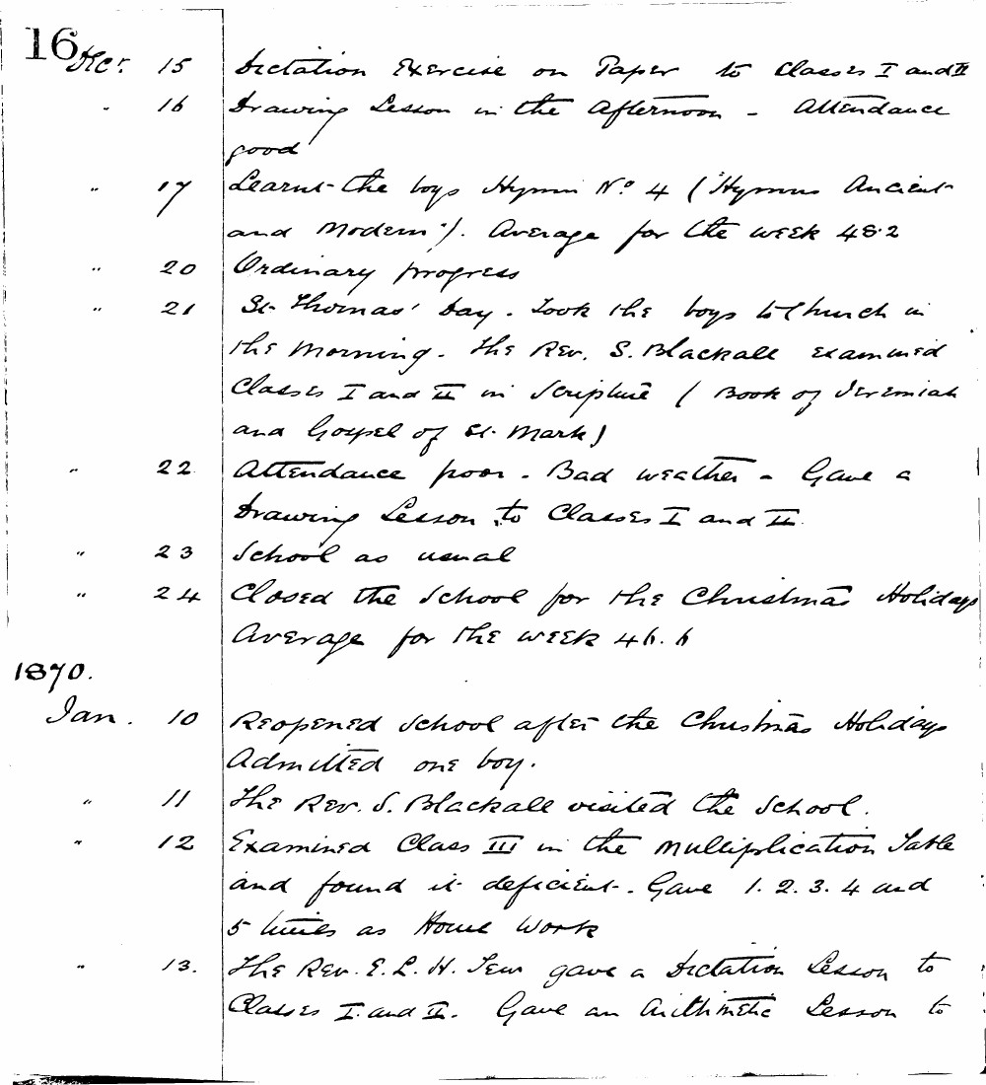

16 Dec. 15 Dictation Exercise on Paper to Classes I and II
- 16 Drawing Lesson in the Afternoon - Attendance good
" 17 Learnt the boys Hymn No. 4 ("Hymns Ancient and Modern"). Average for the week 48.2
" 20 Ordinary progress
" 21 St. Thomas' Day. Took the boys to Church in the morning. The Rev. S. Blackall examined Classes I and II in Scripture (Book of Jeremiah and Gospel of St. Mark)
" 22 Attendance poor - Bad weather - Gave a Drawing Lesson to Classes I and II
" 23 School as usual
" 24 Closed the School for the Christmas Holidays Average for the week 46.6

Jan. 10 Reopened school after the Christmas Holiday Admitted one boy.
" 11 The Rev. S. Blackall visited the School.
" 12 Examined Class III in the multiplication Table and found it deficient. Gave 1. 2. 3. 4 and 5 times as Home Work
" 13 The Rev. E. L. H. Tew gave a Dictation Lesson to Classes I and II. Gave an Arithmetic Lesson to

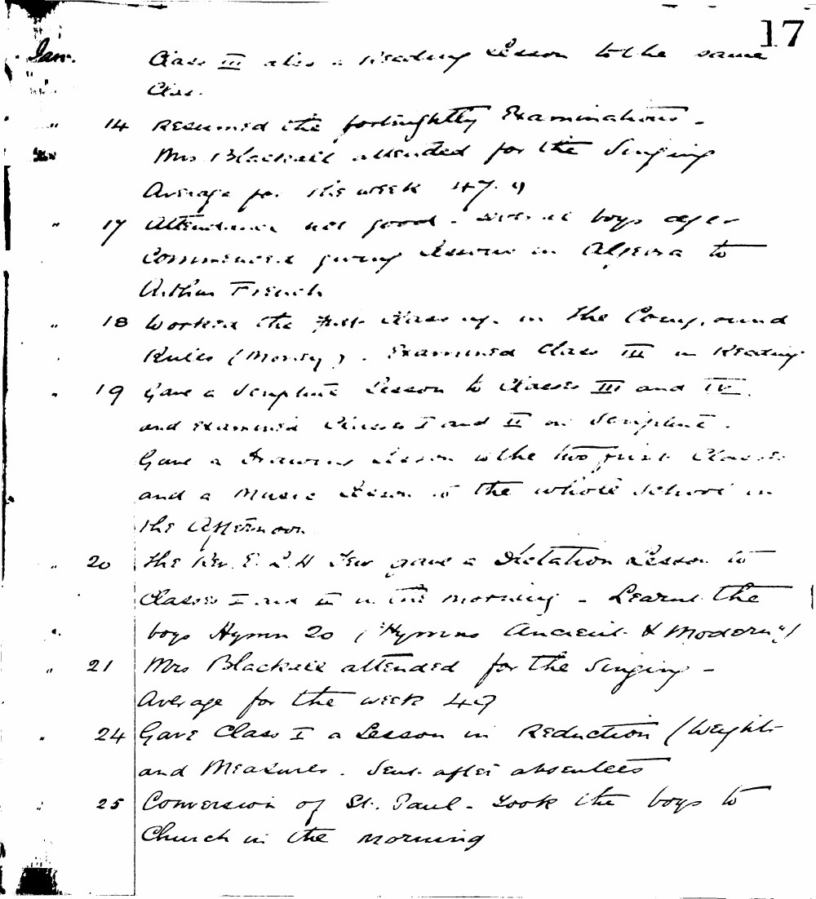

17
Jan. Class III also a reading lesson to the same class.
" 14 Resumed the fortnightly examination. Mrs Blackwell attended for the singing. Average for the week 47.9
" 17 Attendance not good - several boys away. Commenced giving lessons in Algebra to Arthur French.
" 18 Worked the first three rules in the Comp. and Rules (Money). Examined Class III in Reading.
" 19 Gave a Scripture lesson to Classes III and IV and examined Classes I and II in Scripture. Gave a Drawing lesson to the two first classes and a Music lesson to the whole school in the afternoon.
" 20 The Rev. E. L. H. Tew gave a Dictation lesson to Classes I and II in the morning. Learnt the boys Hymn 20 ("Hymns Ancient & Modern").
" 21 Mrs Blackwell attended for the singing. Average for the week 49
" 24 Gave Class I a lesson in Reduction (Weights and Measures). Sent after absentees.
" 25 Conversion of St. Paul. Took the boys to Church in the morning.

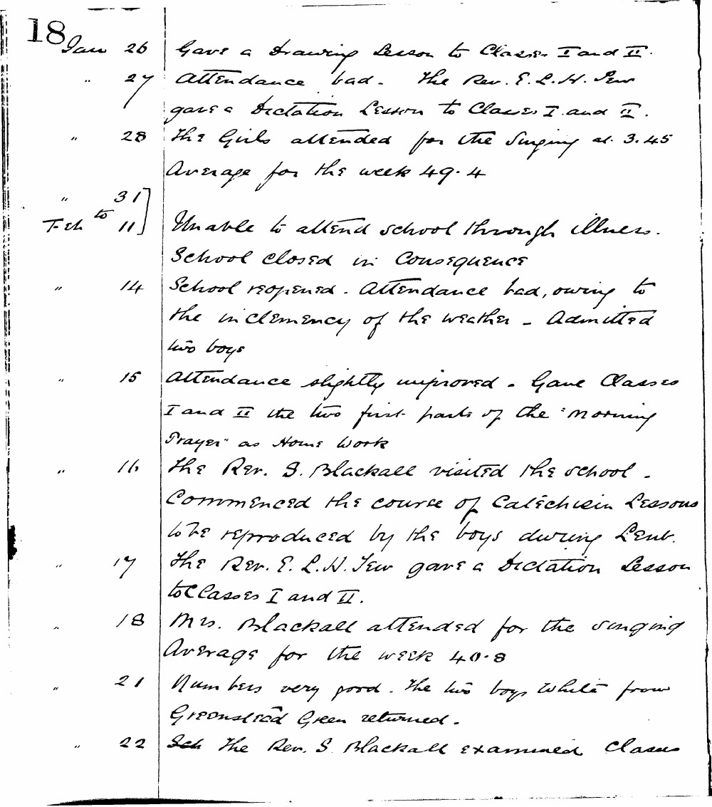

18 Jan 26 Gave a Drawing Lesson to Classes I and II.
" 27 Attendance bad. The Rev. E. L. H. Tew gave a Dictation Lesson to Classes I and II.
" 28 The Girls attended for the Singing at 3.45 Average for the week 49.4
" 31 to Feb 11 Unable to attend school through illness. School closed in consequence
" 14 School reopened. Attendance bad, owing to the inclemency of the weather - Admitted two boys
" 15 Attendance slightly improved. Gave Classes I and II the two first parts of the "Morning Prayer" as Home Work
" 16 The Rev. S. Blackall visited the school. Commenced the course of Catechism Lessons to be reproduced by the boys during Lent.
" 17 The Rev. E. L. H. Tew gave a Dictation Lesson to Classes I and II.
" 18 Mrs. Blackall attended for the singing Average for the week 40.8
" 21 Numbers very good. The two boys White from Greenstead Green returned.
" 22 Sch The Rev. S. Blackall examined Classes

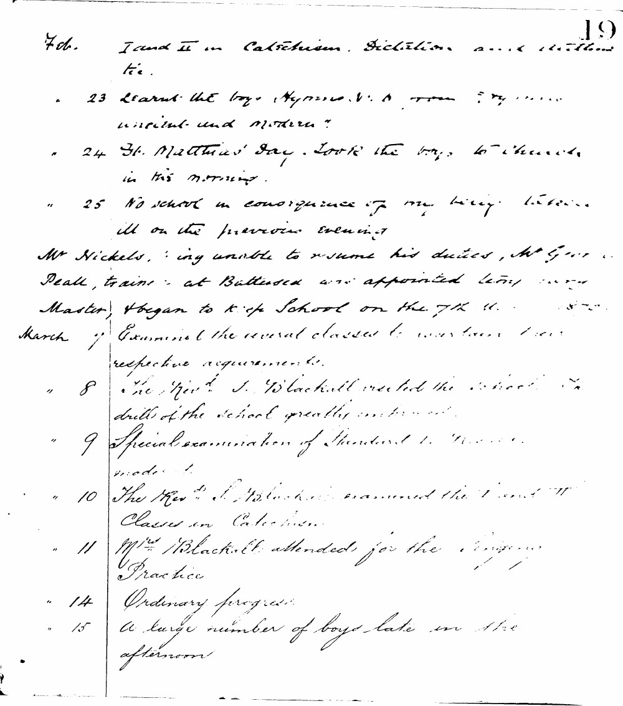

19
Feb. I and II in Catechism, Dictation and Arithmetic.
" 23 Learnt the boys Hymns 1, 6 from "Hymns Ancient and Modern".
" 24 St. Matthias' Day. Took the boys to church in the morning.
" 25 No school in consequence of my being taken ill on the previous evening.
Mr Nickels, being unable to resume his duties, Mr Geo. Peall, trained at Battersea was appointed temporary Master, & began to keep School on the 7th inst.
March 7 Examined the several classes to ascertain their respective acquirements.
" 8 The Revd. S. Blackall visited the school. The drill of the school greatly improved.
" 9 Special examination of Standard I. Progress made.
" 10 The Revd. S. Blackall examined the I and II Classes in Catechism.
" 11 Mrs Blackall attended for the Singing Practice.
" 14 Ordinary progress.
" 15 A large number of boys late in the afternoon.

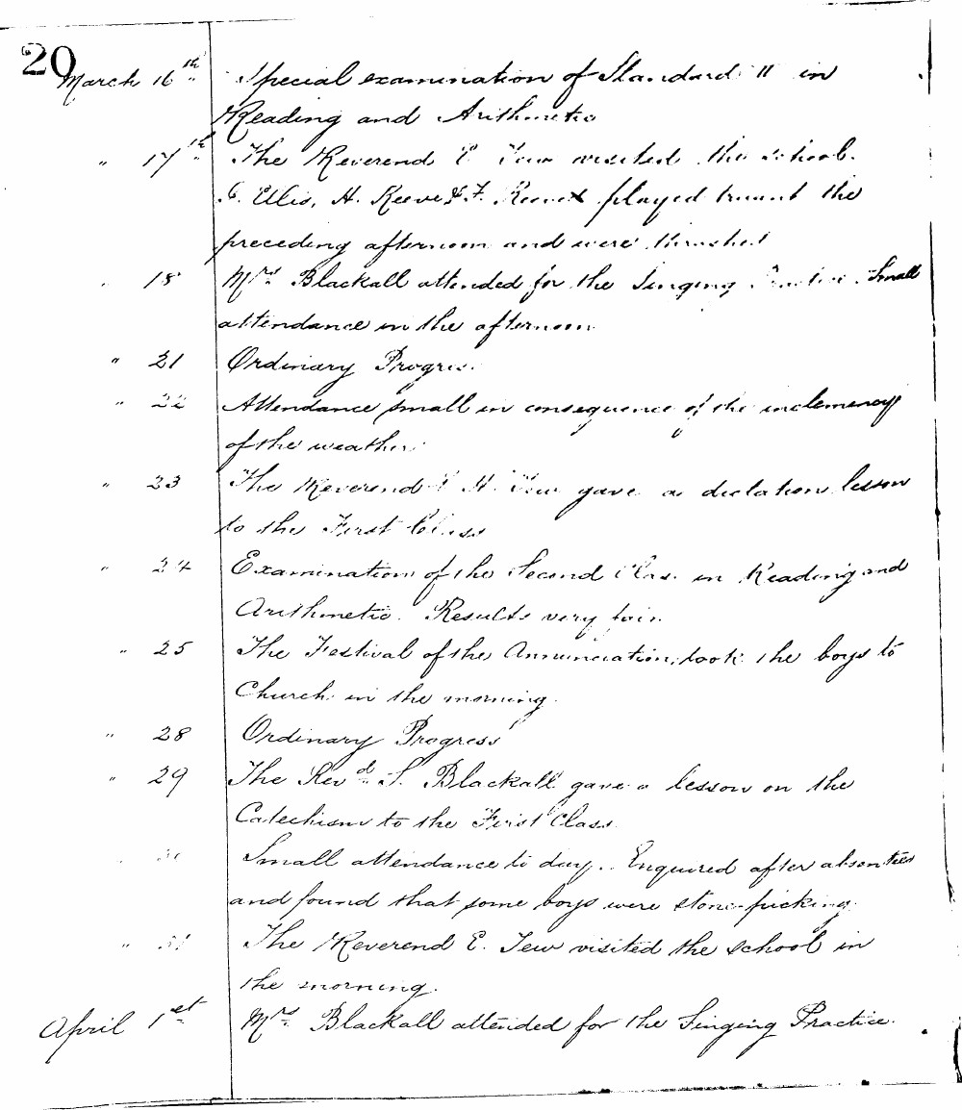

20 March 16th Special examination of Standard II in Reading and Arithmetic
" 17th The Reverend E. Tew visited the school. C. Ellis, H. Reeve & F. Reeve played truant the preceding afternoon and were thrashed.
" 18th Mr. Blackall attended for the Singing Practice. Small attendance in the afternoon.
" 21 Ordinary Progress.
" 22 Attendance small in consequence of the inclemency of the weather.
" 23 The Reverend E. H. Tew gave a dictation lesson to the First Class.
" 24 Examination of the Second Class in Reading and Arithmetic. Results very fair.
" 25 The Festival of the Annunciation, took the boys to Church in the morning.
" 28 Ordinary Progress
" 29 The Revd. S. Blackall gave a lesson on the Catechism to the First Class.
" 30 Small attendance today. Enquired after absentees and found that some boys were stone-picking.
" 31 The Reverend E. Tew visited the school in the morning.
April 1st Mr. Blackall attended for the Singing Practice.

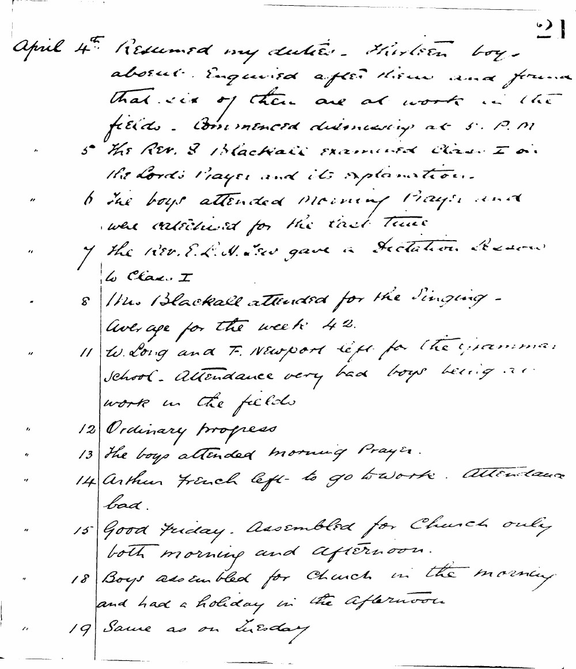

21
April 4th Resumed my duties. Thirteen boys absent. Enquired after them and found that six of them are at work in the fields. Commenced dismissing at 5. P.M
" 5 The Rev. S Blackall examined Class I in the Lord's Prayer and its explanation.
" 6 The boys attended Morning Prayer and were catechised for the first time
" 7 the Rev. E. L. N. (?) gave a Dictation Lesson to Class I
" 8 Mrs. Blackall attended for the Singing - Average for the week 42.
" 11 W. Long and F. Newport left for the Grammar School. Attendance very bad boys being at work in the fields
" 12 Ordinary progress
" 13 The boys attended morning Prayer.
" 14 Arthur French left to go to work. Attendance bad.
" 15 Good Friday. Assembled for Church only both morning and afternoon.
" 18 Boys assembled for Church in the morning and had a holiday in the afternoon
" 19 Same as on Tuesday

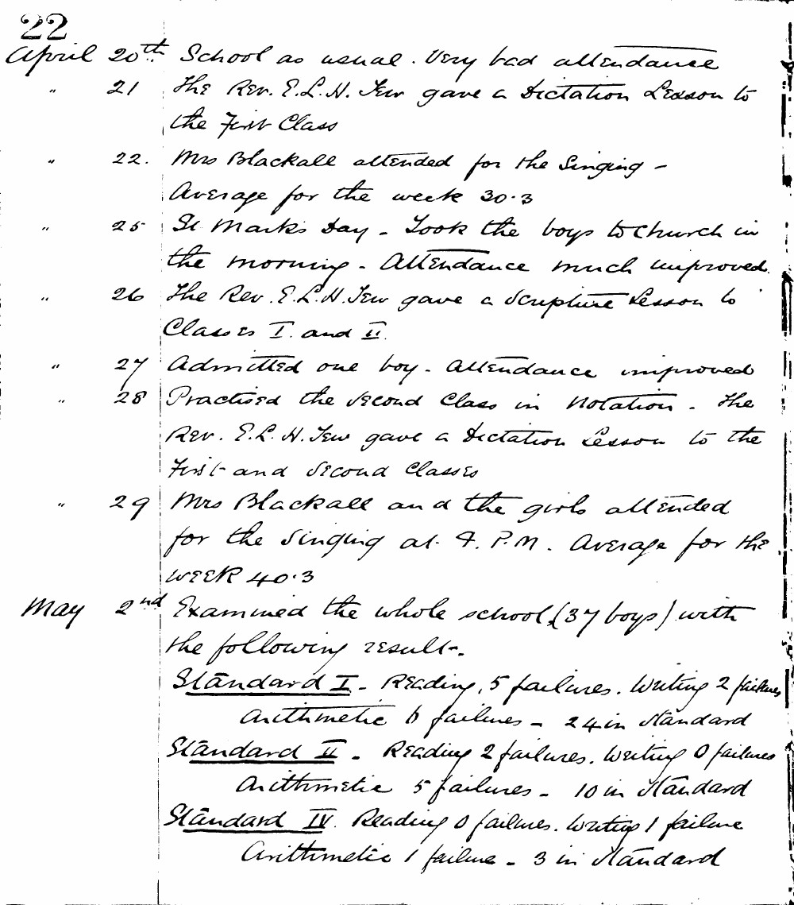

22
April 20th School as usual. Very bad attendance
" 21 The Rev. E.L.H. Tew gave a Dictation Lesson to the first Class
" 22. Mrs Blackall attended for the Singing - Average for the week 30.3
" 25 St Mark's Day - Took the boys to Church in the morning. Attendance much improved.
" 26 The Rev. E.L.H. Tew gave a Scripture Lesson to Classes I. and II.
" 27 Admitted one boy. Attendance improved
" 28 Practised the second Class in Notation. The Rev. E.L.H. Tew gave a Dictation Lesson to the first and second Classes
" 29 Mrs Blackall and the girls attended for the singing at 4. P.M. Average for the week 40.3
May 2nd Examined the whole school (37 boys) with the following results.
Standard I. Reading, 5 failures. Writing 2 failures, Arithmetic 6 failures - 24 in Standard
Standard II. Reading 2 failures. Writing 0 failures Arithmetic 5 failures - 10 in Standard
Standard IV. Reading 0 failures. Writing 1 failure Arithmetic 1 failure - 3 in Standard

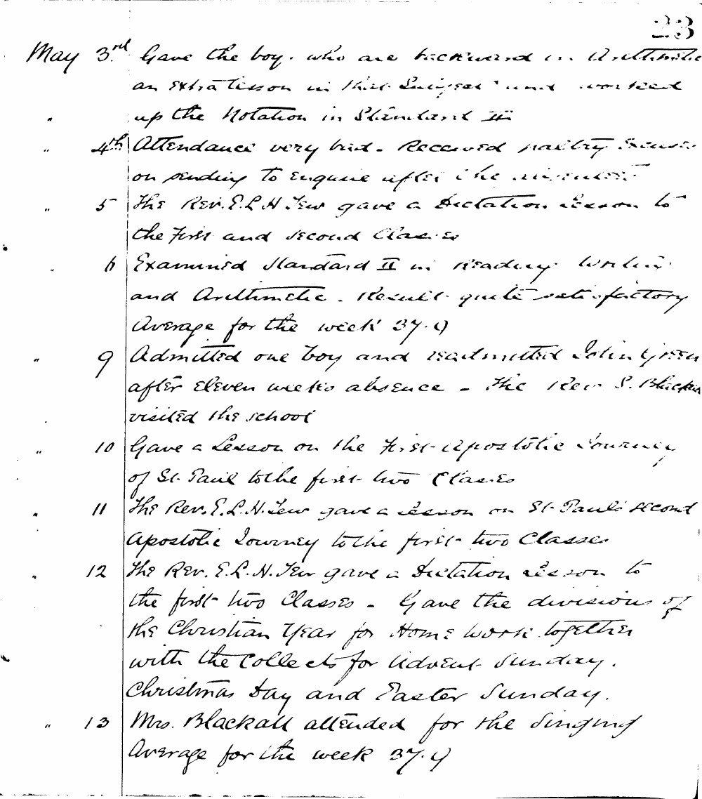

23
May 3rd Gave the boys who are backward in Arithmetic an extra lesson in their sums and worked up the Notation in Standard III
" 4th Attendance very bad. Received paltry excuses on sending to enquire after the absentees
" 5 The Rev. E.L.H. Tew gave a Dictation lesson to the first and second Classes
" 6 Examined Standard II in reading writing and Arithmetic. Results quite satisfactory Average for the week 37.9
" 9 Admitted one boy and readmitted John Green after eleven weeks absence - The Rev. S. Blackall visited the school
" 10 Gave a Lesson on the first Apostolic Journey of St. Paul to the first two Classes
" 11 The Rev. E.L.H. Tew gave a Lesson on St. Paul's second Apostolic Journey to the first two Classes
" 12 The Rev. E.L.H. Tew gave a Dictation lesson to the first two Classes - Gave the divisions of the Christian Year for Home work together with the Collects for Advent Sunday. Christmas Day and Easter Sunday.
" 13 Mrs. Blackall attended for the singing Average for the week 37.9

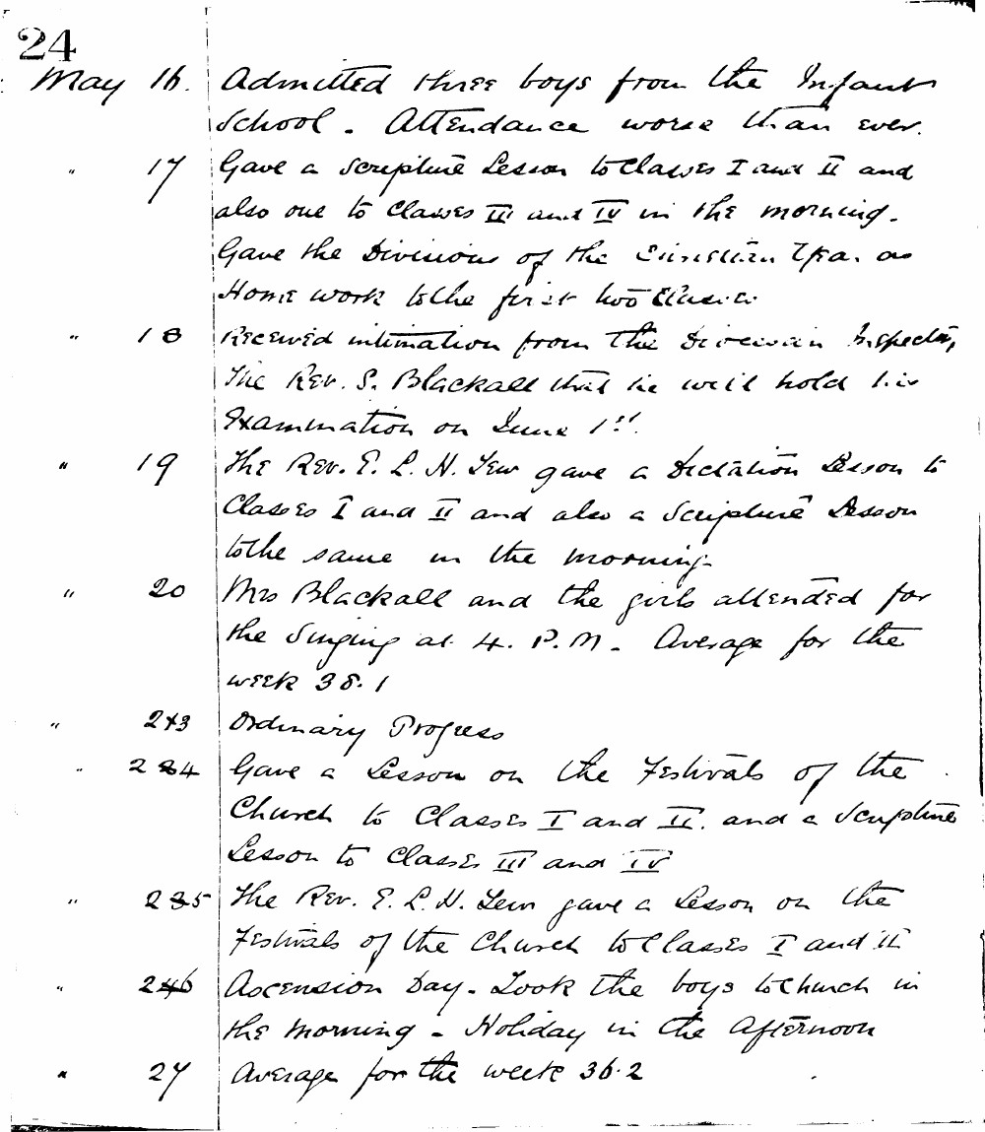

24
May 16. Admitted three boys from the Infant School. Attendance worse than ever.
" 17 Gave a scripture Lesson to Classes I and II and also one to Classes III and IV in the morning. Gave the Division of the Christian Era as Home work to the first two Classes.
" 18 Received intimation from the Diocesan Inspector, the Rev. S. Blackall that he will hold his Examination on June 1st.
" 19 The Rev. E. L. H. Tew gave a Dictation Lesson to Classes I and II and also a Scripture Lesson to the same in the morning.
" 20 Mrs Blackall and the girls attended for the Singing at 4. P.M. Average for the week 38.1
" 23 Ordinary Progress
" 24 Gave a Lesson on the Festivals of the Church to Classes I and II. and a Scripture Lesson to Classes III and IV
" 25 The Rev. E. L. H. Tew gave a Lesson on the Festivals of the Church to Classes I and II
" 26 Ascension Day. Took the boys to Church in the morning. Holiday in the Afternoon
" 27 Average for the week 36.2

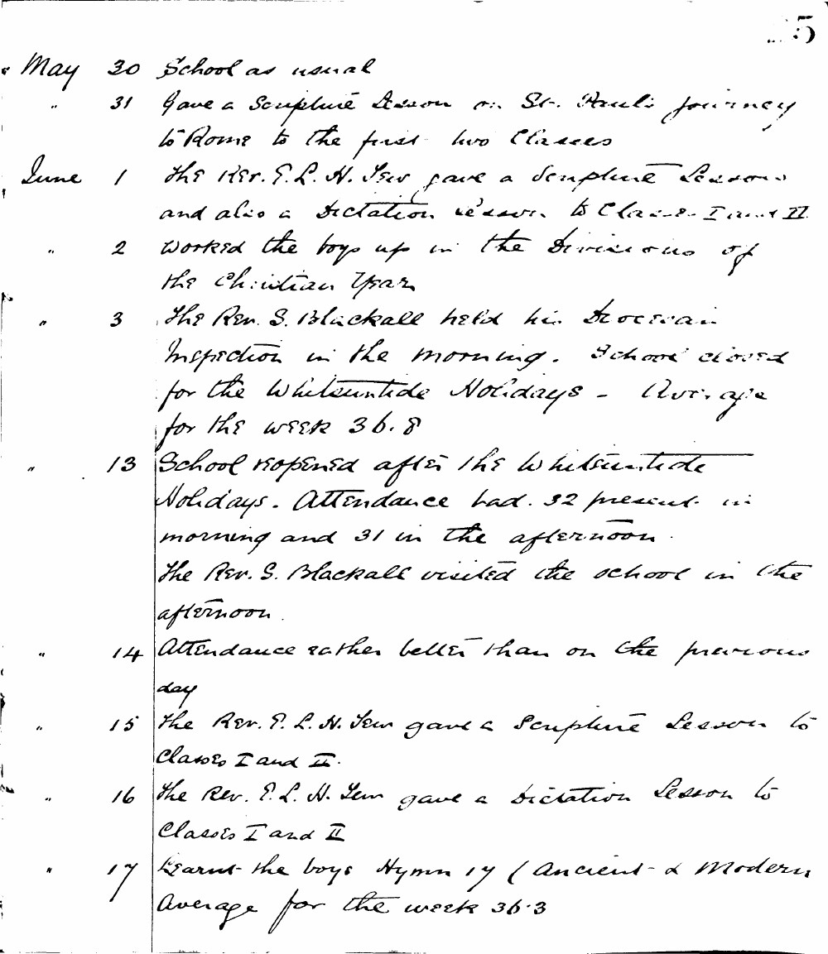

5
May 30 School as usual
" 31 Gave a Scripture Lesson on St. Paul's journey to Rome to the first two Classes
June 1 The Rev. P. L. H. Tew gave a Scripture Lesson and also a Dictation Lesson to Classes I and II
" 2 Worked the boys up in the Divisions of the Christian Year
" 3 The Rev. S. Blackall held his Diocesan Inspection in the morning. School closed for the Whitsuntide Holidays - Average for the week 36.8
" 13 School reopened after the Whitsuntide Holidays. Attendance bad. 32 present in morning and 31 in the afternoon. The Rev. S. Blackall visited the school in the afternoon.
" 14 Attendance rather better than on the previous day
" 15 The Rev. P. L. H. Tew gave a Scripture Lesson to Classes I and II.
" 16 The Rev. P. L. H. Tew gave a Dictation Lesson to Classes I and II
" 17 Learnt the boys Hymn 17 (Ancient & Modern) Average for the week 36.3

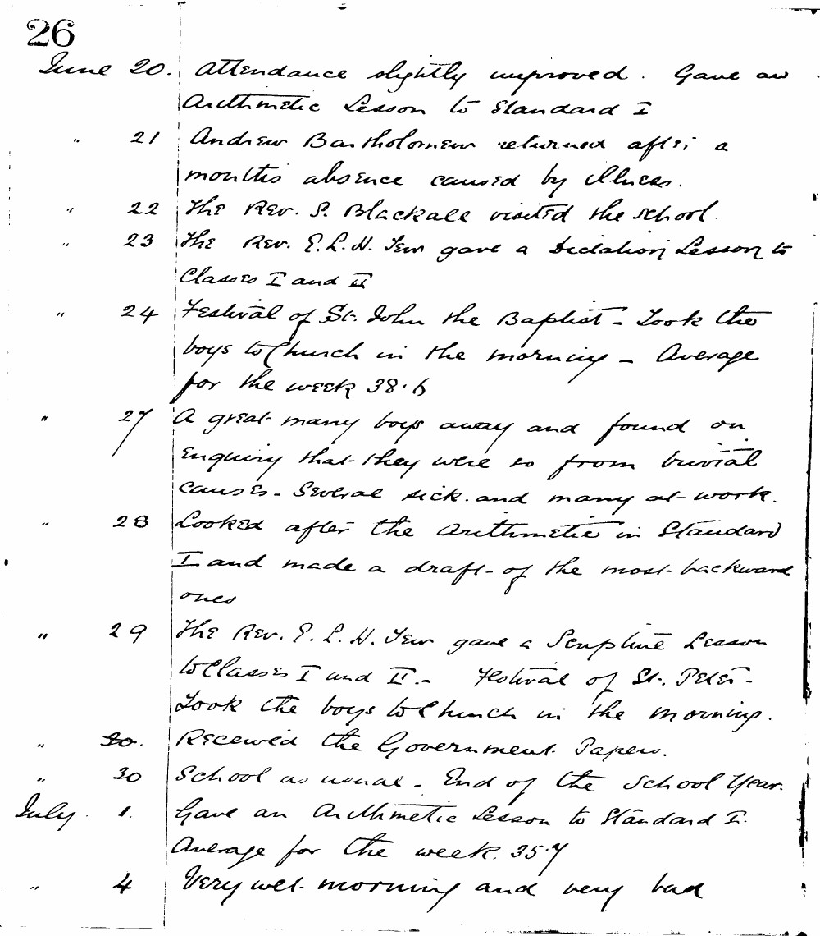

26
June 20. Attendance slightly improved. Gave an Arithmetic Lesson to Standard I
" 21 Andrew Bartholomew returned after a months absence caused by illness.
" 22 The Rev. S. Blackall visited the school.
" 23 The Rev. E. L. H. Tew gave a Dictation Lesson to Classes I and II
" 24 Festival of St. John the Baptist - Took the boys to Church in the morning - Average for the week 38.6
" 27 A great many boys away and found on enquiring that they were so from trivial causes. Several sick and many at work.
" 28 Looked after the Arithmetic in Standard I and made a draft of the most backward ones
" 29 The Rev. E. L. H. Tew gave a Scripture Lesson to Classes I and II. Festival of St. Peter - Took the boys to Church in the morning.
" 30. Received the Government Papers.
" 30 School as usual. End of the School Year.
July 1. Gave an Arithmetic Lesson to Standard I. Average for the week 35.7
" 4 Very wet morning and very bad

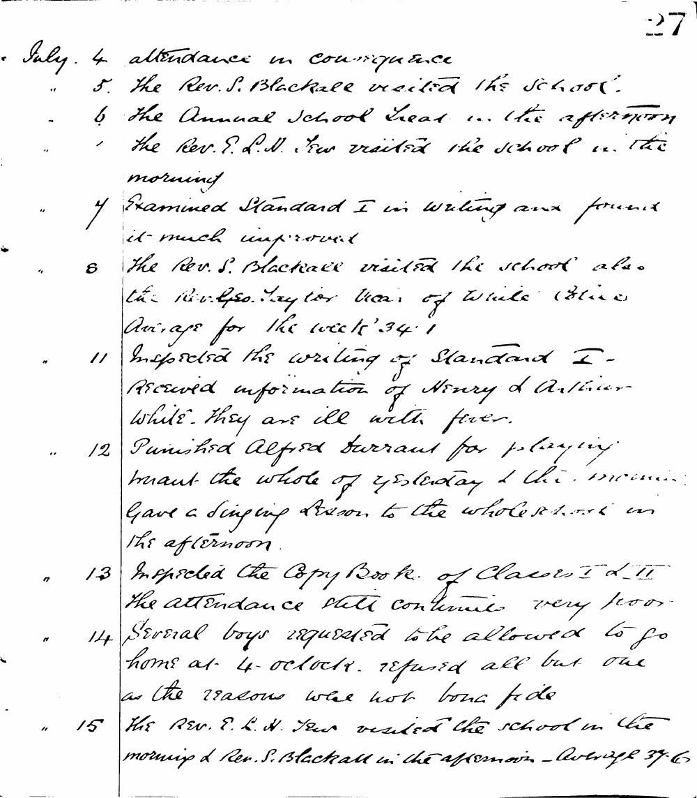

27
July. 4 attendance in consequence
" 5. The Rev. S. Blackall visited the school.
" 6 The Annual School Treat in the afternoon the Rev. E. L. H. Tew visited the school in the morning
" 7 Examined Standard I in writing and found it much improved
" 8 The Rev. S. Blackall visited the school also the Rev. Geo. Taylor Vicar of White Alice Average for the week 34.1
" 11 Inspected the writing of Standard I - Received information of Henry & Arthur White they are ill with fever.
" 12 Punished Alfred Durrant for playing truant the whole of yesterday & this morning. Gave a singing lesson to the whole school in the afternoon.
" 13 Inspected the Copy Books of Classes I & II the attendance still continues very poor.
" 14 Several boys requested to be allowed to go home at 4 o'clock. refused all but one as the reasons were not bona fide
" 15 The Rev. E. L. H. Tew visited the school in the morning & Rev. S. Blackall in the afternoon - Average 37.6

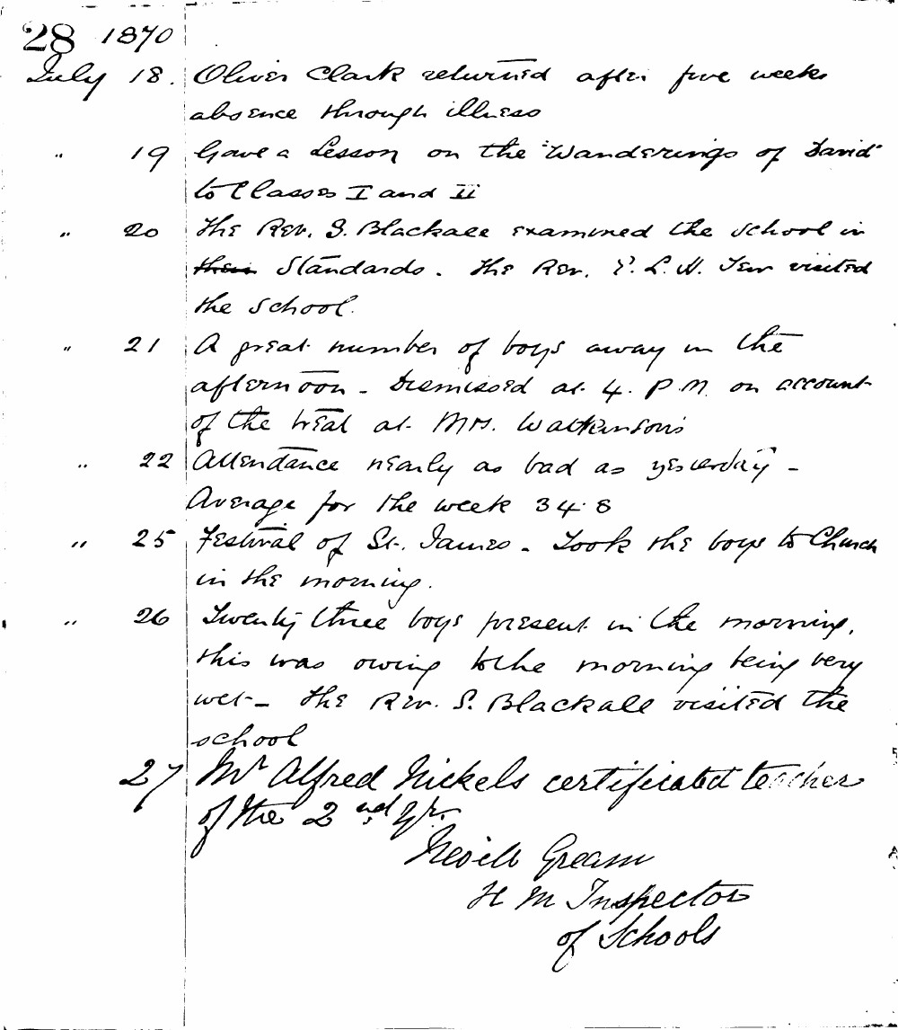

28 1870
July 18. Oliver Clark returned after five weeks absence through illness
" 19 Gave a lesson on the "Wanderings of David" to Classes I and II
" 20 The Rev. S. Blackall examined the school in their standards. The Rev. P. L. W. Tan visited the school.
" 21 A great number of boys away in the afternoon - dismissed at 4. P.M. on account of the trial at Mrs. Watkinson's
" 22 Attendance nearly as bad as yesterday - Average for the week 34.8
" 25 Festival of St. James. Took the boys to Church in the morning.
" 26 Twenty-three boys present in the morning, this was owing to the morning being very wet - The Rev. S. Blackall visited the school
27 Mr Alfred Rickels certificated teacher of the 2nd gr.
Neville Gream
H M Inspector of Schools

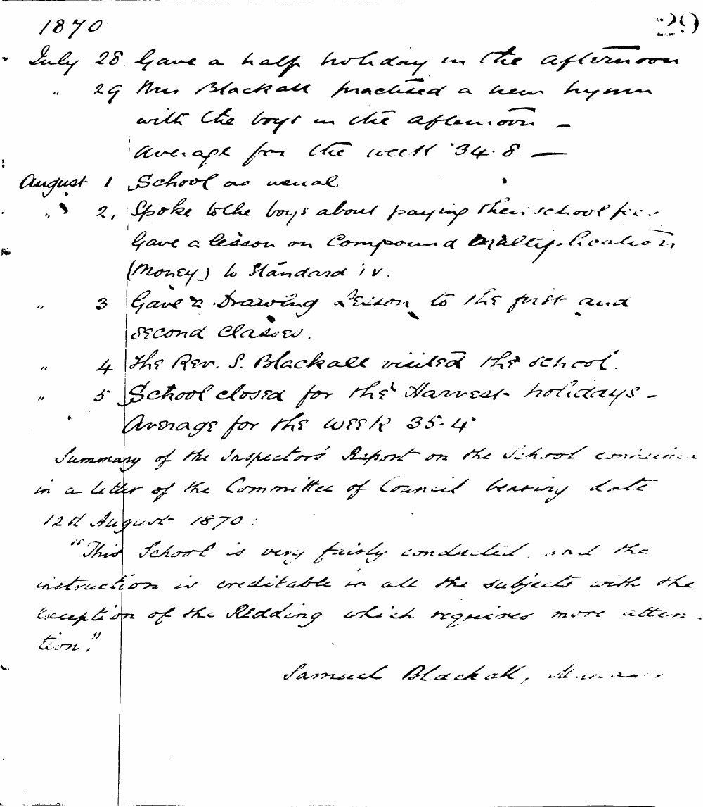

1870 29
July 28. Gave a half holiday in the afternoon
" 29 Mrs Blackall practiced a new hymn with the boys in the afternoon -
Average for the week 34.8 -
August 1 School as usual.
" 2 Spoke to the boys about paying their school fees. Gave a lesson on Compound Multiplication (Money) to Standard IV.
" 3 Gave a Drawing Lesson to the first and second classes.
" 4 The Rev. S. Blackall visited the school.
" 5 School closed for the Harvest holidays -
Average for the week 35.4
Summary of the Inspector's Report on the School contained in a letter of the Committee of Council bearing date 12th August 1870:
"This School is very fairly conducted, and the instruction is creditable in all the subjects with the exception of the Reading which requires more attention."
Samuel Blackall, Manager

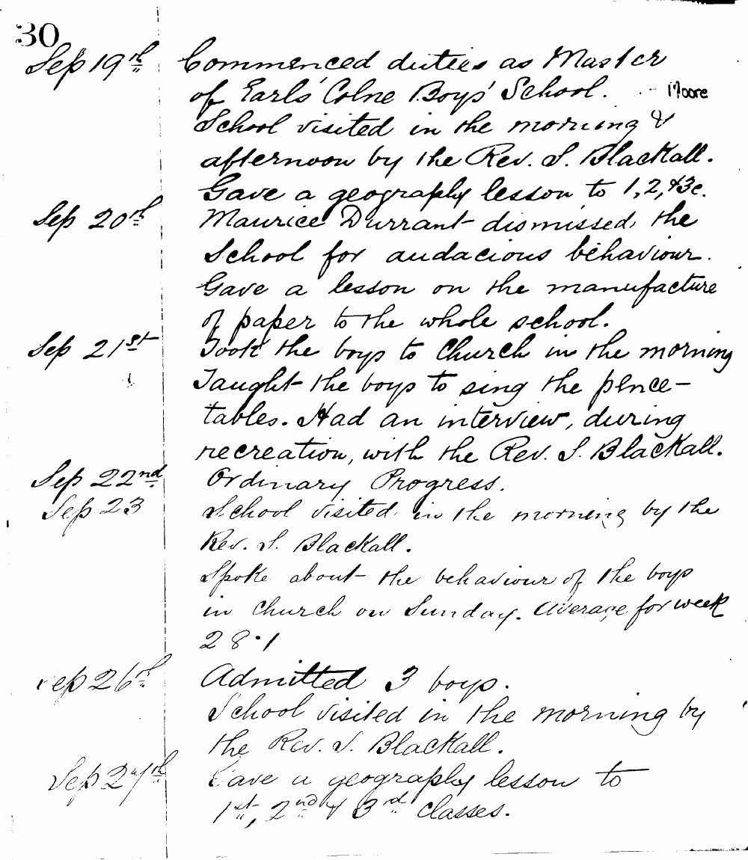

30
Sep 19th Commenced duties as Master of Earls Colne Boys' School. Moore School visited in the morning & afternoon by the Rev. S. Blackall.
Sep 20th Gave a geography lesson to 1, 2, & 3c. Maurice Durrant dismissed the school for audacious behaviour. Gave a lesson on the manufacture of paper to the whole school.
Sep 21st Took the boys to Church in the morning Taught the boys to sing the pence-tables. Had an interview, during recreation, with the Rev. S. Blackall.
Sep 22nd Ordinary Progress.
Sep 23 School visited in the morning by the Rev. S. Blackall. Spoke about the behaviour of the boys in Church on Sunday. Average for week 28.1
Sep 26th Admitted 3 boys. School visited in the morning by the Rev. S. Blackall.
Sep 27th Gave a geography lesson to 1st, 2nd & 3rd Classes.

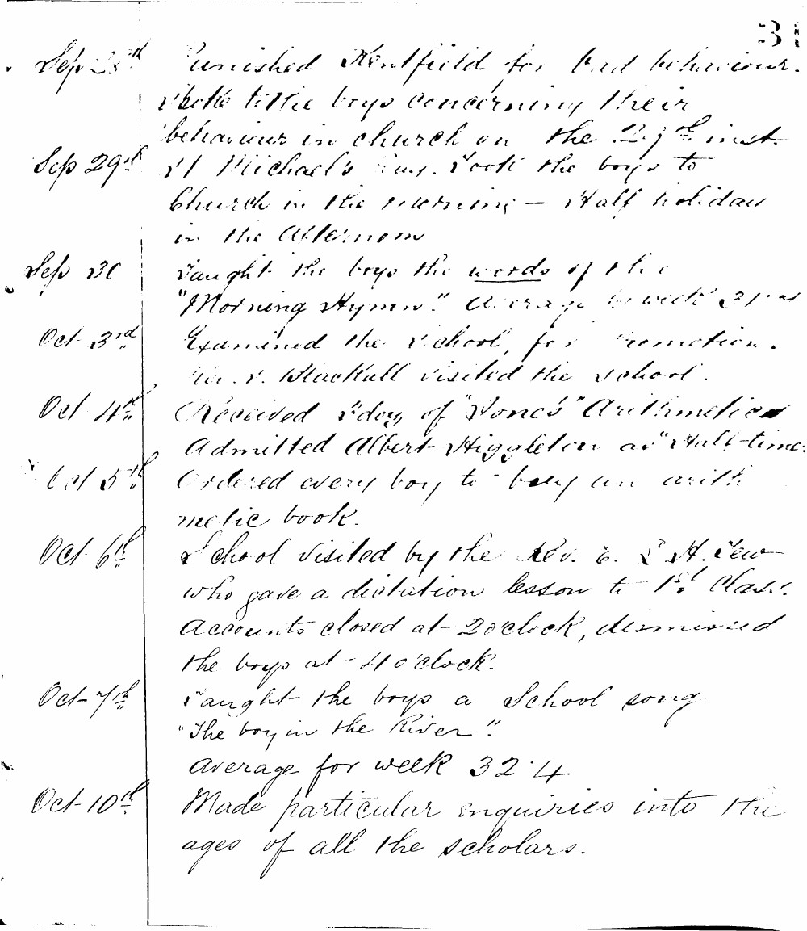

31
Sep 25th Punished Kentfield for bad behaviour. Spoke to the boys concerning their behaviour in church on the 21st inst.
Sep 29th St Michael's Day. Took the boys to Church in the morning - Half holiday in the afternoon.
Sep 30 Taught the boys the words of the "Morning Hymn." Average for week 31.4
Oct 3rd Examined the school for promotion. Mr. J. Blackhall visited the school.
Oct 4th Received 1 doz of "Jones' Arithmetic." Admitted Albert Higgleten as "half-time."
Oct 5th Ordered every boy to buy an arithmetic book.
Oct 6th School visited by the Rev. E. S. Dew who gave a dictation lesson to 1st Class. Accounts closed at 2 o'clock, dismissed the boys at 4 o'clock.
Oct 7th Taught the boys a School song "The boy in the River."
Average for week 32.4
Oct 10th Made particular enquiries into the ages of all the scholars.

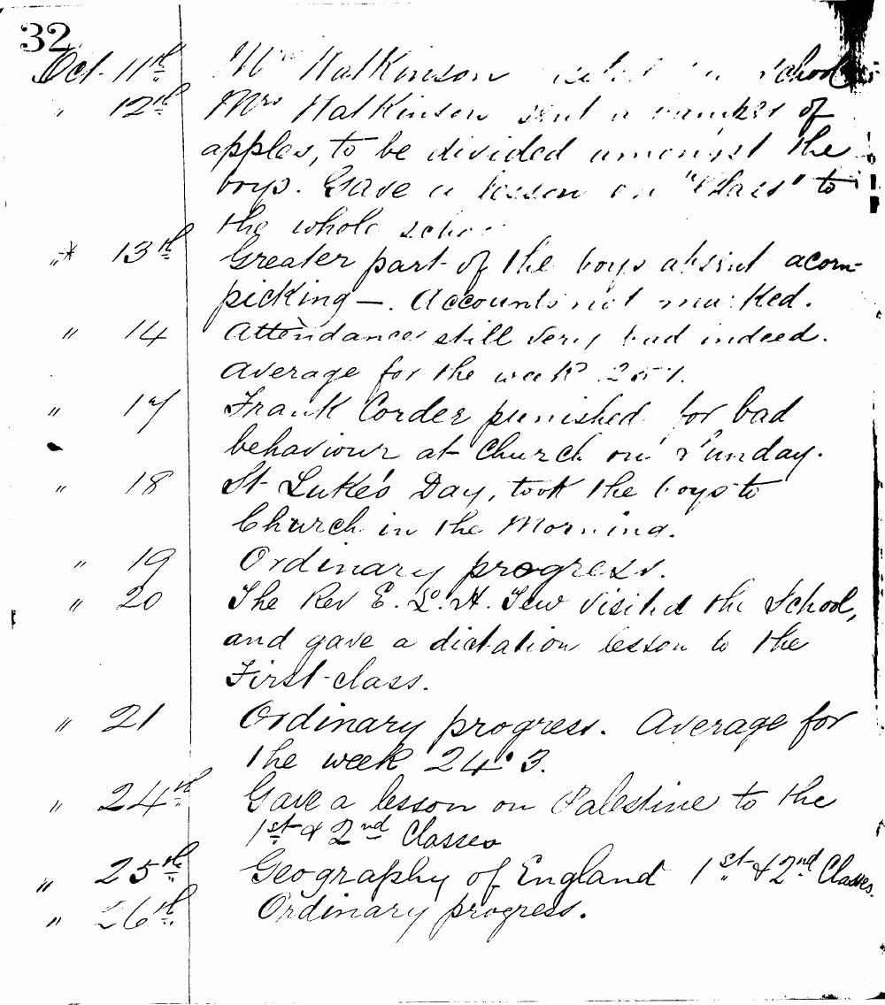

32
Oct 11th Mr Watkinson visited school
12th Mrs Watkinson sent a basket of apples, to be divided amongst the boys. Gave a lesson on "Glass" to the whole school.
- 13th Greater part of the boys absent acorn-picking. Accounts not marked.
" 14 Attendance still very bad indeed. Average for the week 25.1.
" 17 Frank Corder punished for bad behaviour at Church on Sunday.
" 18 St Luke's Day, took the boys to Church in the morning.
" 19 Ordinary progress.
" 20 The Rev E. L. H. Tew visited the School, and gave a dictation lesson to the First Class.
" 21 Ordinary progress. Average for the week 24.3.
" 24th Gave a lesson on Palestine to the 1st & 2nd Classes
" 25th Geography of England 1st & 2nd Classes.
" 26th Ordinary progress.

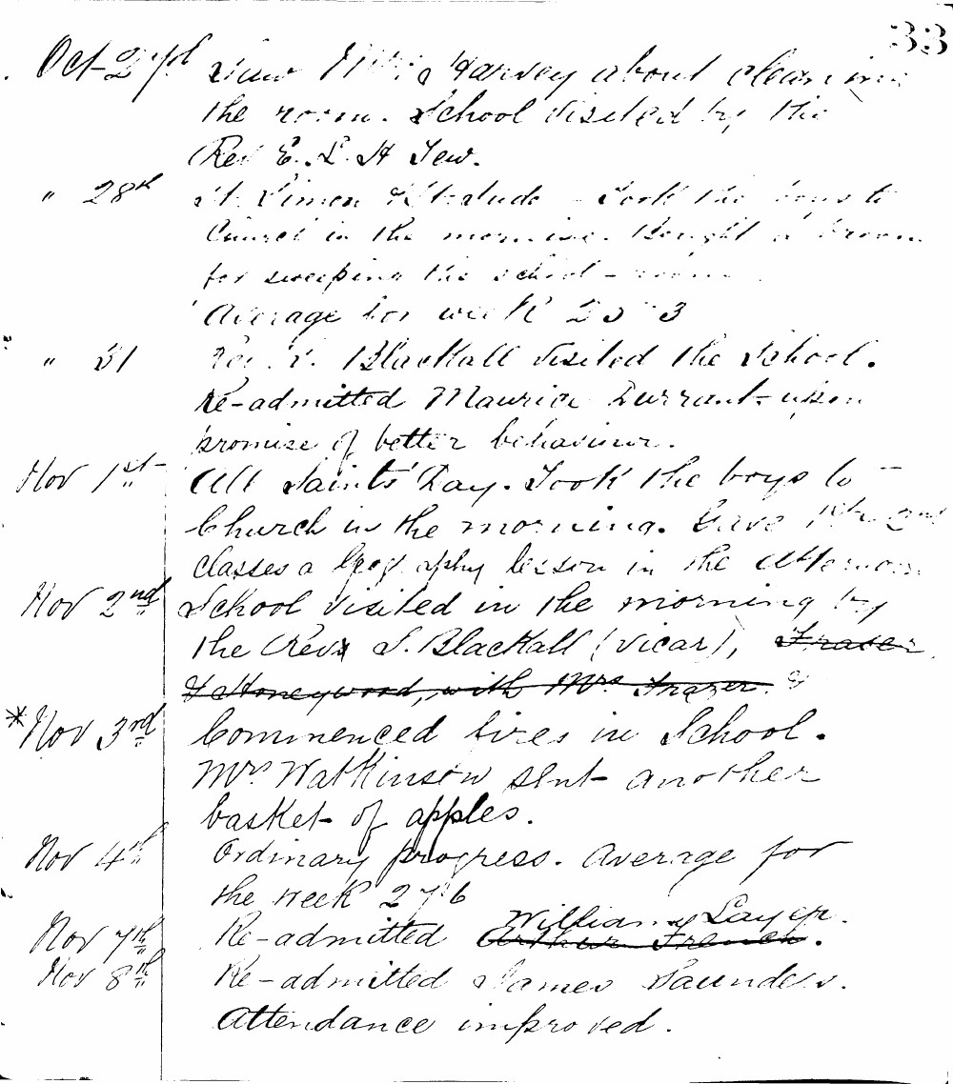

33
Oct 27th Saw Mrs Harvey about cleaning the room. School visited by the Rev E. L. H Tew.
" 28th St Simon & St Jude - Took the boys to Church in the morning. Bought a broom for sweeping the school-room. Average for week 25.3
" 31 Rev S. Blackhall visited the school. Re-admitted Maurice Durrant upon promise of better behaviour.
Nov 1st All Saints' Day. Took the boys to Church in the morning. Gave the 2nd classes a Geography lesson in the afternoon.
Nov 2nd School visited in the morning by the Rev S. Blackhall (vicar).
*Nov 3rd Commenced fires in school. Mr Watkinson sent another basket of apples.
Nov 4th Ordinary progress. Average for the week 27.6
Nov 7th Re-admitted William Layer.
Nov 8th Re-admitted James Saunders. Attendance improved.

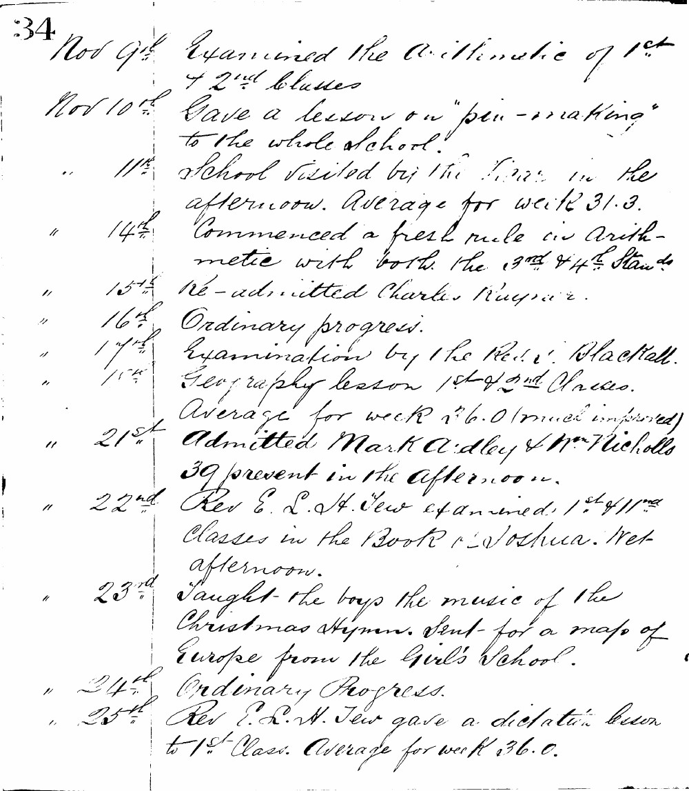

34
Nov 9th Examined the Arithmetic of 1st & 2nd Classes
Nov 10th Gave a lesson on "pin-making" to the whole school.
" 11th School visited by the Vicar in the afternoon. Average for week 31.3.
" 14th Commenced a fresh rule in Arithmetic with both the 3rd & 4th Stands
" 15th Re-admitted Charles Rayner.
" 16th Ordinary progress.
" 17th Examination by the Rev. E. Blackall.
" 18th Geography lesson 1st & 2nd Classes. Average for week 26.0 (much improved)
" 21st Admitted Mark Adley & Wm Nicholls 39 present in the afternoon.
" 22nd Rev E. L. H. Tew examined 1st & 2nd Classes in the Book of Joshua. Wet afternoon.
" 23rd Taught the boys the music of the Christmas Hymn. Sent for a map of Europe from the Girl's School.
" 24th Ordinary Progress.
" 25th Rev E. L. H. Tew gave a dictation lesson to 1st Class. Average for week 36.0.

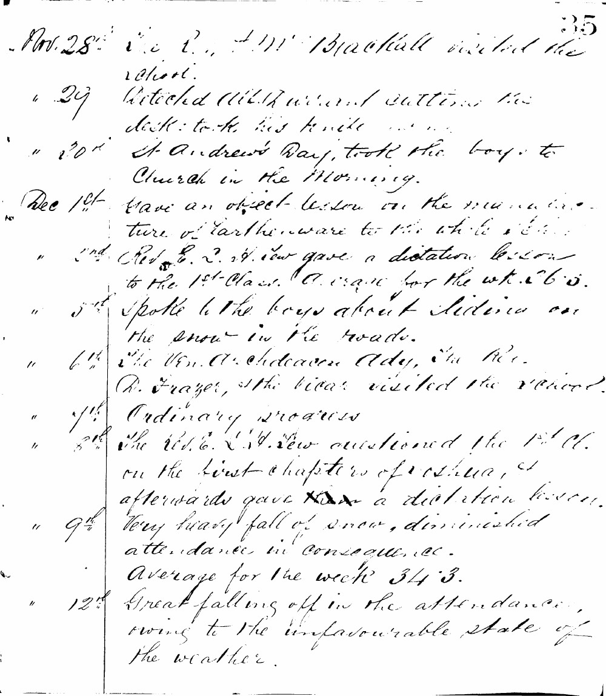

35
Nov. 28th The Rev. W. Blackall visited the school.
" 29 Detected Albert Ward cutting the desk: took his knife away.
" 30th St. Andrew's Day, took the boys to Church in the Morning.
Dec 1st Gave an object-lesson on the manufacture of earthenware to the whole school.
" 2nd Rev. E. W. New gave a dictation lesson to the 1st Class. Average for the week 65.
" 5th Spoke to the boys about sliding on the snow in the roads.
" 6th The Ven. Archdeacon Ady, the Rev. R. Frazer, & the Vicar visited the school.
" 7th Ordinary progress
" 8th The Rev. E. W. New questioned the 1st Cl. on the first chapters of Joshua, & afterwards gave a dictation lesson.
" 9th Very heavy fall of snow, diminished attendance in consequence.
Average for the week 34.3.
" 12th Great falling off in the attendance, owing to the unfavourable state of the weather.

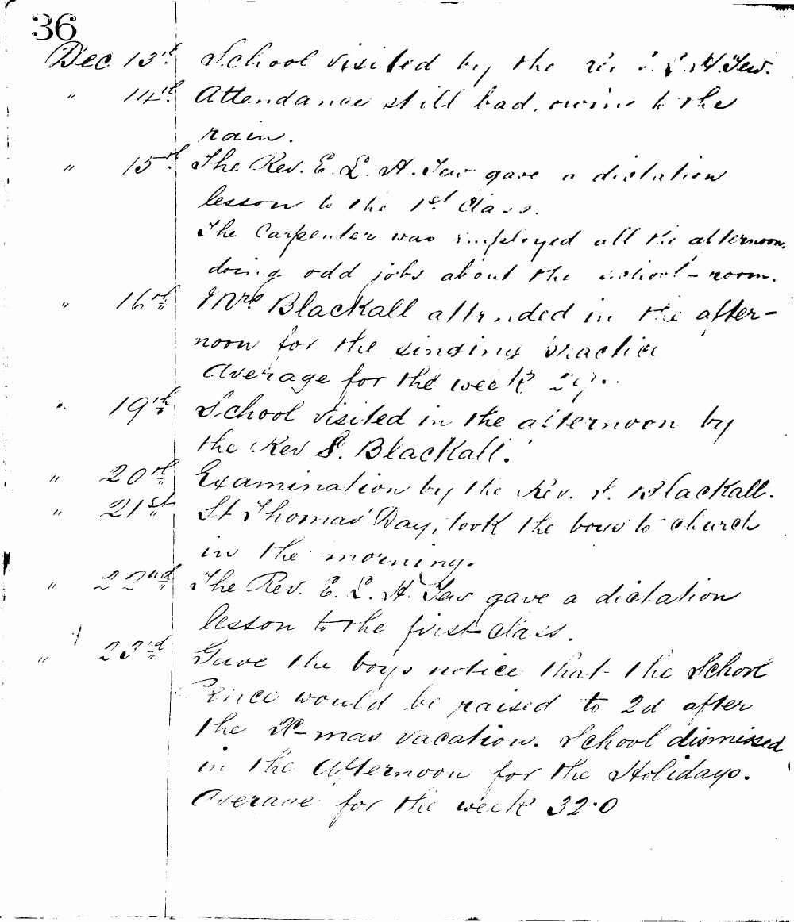

36
Dec 13th School visited by the Rev. S. H. Tew.
" 14th Attendance still bad, owing to the rain.
" 15th The Rev. E. L. H. Tew gave a dictation lesson to the 1st Class. The Carpenter was employed all the afternoon doing odd jobs about the school-room.
" 16th Mrs Blackall attended in the afternoon for the singing practice Average for the week 27.
" 19th School visited in the afternoon by the Rev S. Blackall.
" 20th Examination by the Rev. S. Blackall.
" 21st St Thomas' Day, took the boys to church in the morning.
" 22nd The Rev. E. L. H. Tew gave a dictation lesson to the first class.
" 23rd Gave the boys notice that the school pence would be raised to 2d after the Xmas vacation. School dismissed in the afternoon for the Holidays. Average for the week 32.0

