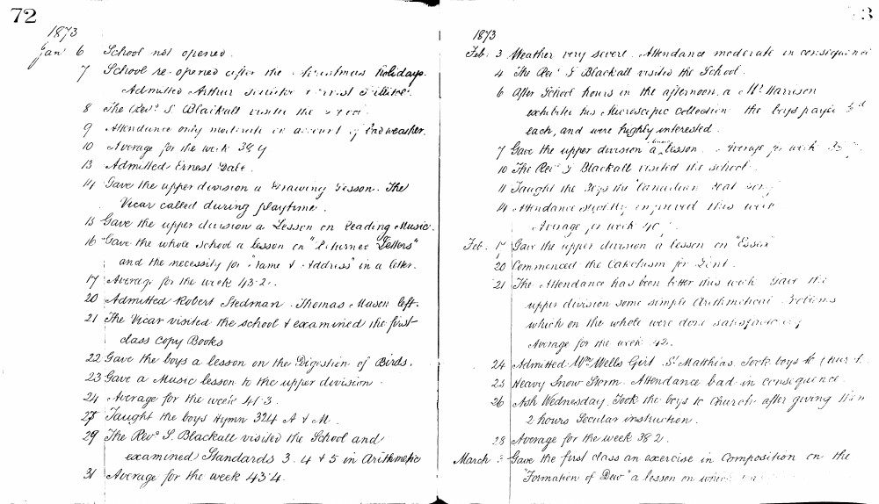

72
1873
Jan 6 School not opened.
7 School re-opened after the Christmas holidays. Admitted Arthur Smith & Ernest Pittard.
8 The Revd. S. Blackall visited the school.
9 Attendance only moderate on account of bad weather.
10 Average for the week 38.9.
13 Admitted Ernest Galt.
14 Gave the upper division a Drawing Lesson. The Vicar called during playtime.
15 Gave the upper division a Lesson on Reading Music.
16 Gave the whole school a lesson on "Returns & Letters" and the necessity for "Name & Address" in a letter.
17 Average for the week 43.2.
20 Admitted Robert Stedman. Thomas Mason left.
21 The Vicar visited the school & examined the first class copy Books.
22 Gave the boys a lesson on the Digestion of Birds.
23 Gave a Music lesson to the upper division.
24 Average for the week 41.3.
27 Taught the boys Hymn 324 A & M.
29 The Revd. S. Blackall visited the School and examined Standards 3. 4 & 5 in Arithmetic.
31 Average for the week 43.4.
1873
Feb: 3 Weather very severe. Attendance moderate in consequence.
4 The Revd. S. Blackall visited the School.
6 After School hours in the afternoon, a Mr Harrison exhibited his Microscopic collection the boys paid 1d each, and were highly interested.
7 Gave the upper division a lesson. Average for week 35.7.
10 The Revd. S. Blackall visited the school.
11 Taught the boys the "Canadian Boat Song".
14 Attendance slightly improved this week. Average for week 40.1.
Feb. 17 Gave the upper division a lesson on "Essex".
20 Commenced the Catechism for Lent.
21 The Attendance has been better this week. Gave the upper division some simple Arithmetical Problems which on the whole were done satisfactorily. Average for the week 42.
24 Admitted Wm Wells Girl St Matthias. Took boys to Church.
25 Heavy Snow Storm. Attendance bad in consequence.
26 Ash Wednesday. Took the boys to Church after giving them 2 hours Secular instruction.
28 Average for the week 38.2.
March 3 Gave the first class an exercise in Composition on the "Formation of Dew" a lesson on which was given.

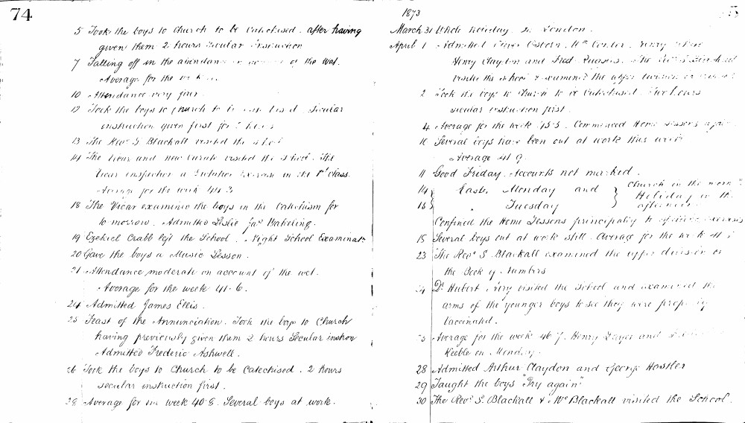

74
5 Took the boys to Church to be Catechised after having given them 2 hours Secular Instruction
7 Falling off in the attendance on account of the Wet. Average for the week
10 Attendance very fair.
12 Took the boys to Church to be Catechised. Secular instruction given first for 2 hours
13 The Revd S. Blackall visited the school
14 The Vicar and new Curate visited the school. The Vicar inspected a Dictation exercise in the 1st class. Average for the week 44.3
18 The Vicar examined the boys in the Catechism for tomorrow. Admitted Leslie Jas Wakeling.
19 Ezekiel Crabb left the School. Night School Examination
20 Gave the boys a Music Lesson.
21 Attendance moderate on account of the wet. Average for the week 41.6.
24 Admitted James Ellis.
25 Feast of the Annunciation. Took the boys to Church having previously given them 2 hours Secular instruction Admitted Frederic Ashwell.
26 Took the boys to Church to be Catechised. 2 hours secular instruction first.
28 Average for the week 40.8. Several boys at work.
1873
March 31 Whole holiday. In London.
April 1 Admitted Amos Ostern, Wm Carter, Henry Tabor Henry Clayton and Fred Quasas. The Revd S. Blackall visited the school & examined the upper division in reading
2 Took the boys to Church to be Catechised. Two hours secular instruction first.
4 Average for the week 45.5. Commenced Home Lessons again
10 Several boys have been out at work this week Average 41.9.
11 Good Friday. Accounts not marked.
14 Easter Monday and Tuesday } Church in the morn Holiday in the afternoon
15 Confined the Home Lessons principally to spelling exercises
18 Several boys out at work still. Average for the week 41.1
23 The Revd S. Blackall examined the upper division in the Book of Numbers
24 Dr Hubert Airy visited the School and examined the arms of the younger boys to see they were properly vaccinated.
25 Average for the week 46.7. Henry Layer and Frederick Keeble on Monday.
28 Admitted Arthur Claydon and George Hostler
29 Taught the boys "Try again"
30 The Revd S. Blackall & Wm Blackall visited the School.

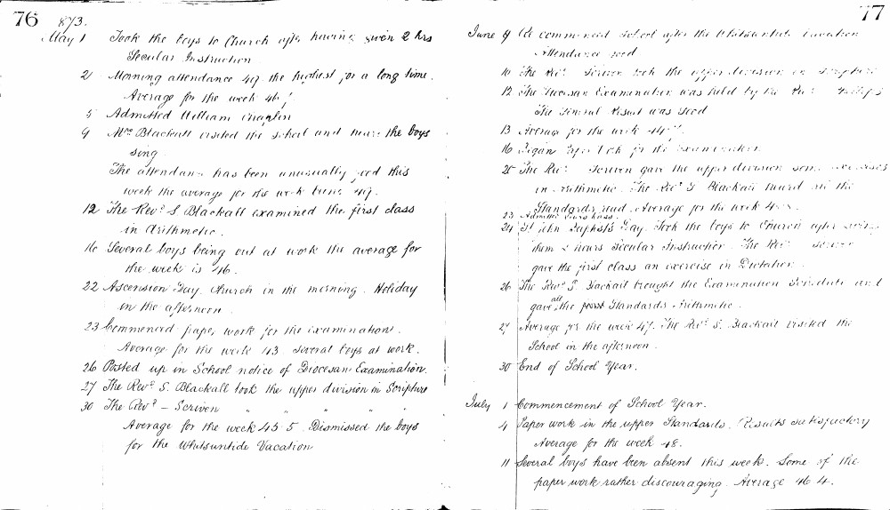

76 87/3.
May 1 Took the boys to Church after having given 2 hrs Secular Instruction
2 Morning attendance 49 the highest for a long time. Average for the week 46.1
5 Admitted William Chaplin
9 Mrs Blackall visited the school and heard the boys sing. The attendance has been unusually good this week the average for the week being 49.
12 The Revd S. Blackall examined the first class in Arithmetic. Several boys being out at work the average for the week is 46.
22 Ascension Day. Church in the morning. Holiday in the afternoon.
23 Commenced paper work for the examination. Average for the week 43. Several boys at work.
26 Posted up in School notice of Diocesan Examination.
27 The Revd S. Blackall took the upper division in Scripture
30 The Revd - Scriven " " " " Average for the week 45.5. Dismissed the boys for the Whitsuntide Vacation
77
June 9 Commenced school after the Whitsuntide Vacation Attendance good.
10 The Revd Scriven took the upper division in Scripture
12 The Diocesan Examination was held by the Revd Philips. The General Result was Good
13 Average for the week 44.7
16 Began paper work for the examination.
20 The Revd Scriven gave the upper division some exercises in Arithmetic. The Revd S. Blackall heard all the Standards read. Average for the week 45.8.
23 Admitted Edward Ross
24 St John Baptist's Day. Took the boys to Church after giving them 2 hours Secular Instruction. The Revd Scriven gave the first class an exercise in Dictation.
26 The Revd S. Blackall brought the Examination Schedule and gave all the Standards Arithmetic.
27 Average for the week 47. The Revd S. Blackall visited the School in the afternoon.
30 End of School Year.
July 1 Commencement of School Year.
4 Paper work in the upper Standards. Results satisfactory Average for the week 48.
11 Several boys have been absent this week. Some of the paper work rather discouraging. Average 46.4.

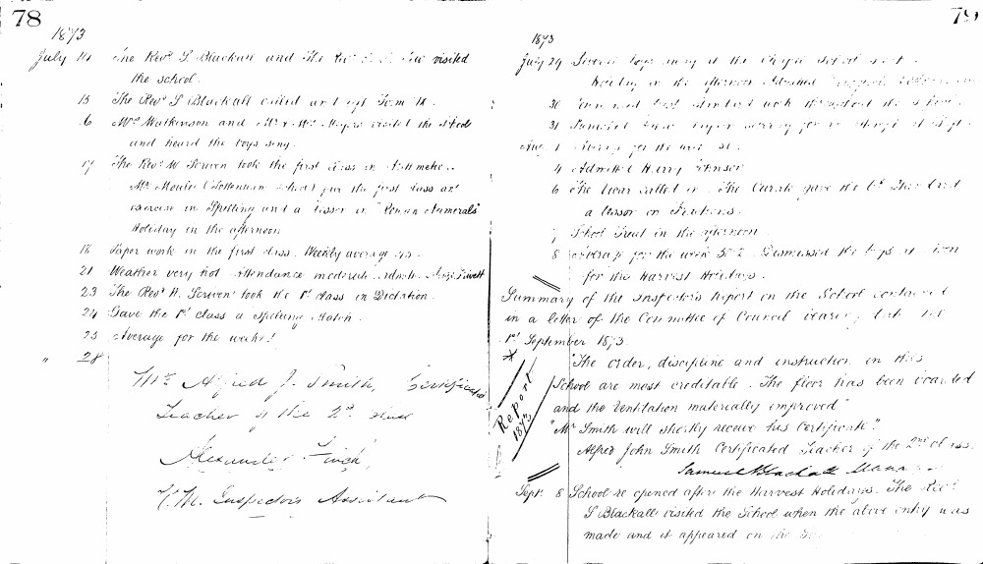

78
1873
July 14 The Revd S. Blackall and the Revd E. J. Luce visited the school.
15 The Revd S. Blackall called at 1.45 P.M. H.
16 Mr Watkinson and Mr & Mrs Major visited the school and heard the boys sing.
17 The Revd W. Scriven took the first class in Arithmetic.
Mr Moule (Tottenham School) gave the first class an exercise in Spelling and a lesson on "Roman Numerals"
Holiday in the afternoon.
18 Paper work in the first class. Weekly average 45.
21 Weather very hot Attendance moderate. Admitted George Rivett
23 The Revd W. Scriven took the 1st class in Dictation.
24 Gave the 1st class a spelling Match.
25 Average for the week 41
28
Mr Alfred J. Smith, Certificated Teacher of the 2nd class
Alexander Finch,
V. M. Inspector's Assistant
79
1873
July 29 Several boys away at the Choir Depot feast.
Weather in the afternoon detained many of the boys.
30 Attendance last about 40 throughout the school.
31 Dismissed for a major holiday for a fortnight at night.
Aug 1 Holiday for the next 14.
4 Admitted Harry Atkinson
6 The Vicar called in. The Curate gave the 1st & 2nd class a lesson on Fractions.
7 School Treat in the afternoon.
8 Average for the week 38.2 Dismissed the boys at noon for the Harvest Holidays.
Summary of the Inspector's Report on the School contained in a letter of the Committee of Council bearing date the 1st September 1873.
Report 1873
"The order, discipline and instruction in this School are most creditable. The floor has been boarded and the ventilation materially improved"
"Mr Smith will shortly receive his certificate."
Alfred John Smith Certificated Teacher of the 2nd class.
Samuel Blackall Manager
Sept 8 School re-opened after the Harvest Holidays. The Revd S Blackall visited the School when the above entry was made and it appeared on the Log.

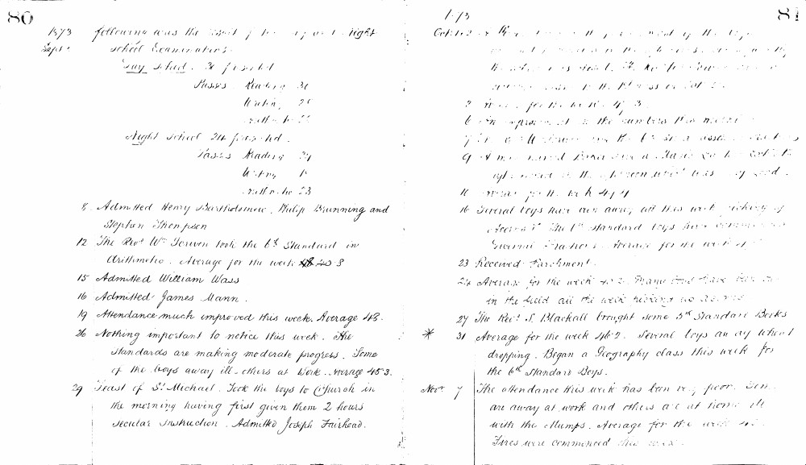

80
1873 Septr. following was the result of the Day and Night school Examination.
Day School. 31 presented
Passes Reading 31
Writing 26
Arith. 25
Night school 24 presented.
Passes Reading 24
Writing 18
Arith. 23
8 Admitted Henry Bartholomew, Philip Brunning and Stephen Thompson
12 The Revd. W. Scriven took the 6th Standard in Arithmetic. Average for the week 40.3
15 Admitted William Wass
16 Admitted James Mann.
19 Attendance much improved this week. Average 43.
26 Nothing important to notice this week. The standards are making moderate progress. Some of the boys away ill - others at work. Average 45.3.
29 Feast of St. Michael. Took the boys to Church in the morning having first given them 2 hours Secular Instruction. Admitted Joseph Fairhead.
81
Oct: 1, 2, 3 These days by the permission of the Managers I was absent in London to see the International Exhibition. The school was left to the Pupil Teacher and monitors. Average for the week 41.
2 Average for the week 47.3
6 An improvement in the numbers this week.
7 Revd. S. Blackall took the 6th St. in Arith. and Dictation.
9 A man named Bond and a Mason came to look at the roof of the school which was very bad.
10 Average for the week 47.4
16 Several boys have been away all this week picking up Acorns. The 1st Standard boys have commenced Drawing Lessons. Average for the week 41.7
23 Received Parchment.
24 Average for the week 40.2. Many boys have been out in the field all the week picking up acorns.
27 The Revd. S. Blackall brought some 5th Standard Books
31 Average for the week 46.2. Several boys away school dropping. Began a Geography class this week for the 6th Standard Boys.
Novr. 7 The attendance this week has been very poor. Some are away at work and others are at home ill with the Mumps. Average for the week 40.5. Fires were commenced this week.

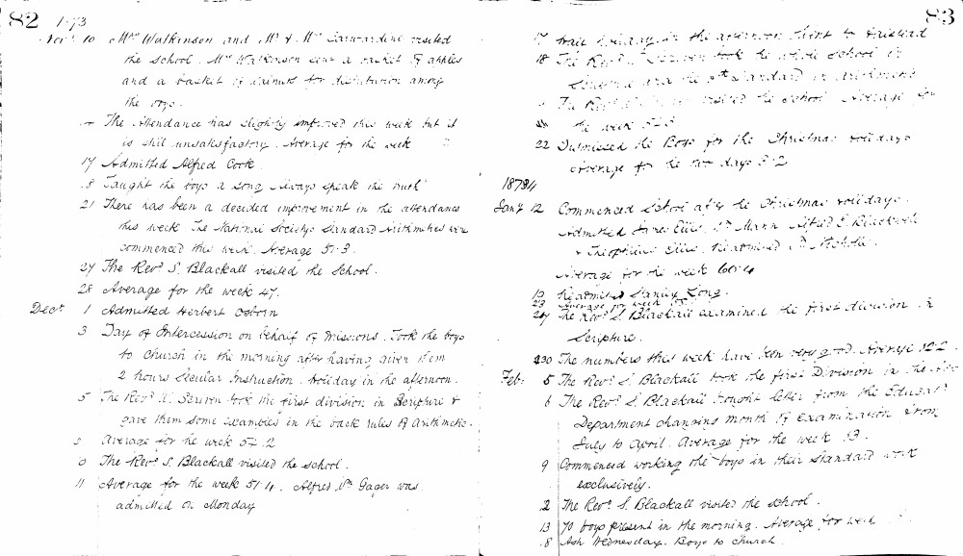

82 1873
Nov 10 Mrs Watkinson and Mr & Mrs Carwardine visited the school. Mrs Watkinson gave a basket of apples and a basket of walnuts for distribution among the boys.
The attendance has slightly improved this week but it is still unsatisfactory. Average for the week
17 Admitted Alfred Cook.
18 Taught the boys a song 'Always speak the truth'
21 There has been a decided improvement in the attendance this week. The National Society's Standard Arithmetics were commenced this week. Average 51.3.
27 The Revd S. Blackall visited the school.
28 Average for the week 47.
Decr 1 Admitted Herbert Osborn.
3 Day of Intercession on behalf of Missions. Took the boys to Church in the morning after having given them 2 hours secular instruction. Holiday in the afternoon.
5 The Revd W. Scriven took the first division in Scripture & gave them some exercises in the back rules of Arithmetic.
8 Average for the week 54.2
10 The Revd S. Blackall visited the school.
11 Average for the week 51.4. Alfred Wm Gager was admitted on Monday.
17 Free holiday in the afternoon. Went to Stratford.
18 The Revd S. Blackall took the whole school in Scripture and the 5th Standard in Arithmetic.
19 The Revd S. Blackall visited the school. Average for the week 52.8.
22 Dismissed the boys for the Christmas holidays. Average for the two days 52.
83
1874
Jany 12 Commenced school after the Christmas holidays. Admitted James Ellis, Wm Mann, Arthur E. Blackwell & Theophilus Ellis. Readmitted A. Rohda. Average for the week 60.4
19 Readmitted Sidney Long.
23 Average for week 55.1
27 The Revd S. Blackall examined the first division in Scripture.
30 The numbers this week have been very good. Average 62.2.
Feb: 5 The Revd S. Blackall took the first Division in the afternoon.
6 The Revd S. Blackall brought letter from the Education Department changing month of Examination from July to April. Average for the week 63.
9 Commenced working the boys in their Standard work exclusively.
12 The Revd S. Blackall visited the school.
13 70 boys present in the morning. Average for week 61.3.
18 Ash Wednesday. Boys to Church.

