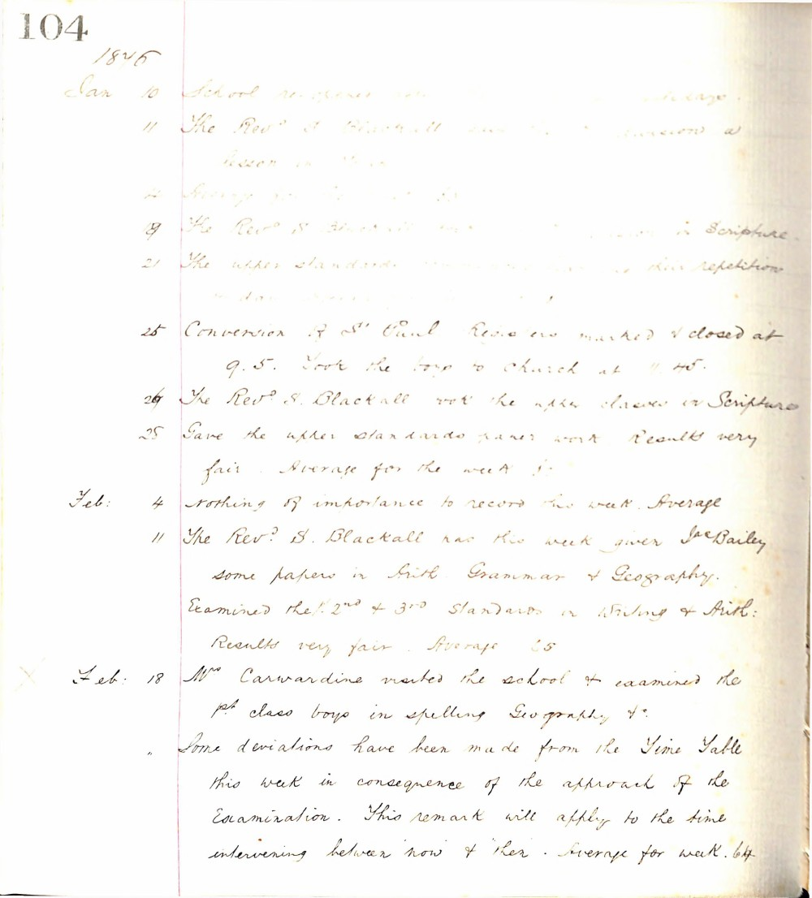

104
1876
Jan 10 School re-opened after the holidays.
11 The Revd S. Blackall gave the upper division a lesson in Scripture.
12 Average for the week 60.
19 The Revd S. Blackall gave the upper division in Scripture.
21 The upper standards commenced their repetition in class.
25 Conversion of St Paul. Registers marked & closed at 9.5. Took the boys to church at 11.45.
26 The Revd S. Blackall took the upper classes in Scripture.
25 Gave the upper standards paper work. Results very fair. Average for the week 61.
Feb: 4 Nothing of importance to record this week. Average 60.
11 The Revd S. Blackall has this week given Jas Bailey some papers in Arith. Grammar & Geography. Examined the 1st 2nd & 3rd Standards in Writing & Arith: Results very fair. Average 65.
Feb: 18 Mrs Carwardine visited the school & examined the 1st class boys in spelling Geography &c.
Some deviations have been made from the Time Table this week in consequence of the approach of the Examination. This remark will apply to the time intervening between now & then. Average for week. 64

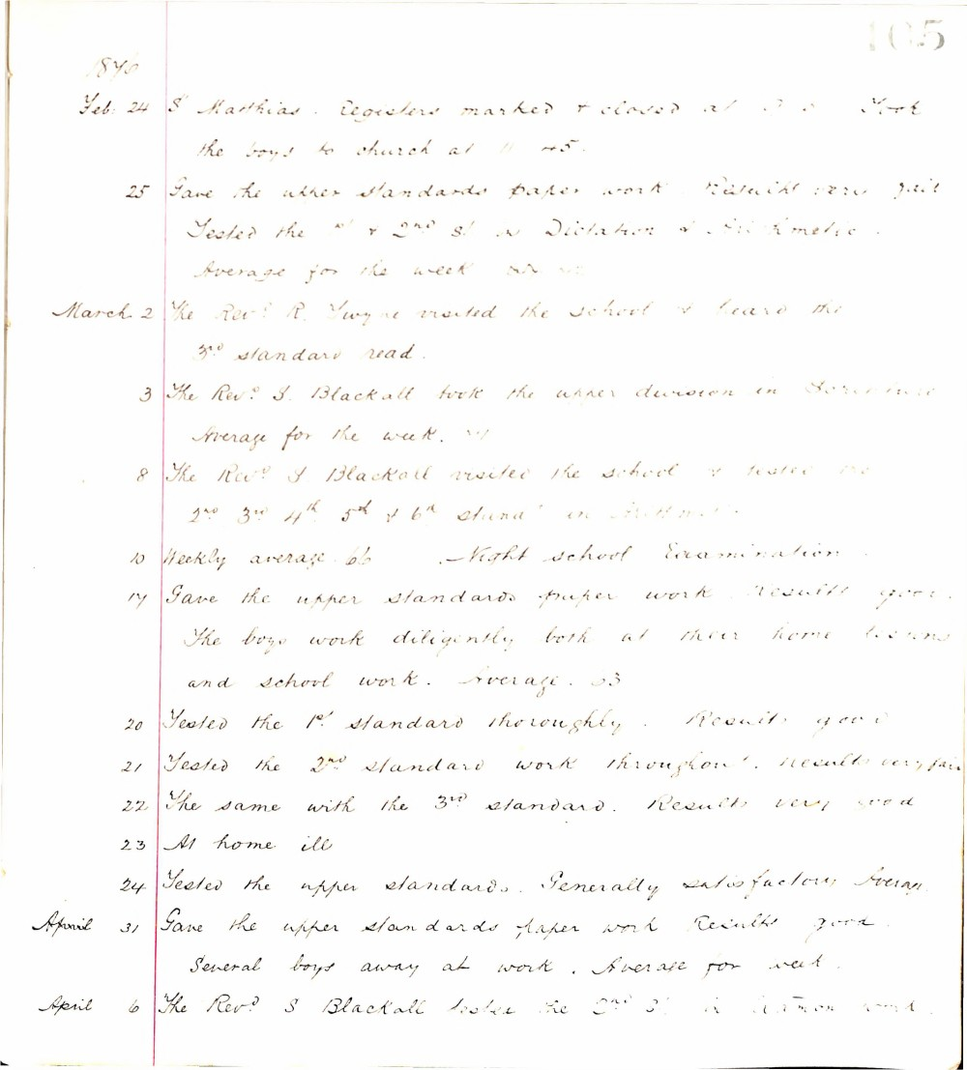

105
1876
Feb. 24 St Matthias. Registers marked & closed at 9.0 York the boys to church at 11.45.
25 Gave the upper standards paper work. Results very fair. Tested the 1st & 2nd St in Dictation & Arithmetic. Average for the week 52.4
March 2 The Revd R. Twyne visited the school & heard the 3rd standard read.
3 The Revd S. Blackall took the upper division in Scripture. Average for the week 51
8 The Revd S. Blackall visited the school & tested the 2nd 3rd 4th 5th & 6th Stand in Arithmetic.
10 Weekly average 66 Night school Examination
17 Gave the upper standards paper work. Results good. The boys work diligently both at their home lessons and school work. Average 53
20 Tested the 1st standard thoroughly. Results good
21 Tested the 2nd standard work throughout. Results very fair
22 The same with the 3rd standard. Results very good
23 At home ill
24 Tested the upper standards. Generally satisfactory. Average
April 31 Gave the upper standards paper work Results good. Several boys away at work. Average for week.
April 6 The Revd S. Blackall tested the 2nd St in Grammar work.

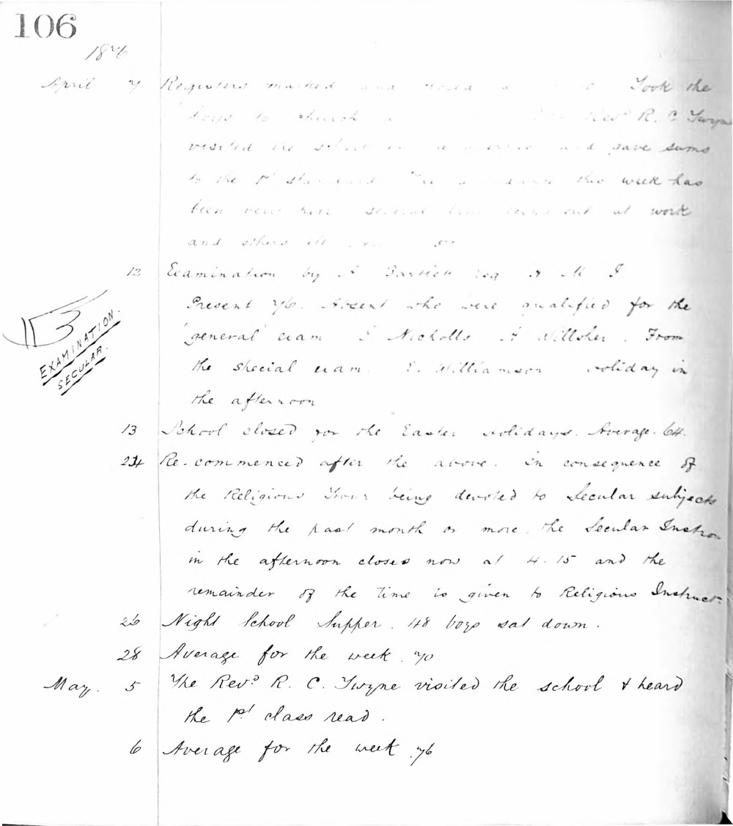

106
1876
April 7 Registers marked and closed at 9.30. Took the boys to church at 11.00. The Revd. R. C. Twyne visited the school in the afternoon and gave sums to the 1st standard. The attendance this week has been very poor several boys being out at work and others ill with cold.
12 Examination by J. Bastick Esq. H. M. I.
Present 76. Absent who were qualified for the 'general' exam. J. Nicholls, F. Willsher. From the special exam. F. Williamson. Holiday in the afternoon.
13 School closed for the Easter holidays. Average 64.
24 Re-commenced after the above. In consequence of the Religious Hour being devoted to Secular subjects during the past month or more, the Secular Instruc. in the afternoon closes now at 4.15 and the remainder of the time is given to Religious Instruct.
26 Night School Supper. 48 boys sat down.
28 Average for the week. 70
May 5 The Revd. R. C. Twyne visited the school & heard the 1st class read.
6 Average for the week 76

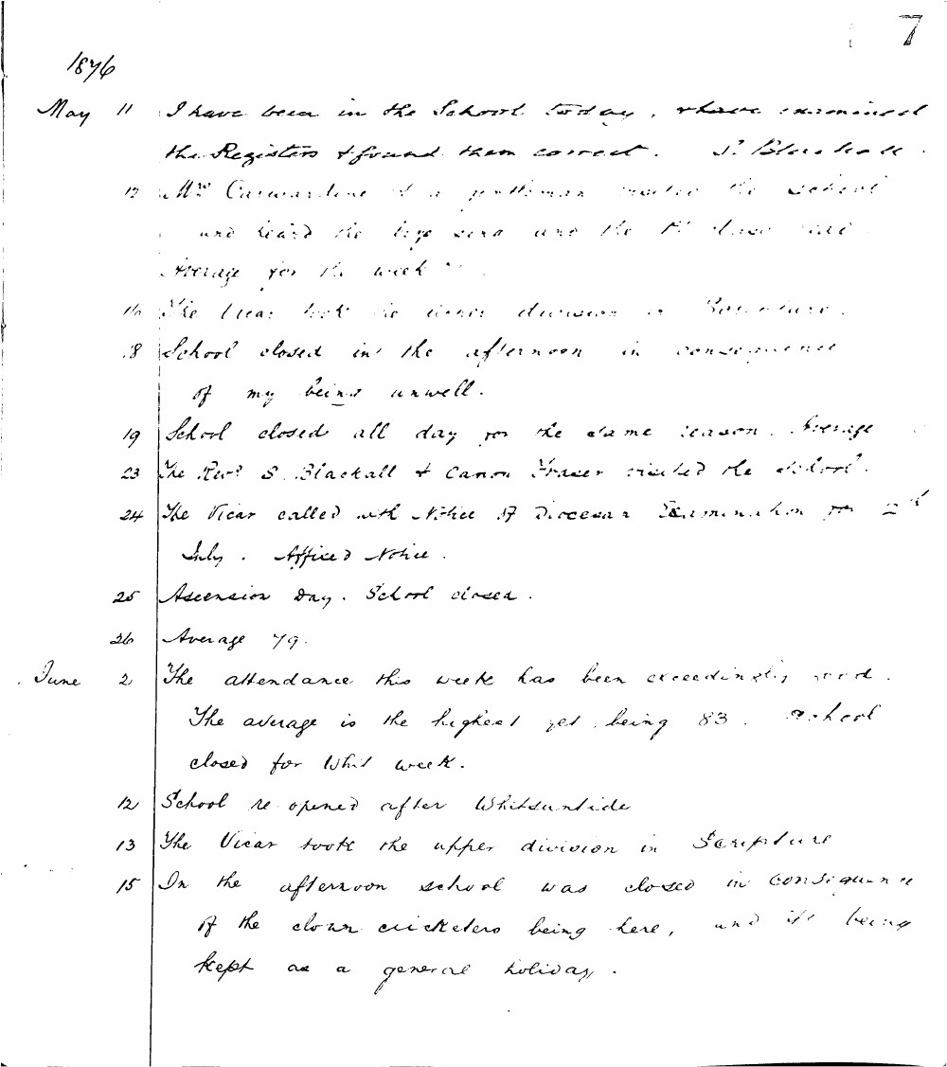

7
1876
May 11 I have been in the School today, where examined the Registers & found them correct. J. Blackhall
12 Mrs Carwardine & a gentleman visited the school and heard the boys read and the 1st class arithmetic. Average for the week 77.
16 The Vicar took the upper division in Scripture.
18 School closed in the afternoon in consequence of my being unwell.
19 School closed all day for the same reason. Average 77.
23 The Revd S. Blackall & Canon Fraser visited the school.
24 The Vicar called with Notice of Diocesan Examination for 2nd July. Affixed Notice.
25 Ascension day. School closed.
26 Average 79.
June 2 The attendance this week has been exceedingly good. The average is the highest yet, being 83. School closed for Whit week.
12 School re-opened after Whitsuntide.
13 The Vicar took the upper division in Scripture.
15 In the afternoon school was closed in consequence of the clown cricketers being here, and it being kept as a general holiday.

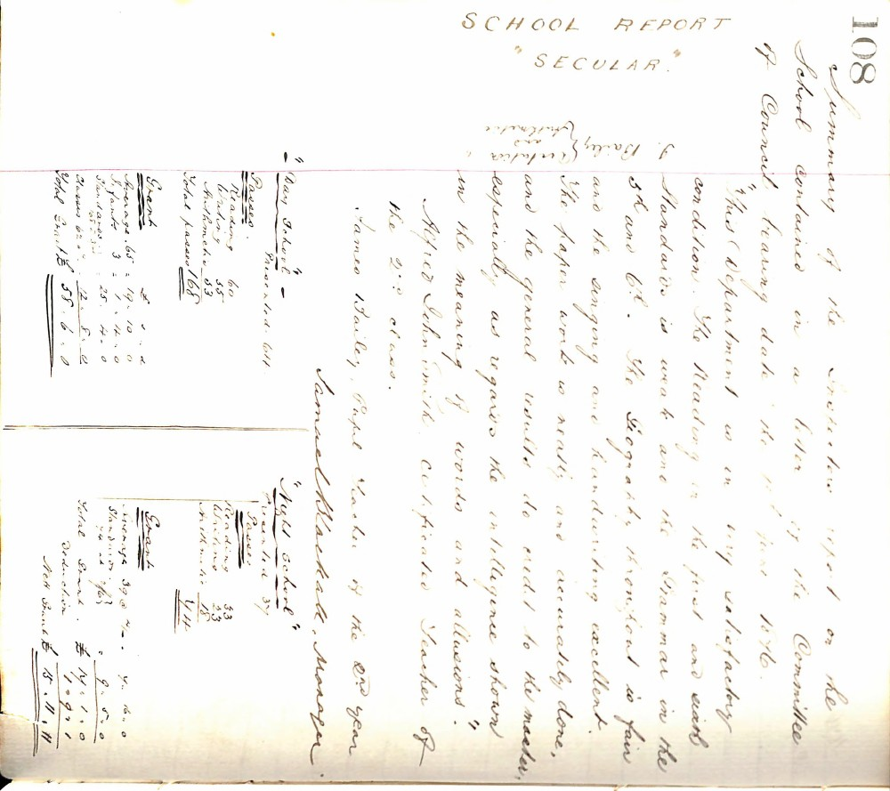

108
Summary of the Inspector's report on the School contained in a letter of the Committee of Council bearing date the 1st of June 1876.
SCHOOL REPORT
"SECULAR."
"This Department is in very satisfactory condition. The Reading in the first and sixth Standards is weak and the Grammar in the 5th and 6th. The Geography throughout is fair and the singing and handwriting excellent. The paper work is neatly and accurately done, and the general results do credit to the master, especially as regards the intelligence shown in the meaning of words and allusions."
Alfred John Smith, certificated Teacher of the 2nd class.
James Bailey, Pupil Teacher of the 2nd year.
Samuel Blackhall, Manager.
"Day School"
Presented 64
Passes
Reading | 60
Writing | 55
Arithmetic | 53
Total passes | 168

Grant
 | £ | s | d
Average 65 | 19 | 10 | 0
Infants 3 | 1 | 4 | 0
Standards of 234 | 25 | 4 | 0
Classes 62 | 12 | 8 | 0
Total Grant | £ 58 | 6 | 0

"Night School"
Presented 37
Passes
Reading | 33
Writing | 23
Arithmetic | 18
 | 74

Grant
 | £ | s | d
Average 39 @ 4/- | 7 | 16 | 0
Standards 24 at 7/6 | 9 | 0 | 0
Total Grant | £ 16 | 16 | 0
Deduction | 1 | 0 | 1
Net Grant | £ 15 | 15 | 11

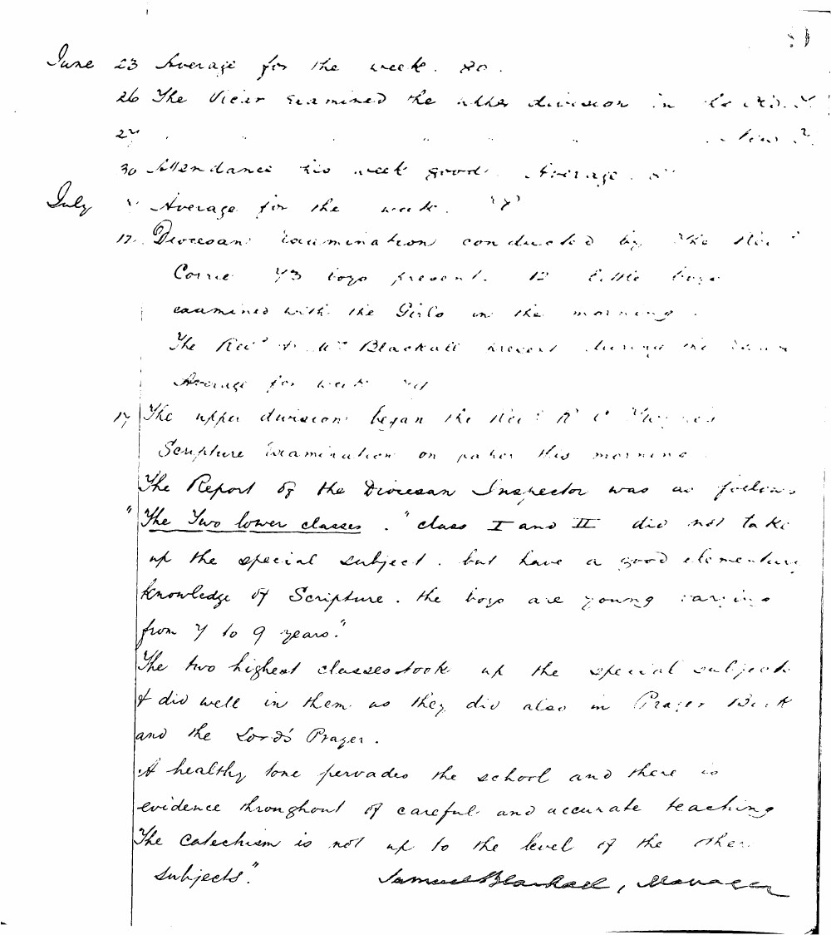

June 23 Average for the week. 80.
26 The Vicar examined the upper division in Scripture.
30 Attendance this week good. Average. 87
July 7 Average for the week. 87
17 Diocesan examination conducted by the Rev. J. Corne. 73 boys present. 12 little boys examined with the girls in the morning.
The Rev. S. M. Blackall present during the exam.
Average for week 78
17 The upper division began the Rev. R. C. Thorne's Scripture examination on paper this morning.
The Report of the Diocesan Inspector was as follows:
"The Two lower classes. class I and II did not take up the special subject but have a good elementary knowledge of Scripture. the boys are young varying from 7 to 9 years."
The two highest classes took up the special subject & did well in them as they did also in Prayer Book and the Lord's Prayer.
A healthy tone pervades the school and there is evidence throughout of careful and accurate teaching. The Catechism is not up to the level of the other subjects."
Samuel Blackall, Manager

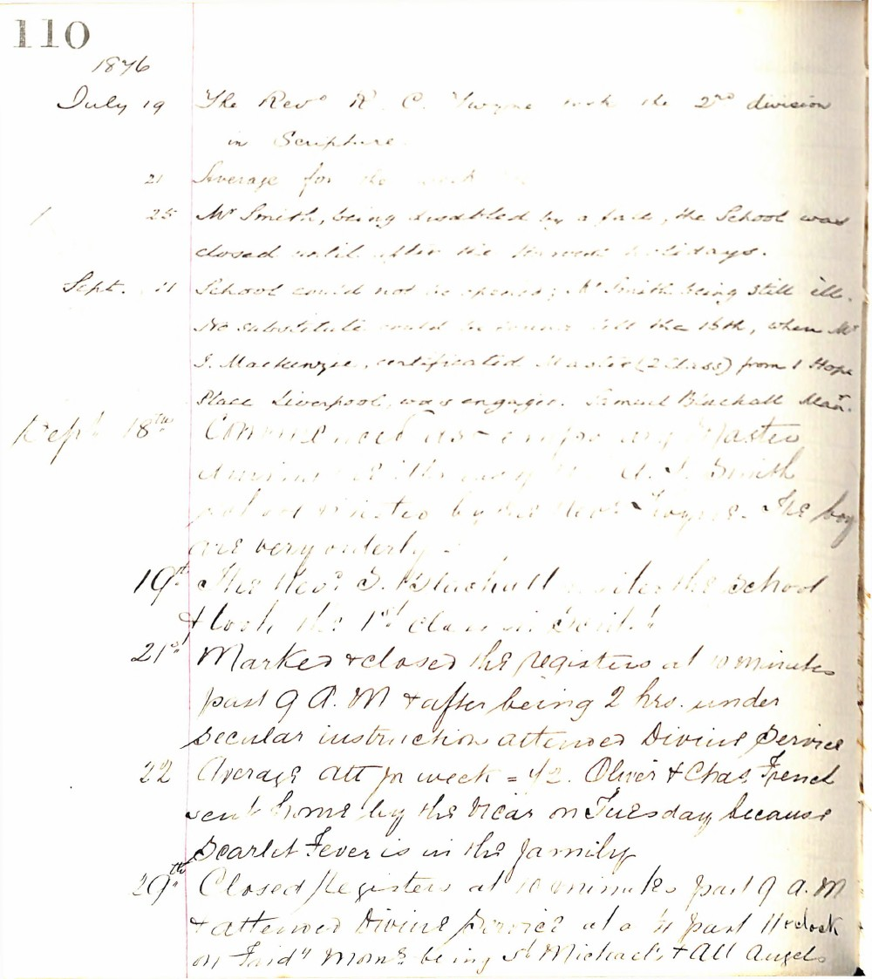

110
1846
July 19 The Revd R. C. Vayne took the 2nd division in Scripture.
21 Average for the week
25 Mr Smith, being disabled by a fall, the School was closed until after the Harvest holidays.
Sept. 11 School could not be opened; Mr Smith being still ill. No substitute could be found till the 15th, when Mr J. Mackenzie, certificated Master (2 Class) from 1 Hope Place Liverpool, was engaged. Samuel Blackhall Man.
Sept 18th Commenced as temporary Master during the illness of Mr J. Smith school visited by the Revd Vayne. The boys are very orderly.
19th The Revd S. Blackhall visited the school & took the 1st class in Script.
21st Marked & closed the registers at 10 minutes past 9 A.M & after being 2 hrs. under secular instruction attended Divine Service
22 Average attn week = 42. Oliver & Chas French sent home by the Vicar on Tuesday because Scarlet Fever is in the family
29th Closed Registers at 10 minutes past 9 a.m & attended Divine Service at a ¼ past 11 oclock on Friday morn being St Michael's & All Angels

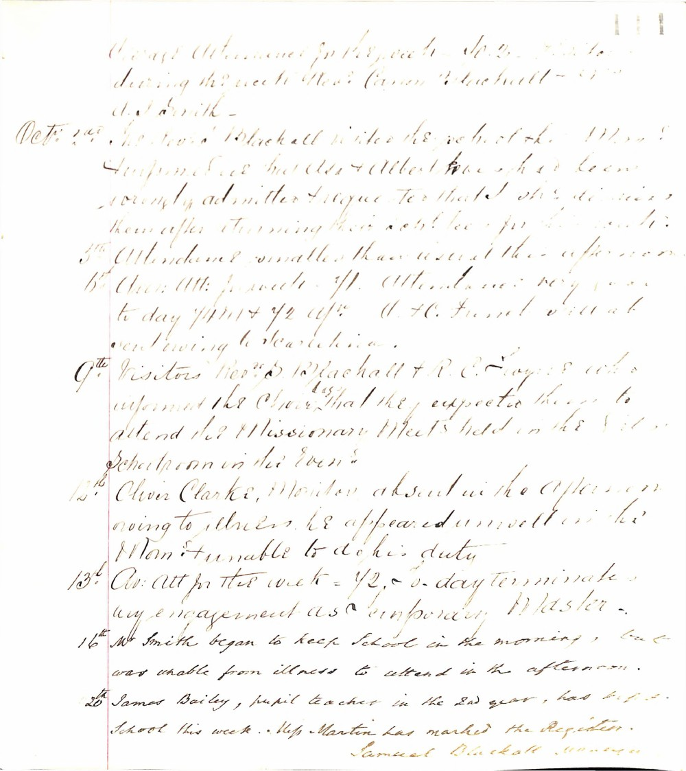

Average Attendance for the week - 102. Visitors during the week Revd Canon Blackhall - Mrs & Miss Smith -
Octr 2nd Revd Samuel Blackhall visited the school this Morn & informed me that Alex & Albert Bone who had been wrongly admitted & requested that she dismiss them after returning their school fees for this month.
3rd Attendance smaller than usual this afternoon.
6th Aver: Att: for week - 111. Attendance very poor today 74 m + 72 aftn. A. H. French visited school during the afternoon.
9th Visitors Revd S. Blackhall & R. C. Rogers Esq who informed the Choir that they expected them to attend the Missionary Meets held in the Girls Schoolroom in the Eveng.
12th Oliver Clarke, Monitor absent in the afternoon owing to illness he appeared unwell in the Morn & unable to do his duty.
13th Av: Att for the week - 112. - Today terminates my engagement as Temporary Master.
16th Mr Smith began to keep school in the morning, but was unable from illness to attend in the afternoon.
20th James Bailey, pupil teacher in the 2nd year, has kept school this week. Miss Martin has marked the Register.
Samuel Blackhall Manager

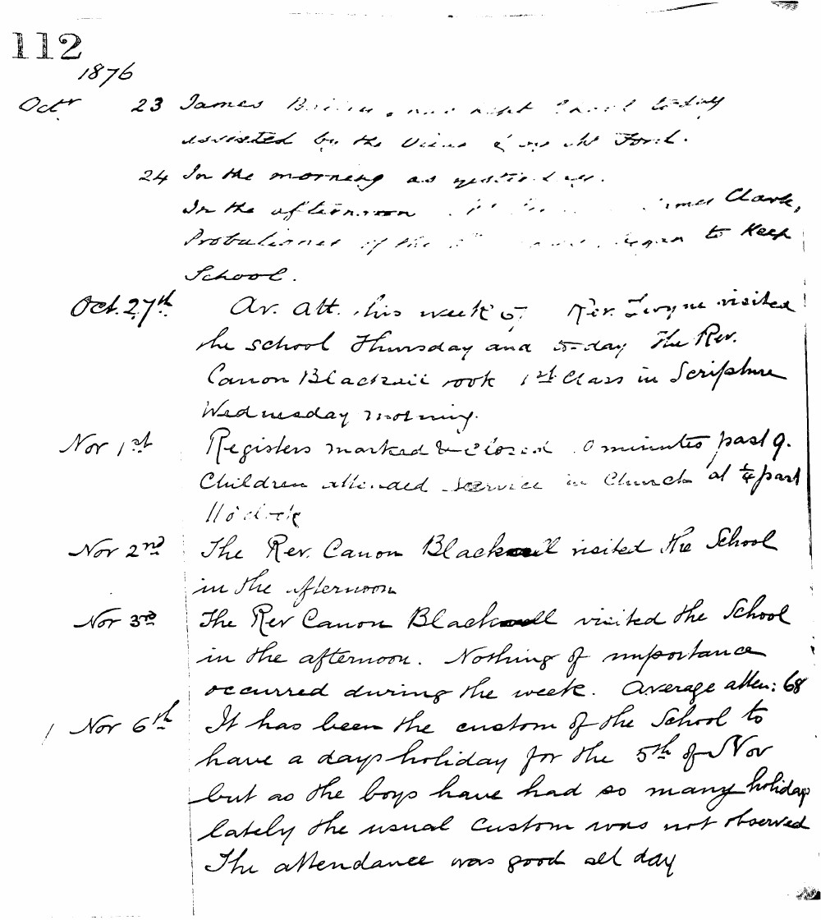

112
1876
Octr 23 James Briden, and night school today assisted by the Vicar & Mr Ford.
24 In the morning as yesterday. In the afternoon James Clark, Probationer of the school, began to keep school.
Oct. 27th Av. att. this week 67. Rev. Longue visited the school Thursday and today the Rev. Canon Blackwell took 1st Class in Scripture Wednesday morning.
Nov 1st Registers marked & closed 10 minutes past 9. Children attended service in Church at 1/4 past 11 o'clock.
Nov 2nd The Rev. Canon Blackwell visited the school in the afternoon.
Nov 3rd The Rev. Canon Blackwell visited the school in the afternoon. Nothing of importance occurred during the week. Average atten: 68
Nov 6th It has been the custom of the school to have a days holiday for the 5th of Nov but as the boys have had so many holidays lately the usual custom was not observed. The attendance was good all day.

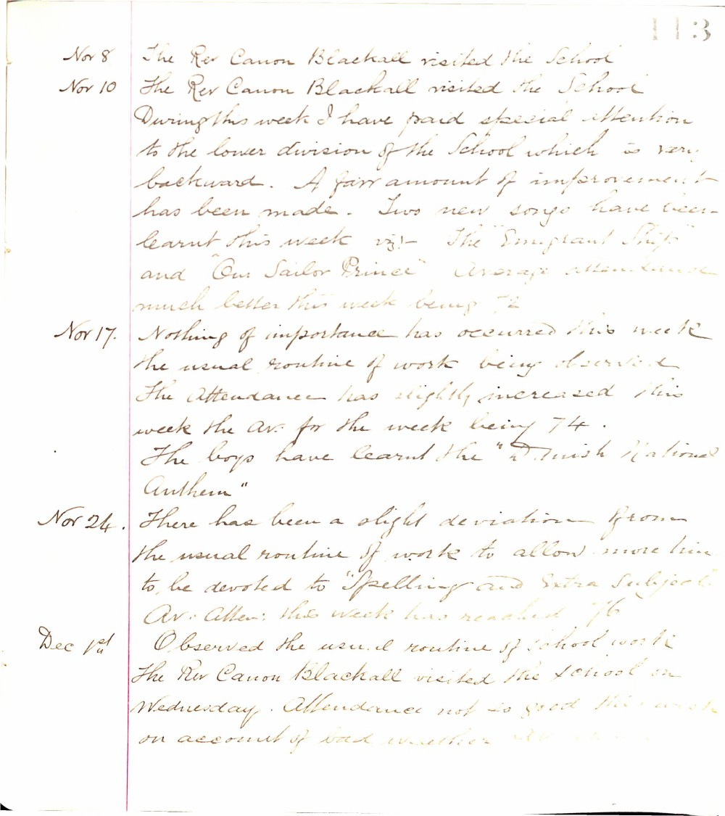

113
Nov 8 The Rev Canon Blackall visited the School
Nov 10 The Rev Canon Blackall visited the School During this week I have paid special attention to the lower division of the School which is very backward. A fair amount of improvement has been made. Two new songs have been learnt this week viz:- The "Emigrant Ship" and "Our Sailor Prince" Average attendance much better this week being 72
Nov 17. Nothing of importance has occurred this week the usual routine of work being observed. The attendance has slightly increased this week the Av. for the week being 74. The boys have learnt the "British National Anthem"
Nov 24. There has been a slight deviation from the usual routine of work to allow more time to be devoted to "Spelling and Extra Subjects" Av. Atten: this week has reached 76
Dec 1st Observed the usual routine of school work The Rev Canon Blackall visited the School on Wednesday. Attendance not so good this week on account of bad weather 66

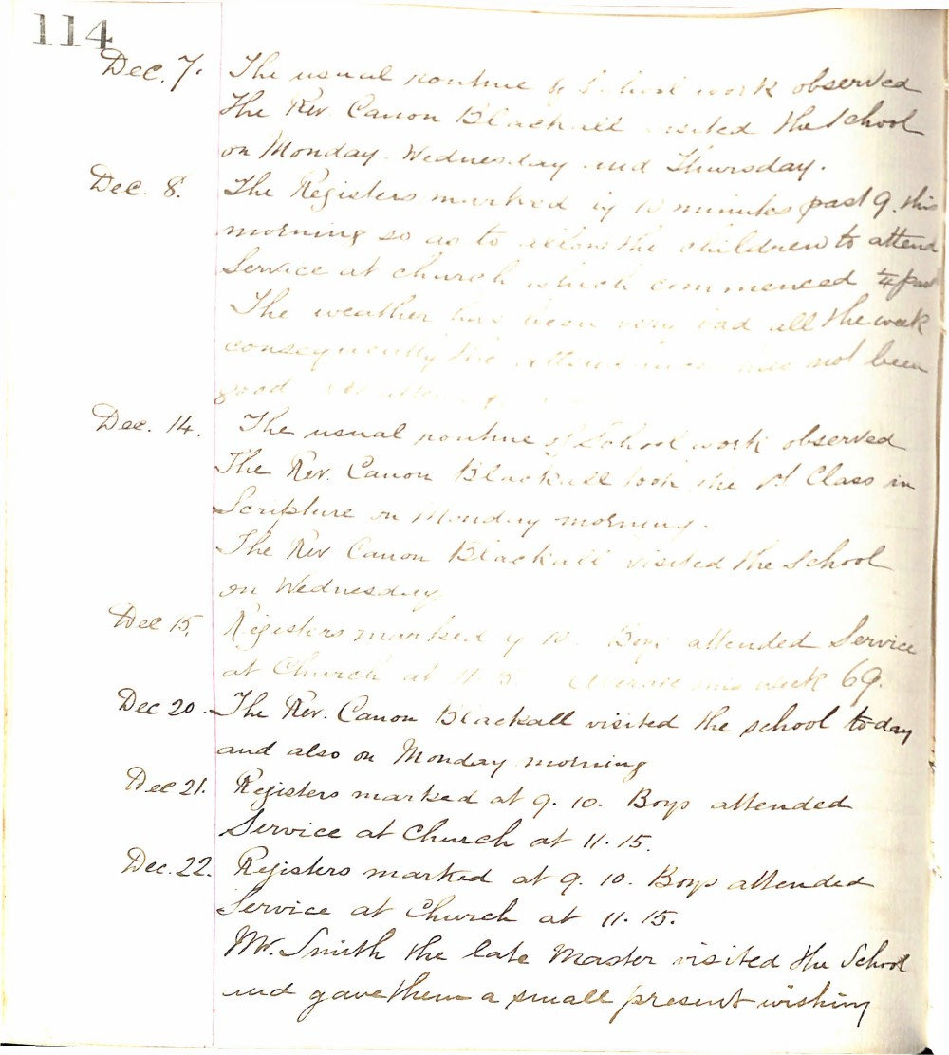

114
Dec. 7. The usual routine of School work observed The Rev. Canon Blackhall visited the School on Monday. Wednesday and Thursday.
Dec. 8. The Registers marked by 10 minutes past 9. this morning so as to allow the children to attend Service at church which commenced at past The weather has been very bad all the week consequently the attendance has not been good
Dec. 14. The usual routine of School work observed The Rev. Canon Blackhall took the 1st Class in Scripture on Monday morning. The Rev Canon Blackhall visited the School on Wednesday
Dec 15. Registers marked by 10. Boys attended Service at Church at 11.15. Average this week 69.
Dec 20. The Rev. Canon Blackhall visited the school today and also on Monday morning
Dec 21. Registers marked at 9. 10. Boys attended Service at Church at 11. 15.
Dec. 22. Registers marked at 9. 10. Boys attended Service at Church at 11. 15. Mr. Smith the late Master visited the School and gave them a small present wishing

